ZONIONS

Technology-React js, SailsJs ,NodeJs , MongoDb

1.HomePage – Displays all the restaurants

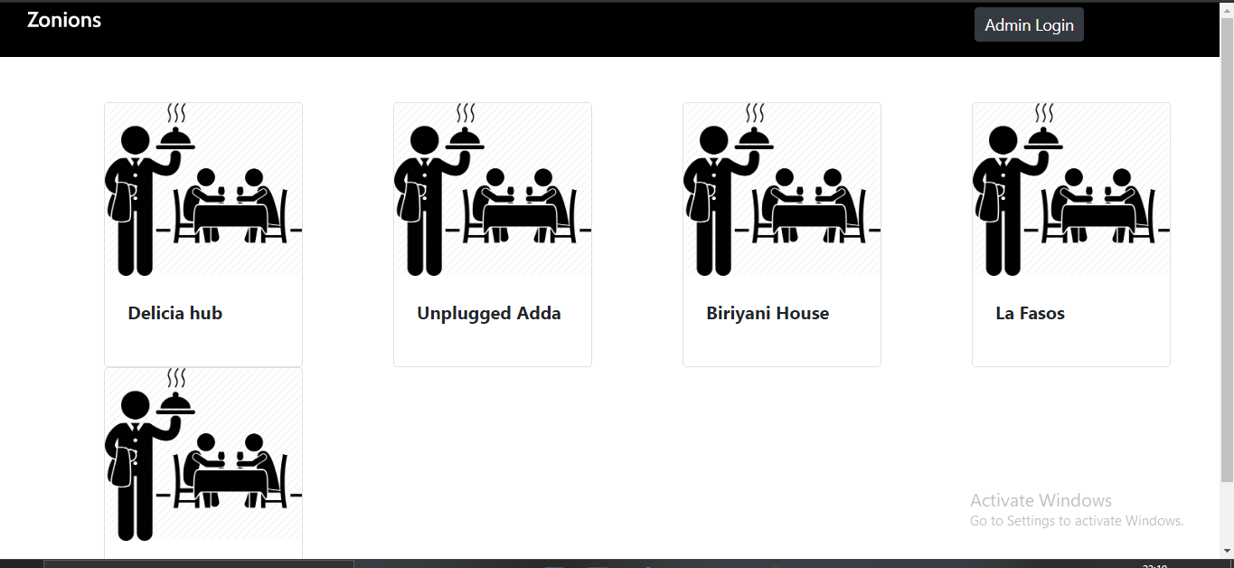

2.Restaurant Details-On clicking on restaurant name it navigate to the corresponding restaurant details page

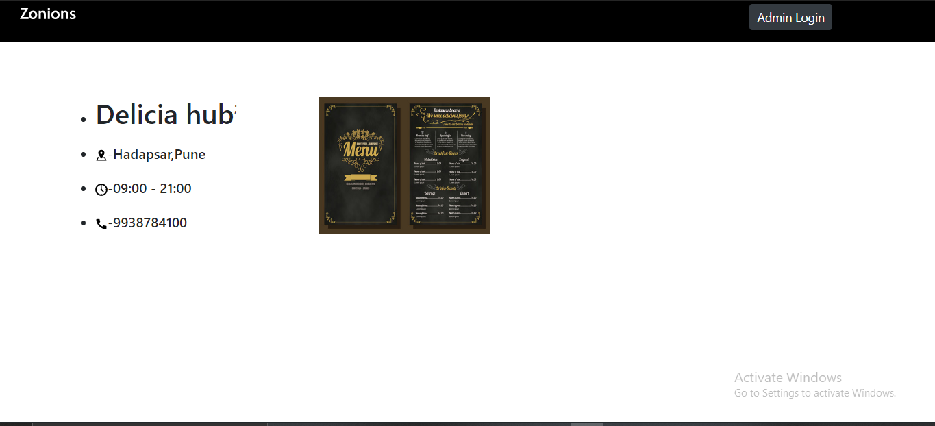

1. On Clicking on the Menu Image it displays menu in a modal.

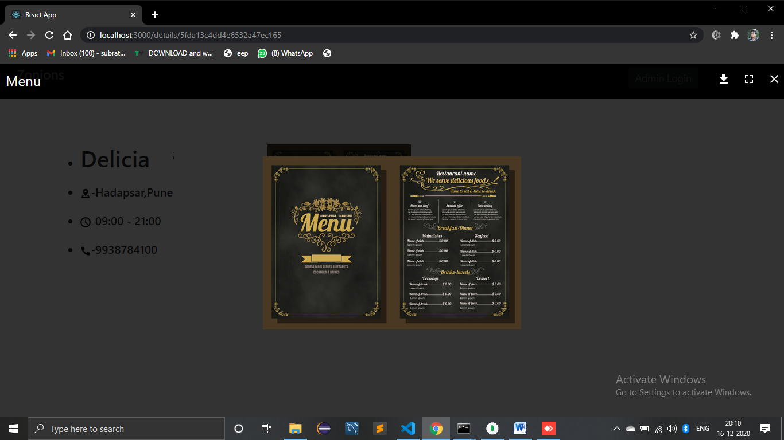

On clicking on zonions icon it navigate back to the home screen

4- Admin Login- On clicking on admin login button in header it opens the admin login display

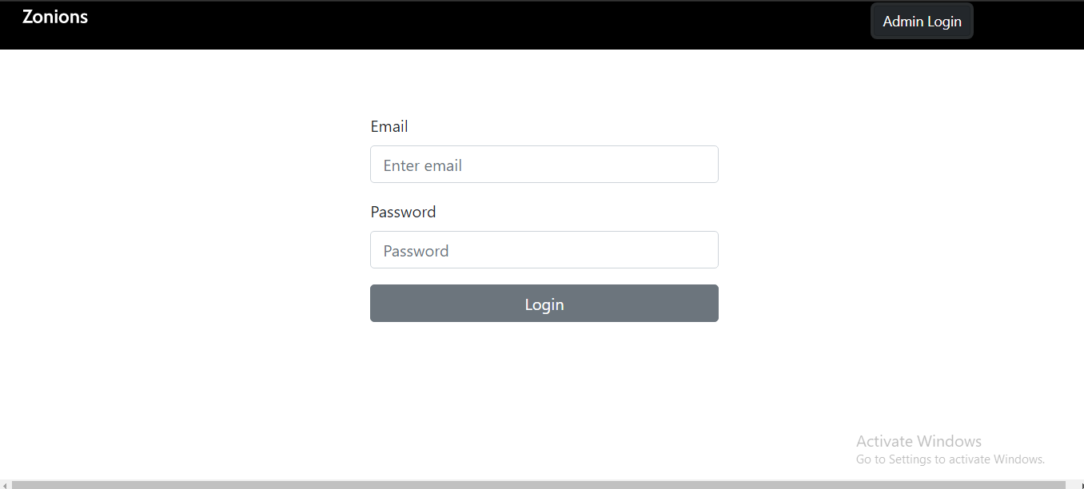

5-Admin Page- On Successful login it navigates to the admin page, where new data can be added or existing restaurant details can be updated.

Restaurants can be deleted by admin also.

Admin [- admin@gmail.com](mailto:%20-%20%20admin@gmail.com)

Password- Admin@123

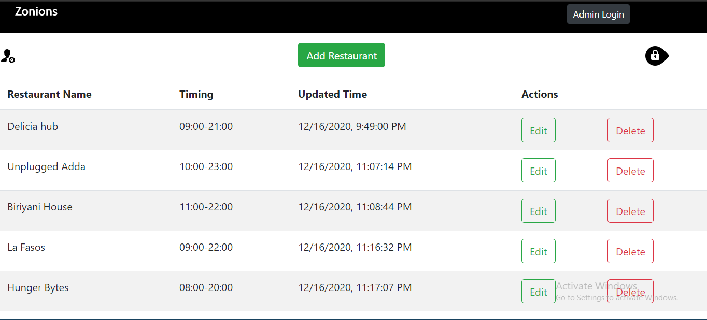

The logout symbol is used to directly logout to homepage.

6-Add user modal- On clicking on add Restaurant button a modal to add restaurant details popup in the window.

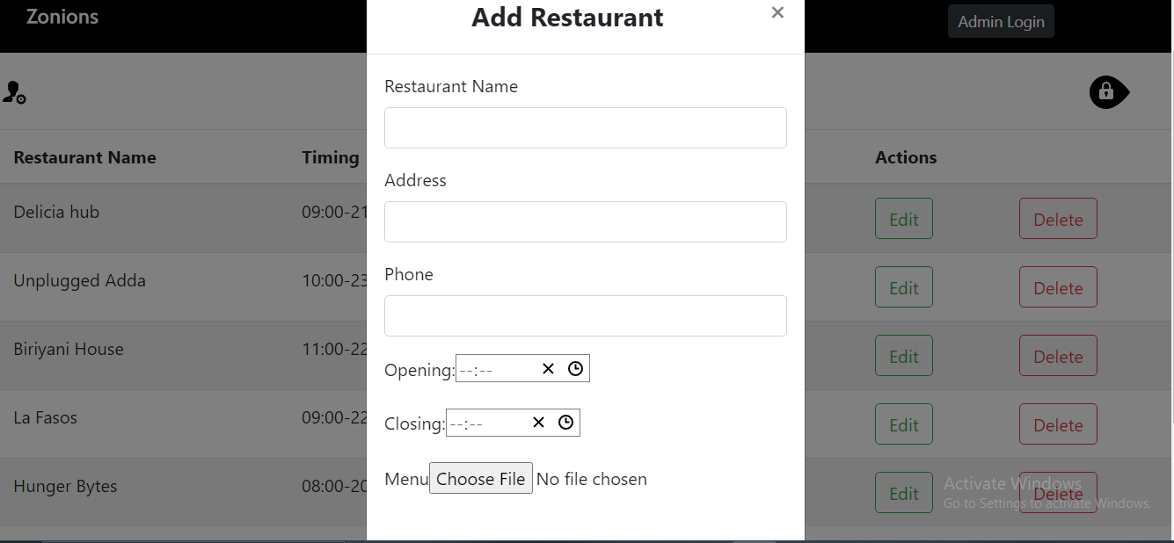

7- Update- On clicking on Edit button the corresponding restaurant details popup in modal to update

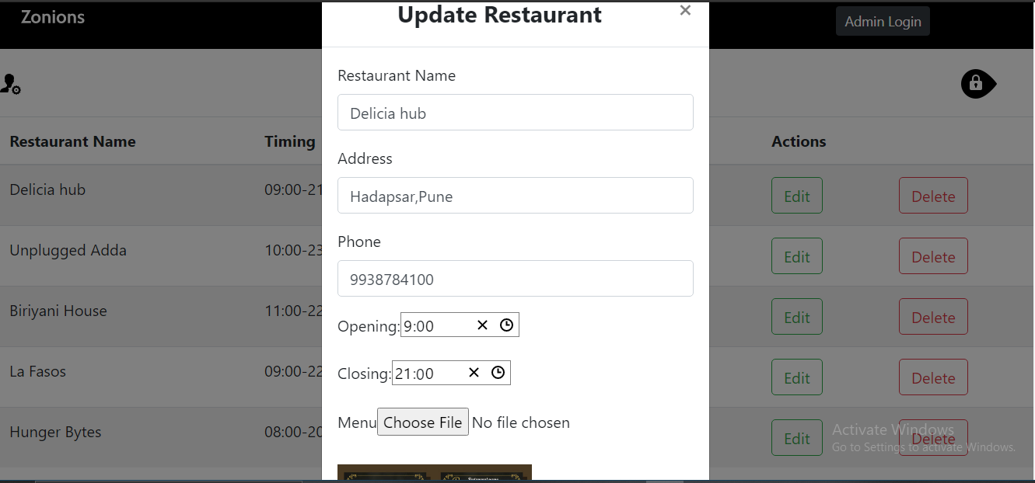

BACKEND-

Model - 1. Restaurant

2.RestaurantDetail

Restaurant and RestaurantDetail have one to one relationship.

Controller – RestaurantController

Restaurant Controller contain actions like create,delete, find,findById and Update

Routes-

'POST /restaurant':'RestaurantController.create',

Used for creating RestApi for posting or inserting data into database.

'GET /restaurant':'RestaurantController.find',

Used for creating RestApi to get all data from database

'DELETE /restaurant/:id':'RestaurantController.delete',

Used for deleting specific restaurant by their id from both the models

'PUT /restaurant/:id':'RestaurantController.update',

Used for updating specific data in the database by Id