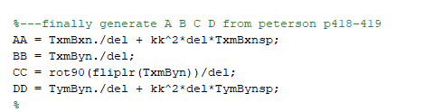

Notation aside

* T: Testing Function
* B: Basis Function
* x: on Jx coordinate system
* y: on Jy coordinate system

Speeding up

* Because we’re using square cells, AA and DD are the same matrix.
* BB has repeating values though. Might be some way to take advantage?
  + In chapter 4 of Peterson, there’s a thing about block Toeplitz

For a 3x3, Jx coordinate system on right

