CCMS editors guide

Overview
This document describes the options available to authors. It offers a brief description of the concepts of a CCMS site and details the actions that are available to the author.

Concepts

A CCMS site consists of Page objects, references to which are arranged in a hierarchical Viewtree. The viewtree is the website hierarchy.
Each Page item will normally have associated with it one or more Content items.
Because the content items exist independently of the pages, a particular content item may in fact be used on more than one page.
Content items may also exist in the system and not be associated with a page at all. For example, news items that are created regularly may be displayed by some code that lists the most recent five items.
A content item consists of at least one version. Versions basically correspond to the editing history of a content item. Further, a version can exist in one of several states, indicating where in the editing cycle that version is (at work, pending approval, active or rejected). The system will display the most recent active version.
Similarly, the same page may be referenced more than once by the viewtree. In other words the same page may exist more than once in the site hierarchy.
The visual look of the site is managed by Layout Templates. These are created and managed by the site administrator. However, the author may have rights to assign an existing layout to the viewtree. The layout thus assigned will then apply to all pages under the viewtree position to which the layout is applied.

Non-editable items
The visual ant structural layout teplate(s) of the site cannot be edited by an author. This is to ensure that the designed look and feel of the site is unaffected by authoring activities.
The layout templates are created and managed by the site administrator. These layouts may include functionality such as automated navigations (menus) based on the viewtree. These automated navigations are not editable by the authors and are very likely to be specific to the design of the website in question.

Editable items
The actions available to an author are dependant on the rights that they have been given. The possible actions include creating and managing content items; creating and managing page items including associating content with pages; managing the viewtree, including assigning of layouts; and uploading of binary content (images, documents etc.).
The available editable items become accessible when the author logs in to the site.

Using Edit Mode
Edit mode can be triggered by a user of the system who has been given editing rights. The system must 'know' who is doing the editing so that the correct rights are given to the user (author, approver etc.). Therefore, the user must log in to the system.
Once logged in, the user is presented with a number of possible actions they are allowed to perform. These options will depend on the rights that the user has been given (the rights are set by the system manager and cannot normally be altered by the user).

Logging in
The login form is triggered by a special addition to the URL (the web address of the page). This addition is 'login'.
Note that because of the way the system works, this must be preceded with either '?' (a question mark) if there are no URL parameters, or by '&' (an ampersand) if there are. The following shows this:

- URL with no parameters that triggers a login:

- URL with parameters that triggers a login:

When the user presses [ENTER] with the login trigger, they are presented with a simple login form. The user should enter their username and password:

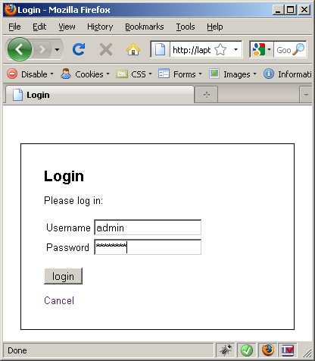

A successful login will re-open the page, but with the addition of a toolbar across the top and possibly one or more drop-down boxes adjacent to areas of text. The available options for both the toolbar and the drop-downs will depend on the rights the user has. The image below shows the Administrator toolbar with full rights:

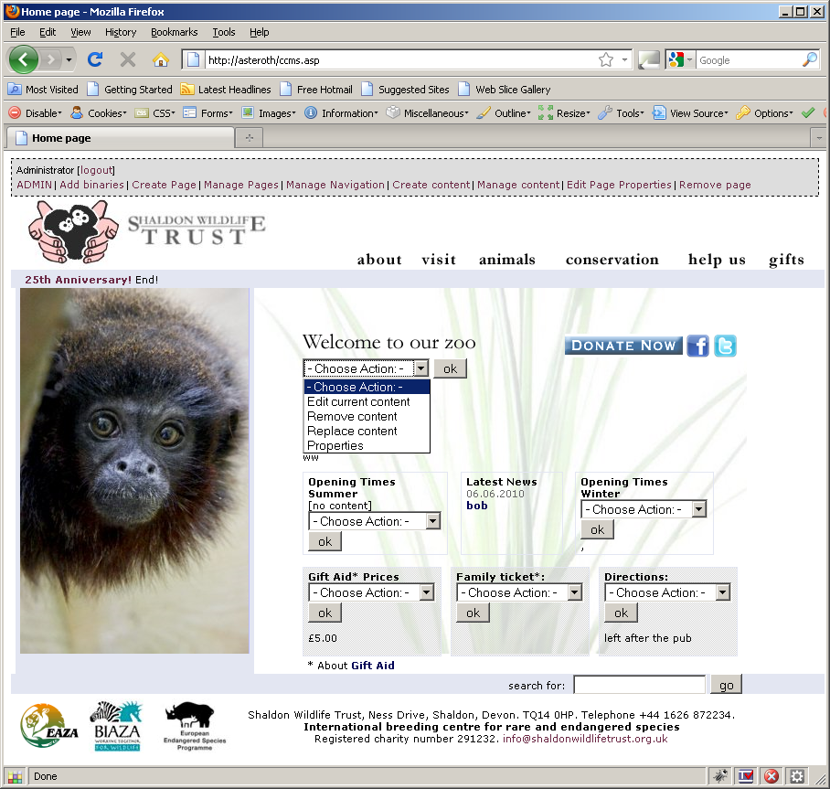

Rights and Permissions
The possible actions that may be available to a user are summarised below.

Toolbar
Most of the Toolbar options are actions that are not directly related to the current page. They include actions that may make changes to several pages at once (e.g. Assign Layouts) or allow management of multiple things at once (e.g. Manage Content)

Admin
This option gives access to administrative functions such as User Management. This option will not normally be available to content creators (it is included here for completeness, and is described fully in the Administrators guide).

Add binaries
This option allows the author to upload of binaries (images, documents, movie files etc.).

Create Page
This option allows the author to create a new page and assign properties such as name.

Manage Pages
This option shows all pages as a list, allows the user to see where they are currently in the site and offers options to place pages in the site hierarchy.

Manage Navigation
This option allows authors to alter the look and feel of the site by assigning a new 'Layout'; to modify navigations by re-ordering sibling nodes and move nodes to alternate locations; and view properties of the nodes and corresponding pages.

Create Content
This option allows authors to create new content. Content created from this option is not automatically associated with a page and is useful for creating, for example, news articles.

Manage Content
This option allows an author to find and display (with an optional filter) any of the content items currently in the system. Once listed, the author has the option to edit or delete each item. [NOTE: the delete option is not yet implemented]

Edit Page Properties
This option allows the author to edit the properties of the current page. These include the name, the page title (as displayed in the browser title bar), the link text (the text of any navigation links that point to the page), the description (normally used for HTML meta description) and keywords (normally used for HTML meta keywords)

Remove Page
This option allows the author to remove the current page from the viewtree. The page is not deleted from the system.

Dropdowns
A dropdown will show at the top of any areas of editable content within a page. The options available in the dropdown are dependant on the rights the user has and the presence or absence of content in that slot.

Edit Current Content
This option will allow the author to make changes to the content item.

Remove Content
This option will remove the content item from the page. It will not delete the content item, and it will still be available in the system.

Replace Content
This option will allow the author to replace the current content item with another that exists in the system.

Properties
This option displays and allows modification of certain properties of the current content item.

Create new content
For an empty slot, this option allows creation and automatic insertion of a new content item.

Add existing content
For an empty slot, this option allows the choosing and insertion of an existing content item.

Logging out
The 'logout' link on the left of the toolbar will log the user out and cease the editing session.

Managing Content
'Content' is the words, and any associated images, that constitute the editable text of a site. This includes content items that are directly associated with pages and items that are retrieved and displayed dynamically and are not explicitly related to any particular page (such as news articles).

Content on Pages
A page usually has areas that can contain content objects. These areas are known as slots. When a user has logged in with appropriate rights, each editable area displays a dropdown. The options available in this dropdown depend on two things: Whether there is any content currently assigned and the specific rights that the user has.

Empty slot
When a page is first created (see Create Page) the slots are empty. The actions that can be performed are to create new content and assign some existing content. The dropdown shows the options for which the user has rights. The following shows all the possible options:

Create new content
Selecting this option opens a dialogue box for creation of a new, empty content item. This dialogue can be accessed in different ways, but the key point here is that the new content item is automatically associated with the specific page and slot from which the creation was triggered:
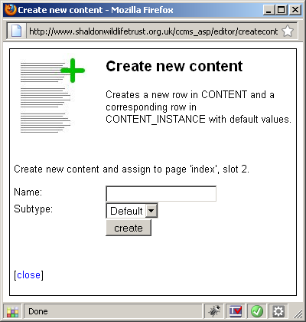

The name can be anything, though it is suggested that a meaningful name is provided. The subtype defaults to 'any' but there may be other subtypes available that have been created by the site administrator (such as 'news') which have specific meanings for the specific site. These will be documented for that site.
Clicking 'create' will create a new content object and an option to edit the content is offered, or the dialogue can be closed:
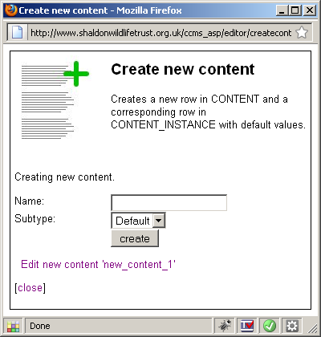

The website page slot options have also changed to reflect the fact that the slot now contains the newly created content object:

These options are described in the Filled slot editing description.

Add existing content
The other option available for an empty slot is to select an existing content item to be placed in the slot. Choosing this option opens a dialogue that allows selection of existing content. Initially, no item is selected:
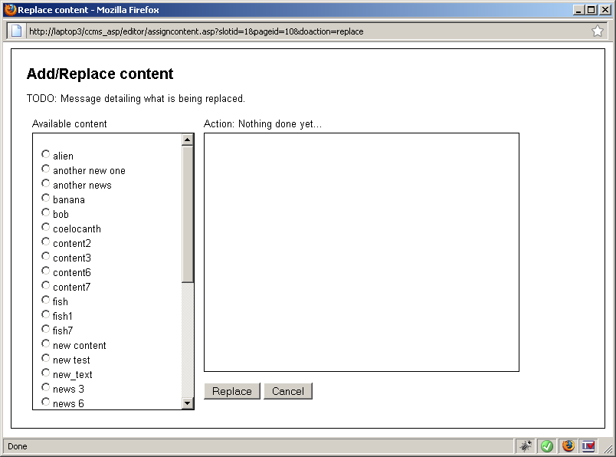
The left-hand list shows all available content items, and the right-hand panel displays the content that is currently selected:

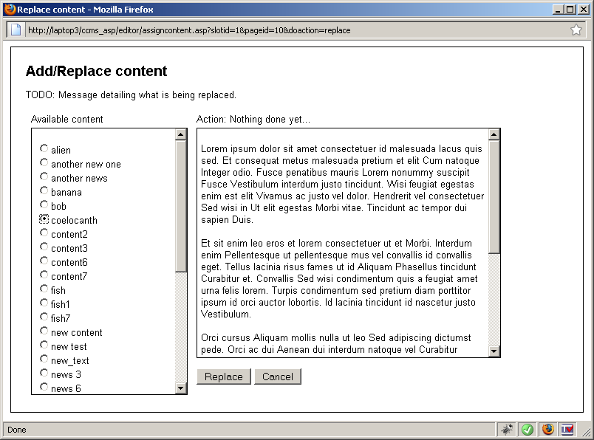
Once the user has chosen the desired content to assign to the page, clicking the 'Replace' button will assign the selected content to the page and slot from which the user triggered dialogue.
Again, the slot dropdown will change to offer options to manage the selected content:

Filled slot
The above actions will fill the slot in question with the selected content item. The list of actions then available to perform on that content will depend on the users rights.

Edit current content
Choosing this option triggers the editor, described here.

Remove content
This option triggers a dialogue that allows the user to remove the content currently assigned to that slot, thus emptying it:
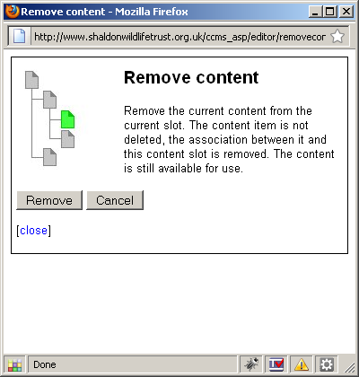
The options are either perform the removal, or cancel.
Cancel simply closes the dialogue and Remove will empty the slot. The dialogue indicates a successful removal:
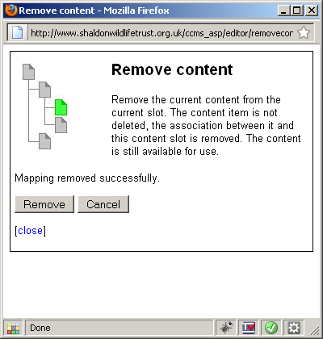

Replace content
Selecting this option opens the same dialogue that is displayed for Add existing content. The procedure is the same.

Properties
Selecting this option opens a dialogue that shows the current name and subtype of the content and allows the user to change the name and subtype. Changes to either of these can be saved by clicking 'update'. Additionally, the dialogues for listing all content and editing the content can be opened by clicking either the 'List all content' or 'Edit this content' links:
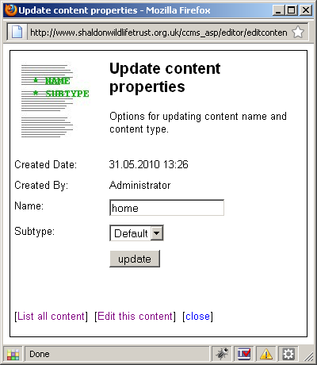

The 'List all content' option is opens the dialogue to list all content, described here and 'Edit this content' option opens the content editor, described here.

Unassociated content
Content items may exist in the system that are not associated with a page. This could be for several reasons – the content may have been removed from a page, it may have been created in anticipation of a relevant page being created or it may be a dynamically displayed content such as a news item.
Creation and management of unassociated content is via the top toolbar options 'Create content' and 'Manage content'. The availability of these is also dependant on the users rights.

Create content
Clicking this link will open the Create content dialogue box. This is the same dialogue as opened from the create content for an empty slot option. The difference is that the newly created content is not associated with any page slot.
Otherwise, the procedure is the same.

Manage content
Clicking this link will open a dialogue box allowing the user to search for content by name and subtype. The resulting list offers options to edit, update the properties and delete the content items.
When this option is first clicked, the content search dialogue is displayed:
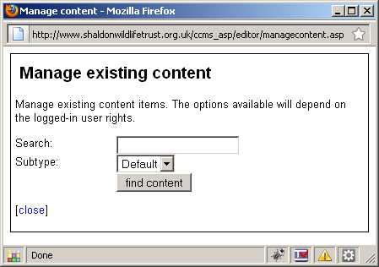
The 'search' field can optionally have a filter added and the subtype can be selected. Clicking 'find content' will list all content items matching the entered filter. The following example shows a filter of 'a' and subtype of 'any':
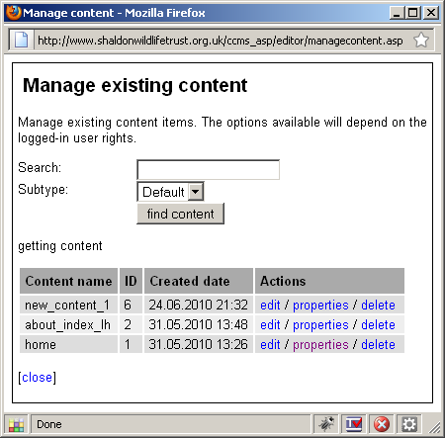

The list shows the content name, ID (the unique identifier in the database), created date and the actions that the users current rights will allow.

Edit
The edit option will open the editor to allow amending of the text as described in Editing content.

Properties
The properties option will open the content properties dialogue as described in the Content Properties section.

Delete
This option deletes the selected content. [NOTE – this is not yet implemented]

Editing content
As described above, there are various ways to trigger the editor. When triggered, the user will see the editor tool.
This tool allows the management of the content item and the state of each version. The available options are again dependant on the rights the user has. For example, the user may not have rights to make a version active.
The editor displays a list of versions of the current content. The state of each version is indicated by a small icon. The editor also offers a WYSIWYG interface and a familiar text editing environment. This interface is a third party open source product called TinyMCE that has been integrated into CCMS. It is fully documented on the creators website at http://tinymce.moxiecode.com/ :

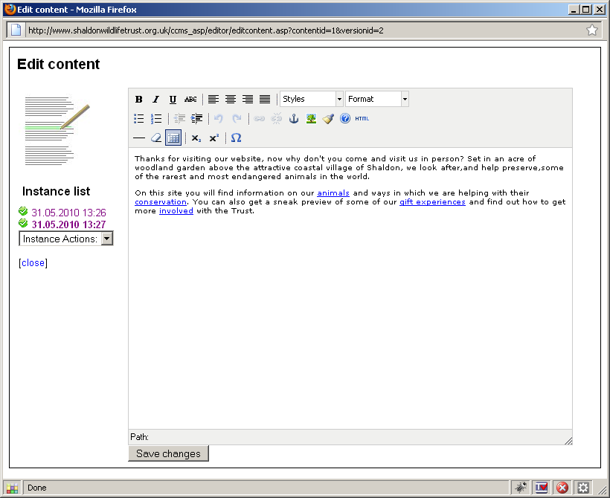
The areas of the editor are described below:

List of versions
Indicated as 1. The most recent version is at the bottom. When the editor is first opened, the most recent active version is highlighted, and the instance text is shown in the editing area (4). Clicking on an alternative version will open the text of that version in the main editor window. This may then be used as the basis for a new version.

Version actions
Indicated as 2. This dropdown offers the available actions that can be performed on the new version:

The change of state, or deletion, is triggered by simply selecting the desired item in the list.
The options available here will depend on the rights that the user has.

Editor tool options
Indicated as 3. Standard text editing tools. The styling, paragraph, image and table options used are shown appropriately styled in the text display area.
The options available here are configurable, but only by the site administrator.

Text of selected version of content.
Indicated as 4. When a version is selected, the text of that version is displayed in this area. The author is free to make alterations as desired. The display is styled and the editing is intuitive. Note that the options available here may be different if the site administrator has re-configured TinyMCE.

Save Changes:
Indicated as 5. Clicking this button will save the text currently displayed in the editor window as a new version. This new version is created in an at-work state. Note that a new version is created every time the save changes button is clicked. The state of this new version can be altered using the 'Instance actions' dropdown.
Note that the system will display the most recent active version on the live website.

Page management
In the context of many Content Management Systems, including CCMS, a page can be considered a container for content items. And, more importantly, a page defines a position in the site information architecture for that content and this is defined by its position in the viewtree.
Using CCMS, a user with appropriate rights can create pages, assign or remove a page from the viewtree and add or remove content from that page.
A page does not contain any visual look and feel information. This is managed by the assignment of layouts.
The options to manage pages with CCMS are all available from the toolbar visible when logged in. As before, the available actions are dependant on the permissions the logged-in user has. The options are described in the following sections.

Create page
Clicking this option opens a dialogue box for creation of a new page. There are a number of fields to fill in, described below:
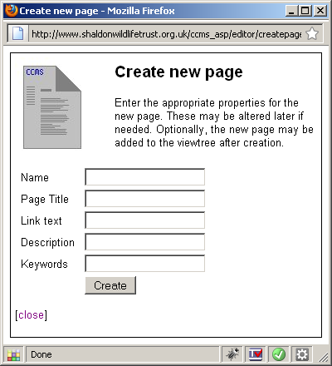

New page properties

Name
Name of the new page. It can be anything, but it is suggested that something meaningful is used.

Page Title
This is the text that will appear in the web browser title bar when the new page is viewed.

Link Text
This is the text that will be used as the text of automatically generated navigation links to the new page.

Description
Text that is used in the HTML META description tag, used by search engines.

Keywords
Text that is used in the HTML META keywords tag, also used by search engines.

Create the page
Clicking 'Create' will create the page. The confirmation dialogue box will offer the option to add the new page to the viewtree, or to close the dialogue [NOTE this is to complete]

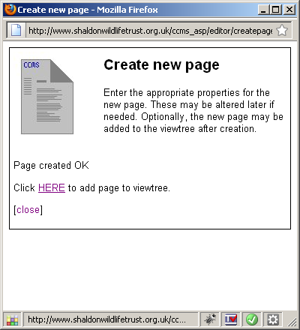

Adding new page to viewtree
Clicking the 'Add to viewtree' link opens a dialogue box that displays the entire site hierarchy of pages, each with a radio button:

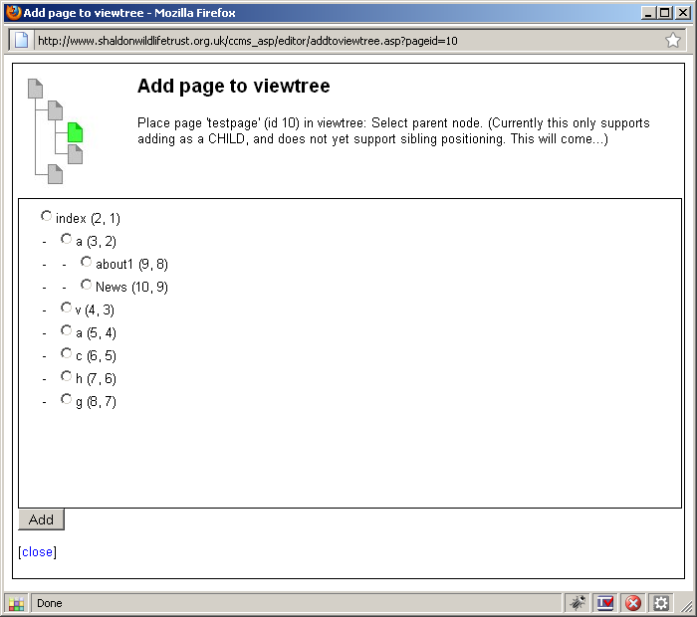

The user should select the PARENT for the new page. For example, if the new page should be in the section 'a', the 'a' radio button should be selected. This section currently has two direct children:

Finally, clicking 'Add' will insert the new page as a child of 'about' as a child below the last existing item. The dialogue box will refresh to show the new page:

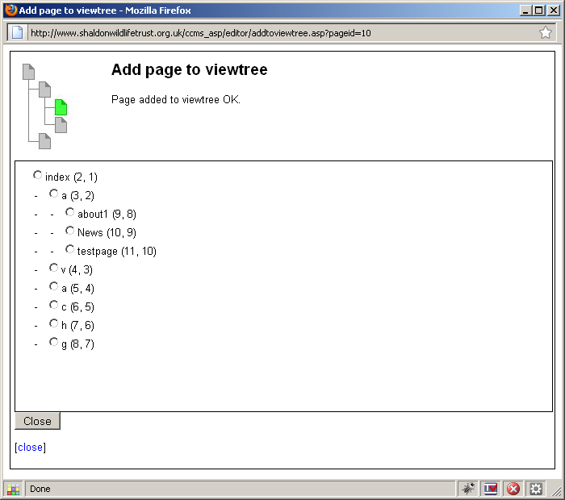

Note that the link text ('testpage') entered during page creation is displayed.
Refreshing the site will show that the new page has been automatically added to the appropriate navigation – direct, last child of 'a':

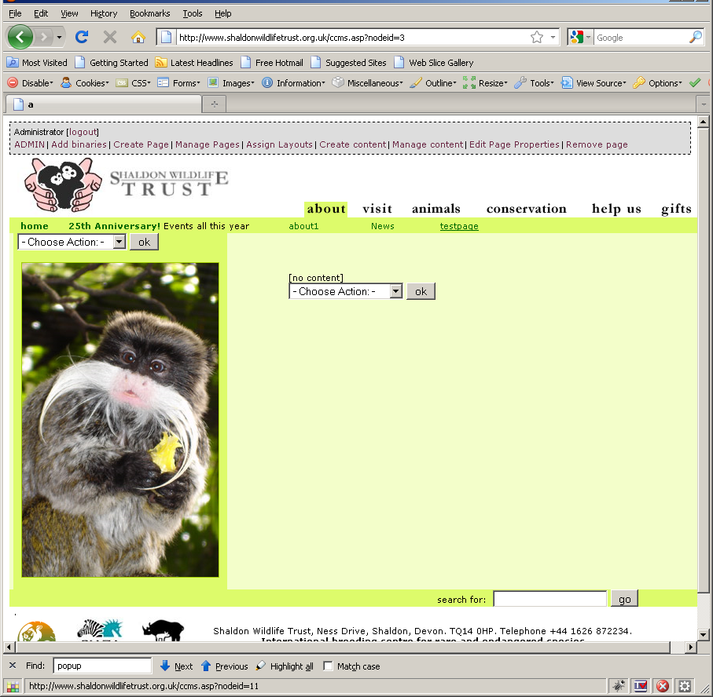
Notice that the content slots are empty. These can be managed as described in Managing Empty Slots.

Manage Pages
Clicking the 'Manage Pages' toolbar link opens a list of all existing pages. These include both those that are already in the viewtree, and those that are not (for example if a page was created but not added to the viewtree):
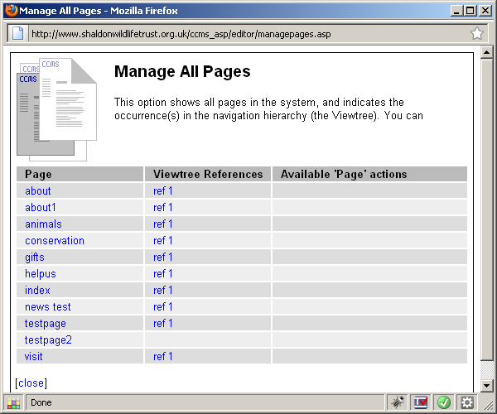

Available options
The list of pages offers a number of actions that may be performed. These include viewing where in the site each page is used and options for managing those references.

Viewtree References
This column shows the occurrences of each page in the viewtree. In the above example, most of the pages are present one time in the viewtree, two are referenced twice, and four are not referenced at all. Clicking one of these 'ref' links will open the viewtree reference in the browser.

Page
This column shows each page, with a link, that when clicked, offers the actions available to perform on the page.

Available actions
The actions available depend on whether the page is referenced in the viewtree.
Unreferenced page: A page that is not referenced can be added to the viewtree, deleted or its properties can be amended:

Referenced page: A page that is currently referenced by the viewtree can have another viewtree reference added, the viewtree itself can be managed [not yet implemented] and the page properties can be managed:

Add page to viewtree
Selecting 'Add Page to viewtree' triggers a confirmation dialogue:

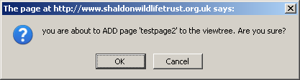
Confirming the addition opens the same dialogue as for adding a newly created page. The end result is that a reference to the existing page is added to the viewtree.

Delete page
This option will delete the page from the system [Note this is not yet implemented]

Add another page reference to viewtree
This offers the same dialogue as Add page to viewtree. The end result is that another reference to the existing page is added to the viewtree.

Manage Viewtree
Selecting this option, following a confirmation dialogue, opens the 'Manage Viewtree' dialogue [Not yet implemented].

Edit Page Properties

Clicking this toolbar option opens a similar dialogue box as for the initial create page step, but pre-populated with the values for the 'current' page. For example, clicking 'edit page properties' for the page 'Gardens':
opens the dialogue pre-populated as follows:
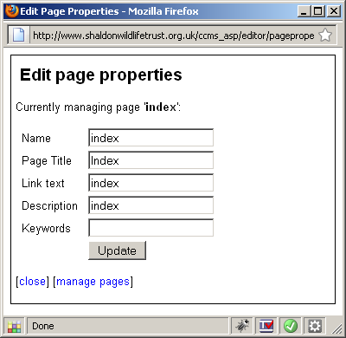

Any of these values may be amended. Clicking 'Update' will apply the changes.

Remove Page
Clicking the toolbar option 'remove page' offers an option to remove the REFERENCE to the current page from the viewtree – it is the reverse of adding a page to the viewtree, it is NOT permanently deleting the page from the system.

Pages with children
Obviously, if a page is a main section page – such as the 'about' page in these examples – it is very likely to have child pages. Removing a viewtree reference that has children is inadvisable as all the child pages would also become detached from the viewtree. Therefore, if the author does try to remove a page that has children, the system will not let them:

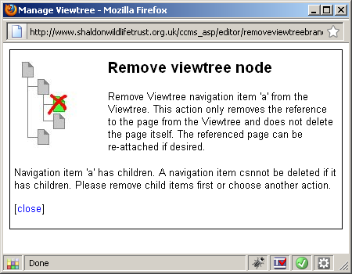

Pages without children
Pages without children may also be thought of as the tips of branches of the viewtree. As there are no childs in this scenario that would also be detached from the viewtree, the system will allow the removal of the page:

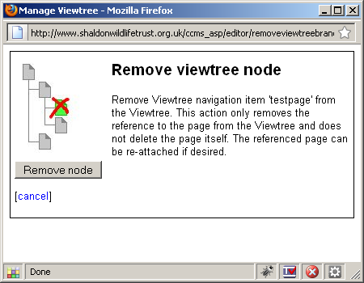
The 'Remove Node' button triggers the removal. This action must be confirmed. The dialogue box reloads with a confirmation message. Note that the page still exists in the system and can be re-attached to the viewtree using the procedure described in Manage Pages/Add page to viewtree.

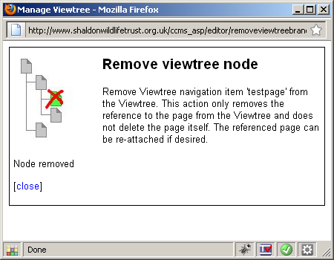

Managing look and feel
As described elsewhere in this document, the site hierarchy is made up of Page objects that contain Content objects. These objects DO NOT contain any information that defines how the page looks when viewed in a browser. This look and feel is defined by one or more Layout Templates. A layout may also contain functional aspects such as site-specific navigations or news displays. These layouts are defined by the Site Administrator and cannot be altered by the authors.

However, the administrator will have made one or more layout templates available for selection by authors with sufficient permissions.

A layout can be assigned to a viewtree node and that node AND ALL ITS DESCENDENTS will be displayed using that layout. Further, if a descendent has a different layout applied, that descendent (and all deeper descendants) will use that alternative layout page.

For example, clicking the toolbar option 'Assign Layouts' when viewing the 'about' page opens the following dialogue, with the 'about' page highlighted by default:

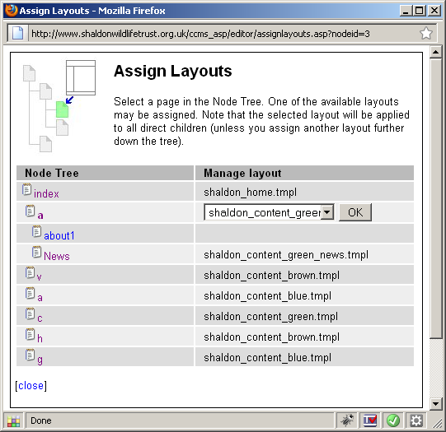
Node Tree: This column shows a hierarchical view of the viewtree. Each node is a link. Clicking on these will open that page in the browser.
Manage Layout: This column shows the layout template assigned to the nodes. In the above example, the 'about' page has the template 'shaldon_content_green' assigned. It is important to note that ALL descendants of this page will ALSO use this layout, unless specifically assigned a different layout.

Assign a new layout
The user may select a new layout template from the dropdown:

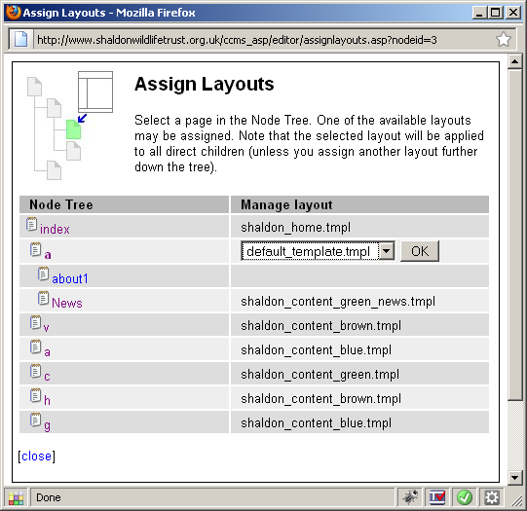
Selecting this new layout will affect the current page and all descendant pages.
The following pair of images show the same page, but with alternate layout templates applied. Note that the texts are in different places on the design and the navigation now appears on the left.

Site-specific layout:

Demo layout:

