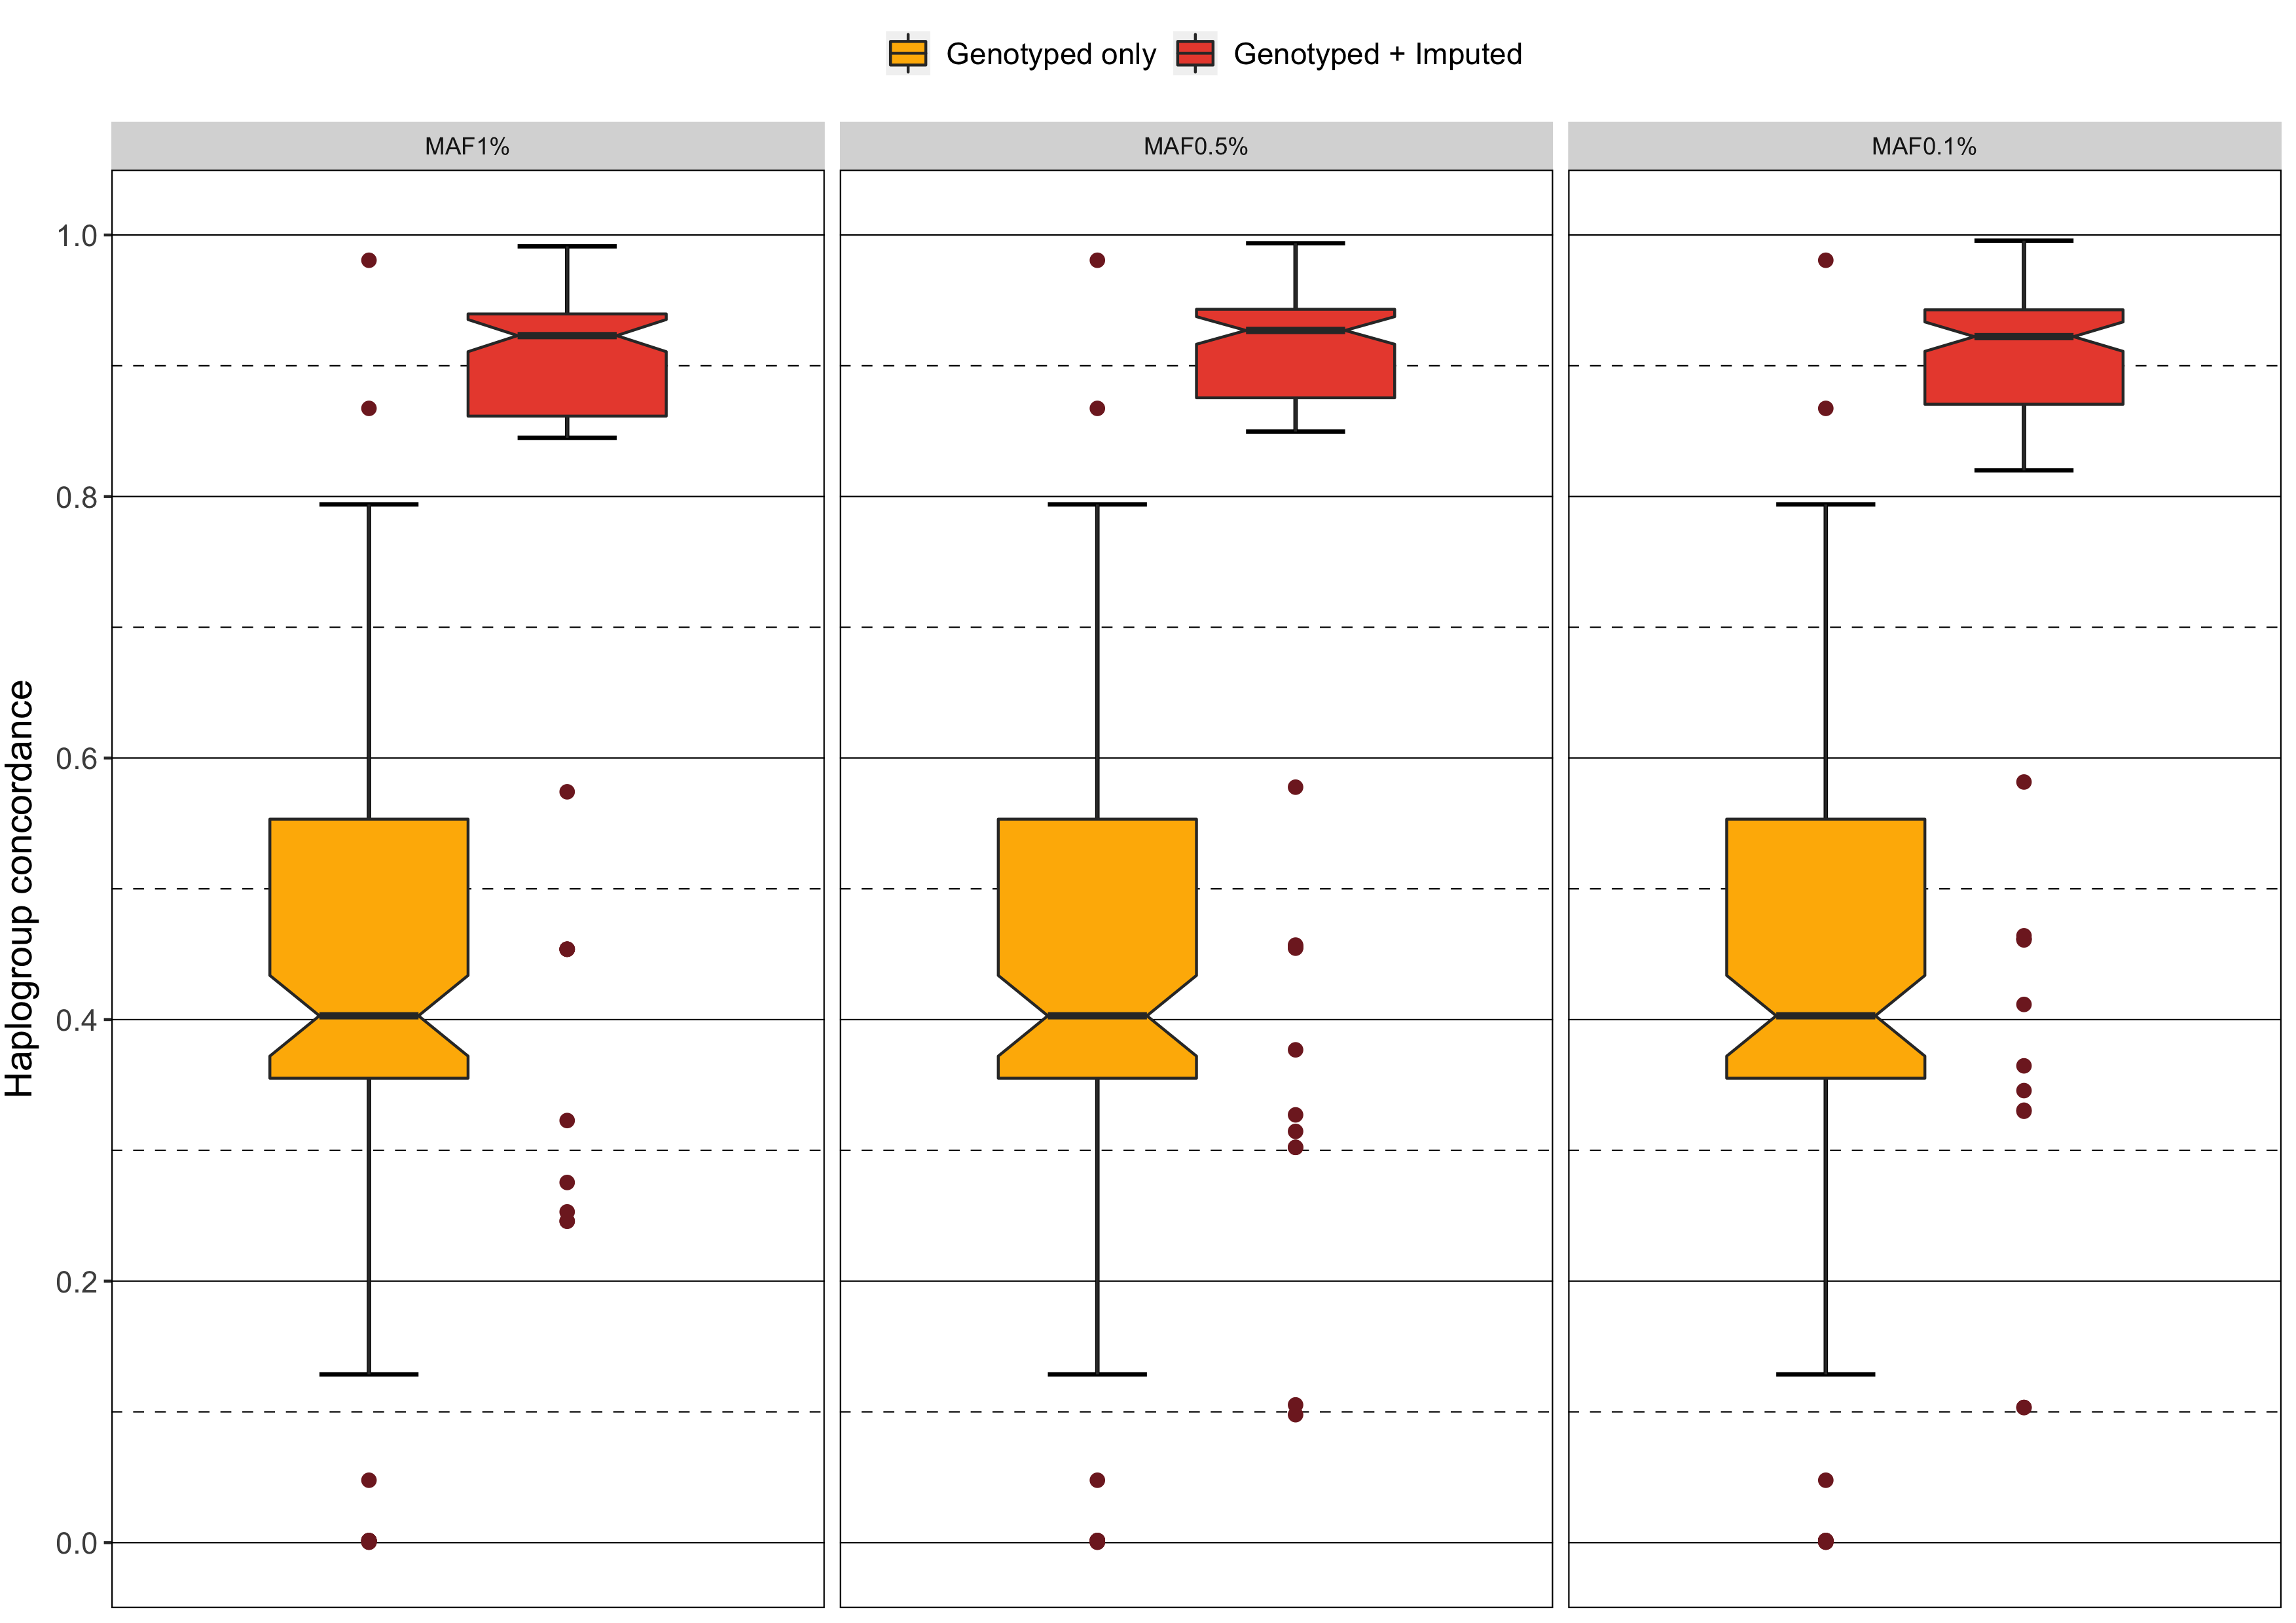  
Supplementary Figure 1. Distribution of mean haplogroup concordance per *in silico* microarray before (yellow) and after imputing missing mtSNVs for minor allele frequency 1%, 0.5%, and 0.1%.

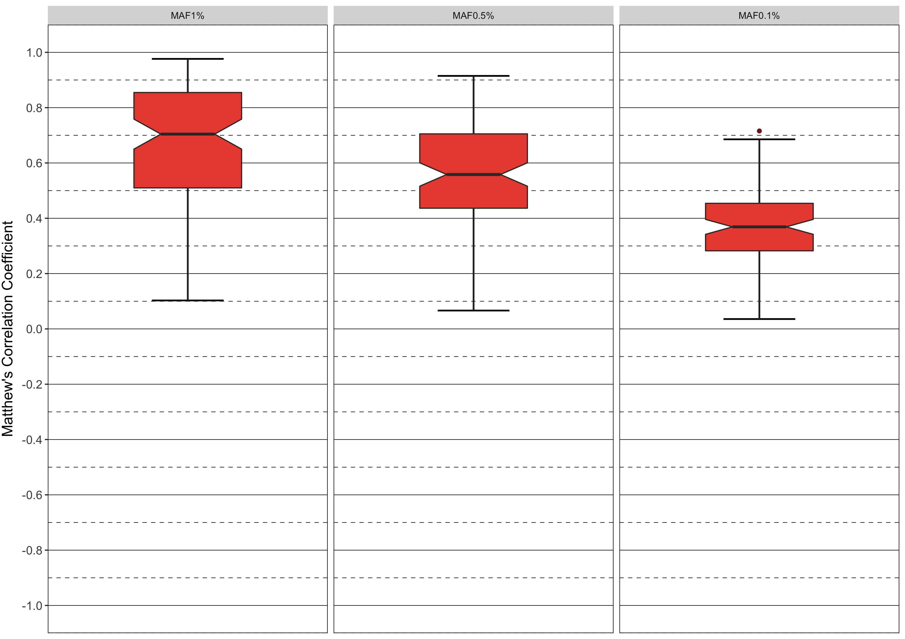  
Supplementary Figure 2. Distribution of mean genotype concordance measured by Matthew’s correlation coefficient per *in silico* microarray after imputing missing mtSNVs for minor allele frequency 1%, 0.5%, and 0.1%.

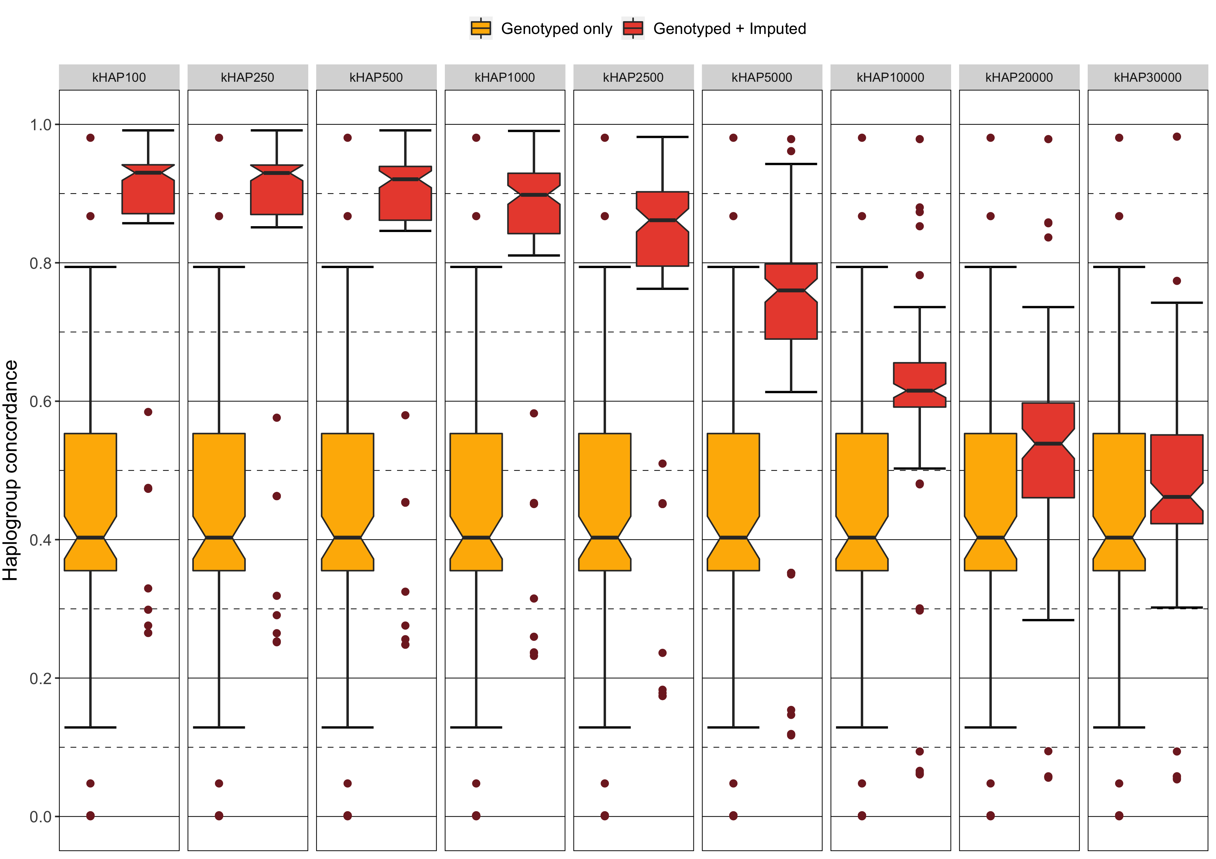  
Supplementary Figure 3. Distribution of mean genotype concordance measured by Matthew’s correlation coefficient per *in silico* microarray after imputing missing mtSNVs for number of included reference haplotypes 100, 250, 500, 1000, 2500, 5000, 10000, 20000, 30000.

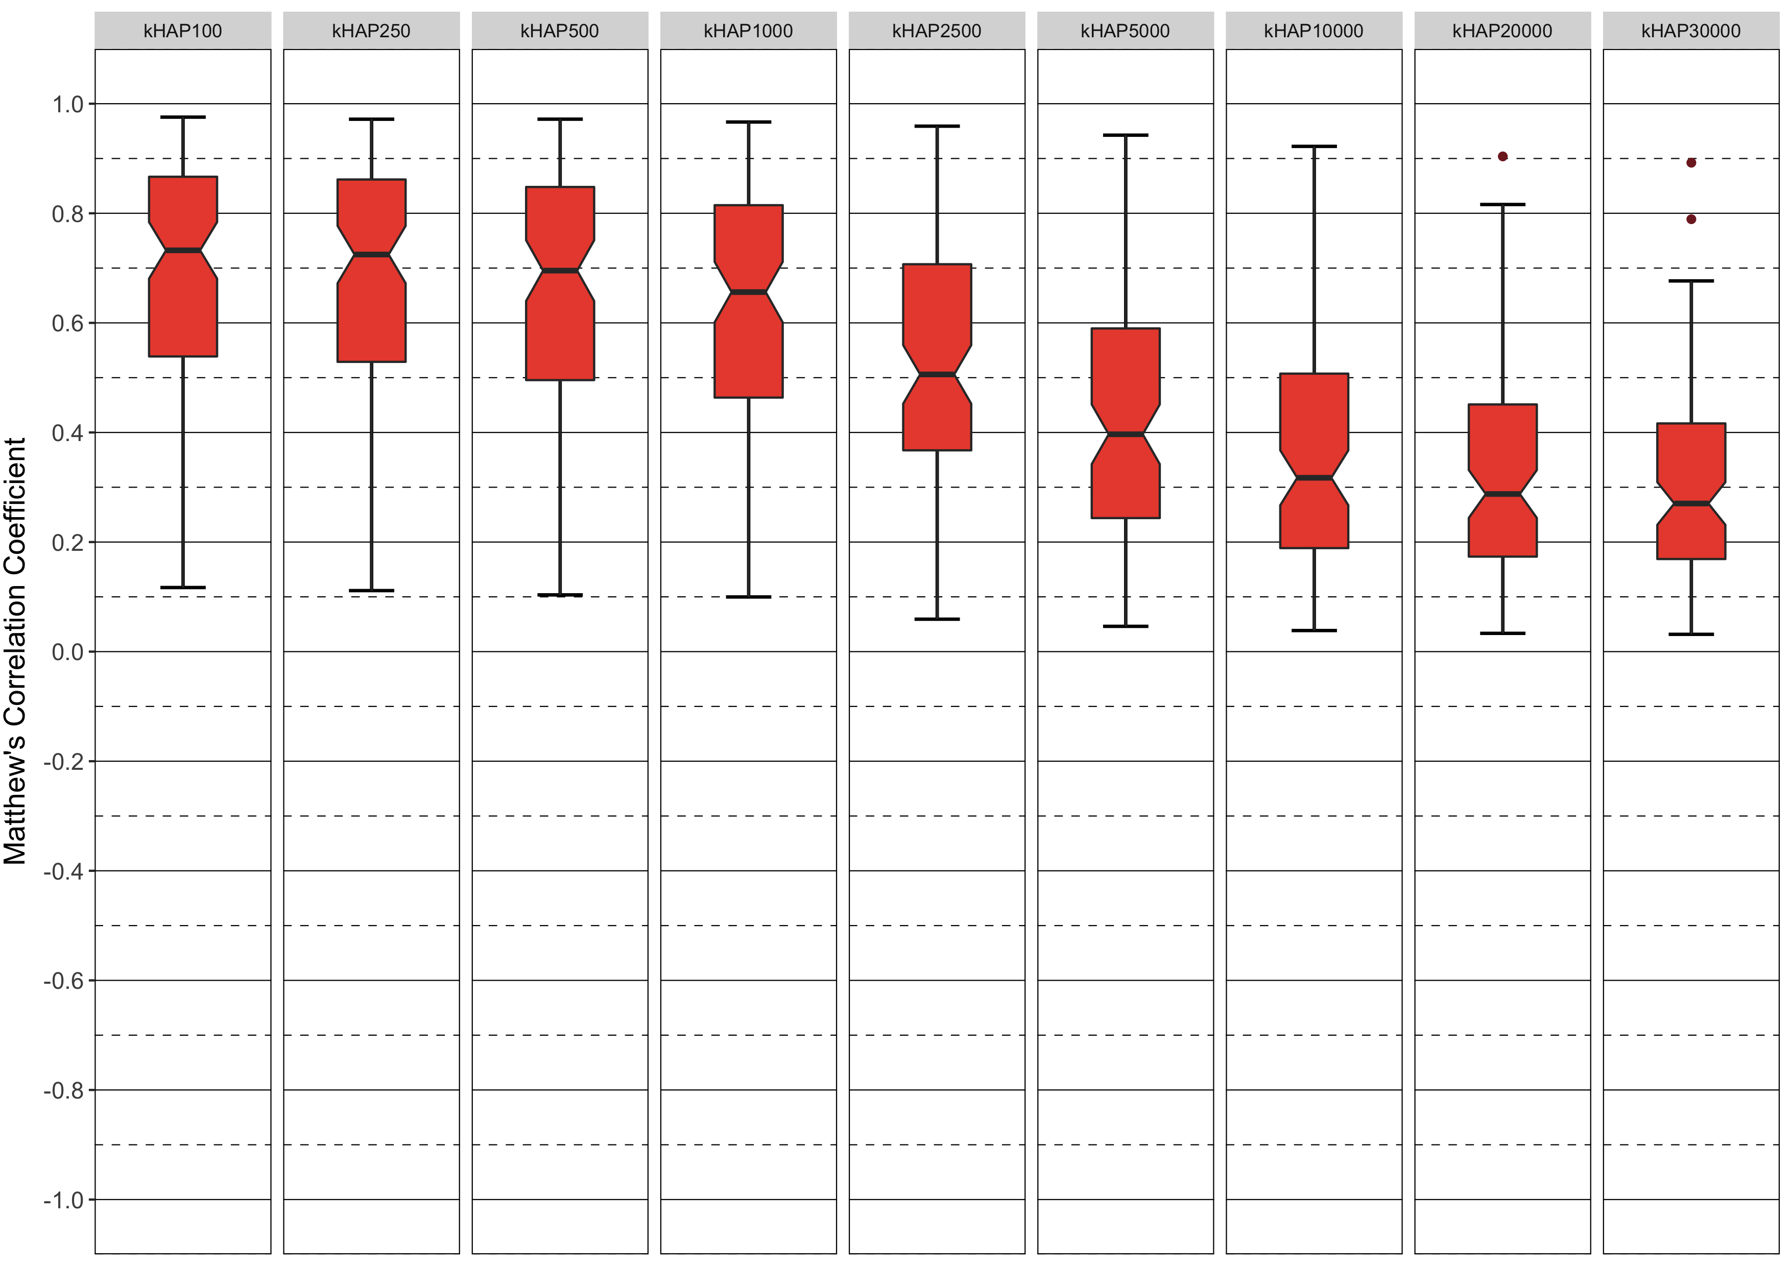  
Supplementary Figure 4. Distribution of mean genotype concordance measured by Matthew’s correlation coefficient per *in silico* microarray after imputing missing mtSNVs for number of included reference haplotypes 100, 250, 500, 1000, 2500, 5000, 10000, 20000, 30000.