**Supplementary Methods**

The following search term was used to identify whole human mtDNA sequences from GenBank on 2018-07-18:

(016500[SLEN]:016600[SLEN]) AND Homo[Organism] AND mitochondrion[FILT] AND complete genome NOT (Homo sp. Altai OR Denisova hominin OR neanderthalensis OR heidelbergensis OR consensus OR ancient human remains OR shotgun)

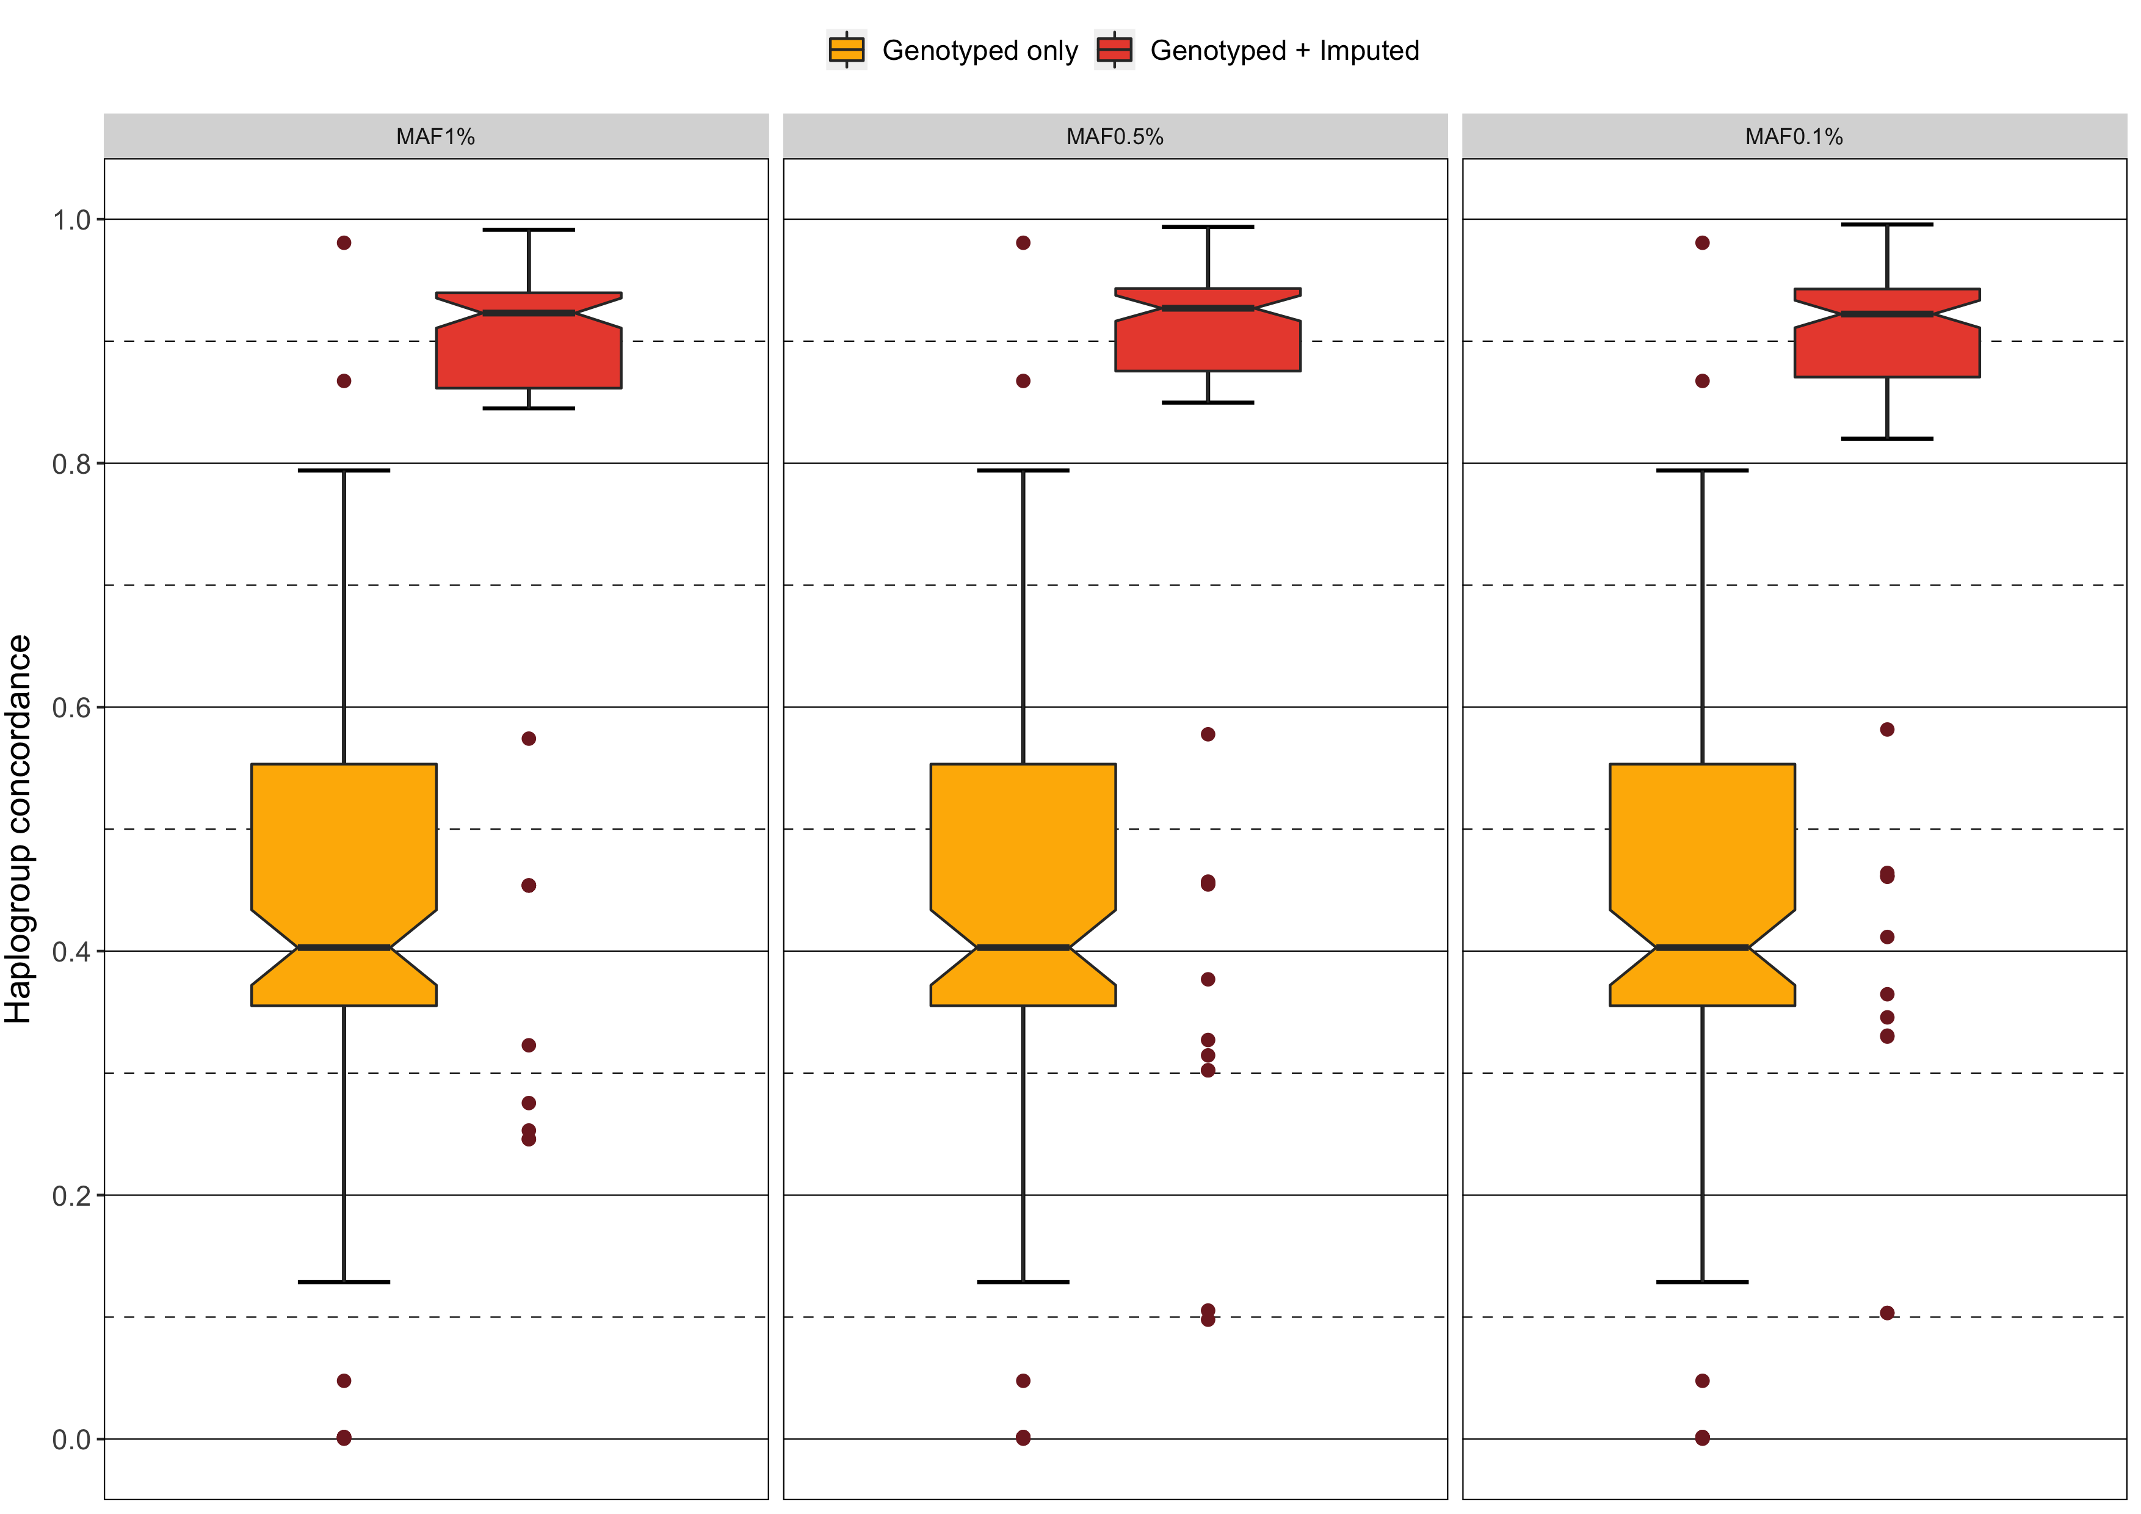  
Supplementary Figure 1. Distribution of mean haplogroup concordance per *in silico* microarray before (yellow) and after imputing missing mtSNVs for minor allele frequency 1%, 0.5%, and 0.1%.

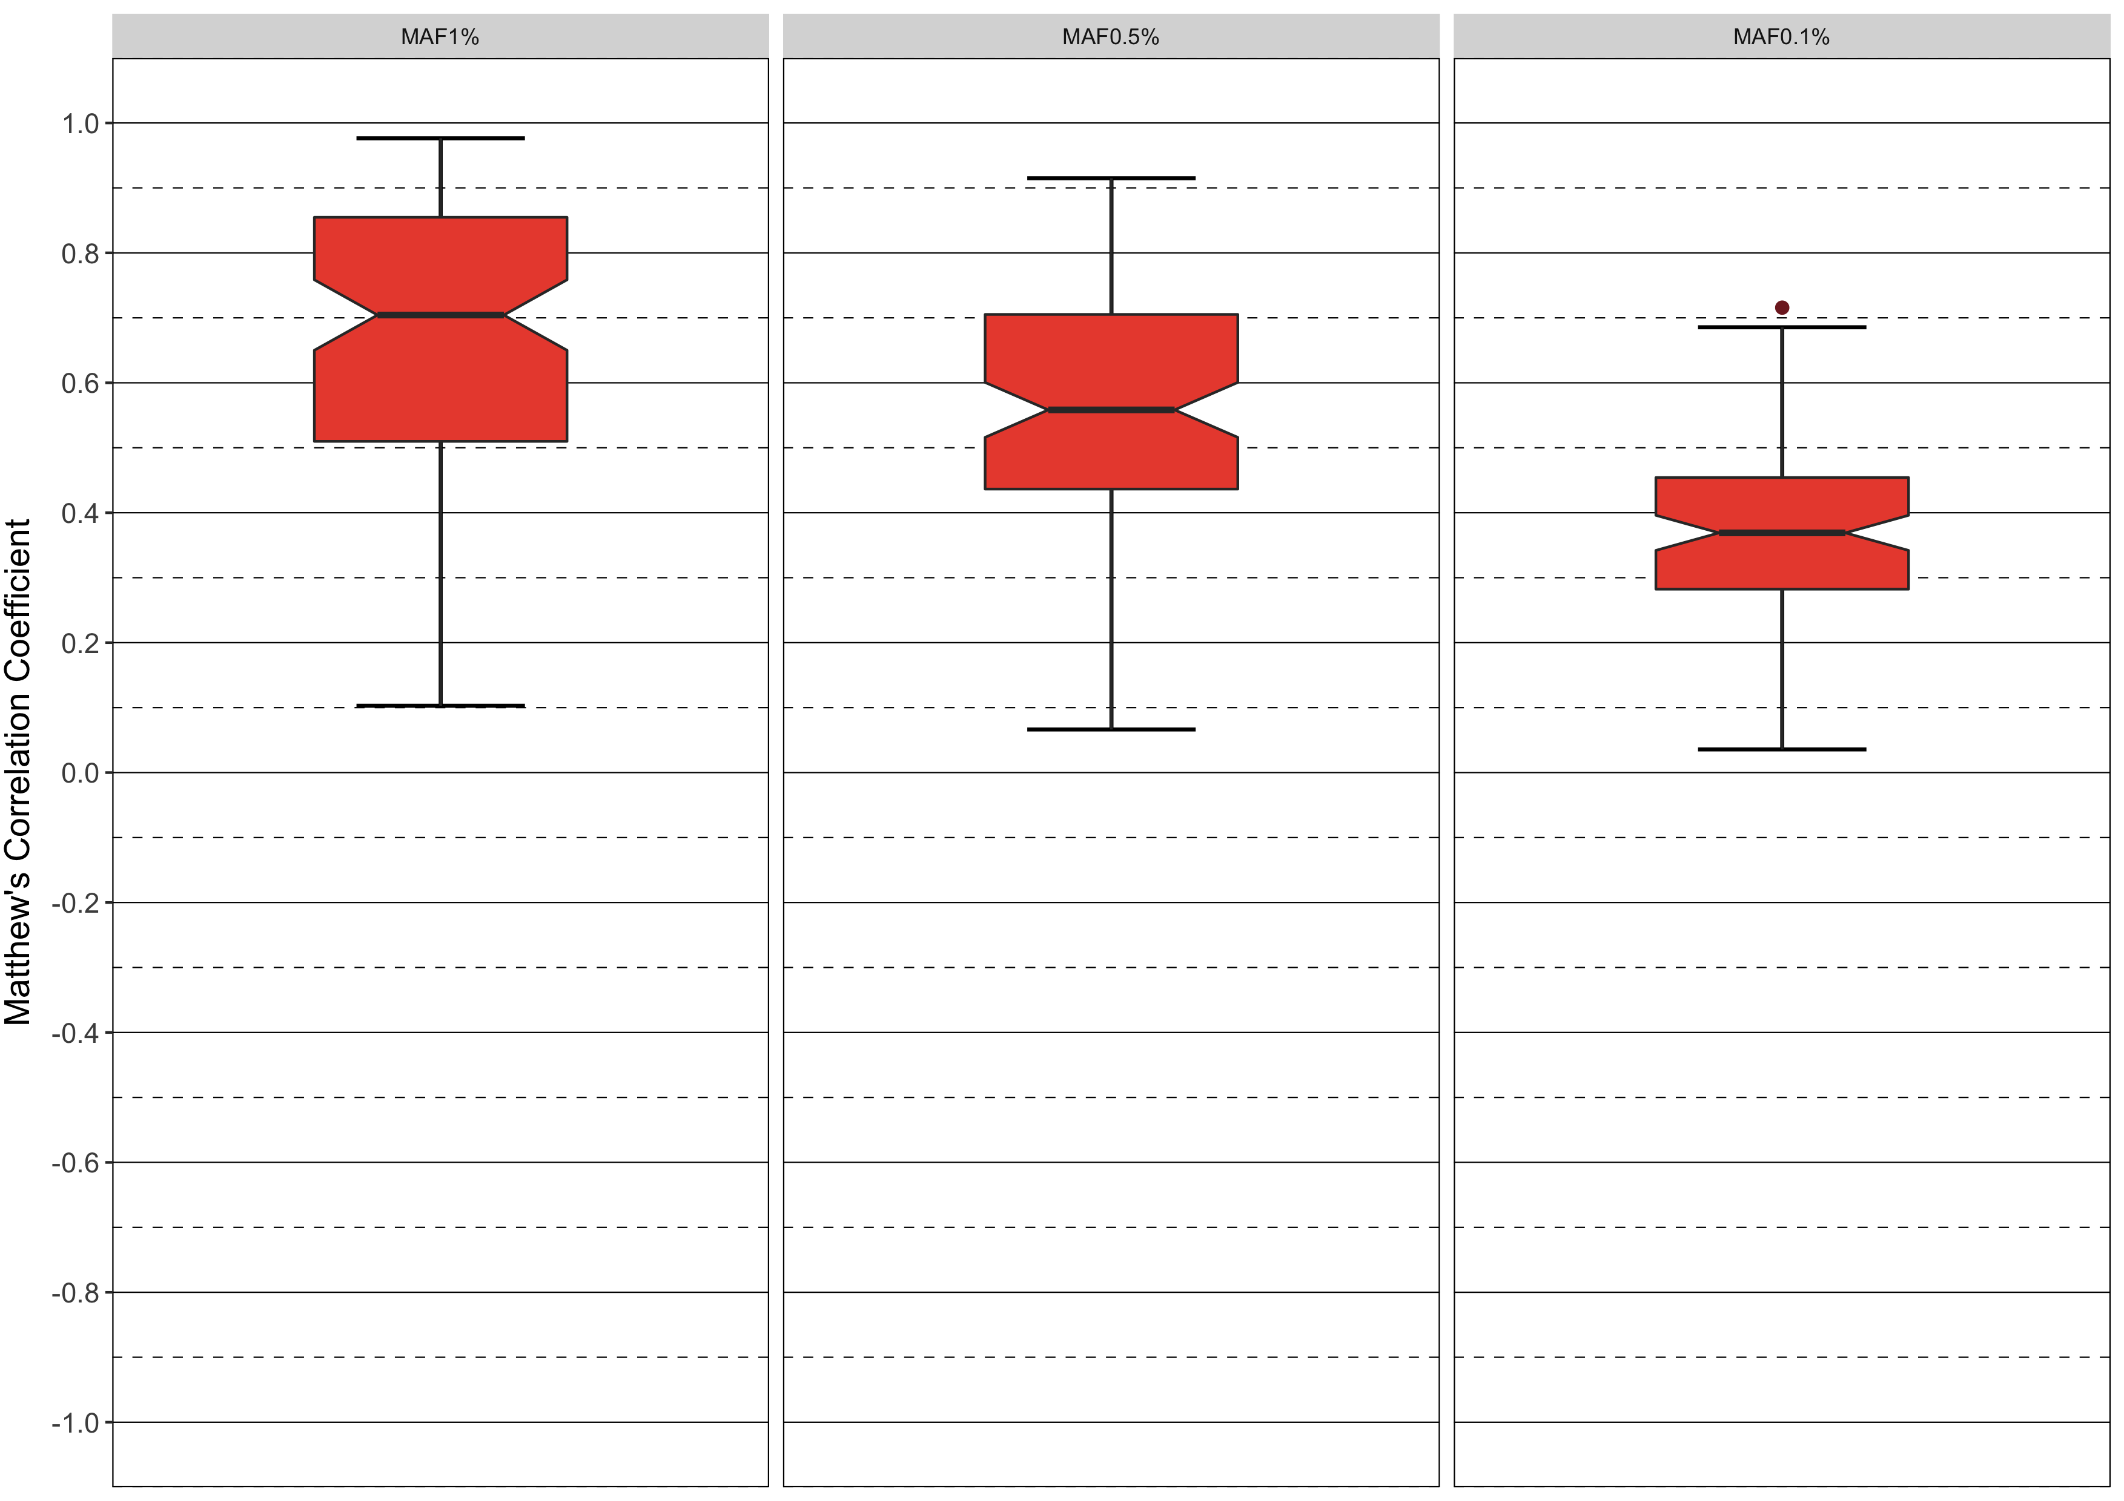  
Supplementary Figure 2. Distribution of mean genotype concordance measured by Matthew’s correlation coefficient per *in silico* microarray after imputing missing mtSNVs for minor allele frequency 1%, 0.5%, and 0.1%.

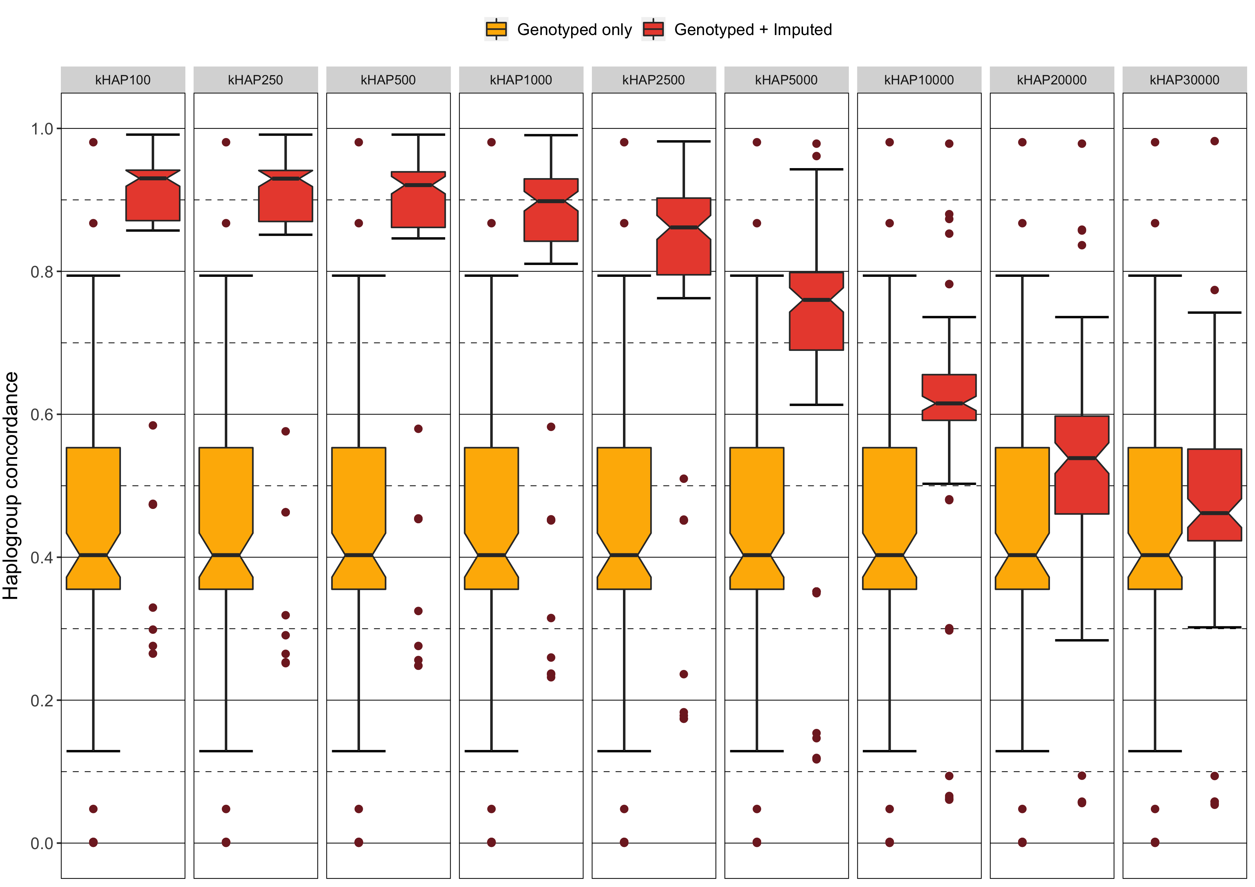  
Supplementary Figure 3. Distribution of mean genotype concordance measured by Matthew’s correlation coefficient per *in silico* microarray after imputing missing mtSNVs for number of included reference haplotypes 100, 250, 500, 1000, 2500, 5000, 10000, 20000, 30000.

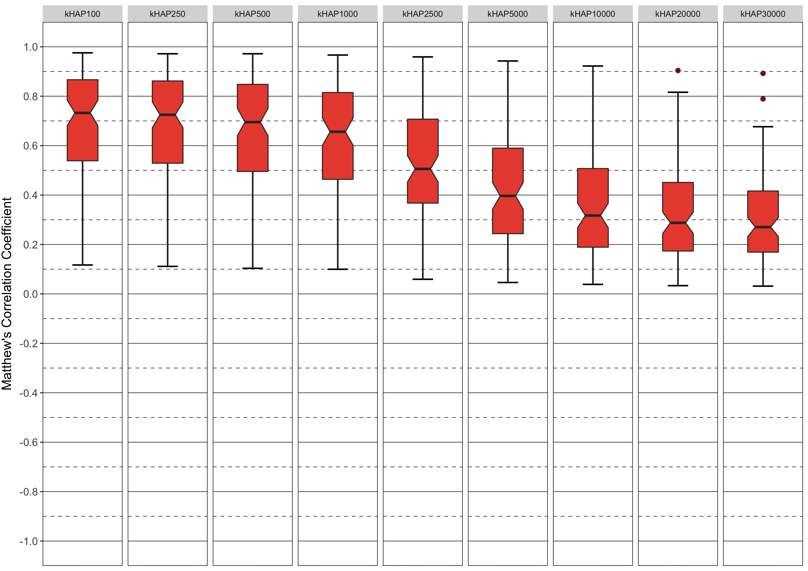  
Supplementary Figure 4. Distribution of mean genotype concordance measured by Matthew’s correlation coefficient per *in silico* microarray after imputing missing mtSNVs for number of included reference haplotypes 100, 250, 500, 1000, 2500, 5000, 10000, 20000, 30000.