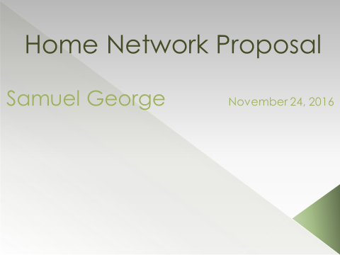

Not everyone in the world has the luxury of being able to use the Internet. The understanding and knowledge of putting together a network is no simple task. There are quite a lot of factors to make sure to you have the optimal and safest system around. You need a modem to be able to connect you to the Internet, a router that will allow you to have connectivity, and the cables to hardwire all your microcomputers like a desktop computer and gaming system.

**Router:** Trying to figure out the idle router is no easy task, well, it was relatively straightforward because this site had a side-by-side comparison of all the best routers and was still relatively cost effective. From the list, I researched out the three that would be best for the network:

* Linksys EA9500 Max-Stream AC5400 MU-MIMO Gigabit Router,
* D-Link Ultra Wi-Fi Router (DIR-895L/R),
* Asus RT-AC3500 Wireless AC5300 Tri-Band Gigabit Router.

From the three routers, I picked this one router I thought was best was this: **D-Link Ultra Wi-Fi Router (DIR-895L/R)***.* As the price is cost effective compared to the other two routers, even though, there isn’t that big of a difference of the prices. This router is cost efficient and still performs particularly well. The product information informs us: “Tri-Band for the Entire Family, Mult-User MIMO (MU-MIMO), Smart Connect, Smart Beam Forming.” The vendor had to say about each one these features: “The DIR-895L/R delivers breakthrough tri-band Wi-Fi technology with incredible combined wireless speeds of up to 5,332 Mbps (1,000 Mbps in 2.4 GHz + 2,166 Mbps in 5 GHz + 2,166 Mbps in 5 GHz). Thanks to 4x4 data streams that is combined with beamforming and MU-MIMO technology to increase reliability and range, the entire family can now enjoy 4K streaming and gaming on multiple devices without any lag. Not all Wi-Fi bands are the same, but you do not need to worry about that. With Smart Connect Technology, the Ultra Wi-Fi Router chooses from the three Wi-Fi bands and automatically connects each device on your network to the best, clearest band available for the best connection every time. Improves coverage by directing bandwidth to your devices as you move around your home. You can stream HD video, surf the web, Skype your friends and play online games from wherever you are so you will always get the best experience. All-in-all this router is the best purchase for the optimal network you need. The types of security that this router supports are these: WEP, WPA, WPA2, WPS (Wi-Fi Protected Setup). This is router also IPv6 compatible and also allows you to put parental controls to restrict which websites you are allowed to go to and which you are not able to.

In this day and age, there is always the threat of your information being stolen and used against you. This router can support protection when you are using Wi-Fi through these security protocols: WPA, WPA2. The WEP referred to being a weak encryption tool because critics claimed that it was not powerful enough to stop wiretapping. They came up with a temporary security standard which is the Wi-Fi Protected Access (WPA), among it was this the Temporal Key Integrity Program (TKIP). TKIP uses a 128-bit key on each packet, and it changes with each packet transmitted, making it nearly impossible for an unauthorized user with a wireless device to connect to a WPA-protected signal and eventually figure out the transmission scheme. Wi-Fi Protected Access II (WPA2) is the latest encryption standard to support wireless LANs and has replaced TKIP with an even more robust encryption technique called CCMP (Counter Mode with Cipher Block Chaining Message Authentication Code Protocol). Any homeowner can rest easy knowing that their data is safe from any and all hackers trying to get that data.

**Printer:** Every household needs a printer and not just a single function printer, no, this printer should be able to fax, scan, copy, and print. Buying each machine individually would be quite expensive and time-consuming and also space-consuming. Having the luxury of equipment that can do all those functions is beneficial. These are the three printers that I thought would be the best:

* Epson Workforce Pro WF-4630
* Samsung SL-M202W/XAA
* Canon Office, and Business MX922.

The best printer, in my opinion, would be the Canon Office and Business MX922. Again, the primary reason for buying this printer would be the cost and this one feature as well. This printer does not just have four ink trays, but five ink trays. The manufacturer gave a brief overview on the vendor’s Website: “Bring superior quality and many wireless capabilities to your home office with the PIXMA MX922. This printer has built-in Wi-Fi

1. For printing and scanning virtually anywhere in your home. It also includes AirPrint which lets you wirelessly print from your iPad, iPhone or iPod touch devices.
2. An integrated 35-sheet Duplex Auto Document Feeder and Dual Function Panel are just some of the features that can allow you to multi-task easily. The MX922 also has a new high-capacity 250-sheet plain paper cassette so you can focus on your work and not run out of paper. This brings office efficiency to all-new levels.
3. Superior 9600x2400 maximum color dpi to give maximum picture quality
4. Five individual ink tanks mean incredible business document printing and efficiency with the option of a high-yield pigment black ink tank to print more documents without changing the pigment black ink as often.

The MX922 delivers outstanding business quality and versatile solutions that will assist in bringing your home business to the next level. Not many printers have an additional tank; this bonus feature is a big money saver because, even though, you may run out of color ink and black ink; there’s a backup black ink tank in case of emergency. Because this printer can support Wi-Fi, you could put the printer anywhere in the house, and it still would be in the range of your desktop computer. It also has the feature of having connectivity with your iPhone and iPad and iPod. For example, say that you forgot your USB and had no way to save your document, but you have your iPhone you can connect the phone to the computer and save the document. Moreover, when you get home, you will be able to print out that report in due time.

**Blu-ray Player**: This is a must in almost every household an entertainment system or a Blu-ray player. This a must because it could be used for educational programs and movies. Why do you need to go to the movies when you can just stay at home and watch a movie in the comfort of your home? After all, Blu-ray players can support 4K display movies nowadays. From the top 5 products been a list and I choose the best:

* Samsung UBD-K8500 3D Wi-Fi 4K Ultra HD Blu-ray (2016 Model)
* Sony BDPS6500 Blu-ray Player with Wi-Fi (2015 Model)
* OPP BDP-103 Universal Disc Player (SACD/DVD-Audio/3D Blu-ray).

Sony BDPS6500 Blu-ray Player with Wi-Fi (2015 Model). One of the biggest reasons I picked this one is that it was quite less than the competitor’s Blu-ray players. These are the features that come with the Blu-ray player, it's cited by vendor: “Stream from your favorite apps in Full HD, Upscale your entertainment to near-4K quality, Play PS3 games directly on your TV—no game console required, Upscale your DVDs and Blu-ray discs to 3D. Brighter and more lifelike picture, Stronger and faster Wi-Fi connectivity, Easy navigation with a more user-friendly interface.” Being able to PS3 games without the need of a PS3 gaming console itself is quite impressive. You could save quite a bit of money because there is no need to buy a console, all you need to do is just subscribe to **PlayStation Now**, and then be able to play some of PS3 lineups.

The most important aspect of a network is the network medium it being wired or wireless. For this network, it should be both wired and wireless. We are going to assume there are three bedrooms in this house and that it is a decent size house rounding off at 850 cubic square feet. In every house, there should be a decent size office. In two of the three bedrooms, there should be a computer for the kids to do be able to do their homework and projects and also be able to play games. The modem, router, switch, and PC should be there. This is how the design going to be the modem would be connected to the switch, and then the router would be connected to the switch, and the PC would be connected to switch. My reasoning behind this is that the PC would be directly connecting to the modem if there were no switch there the modem would be connected to the router, and then the PC would be wired to the router.

**Network Switch:** I researched through the top 9 best network switches of the year, and these were the results:

* Buffalo 8-Port Desktop Gigabit Green Ethernet Smart Switch (BS-GS2008)
* Cisco SYSTEMS 8-Port Gigabit (SG100D-08P-NA)
* D-Link 8-Port Gigabit Switch (DGS-1008G)
* HP ProCurve 1800-8G 8-Ports 10/100/1000Base-T LAN Managed Ethernet Switch (Refurbished) Mfr P/N J9029A#ABA
* Linksys SE1500 5-Port Fast Ethernet Switch
* NETGEAR 8-Port Gigabit Ethernet Switch (GS208)
* TP-Link 5-Port Gigabit Ethernet Desktop Switch (TL-SG1005D)
* TRENDnet 8-Port Unmanaged Gigabit GREENnet Desktop Metal Housing Switch, TEG-S80g
* Ubiquiti Edgerouter PoE - Router - Desktop, Wall-Mountable - Black (ERPOE-5)
* ZyXEL ES100-8P 8-Port Fast Ethernet PoE Unmanaged Switch

As you can see for a few of these switches are marked with Unmanaged. An unmanaged switch you are unable to customize how you want, it is already programmed to work a certain way. The best network switch would be D-Link 8-Port Gigabit Switch (DGS-1008G).

**File Sharing**: Sharing of files is relatively straightforward; there isn’t much to do in the way of allowing the exchange of data. There is no hardware necessary to support this functionality. This is the information I got that will allow you to share files with a Windows or Mac Operating System. “If you store all of your pictures, music, or movies on one computer, those files or folders can be shared across your home network so that another computer attached to the same network can access them. If you are on a Windows 8 computer, you can put your files in a public folder, or you can set up specific users to have access to any folder on your hard drive. If you are using a Mac, sharing can be accomplished through OS X Mountain Lion or upwards. Regardless of what operating system you have, using the shared drive method gives you the power to access your music library from any room in your house on any device you own—turning you into a living, breathing dance machine no matter where you are. Another great sharing idea is to set up a personal cloud storage account. Not only does this let you access your stuff from anywhere at any time, but you can also give access to your friends and family. This is one of the simplest ways to share files between computers, and the cool thing about this is that you do not even have to be in the same city, state, or even country. If you do not have a personal storage account already, you can get free and easy access through traditional services like Dropbox and Google Drive. Keeping all of your files in personal cloud storage is also a great way to keep your gigabytes of music, movies, personal photos, and other irreplaceable files safe if your computer or hard drive ever fails.” Cloud storage is a great alternative than just creating a shared folder on your home network because it could get hacked or even the data could get corrupted. Cloud storage gives you peace of mind knowing that your personal files are safe and sound and that you could access them in any city, state, or country in the world. The biggest factor is that it could store tons of data and also that friends and family can access them anytime they want.

**Antivirus/Security Protection Software**: This a must in every desktop computer no matter the configuration and operating system. Security is the only line of defense when it comes to viruses, malware, ransomware, etc… It could come out of nowhere and steal all your data and leave you nothing at all. You do not know if it is embedded in code when you download something from an unofficial site. These are the top 10 best antivirus programs:

* McAfee
* Norton
* Bitdefender
* AVG
* Total AV
* Malwarebytes
* Kaspersky Lab
* Trend Micro
* BullGuard
* Panda.

Some of these programs are not compatible with all the main operating systems. Some of these programs can support the mobile operating system base and some of them only support the Windows operating system. The best antivirus program, well, all these programs can protect the system from all viruses, spyware, ransomware, malware, and monitor the network. The best one, in my opinion, is McAfee it can support Windows 7, 8.x, 10, Mac OS X, Android 2.1 and higher, and IOS 6 and higher.

**Gaming Adaptor**: If you want to be able to connect all devices to your network, you will need an adapter for your gaming console and your Smart TV. The NETGEAR N900 Video and Gaming Adapter. This simple tool should allow you connect your devices to the network for easy access. If you want to make your entire house work on the system; just a simple adapter is not enough for some of the things. Having your door connected to the network is a bit of a complicated procedure, but not too complex.

**Internet Service Provider**: While researching which Internet Service Provider (ISP) would be the best near the area of Orangeburg:

* Verizon FIOS
* Verizon
* Time Warner Cable
* Optimum

The best Internet Service Provider, in my opinion, would be Verizon FIOS. For one all of their network mediums are fiber-optic oriented. Fiber-optic is much better than coaxial cables that which is used by their competitors with some fiber-optic. Fiber-optic means faster download and upload speeds; the slow transmission speeds is something that nobody wants to wait.

Now that we have everything that we need except for, the modem, but that is something Verizon FIOS will give. All that is left is the cabling to connect all the devices together. It is not the just simple task of picking out a medium; you have to look at the transmission speed and distance, security, noise, and price. The appropriate network mediums are this: CAT 5, 5e, 6, 7; Thin Coaxial Cable (Baseband Single Channel); Thick Coaxial Cable (Broadband Multichannel); LED Fiber-Optic; Laser Fiber-Optic. The CAT 5 – 7 twisted pair wire is quite an inexpensive and versatile medium, but there are some flaws to this medium like security and noise. Noise is unwanted electrical or electromagnetic energy that degrades the quality of signals and data. In other words, the data you send isn’t going to be same sometimes when you receive it. This type of medium lacks in security because it can be easily be wiretapped. However, if you were to go with LED Fiber-Optic, you will not have to worry about those issues because it cannot be wiretapped. Fiber-optic cables are solid glass wires that transmit light pulses. Fiber-optic cables cable is capable of transmitting data at more than 100 Gbps over several kilometers. Because many standard local area network installations use a LED source, however, real-world fiber-optic transmissions are limited to 10 gigabits for 300 meters. So the best network medium would be the LED Fiber-Optic.

I have provided spreadsheet comparison by products with pricing and details information for each category.

Based on the best product from each category I have provided the summary for quick view regarding the total out of pocket spend for implementation which doesn’t cover man power (labor) cost and network medium cost (as the cost would be based on total area coverage).

|  |  |  |
| --- | --- | --- |
| **Category** | **Product Description** | **Price** |
| Router | D-Link AC5300 Ultra Wi-Fi Router (DIR-895L/R) | $ 309.99 |
| Printer | Canon Office and Business MX922 | $ 69.99 |
| Blu Ray Player | Sony BDPS6500 Blu-ray Player with Wi-Fi (2015 Model) | $ 54.13 |
| Network Switch | D-Link 8-Port Gigabit Switch (DGS-1008G) | $ 32.15 |
| Antivirus | McAfee | $ 19.99 |
| ISP | Verizon FIOS | $ 49.99 |
|  | **Total :** | **$ 536.24** |

**Overall my thoughts:**

I do not know if I particularly am interested in a job like this. Just thinking about the time it will take to construct a proposal and then, worrying over if the committee will pass the proposal. Researching all the information needed to construct the network from ground up if need be. Also, this, taking the time to instruct others on how to build the network to specification is also no easy task. This sort of task was a fun one, but it is also exhausting.

**Works Cited**

Source Information (Best Wireless Routers): <http://www.pcmag.com/article2/0,2817,2398080,00.asp>

Source Information (D-Link AC5300 Ultra Wi-Fi Router (DIR-895L/R): <https://www.amazon.com/D-Link-Tri-Band-Antennas-4-Stream-DIR-895L/dp/B00PVDNQ34%3FSubscriptionId%3DAKIAICE7LOAJMK3SSLPA%26tag%3Dpcm_contextual-20%26linkCode%3Dxm2%26camp%3D2025%26creative%3D165953%26creativeASIN%3DB00PVDNQ34%26ascsubtag%3D43b5fb69-5abd-4643-bbf7-768fcdaa90fc>

Source Information (Best Printer): <http://bestreviews.com/best-home-printers>

Source Information (Canon Office and Business MX922): <https://www.amazon.com/gp/product/B00AVWKUJS/ref=as_li_tf_tl?ie=UTF8&camp=1789&creative=9325&creativeASIN=B00AVWKUJS&linkCode=as2&tag=bestprodtag23974-20>

Source Information (Best Blu-ray): <http://bestreviews.com/5-best-blu-ray-players>

Source Information (Sony BDPS6500 Blu-ray Player with Wi-Fi (2015 Model)): <https://www.amazon.com/dp/B00X6AGWRQ?ref=emc_b_5_t>

Source Information (Sharing): <http://www.intel.com/content/www/us/en/tech-tips-and-tricks/how-to-share-files-between-computers.html>

Source Information (Antivirus): <https://www.bestonlinesecurity.com/?ht=antivirus&lz_c=b26us&lz_s=07e.o20&lz_t=best%20antivirus%20programs&t=kwd-142000273550&raw=best%20antivirus%20programs&bclid=c93c96d1393149578c0aabafaa90eb53&url=https%3A%2F%2Fwww.bestonlinesecurity.com>

Source Information (Best Ethernet Switches): <http://www.toptenreviews.com/computers/networking/best-ethernet-switches/>

Source Information (D-Link 8-Port Gigabit Switch (DGS-1008G)): [https://www.amazon.com/gp/product/B003X7TRWO?tag=ttr_ethernet-switches-20&ascsubtag=[site|ttr[cat|1806[art|NA[pid|66449[tid|NA[bbc|NA](https://www.amazon.com/gp/product/B003X7TRWO?tag=ttr_ethernet-switches-20&ascsubtag=%5bsite|ttr%5bcat|1806%5bart|NA%5bpid|66449%5btid|NA%5bbbc|NA)

Source Information (ISP): <https://www.highspeedinternet.com/ny/orangeburg?zip=10962>

**Appendix**

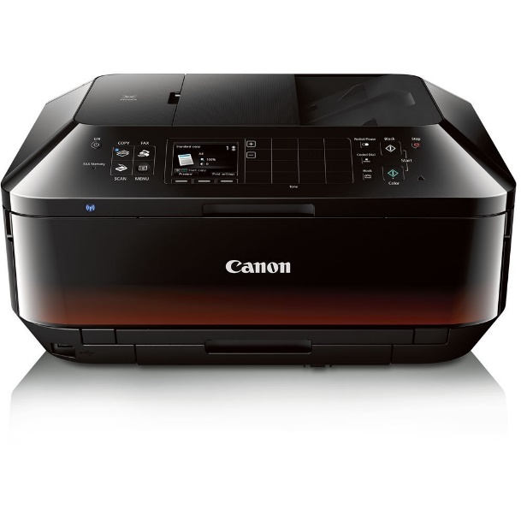**All-In-One Printer**

Canon Office and Business MX922

Epson WorkForce Pro WF-4630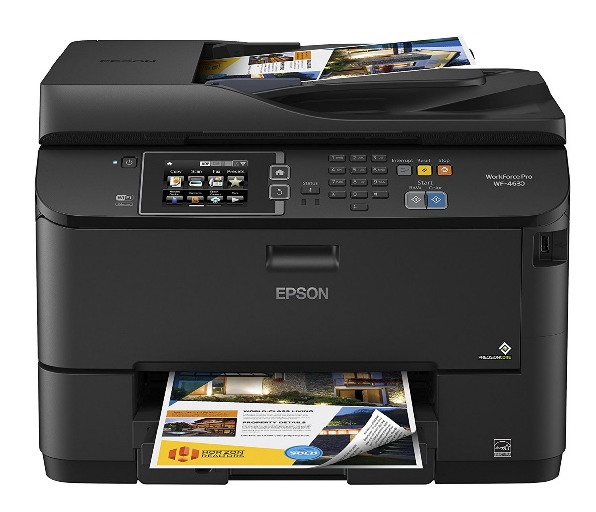

Samsung SL-M202W/XAA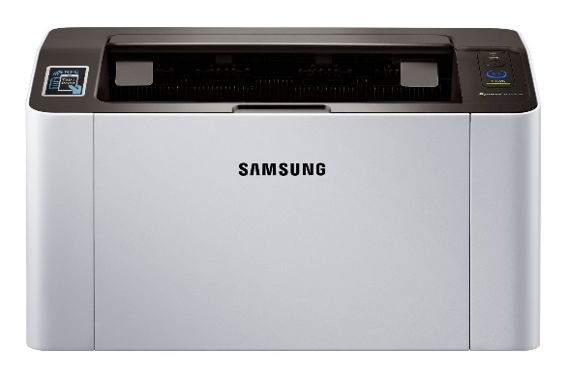

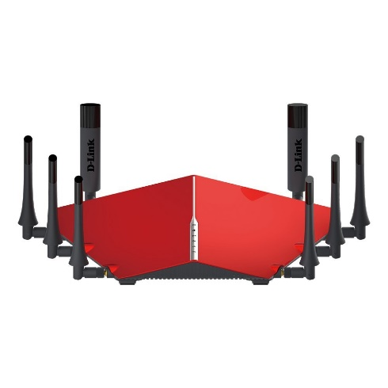**Wireless Router**

D-Link AC5300 Ultra Wi-Fi Router (DIR-895L/R)

Linksys EA9500 Max-Stream AC5400 MU-MIMO Gigabit Router

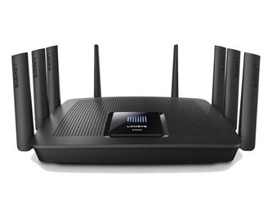

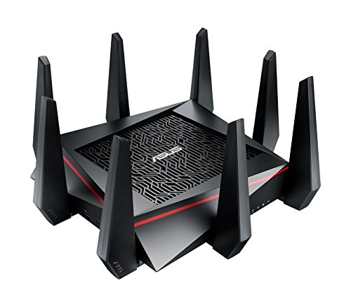Asus RT-AC5300 Wireless AC5300 Tri-Band Gigabit Router

**Blu-ray Player**

Sony BDPS6500 Blu-ray Player with Wi-Fi (2015 Model)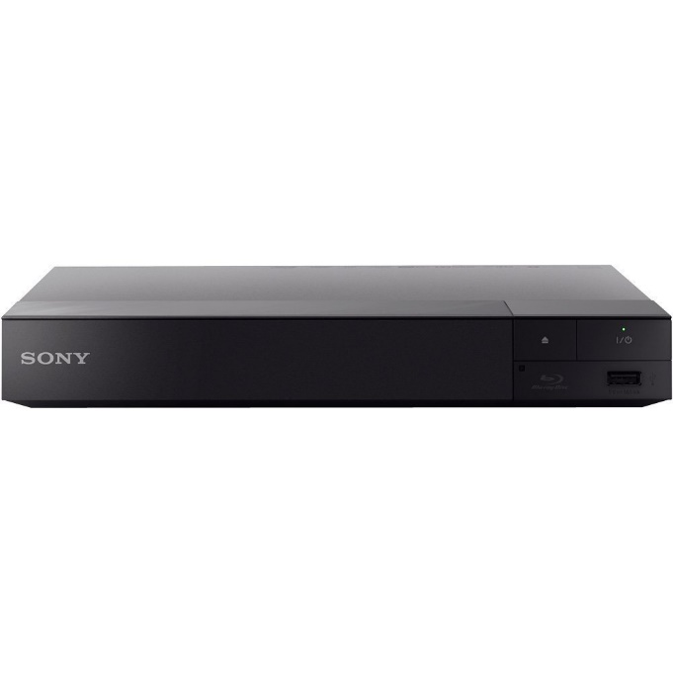

Samsung UBD-K8500 3D Wi-Fi 4K Ultra HD Blu-ray (2016 Model)

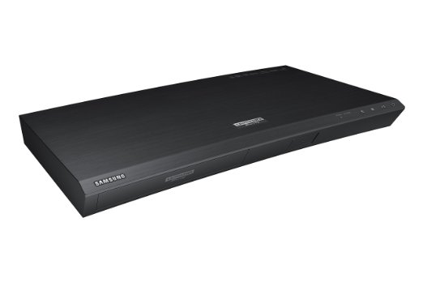

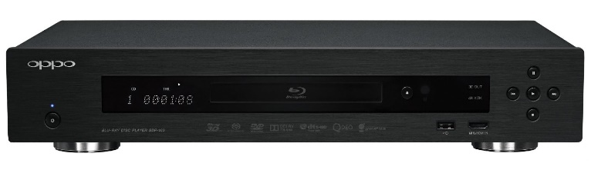

OPP BDP-103 Universal Disc Player (SACD/DVD-Audio/3D Blu-ray)

**Best Network Switches**

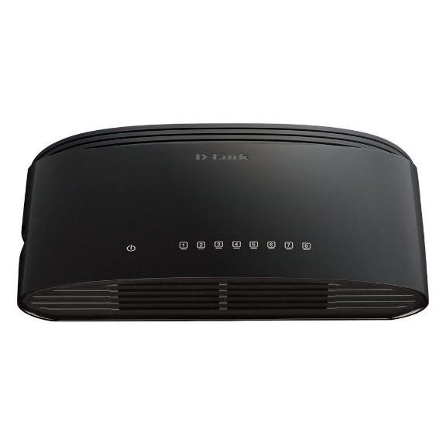D-Link 8-Port Gigabit Switch (DGS-1008G)

Buffalo 8-Port Desktop Gigabit Green Ethernet Smart Switch (BS-GS2008)

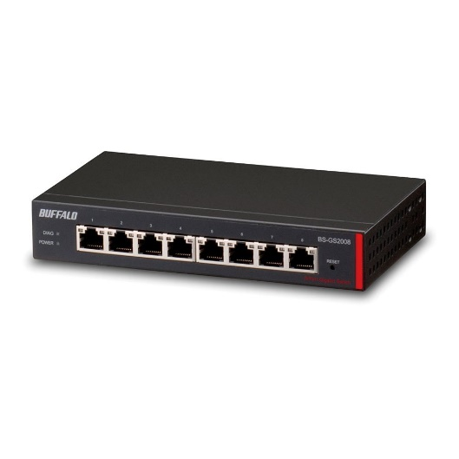

Cisco SYSTEMS 8-Port Gigabit (SG100D-08P-NA)

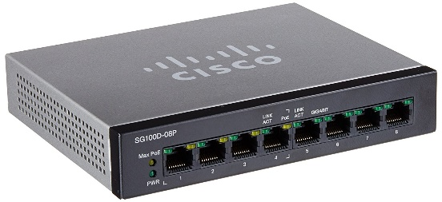

HP ProCurve 1800-8G 8-Ports 10/100/1000Base-T LAN Managed Ethernet Switch (Refurbished) Mfr P/N J9029A#ABA

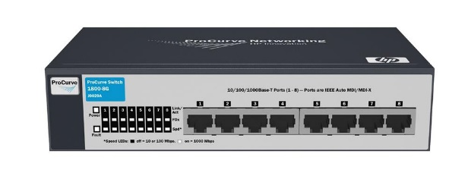

Linksys SE1500 5-Port Fast Ethernet Switch

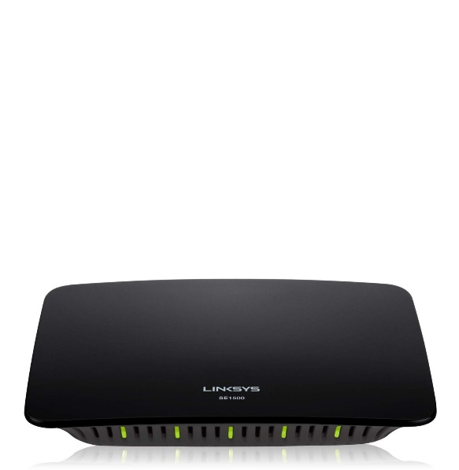

NETGEAR 8-Port Gigabit Ethernet Switch (GS208)

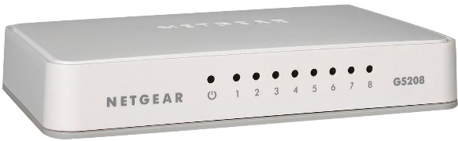

TP-Link 5-Port Gigabit Ethernet Desktop Switch (TL-SG1005D)

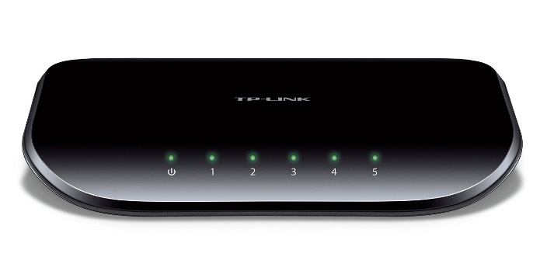

TRENDnet 8-Port Unmanaged Gigabit GREENnet Desktop Metal Housing Switch, TEG-S80g

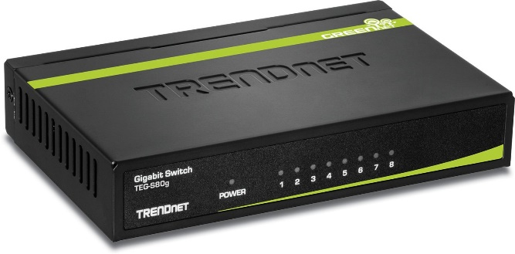

Ubiquiti Edgerouter PoE - Router - Desktop, Wall-Mountable - Black (ERPOE-5)

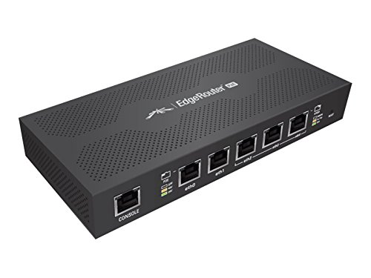

ZyXEL ES100-8P 8-Port Fast Ethernet PoE Unmanaged Switch

