# Introduction

**Prepared by:** UTS research team, lead author Monique Potts

**Prepared for:** iyarn research partner

**Purpose:** This document provides a synthesis of existing evidence. This synthesis is designed with an intent to:

1. be useful to iyarn, because it represents the evidence base iyarn is grounded in and helps give a language to that;
2. be something iyarn can share to demonstrate the evidence base to external stakeholders;
3. guide future development and evaluation within the iyarn tool and its use

**Using this resource:** To do that, these documents are designed to:

1. provide a summary of the key evidence;
2. highlight key implications for iyarn in tool design and implementation;
3. point towards lessons for future evaluation work.

Introduction 1

iyarn Desktop Research – Overview 2

Sample Desktop Research/Literature Review 4

**Topic:** How do check-in apps build wellbeing, and what are young people’s key concerns when using them in schools? 4

Background assumptions and context 4

How accurate is the information from check-ins? 5

Do check-in apps support awareness and reflection? 5

Do check-in apps build health routines? 5

Do check-in apps contribute to wellbeing outcomes? 6

And, what is the evidence around how apps support teachers to support their students? 6

What are the key concerns and preferences for young people in using check-in apps? 7

What are the UX/design implications for high efficacy MH apps? 8

What are potential implications of these findings for iyarn? 9

Area of exploration and future evaluation for iyarn: 10

Bibliography 12

Appendix 14

## iyarn Desktop Research – Overview

The following sample of desktop research approach aims to provide an indicative document for discussion, feedback and dialogue to inform the further research. It focuses on one of the key questions identified through the mapping of key drivers and outlined below and presented previously. A list of the key questions and themes for the desktop research are also outlined below.

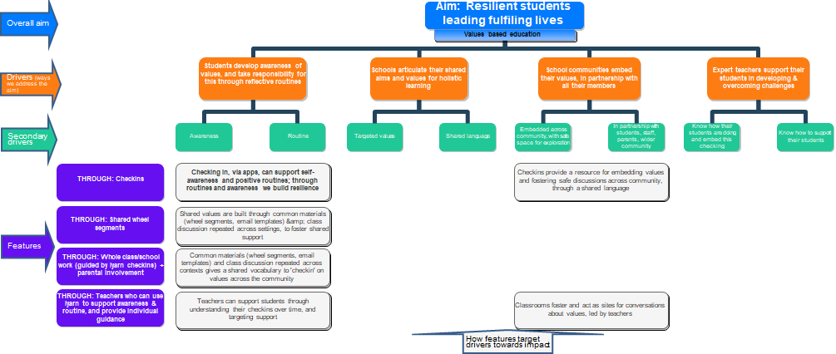

*Figure 1: iyarn primary and secondary drivers research mapping*

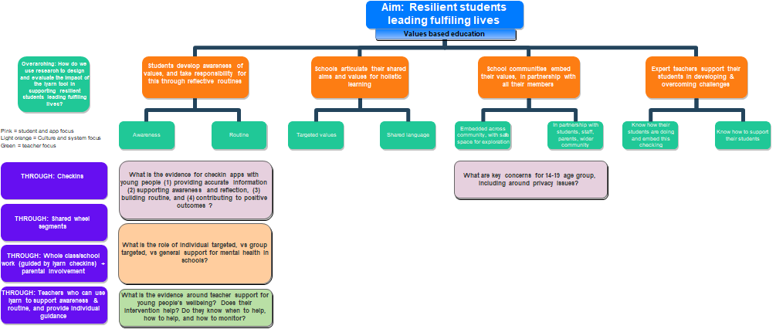

## Desktop Research/Literature Review

## **Topic:** How do check-in apps build wellbeing, and what are young people’s key concerns when using them in schools?

***Key questions:*** *What is the evidence for check-in apps with young people (1) providing accurate information (2) supporting awareness and reflection, (3) building routine, and (4) contributing to positive outcomes?*

### Background assumptions and context

There are some key provisos in this review:

* The majority of evidence-based studies (particularly Random Controlled Trial – RCT’s) focus on intervening in or improving mental health for students rather than focusing on building general resilience and wellbeing.
* Many of the findings referenced below are from research done with mobile rather than web-based apps

Many studies are primarily run with individual students rather than class-based or cohort-based studies (unless noted otherwise). Relatedly, many studies focus on interventions with targeted students (tier 2 and 3 interventions), rather than activities all students do (universal, or tier 1, interventions).[1]

### How accurate is the information from check-ins?

The use of Experience Sampling Methodology (ESMs) involves a systematic collection of self-report data from individuals throughout day has been found to be an effective way for young people to self-monitor their moods and mental health (Miller et al., 2015; Rickard et al., 2016) This has been confirmed in a number of studies including for MH apps, MyCompass (Harrison et al., 2011) and mobiltype (Reid et al., 2011). Self-monitoring and check-ins applied in these trials involved participants checking in daily or multiple times a day. Self-monitoring using ESM is most accurate when done in real-time so the use of MH apps in locations such as classrooms during a usual daily routine are more useful that reflections after the fact, as this reduces the bias in self-monitoring and improves accuracy (Shiffman et al., 2008).

One of the challenges identified by researchers in assessing the outcomes of tech-mediated MH apps is the ability to engage young people sufficiently to be able to determine the effect of the intervention or program (Punukollu et al., 2020). This is a common problem, and an issue in research evidence in which app use (duration, occurrences, or specific features), and external measures (validated instruments, diary methods) are not always reported (Eisenstadt et al., 2021). Most research for MH apps indicate good short-term engagement, however longer term engagement and compliance is often low (Huberty et al., 2021; Rickard et al., 2016). This was found by Rickard et al. (2016) when testing the MyCompass check-in app which had high initial compliance followed by a high drop-out rate (Rickard et al., 2016). This is also an issue in digital vs telephone surveys, although here too as evidenced in the Australian Young and Well Survey, web-surveys provide quality data (Milton et al., 2017). Engagement and participation have been found to be improved by integration with face-to-face and or web-based in person communication (Clarke et al., 2015; Rickard et al., 2016).

### Do check-in apps support awareness and reflection?

Current evidence shows that self-monitoring through tech-mediated platforms (via mobile apps or websites) is an effective tool for building self-awareness and reflection (Bakker et al., 2016; Miller et al., 2015). Self-monitoring is a core feature of many evidence-based psychological therapeutic techniques including Cognitive Behavioural Therapy (CBT) and acceptance and commitment therapy (ACT). Self-monitoring of mood can boost overall emotional self-awareness (ESA) which in turn can lead to improvements in self-regulation (Kauer et al., 2012).

In a number of cases check-in and check-out practices (CICO) are applied as part of a Tier 2 intervention years as part of Positive Behaviour Intervention Support (PBIS) or Schoolwide Positive Behaviour Support Model (Bruhn et al., 2017; Clarke et al., 2015). This approach typically involves a morning check-in (often in a discussion with a mentor or coach), and an end-of-day check-out with the same person, to review how the day went against the morning check-in. Online tools and apps have adopted this approach. Research in the US using technology-mediated CICO practices along with mentoring have found potential for self-monitoring to build greater independence (Eg. self-awareness and regulation) which may replace formal behaviour monitoring by teachers over time (Miller et al., 2015).

### Do check-in apps build health routines?

There is increasing evidence that that self-monitoring is effective tool for routine/habit formation (Shiffman et al., 2008). Multiple studies have found that for young people the regular use of online platforms with a component of self-monitoring and CBT have been effective in reducing symptoms of anxiety and depression and increasing wellbeing over time (Bakker & Rickard, 2018 (correlational), 2019 (correlational); Clarke et al., 2015 (PRISMA systematic review); Eisenstadt et al., 2021 (PRISMA systematic review); Goldberg et al., 2022 (PRISMA+ systematic review); Kenny et al., 2020 (RCT); Lappalainen et al., 2021 (RCT)). Obtaining daily information on significant changes to emotional state has the capacity to support early intervention and promote emotional health (Bakker et al., 2016). Habit formation can be driven in MH apps linked to activities that decrease psychological distress, increase self-efficacy or reward users in some other way (Bakker et al., 2016; Wendel, 2020). An important consideration is internal and external triggers for engagement, while external triggers (such as group class-based check-ins) may help to initiate the engagement process, internal triggers (motivated by an intention of self-care) are more reliable drivers of long-term habit (Bakker et al., 2016; Eyal, 2014).

### Do check-in apps contribute to wellbeing outcomes?

While the number of Mental Health apps (MH apps) and wellbeing/mindfulness platforms are increasing rapidly there have only been a limited number of RCT trials in schools to assess their effectiveness (Bakker et al., 2016) with a need for many more in this field. Mobile based apps can be effective for improving anxiety and depression and are most effective combined with face-to-face support and treatment (Chandrashekar, 2018), tentative evidence for use of apps to improve wellbeing and decrease depression (but not anxiety) in adults comes from an RCT comparison of 3 apps (Bakker et al., 2018),

The evidence of whether check-in apps alone can contribute to health outcomes is inconclusive. A recent RCT 2020 study in Ireland of CopeSmart MH app across a cluster of 10 schools and 560 students aged 15-18 years involved students checking in daily on their mobile phone on the mood and mental state with the option to access support resources (Kenny et al., 2020). The trial ran for four weeks and expected to find an increased level of emotional self-awareness (ESA) and improved positive coping strategies. However, they found no significant change in the intervention group compared to the control group in terms of ESA, wellbeing or positive coping strategies. Their findings suggest that four weeks might not be a long enough period to assess the outcomes or that the level of participant engagement was not sufficient to effect improvements. These findings are echoed by Clarke et al.,’s (2015) systematic review, which found tentative evidence in support of online mental health promotion interventions – largely skills-based modular-format ones – for young people, but also highlighted the limited amount of research and variation in quality.

#### And, what is the evidence around how apps support teachers to support their students?

Other examples of recent school integrated MH app research includes SafeSpot in Scotland, where using a mixed methods approach with 2,300 students and 90 teachers, the research tested the ability of online and mobile apps to enable teachers to support their students’ mental health (Punukollu et al., 2020). The response and engagement of both teachers and students was positive in this study and it highlighted the potential for further develop MH awareness programs incorporating both classroom activities and a mobile app, ‘that are likely to improve the mental health and resilience of young people’ (Punukollu et al., 2020). One of the aims of the NHS Scotland Mental Health Strategy is ‘that every child and young person should have appropriate access to emotional and mental well-being support in school’ (Scottish Government, 2017). Australia has similar stated goals in the Australian Student Wellbeing Framework (Education Council, 2018).

Some studies have linked self-monitoring with improved help-seeking behaviour for mental health in young people as well as showing promising early intervention outcomes (Rickard et al., 2016). Monitoring for early detection of mental health problems allows for early intervention, which improves longer term outcomes (Rickard et al., 2016).

## What are the UX/design implications for high efficacy MH apps?

The literature has a number of potential implications for iyarn development. *However* it is important to remember that any recommendations from literature are based on the specific aims and theories of change being evaluated and investigated in that literature. Iyarn adopts a different model to much of this literature, and therefore the recommendations are not directly transferable.

Research regarding the user interface and design of MH apps for young people is summarised below, alongside a preliminary assessment of iyarn against these key implications (note these are primarily from reviews of mobile apps).

|  |  |  |  |
| --- | --- | --- | --- |
|  | **Design Implication** | **Iyarn status** | **Comment** |
| Automated tailoring (using self-report, self-monitoring, and prediction of which features users are likely to engage with)* | | Hourglass | Less suitable in school context. |
| Reporting of thoughts, feelings, or behaviours: self monitoring to support emotional-self awareness and reflection. Keep self-reports structured in a simple interface to allow quick reporting* | | Checkmark | Core function, with easy checkin model. |
| Allow user to see feedback-focused progress eg. Chart of moods/data* | | Hourglass | Unclear status |
| Build in recommended activities, including: Activities that directly enhance mood (e.g. exercise, music); engage behavioural activiation (setting goals, planning activities); provide coping skills training; give mental health information; with real-time engagement.* | | No sign | Priority area |
| Link activities explicitly to the specific issues identified* | | No sign | Priority area |
| Encourage nontechnology-based activities | | No sign | (will be part of above responses) |
| Try to use internal rather than external triggers to engage, with a log of app use (promoting personal investment) to promote repeated engagement* | | Hourglass | Explicitly in iyarn model to build student routine and culture. Requires evaluation over time. |
| Language to be simple, concrete, confident and hopeful* | | Checkmark | Largely present, may need some framing around segments and support resources |
| Link to support services with optional ‘Get help’ ‘Learn more’ prompts* | | No sign | Two features, (1) general support (as above) other is crisis support-to discuss. |
| Evaluate – use other measures, EMA, app use data, etc. to measure impact*+ | | Hourglass | See below |

*\*Mental Health Smartphone Apps: Review and Evidence-Based Recommendations for Future Development,* (Bakker et al., 2016), specifically targeted at MHapp development; Note their first 3 major recommendations: Use of CBT, addressing anxiety and low mood, and design for non-clinical populations are not covered here; crucially, the first is focused on use of an evidence-based framework – which iyarn has, albeit not CBT – the second is largely around clinical populations; the third is core to iyarn’s approach.   
+ Noting also the provisos, and limitations in systematic evidence syntheses thus far noted above, and in Punukollu and Marques (2019), who specifically reviewed evidence around apps for young people.

## What are potential implications of these findings for iyarn?

This table is intended to provide an overview summary of the evidence synthesis, mapping the key takeaways to the driving questions.

|  |
| --- |
| **Explanatory note.**  Magnifying glass = strength of evidence, with 3*Magnifying glass indicating very strong evidence (e.g. from systematic reviews, meta-analyses, and multiple robust randomised control trials); 2* indicating multiple experimental or quasi experimental designs; and 1 * other studies such as observational or correlational work.  Zoom in is used to indicate a positive effect found, or supportive evidence.  is used to indicate a negative effect found, or non-supportive evidence.  Hourglassis used to indicate the evidence is unclear or/and underexplored or/and cannot be addressed using quantitative research.  This approach is informed by van der Bles et al.’s discussion (n.d.) |

|  |  |  |  |
| --- | --- | --- | --- |
|  | Driver | **Evidence** | **Comment** |
| Do wellbeing check-in apps provide accurate information? | | Zoom inZoom inZoom out | Realtime class integration improves the likelihood of ongoing engagement and thus positive wellbeing outcomes. Checkins suffer from safe measurement issues as other self-reports & issues around what the target constructs are. |
| Do wellbeing check-in apps support awareness and reflection? | | Zoom inZoom inZoom inZoom out | self-monitoring or check-ins that take place in real-time and are based in the environment relevant to the behaviour or experience is more accurate and potentially effective (than reflecting afterwards for example). |
| Do wellbeing check-in apps supporting building routines? | | Zoom inZoom inZoom inZoom out | Apps can support routines especially when integrated into other aspects of life (such as classroom routine and culture) |
| Do wellbeing check-in apps contribute to positive wellbeing outcomes? | | Zoom inZoom inZoom inZoom out | Positive small effects, stronger for general wellbeing than specific disorders, with provisos in evidence as below |
| Do wellbeing check-in apps support teachers to support their students? | | Zoom inHourglass | Combining online with face-to-face engagement supports iyarn’s approach to classroom-based check-in practices. |
| What are the key concerns and preferences for young people in using check-in apps? | | Hourglass | Area for ongoing exploration. Students value privacy and autonomy, must be seen in context of needs, and regulatory environment. |

## Area of exploration and future evaluation for iyarn:

|  |  |
| --- | --- |
| Issue | **Implication** |
| **There is a gap in the research in the area of using technology for regular check-ins in schools that focuses on wellbeing and resilience rather than behaviour management and mental health interventions.** Monitoring for early support and intervention in mental health for students is another potential valuable application of the tool.  There is an increasing demand for monitoring and responding to mental health challenges and development of wellbeing frameworks in schools (see reference above to Scottish and Australian examples). | Iyarn should consider establishing an ongoing research evaluation, investigating the tool’s impact in schools. This should include use of validated instruments (survey tools) regarding targeted wellbeing factors or mindfulness and motivational drivers, to act as an external measure alongside the iyarn ‘scores’. Ongoing teacher and student interviews are also likely to be useful. |
| **Teachers in most of the studies said they feel unprepared and undertrained** to deal with monitoring wellbeing and mental health for their students (See Teacher Support for further details). | The priority UX area around support resources provides a useful step forward here, these resources must consider how teachers will interact with them and students as part of their efficacy. |
| **A key recommendation in the literature is evaluation** of any tool against its intended outcomes |  |

In addition, Chan et al (2015) reviewed guidelines for other types of health app, and provide a set of principles for patients and providers of primarily adult-clinical-population-focused mental health oriented apps; while this target group, and the specific app context is somewhat different, these may be informative. Verbatim, they are:

* + - 1. “Usefulness dimension
         1. Validity and accuracy: Does the app work as advertised?
         2. Reliability: Will the app consistently function from session to session?
         3. Effectiveness: Is the app clinically effective—with demonstrated improved outcomes—for the target population, disease, or disability?
         4. Time and number of sessions: What time is required for the user to derive some benefit from the app?
      2. Usability dimension
         1. Satisfaction and reward: Is the app pleasurable and enjoyable to use, or does it discourage repeat use?
         2. Usability: Can the user easily—or with minimal training—use and understand the app?
         3. Disability accessibility: Is the app usable by those with disabilities (e.g., incorporates screen readers for blind users, closed captions for the hard-of-hearing and deaf communities)?
         4. Cultural accessibility: Does the app work effectively with the user’s culture (as defined by factors such as ethnicity and language)?
         5. Socioeconomic and generational accessibility: Does the app take into account socioeconomic status and the user’s age, with potential implications for the user’s digital health literacy?
      3. Integration and infrastructure dimension
         1. Security: Are the app’s data encrypted on the device and/or in transmission? Are they anonymized, or do they contain personal health information? If so, what do they do?
         2. Workflow integration: Does the app work within its user’s workflow?
         3. Data integration: Does the app share data with other apps, networks, and medical record systems?
         4. Safety: Does the app take into account patient safety, such as suicidality or homicidality?
         5. Privacy: Does the app contain a robust privacy policy addressing the type of information collected, rationale for collecting information, sharing of information, and user controls?”

## Bibliography

Bakker, D., Kazantzis, N., Rickwood, D., & Rickard, N. (2016). Mental Health Smartphone Apps: Review and Evidence-Based Recommendations for Future Developments. *JMIR Mental Health*, *3*(1), e4984. https://doi.org/10.2196/mental.4984

Bakker, D., Kazantzis, N., Rickwood, D., & Rickard, N. (2018). A randomized controlled trial of three smartphone apps for enhancing public mental health. *Behaviour Research and Therapy*, *109*, 75–83. https://doi.org/10.1016/j.brat.2018.08.003

Bakker, D., & Rickard, N. (2018). Engagement in mobile phone app for self-monitoring of emotional wellbeing predicts changes in mental health: MoodPrism. *Journal of Affective Disorders*, *227*, 432–442. https://doi.org/10.1016/j.jad.2017.11.016

Bakker, D., & Rickard, N. (2019). Engagement with a cognitive behavioural therapy mobile phone app predicts changes in mental health and wellbeing: MoodMission. *Australian Psychologist*, *54*(4), 245–260. https://doi.org/10.1111/ap.12383

Bruhn, A. L., Woods-Groves, S., Fernando, J., Choi, T., & Troughton, L. (2017). Evaluating technology-based self-monitoring as a tier 2 intervention across middle school settings. *Behavioral Disorders*, *42*(3), 119–131. https://doi.org/10.1177/0198742917691534

Chan, S., Torous, J., Hinton, L., & Yellowlees, P. (2015). Towards a Framework for Evaluating Mobile Mental Health Apps. *Telemedicine and E-Health*, *21*(12), 1038–1041. https://doi.org/10.1089/tmj.2015.0002

Chandrashekar, P. (2018). Do mental health mobile apps work: Evidence and recommendations for designing high-efficacy mental health mobile apps. *Mhealth*, *4*. https://doi.org/10.21037/mhealth.2018.03.02

Clarke, A. M., Kuosmanen, T., & Barry, M. M. (2015). A systematic review of online youth mental health promotion and prevention interventions. *Journal of Youth and Adolescence*, *44*(1), 90–113. https://doi.org/10.1007/s10964-014-0165-0

Education Council. (2018). *Australian Student Wellbeing Framework*. https://studentwellbeinghub.edu.au/educators/framework/

Eisenstadt, M., Liverpool, S., Infanti, E., Ciuvat, R. M., & Carlsson, C. (2021). Mobile Apps That Promote Emotion Regulation, Positive Mental Health, and Well-being in the General Population: Systematic Review and Meta-analysis. *JMIR Mental Health*, *8*(11), e31170. https://doi.org/10.2196/31170

Eyal, N. (2014). *Hooked: How to build habit-forming products*. Penguin.

Goldberg, S. B., Lam, S. U., Simonsson, O., Torous, J., & Sun, S. (2022). Mobile phone-based interventions for mental health: A systematic meta-review of 14 meta-analyses of randomized controlled trials. *PLOS Digital Health*, *1*(1), e0000002. https://doi.org/10.1371/journal.pdig.0000002

Harrison, V., Proudfoot, J., Wee, P. P., Parker, G., Pavlovic, D. H., & Manicavasagar, V. (2011). Mobile mental health: Review of the emerging field and proof of concept study. *Journal of Mental Health*, *20*(6), 509–524. https://doi.org/10.3109/09638237.2011.608746

Huberty, J., Green, J., Puzia, M., & Stecher, C. (2021). Evaluation of Mood Check-in Feature for Participation in Meditation Mobile App Users: Retrospective Longitudinal Analysis. *JMIR MHealth and UHealth*, *9*(4), e27106. https://doi.org/10.2196/27106

Kauer, S. D., Reid, S. C., Crooke, A. H. D., Khor, A., Hearps, S. J. C., Jorm, A. F., Sanci, L., & Patton, G. (2012). Self-monitoring using mobile phones in the early stages of adolescent depression: Randomized controlled trial. *Journal of Medical Internet Research*, *14*(3), e1858. https://doi.org/10.2196/jmir.1858

Kenny, R., Fitzgerald, A., Segurado, R., & Dooley, B. (2020). Is there an app for that? A cluster randomised controlled trial of a mobile app–based mental health intervention. *Health Informatics Journal*, *26*(3), 1538–1559. https://doi.org/10.1177/1460458219884195

Lappalainen, R., Lappalainen, P., Puolakanaho, A., Hirvonen, R., Eklund, K., Ahonen, T., Muotka, J., & Kiuru, N. (2021). The Youth Compass -the effectiveness of an online acceptance and commitment therapy program to promote adolescent mental health: A randomized controlled trial. *Journal of Contextual Behavioral Science*, *20*, 1–12. https://doi.org/10.1016/j.jcbs.2021.01.007

Miller, L. M., Dufrene, B. A., Olmi, D. J., Tingstrom, D., & Filce, H. (2015). Self-monitoring as a viable fading option in check-in/check-out. *Journal of School Psychology*, *53*(2), 121–135. https://doi.org/10.1016/j.jsp.2014.12.004

Milton, A. C., Ellis, L. A., Davenport, T. A., Burns, J. M., & Hickie, I. B. (2017). Comparison of Self-Reported Telephone Interviewing and Web-Based Survey Responses: Findings From the Second Australian Young and Well National Survey. *JMIR Mental Health*, *4*(3), e8222. https://doi.org/10.2196/mental.8222

Punukollu, M., Leighton, E. L., Brooks, A. F., Heron, S., Mitchell, F., Regener, P., Karagiorgou, O., Bell, C., Gilmour, M., Moya, N., Sharpe, H., & Minnis, H. (2020). SafeSpot: An innovative app and mental health support package for Scottish schools – a qualitative analysis as part of a mixed methods study. *Child and Adolescent Mental Health*, *25*(2), 110–116. https://doi.org/10.1111/camh.12375

Punukollu, M., & Marques, M. (2019). Use of mobile apps and technologies in child and adolescent mental health: A systematic review. *Evidence-Based Mental Health*, *22*(4), 161–166. https://doi.org/10.1136/ebmental-2019-300093

Reid, S. C., Kauer, S. D., Hearps, S. J., Crooke, A. H., Khor, A. S., Sanci, L. A., & Patton, G. C. (2011). A mobile phone application for the assessment and management of youth mental health problems in primary care: A randomised controlled trial. *BMC Family Practice*, *12*(1), 1–14. https://doi.org/10.1186/1471-2296-12-131

Rickard, N., Arjmand, H.-A., Bakker, D., & Seabrook, E. (2016). Development of a mobile phone app to support self-monitoring of emotional well-being: A mental health digital innovation. *JMIR Mental Health*, *3*(4), e6202. https://doi.org/10.2196/mental.6202

Scottish Government. (2017). *Mental Health Strategy 2017-2027*. https://www.gov.scot/publications/mental-health-strategy-2017-2027/

Shiffman, S., Stone, A. A., & Hufford, M. R. (2008). Ecological momentary assessment. *Annu. Rev. Clin. Psychol.*, *4*, 1–32. https://doi.org/10.1146/annurev.clinpsy.3.022806.091415

van der Bles, A. M., van der Linden, S., Freeman, A. L. J., Mitchell, J., Galvao, A. B., Zaval, L., & Spiegelhalter, D. J. (n.d.). Communicating uncertainty about facts, numbers and science. *Royal Society Open Science*, *6*(5), 181870. https://doi.org/10.1098/rsos.181870

Wendel, S. (2020). *Designing for behavior change: Applying psychology and behavioral economics*. O’Reilly Media.

For an additional slice of the literature and issues around use of digital technologies in wellbeing and mental health work with young people see:

Burns, P. J. (2017). *Technology use by, and to support, children and young people – a snapshot of the research evidence*. 17. <https://www.ccyp.wa.gov.au/media/2522/report-technology-use-by-and-to-suppo-ementary-document-to-the-report-of-the-2016-17-thinker-in-residence-june-2017.pdf>

## Appendix

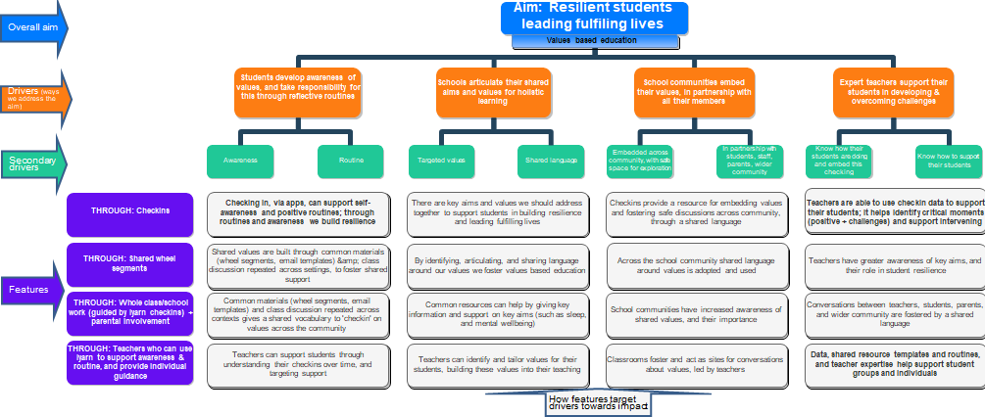

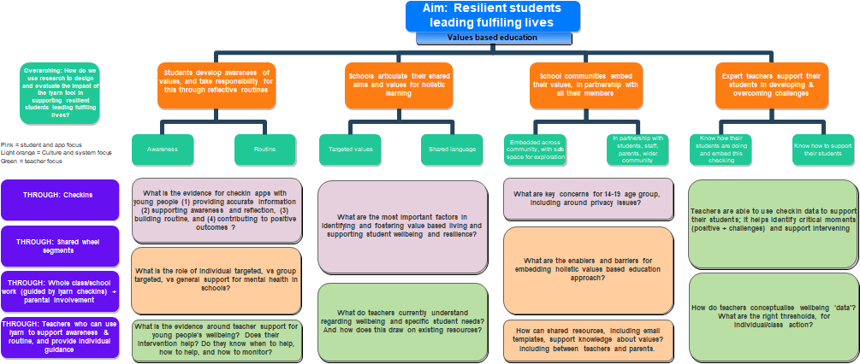

1. Broadly Tier 1 interventions: All students undertake; Tier 2: those with risk factors; tier 3: those with clear symptoms or diagnoses. These are cumulative, not exclusive.