MIQUEST Manager User Guide

30 September 2011, Version 0.6, DRAFT

Document Control

Document Details

|  |  |
| --- | --- |
| Project | MIQUEST Manager |
| Product |  |
| Author | Simon Heathfield |
| Contact | Simon Heathfield,  [simon.heathfield@capita.co.uk](mailto:simon.heathfield@capita.co.uk)  07760 297249 |

History

|  |  |  |  |
| --- | --- | --- | --- |
| Date | Name | Version | Action |
| 20/06/2011 | Simon Heathfield | 0.1 | Created |
| 29/07/2011 | Simon Heathfield | 0.2 | Added Collator |
| 31/08/2011 | Simon Heathfield | 0.3 | Added Encounter Split description |
| 05/09/2011 | Simon Heathfield | 0.4 | Corrections and A2 folder create |
| 15/09/2011 | Simon Heathfield | 0.5 | Initial Load and practice population suggestions |
| 30/09/2011 | Simon Heathfield | 0.6 | Collator changes |

Notice

*This report is for the benefit of MIQUEST Manager User only and has been released on the basis that it shall not be copied, referred to or disclosed, in whole or in part, without our prior written consent. We have not verified the reliability or accuracy of any information obtained from third parties in the course of our work. Any party that obtains access to this Report or a copy (under Freedom of Information Act 2000 or otherwise) and chooses to rely on this Report (or any part of it) does so at their own risk. To the fullest extent permitted by law, Capita does not assume any responsibility and will not accept any responsibility in respect of this Report to any party other than the original addressee.*

Contents

1 Introduction 4

2 The Export Process 5

3 Installation 6

3.1 MIQUEST Manager Installation 6

3.2 Prerequisites 6

4 Miquest Updater Operation 7

4.1 Selecting the Query Split Parameters 8

4.2 Output 9

4.3 Running the queries 9

5 Miquest Collator Operation 10

# Introduction

MIQUEST is a standard export process included in the GP Systems of Choice specification. It is mandated by the NHS and included in all GP systems. Thus it is a universal export method that can be employed in all practices. It is a manual process and requires intervention for every export performed.

Connecting for Health describes it as follows:

“MIQUEST is a methodology and an approach to common data access which enables enquirers to execute queries and extract data from different types of general medical practice computer systems using a common query language. It has been endorsed by the NHS Executive as the recommended method and therefore adopted as a standard, for this purpose.”

The MIQUEST Manager is a tool to configure the Capita ACG set of MIQUEST queries to export data from a GP Practice Management System.

The queries have been tested on:

* TPP SystmOne.
* In Practice Vision V3.

# The Export Process

This section describes the overall export process. The details will differ in different locations, however the pattern remains similar.

There are two programs provided in the Capita MIQUEST toolkit they are:

* MIQUEST Updater, that prepares the MIQUEST query files for running on the target system.
* MIQUEST Collator, that reads the output of the MIQUEST files (the response files) and converts into the format necessary for loading into the ACG system.

|  |
| --- |
|  |
| Figure . Export Process |

The general export process is illustrated in Figure 1. The query templates (provided in the MIQUEST Manager package) are configured to run in the target system by the MIQUEST Updater program. The queries created must then be run in the target GP system, the process to run the MIQUEST queries will be different for each system. Once run, the resulting set of MIQUEST response files must be processed using the MIQUEST Updater in order to produce the three files necessary for input to the ACG processing system.

The files must be transmitted from the GP practice to the data centre for loading. This may occur following the MIQUEST run (sending the MIQUEST response files to the data centre for collation) or following collation (sending the three output files). The process may be a secure file transfer or via a nominated NHS mail account.

Loading into the ACG processing system depends upon local configuration. The three files are simply placed in a folder on the server where they are picked up for processing.

The localisations are illustrated in Table 1. You need to understand the local process before the exports can be completed.

Table 1. Localisation Settings

|  |  |
| --- | --- |
| Localisation | Local configuration |
| Collation operates at practice or data centre? |  |
| Data transmission process |  |
| ACG load folder server and pathname | (This will be the A2 folder) |

# Installation

## MIQUEST Manager Installation

The files are delivered in a zip file, unzip to a temporary location for the install process.

1. Install files for the program files in folder ‘INSTALL’.
2. A set of MIQUEST query template files (CTV3 and 5 Byte) in folder ‘MIQUEST_Manager_Templates’.
3. The two executable files that may be used instead of installing (MIQUEST_Manager_Collator.exe and MIQUEST_Manager_Updater.exe).

To install:

* Double click ‘setup.exe’ or ‘.application’ files and follow instructions in order to install the application.
* Copy the templates to a location of your choice.

If you have installed, you may then delete the install files and temporary folder. If you plan to use the .exe files they will need to be retained.

## Prerequisites

The programs require the **Microsoft .net framework V4.0** to be installed. The install programs attempt to download and install if it is missing.

# Miquest Updater Operation

Invoke ‘MIQUEST Updater’ from the start menu or double click on the .exe file. The main window should appear.

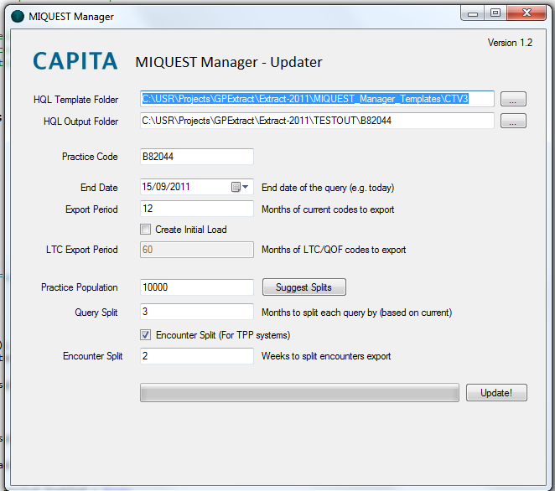

The program allows the queries to be tailored to the GP system and practice size. It is often good to run a set of small queries, rather than single large queries.

|  |  |
| --- | --- |
| Field | Purpose |
| HQL Template Folder | The folder path of the MIQUEST template files delivered with the updater application. (The button marked ‘…’ allows you to select the folder, or you can simply type the full path in).  There are two sets of template files provided, CTV3 and Read 2 (5 Byte). You must select the correct code type for the target system[1]. |
| HQL Output Folder | The folder where you would like the output to be placed. (The button marked … allows you to select the folder, or you can simply type the full path in). |
| Practice Code | The national code of your practice e.g. B82003. |
| End Date | The **END** date of the export period. |
| Export Period | The period in months to export of **current** diagnoses, prescription items and encounters. |
| Create Initial Load | Select this to create the full file set for an Initial Load (include LTCs and QOF queries). |
| LTC Export Period | The period in months of **‘Long Term Condition’** codes to export. The queries will be split based on the query split, i.e. the LTC export period / *export parts*. Only active if Create Initial Load is selected. |
| Practice Population | This provides suggestions for the ‘Query Split’ and ‘Encounter Split’ parameters based on a practice population. Type your practice population into the text box and press ‘Suggest Splits’, the Query Split and Encounter Split will be set to appropriate values. (Note these are just suggestions and based on TPP tests so far). |
| Query Split | The split, i.e. the number of separate file sets to export the complete period. This is included because some large practices may find it more efficient to export multiple small batches rather than on large one. Also some systems have a limit on the number of records that can be output, and so require multiple smaller exports. The ‘Export Period’ for current codes is used to calculate the split. For example a period of 12 months and a query split of 3 months will generate 4 *export parts*. |
| Encounter Split (For TPP systems) | TPP SystmOne supresses output when row numbers become large (approx. 30,000), encounter files can be very large so this option allows the encounter queries to be output separately and split into smaller chunks (using the Encounter Split parameter below).  *NOTE: This split encounter option is only available for CTV3.* |
| Encounter Split | When the ‘Encounter Split (For TPP systems)’ option is selected, the encounter export is managed as a separate query set, this parameter sets the number of ***weeks*** data exported in each of the queries produced. |
| Update! | Press this button to start the export. The progress bar will fill, and a pop up will indicate when the process is complete. |

The system will remember all settings between invocations.

## Selecting the Query Split Parameters

Setting the Query Split and Encounter Split depends upon the type of system and the size of the practice population. For example TPP SystmOne has a limit on the number of rows that will be output in a single query. Setting the splits depends upon the size of the practice population.

## Output

Following a run the generated queries will be found in the folder specified by the ‘HQL Output Folder’. Each query set will be in a separate folder. Queries will be in folders named ‘PARTn’, where n is the number of query splits. Where there is no split, the queries will all be in ‘PART1’.

When the ‘Encounter Split (For TPP systems)’ option is selected the encounter queries will appear in a folder named ‘ENCOUNTERS’.

**Note:** The program deletes all content in the output folder before creating the query set.

**Note**: it is vital to inspect the output on first runs at a practice to ensure the response files have been populated with data, some refinement of the query split parameters may be necessary to successfully output a complete dataset.

## Running the queries

Run the queries as appropriate to the target system. Note that the query sets do create response files with the same names. To avoid overwriting response files, they must be saved to a set of distinct output folders. The structure of the folders for the responses should be the same as the query files, i.e.

ENCOUNTERS (when the ‘Encounter Split (For TPP systems)’ option is selected)  
PART1  
PART2  
…

**NOTE: The encounters file MUST be named ENCOUNTERS or the data will be ignored.**

# Miquest Collator Operation

Invoke ‘MIQUEST Collator from the start menu or double click on the .exe file. The main window should appear.

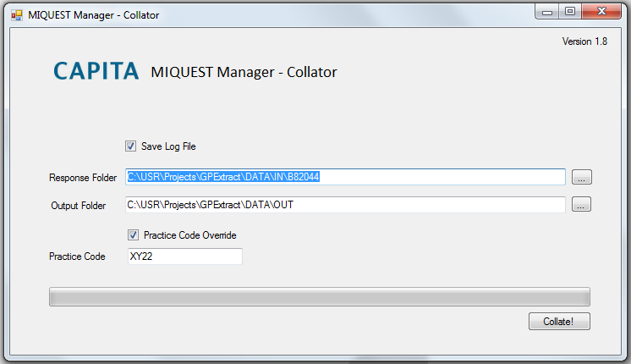

|  |  |
| --- | --- |
| Field | Purpose |
| Save Log File | Select to save a log file describing the process and listing any errors and warnings. The Log file has important information concerning the processing and should be checked following a program run. |
| Response Folder | The folder where the MIQUEST response files from the export will be read from. (The button marked ‘…’ allows you to select the folder, or you can simply type the full path in). |
| Output Folder | The folder where you would like the output to be placed. The program creates the necessary folder structure in the output folder (i.e. YEAR\MONTH\DAY). (The button marked … allows you to select the folder, or you can simply type the full path in). |
| Practice Code Override | This is used to select the option to override the practice code that is present in the MIQUEST response files. This can be used where a group of practices share a single GP system, but the data should be labelled for the local practice. |
| Practice Code | This is the practice code used when the practice code override is selected. |

The system will remember all settings between invocations.

For Sollis ACG systems, the output folder will normally be ‘server\A2\NON-APOLLO\’.

1. TPP SystmOne uses CTV3, others use Read 2 5Byte.