OS 2022fall 11.17 hw11

20307140008 施君豪

运行环境：Windows 10 (pycharm)

1. **第三十八章**
2. **基本映射测试（改变-L的值）：**

**raid.py -n 10 -L 0 -c -W seq**

**raid.py -n 10 -L 1 -c -W seq**

**raid.py -n 10 -L 4 -c -W seq**

**raid.py -n 10 -L 5 -c -W seq**

**左对称与左不对称之间的区别：**

**（左对称）**

**raid.py -n 10 -L 5 -5 LS -c -W seq**

LOGICAL READ from addr:0 size:4096

read [disk 0, offset 0]

LOGICAL READ from addr:1 size:4096

read [disk 1, offset 0]

LOGICAL READ from addr:2 size:4096

read [disk 2, offset 0]

LOGICAL READ from addr:3 size:4096

read [disk 3, offset 1]

LOGICAL READ from addr:4 size:4096

read [disk 0, offset 1]

LOGICAL READ from addr:5 size:4096

read [disk 1, offset 1]

LOGICAL READ from addr:6 size:4096

read [disk 2, offset 2]

LOGICAL READ from addr:7 size:4096

read [disk 3, offset 2]

LOGICAL READ from addr:8 size:4096

read [disk 0, offset 2]

LOGICAL READ from addr:9 size:4096

read [disk 1, offset 3]

存储方式为：

0 1 2 P

4 5 P 3

8 P 6 7

**（左不对称）**

**raid.py -n 10 -L 5 -5 LA -c -W seq**

LOGICAL READ from addr:0 size:4096

read [disk 0, offset 0]

LOGICAL READ from addr:1 size:4096

read [disk 1, offset 0]

LOGICAL READ from addr:2 size:4096

read [disk 2, offset 0]

LOGICAL READ from addr:3 size:4096

read [disk 0, offset 1]

LOGICAL READ from addr:4 size:4096

read [disk 1, offset 1]

LOGICAL READ from addr:5 size:4096

read [disk 3, offset 1]

LOGICAL READ from addr:6 size:4096

read [disk 0, offset 2]

LOGICAL READ from addr:7 size:4096

read [disk 2, offset 2]

LOGICAL READ from addr:8 size:4096

read [disk 3, offset 2]

LOGICAL READ from addr:9 size:4096

read [disk 1, offset 3]

存储方式为：

0 1 2 P

3 4 P 5

1. P 7 8
2. **-C改变了块的大小，从而原本会填入别的块的数据会先先填满原来的块（将其填满在写入别的部分）**

**raid.py -n 12 -L 5 -5 LS -c -W seq -C 8K**

LOGICAL READ from addr:0 size:4096

read [disk 0, offset 0]

LOGICAL READ from addr:1 size:4096

read [disk 0, offset 1]

LOGICAL READ from addr:2 size:4096

read [disk 1, offset 0]

LOGICAL READ from addr:3 size:4096

read [disk 1, offset 1]

LOGICAL READ from addr:4 size:4096

read [disk 2, offset 0]

LOGICAL READ from addr:5 size:4096

read [disk 2, offset 1]

LOGICAL READ from addr:6 size:4096

read [disk 3, offset 2]

LOGICAL READ from addr:7 size:4096

read [disk 3, offset 3]

LOGICAL READ from addr:8 size:4096

read [disk 0, offset 2]

LOGICAL READ from addr:9 size:4096

read [disk 0, offset 3]

LOGICAL READ from addr:10 size:4096

read [disk 1, offset 2]

LOGICAL READ from addr:11 size:4096

read [disk 1, offset 3]

存储方式为：

0 2 4 P

1 3 5 P

————————————

8 10 P 6

1. 11 P 7
2. **-r只改变显示的为LOGICAL READ还是实际read的值，不改变实际问题答案。**

**raid.py -n 12 -L 5 -5 LS -c -W seq -C 8K -r**

LOGICAL READ from addr:0 size:4096

read [disk 0, offset 0]

LOGICAL READ from addr:1 size:4096

read [disk 0, offset 1]

LOGICAL READ from addr:2 size:4096

read [disk 1, offset 0]

LOGICAL READ from addr:3 size:4096

read [disk 1, offset 1]

LOGICAL READ from addr:4 size:4096

read [disk 2, offset 0]

LOGICAL READ from addr:5 size:4096

read [disk 2, offset 1]

LOGICAL READ from addr:6 size:4096

read [disk 3, offset 2]

LOGICAL READ from addr:7 size:4096

read [disk 3, offset 3]

LOGICAL READ from addr:8 size:4096

read [disk 0, offset 2]

LOGICAL READ from addr:9 size:4096

read [disk 0, offset 3]

LOGICAL READ from addr:10 size:4096

read [disk 1, offset 2]

LOGICAL READ from addr:11 size:4096

read [disk 1, offset 3]

**存储方式仍为：**

**0 2 4 P**

**1 3 5 P**

**————————————**

**8 10 P 6**

**9 11 P 7**

1. **当请求的块的大小超过了实际磁盘块的大小时，一个请求会切分成多个小块在多个磁盘之中进行写入。**

**对于对于 RAID-4 和 RAID-5，请求块大小为16K时，效率更高，因为可以同时利用所以磁盘，相当于全条带写入。16K = 4K * 4（四个磁盘，每个磁盘块为4k）**

**（16K的值会随设定值而改变）**

**raid.py -n 12 -L 4 -W seq -S 8K -r -c**

0 2

LOGICAL READ from addr:0 size:8192

read [disk 0, offset 0] read [disk 1, offset 0]

2 2

LOGICAL READ from addr:2 size:8192

read [disk 2, offset 0] read [disk 0, offset 1]

4 2

LOGICAL READ from addr:4 size:8192

read [disk 1, offset 1] read [disk 2, offset 1]

6 2

LOGICAL READ from addr:6 size:8192

read [disk 0, offset 2] read [disk 1, offset 2]

8 2

LOGICAL READ from addr:8 size:8192

read [disk 2, offset 2] read [disk 0, offset 3]

10 2

LOGICAL READ from addr:10 size:8192

read [disk 1, offset 3] read [disk 2, offset 3]

12 2

LOGICAL READ from addr:12 size:8192

read [disk 0, offset 4] read [disk 1, offset 4]

14 2

LOGICAL READ from addr:14 size:8192

read [disk 2, offset 4] read [disk 0, offset 5]

16 2

LOGICAL READ from addr:16 size:8192

read [disk 1, offset 5] read [disk 2, offset 5]

18 2

LOGICAL READ from addr:18 size:8192

read [disk 0, offset 6] read [disk 1, offset 6]

20 2

LOGICAL READ from addr:20 size:8192

read [disk 2, offset 6] read [disk 0, offset 7]

22 2

LOGICAL READ from addr:22 size:8192

read [disk 1, offset 7] read [disk 2, offset 7]

**raid.py -n 12 -L 4 -W seq -S 12K -r -c**

0 3

LOGICAL READ from addr:0 size:12288

read [disk 0, offset 0] read [disk 1, offset 0] read [disk 2, offset 0]

3 3

LOGICAL READ from addr:3 size:12288

read [disk 0, offset 1] read [disk 1, offset 1] read [disk 2, offset 1]

6 3

LOGICAL READ from addr:6 size:12288

read [disk 0, offset 2] read [disk 1, offset 2] read [disk 2, offset 2]

9 3

LOGICAL READ from addr:9 size:12288

read [disk 0, offset 3] read [disk 1, offset 3] read [disk 2, offset 3]

12 3

LOGICAL READ from addr:12 size:12288

read [disk 0, offset 4] read [disk 1, offset 4] read [disk 2, offset 4]

15 3

LOGICAL READ from addr:15 size:12288

read [disk 0, offset 5] read [disk 1, offset 5] read [disk 2, offset 5]

18 3

LOGICAL READ from addr:18 size:12288

read [disk 0, offset 6] read [disk 1, offset 6] read [disk 2, offset 6]

21 3

LOGICAL READ from addr:21 size:12288

read [disk 0, offset 7] read [disk 1, offset 7] read [disk 2, offset 7]

24 3

LOGICAL READ from addr:24 size:12288

read [disk 0, offset 8] read [disk 1, offset 8] read [disk 2, offset 8]

27 3

LOGICAL READ from addr:27 size:12288

read [disk 0, offset 9] read [disk 1, offset 9] read [disk 2, offset 9]

30 3

LOGICAL READ from addr:30 size:12288

read [disk 0, offset 10] read [disk 1, offset 10] read [disk 2, offset 10]

33 3

LOGICAL READ from addr:33 size:12288

read [disk 0, offset 11] read [disk 1, offset 11] read [disk 2, offset 11]

**raid.py -n 12 -L 4 -W seq -S 16K -r -c**

0 4

LOGICAL READ from addr:0 size:16384

read [disk 0, offset 0] read [disk 1, offset 0] read [disk 2, offset 0] read [disk 0, offset 1]

4 4

LOGICAL READ from addr:4 size:16384

read [disk 1, offset 1] read [disk 2, offset 1] read [disk 0, offset 2] read [disk 1, offset 2]

8 4

LOGICAL READ from addr:8 size:16384

read [disk 2, offset 2] read [disk 0, offset 3] read [disk 1, offset 3] read [disk 2, offset 3]

12 4

LOGICAL READ from addr:12 size:16384

read [disk 0, offset 4] read [disk 1, offset 4] read [disk 2, offset 4] read [disk 0, offset 5]

16 4

LOGICAL READ from addr:16 size:16384

read [disk 1, offset 5] read [disk 2, offset 5] read [disk 0, offset 6] read [disk 1, offset 6]

20 4

LOGICAL READ from addr:20 size:16384

read [disk 2, offset 6] read [disk 0, offset 7] read [disk 1, offset 7] read [disk 2, offset 7]

24 4

LOGICAL READ from addr:24 size:16384

read [disk 0, offset 8] read [disk 1, offset 8] read [disk 2, offset 8] read [disk 0, offset 9]

28 4

LOGICAL READ from addr:28 size:16384

read [disk 1, offset 9] read [disk 2, offset 9] read [disk 0, offset 10] read [disk 1, offset 10]

32 4

LOGICAL READ from addr:32 size:16384

read [disk 2, offset 10] read [disk 0, offset 11] read [disk 1, offset 11] read [disk 2, offset 11]

36 4

LOGICAL READ from addr:36 size:16384

read [disk 0, offset 12] read [disk 1, offset 12] read [disk 2, offset 12] read [disk 0, offset 13]

40 4

LOGICAL READ from addr:40 size:16384

read [disk 1, offset 13] read [disk 2, offset 13] read [disk 0, offset 14] read [disk 1, offset 14]

44 4

LOGICAL READ from addr:44 size:16384

read [disk 2, offset 14] read [disk 0, offset 15] read [disk 1, offset 15] read [disk 2, offset 15]

**raid.py -n 12 -L 5 -W seq -S 8K -r -c**

0 2

LOGICAL READ from addr:0 size:8192

read [disk 0, offset 0] read [disk 1, offset 0]

2 2

LOGICAL READ from addr:2 size:8192

read [disk 2, offset 0] read [disk 3, offset 1]

4 2

LOGICAL READ from addr:4 size:8192

read [disk 0, offset 1] read [disk 1, offset 1]

6 2

LOGICAL READ from addr:6 size:8192

read [disk 2, offset 2] read [disk 3, offset 2]

8 2

LOGICAL READ from addr:8 size:8192

read [disk 0, offset 2] read [disk 1, offset 3]

10 2

LOGICAL READ from addr:10 size:8192

read [disk 2, offset 3] read [disk 3, offset 3]

12 2

LOGICAL READ from addr:12 size:8192

read [disk 0, offset 4] read [disk 1, offset 4]

14 2

LOGICAL READ from addr:14 size:8192

read [disk 2, offset 4] read [disk 3, offset 5]

16 2

LOGICAL READ from addr:16 size:8192

read [disk 0, offset 5] read [disk 1, offset 5]

18 2

LOGICAL READ from addr:18 size:8192

read [disk 2, offset 6] read [disk 3, offset 6]

20 2

LOGICAL READ from addr:20 size:8192

read [disk 0, offset 6] read [disk 1, offset 7]

22 2

LOGICAL READ from addr:22 size:8192

read [disk 2, offset 7] read [disk 3, offset 7]

**raid.py -n 12 -L 5 -W seq -S 12K -r -c**

0 3

LOGICAL READ from addr:0 size:12288

read [disk 0, offset 0] read [disk 1, offset 0] read [disk 2, offset 0]

3 3

LOGICAL READ from addr:3 size:12288

read [disk 3, offset 1] read [disk 0, offset 1] read [disk 1, offset 1]

6 3

LOGICAL READ from addr:6 size:12288

read [disk 2, offset 2] read [disk 3, offset 2] read [disk 0, offset 2]

9 3

LOGICAL READ from addr:9 size:12288

read [disk 1, offset 3] read [disk 2, offset 3] read [disk 3, offset 3]

12 3

LOGICAL READ from addr:12 size:12288

read [disk 0, offset 4] read [disk 1, offset 4] read [disk 2, offset 4]

15 3

LOGICAL READ from addr:15 size:12288

read [disk 3, offset 5] read [disk 0, offset 5] read [disk 1, offset 5]

18 3

LOGICAL READ from addr:18 size:12288

read [disk 2, offset 6] read [disk 3, offset 6] read [disk 0, offset 6]

21 3

LOGICAL READ from addr:21 size:12288

read [disk 1, offset 7] read [disk 2, offset 7] read [disk 3, offset 7]

24 3

LOGICAL READ from addr:24 size:12288

read [disk 0, offset 8] read [disk 1, offset 8] read [disk 2, offset 8]

27 3

LOGICAL READ from addr:27 size:12288

read [disk 3, offset 9] read [disk 0, offset 9] read [disk 1, offset 9]

30 3

LOGICAL READ from addr:30 size:12288

read [disk 2, offset 10] read [disk 3, offset 10] read [disk 0, offset 10]

33 3

LOGICAL READ from addr:33 size:12288

read [disk 1, offset 11] read [disk 2, offset 11] read [disk 3, offset 11]

**raid.py -n 12 -L 5 -W seq -S 16K -r -c**

0 4

LOGICAL READ from addr:0 size:16384

read [disk 0, offset 0] read [disk 1, offset 0] read [disk 2, offset 0] read [disk 3, offset 1]

4 4

LOGICAL READ from addr:4 size:16384

read [disk 0, offset 1] read [disk 1, offset 1] read [disk 2, offset 2] read [disk 3, offset 2]

8 4

LOGICAL READ from addr:8 size:16384

read [disk 0, offset 2] read [disk 1, offset 3] read [disk 2, offset 3] read [disk 3, offset 3]

12 4

LOGICAL READ from addr:12 size:16384

read [disk 0, offset 4] read [disk 1, offset 4] read [disk 2, offset 4] read [disk 3, offset 5]

16 4

LOGICAL READ from addr:16 size:16384

read [disk 0, offset 5] read [disk 1, offset 5] read [disk 2, offset 6] read [disk 3, offset 6]

20 4

LOGICAL READ from addr:20 size:16384

read [disk 0, offset 6] read [disk 1, offset 7] read [disk 2, offset 7] read [disk 3, offset 7]

24 4

LOGICAL READ from addr:24 size:16384

read [disk 0, offset 8] read [disk 1, offset 8] read [disk 2, offset 8] read [disk 3, offset 9]

28 4

LOGICAL READ from addr:28 size:16384

read [disk 0, offset 9] read [disk 1, offset 9] read [disk 2, offset 10] read [disk 3, offset 10]

32 4

LOGICAL READ from addr:32 size:16384

read [disk 0, offset 10] read [disk 1, offset 11] read [disk 2, offset 11] read [disk 3, offset 11]

36 4

LOGICAL READ from addr:36 size:16384

read [disk 0, offset 12] read [disk 1, offset 12] read [disk 2, offset 12] read [disk 3, offset 13]

40 4

LOGICAL READ from addr:40 size:16384

read [disk 0, offset 13] read [disk 1, offset 13] read [disk 2, offset 14] read [disk 3, offset 14]

44 4

LOGICAL READ from addr:44 size:16384

read [disk 0, offset 14] read [disk 1, offset 15] read [disk 2, offset 15] read [disk 3, offset 15]

1. **RAID0，RAID1，RAID5速度差不多，RAID4较慢**

**RAID0：**

**raid.py -L 0 -t -n 100 -c -D 4**

disk:0 busy: 100.00 I/Os: 28 (sequential:0 nearly:1 random:27)

disk:1 busy: 93.91 I/Os: 29 (sequential:0 nearly:6 random:23)

disk:2 busy: 87.92 I/Os: 24 (sequential:0 nearly:0 random:24)

disk:3 busy: 65.94 I/Os: 19 (sequential:0 nearly:1 random:18)

STAT totalTime 275.7

**RAID1：**

**raid.py -L 1 -t -n 100 -c -D 4**

disk:0 busy: 100.00 I/Os: 28 (sequential:0 nearly:1 random:27)

disk:1 busy: 86.98 I/Os: 24 (sequential:0 nearly:0 random:24)

disk:2 busy: 97.52 I/Os: 29 (sequential:0 nearly:3 random:26)

disk:3 busy: 65.23 I/Os: 19 (sequential:0 nearly:1 random:18)

STAT totalTime 278.7

**RAID4：**

**raid.py -L 4 -t -n 100 -c -D 4**

disk:0 busy: 78.48 I/Os: 30 (sequential:0 nearly:0 random:30)

disk:1 busy: 100.00 I/Os: 40 (sequential:0 nearly:3 random:37)

disk:2 busy: 76.46 I/Os: 30 (sequential:0 nearly:2 random:28)

disk:3 busy: 0.00 I/Os: 0 (sequential:0 nearly:0 random:0)

STAT totalTime 386.1

**RAID5：**

**raid.py -L 5 -t -n 100 -c -D 4**

disk:0 busy: 100.00 I/Os: 28 (sequential:0 nearly:1 random:27)

disk:1 busy: 95.84 I/Os: 29 (sequential:0 nearly:5 random:24)

disk:2 busy: 87.60 I/Os: 24 (sequential:0 nearly:0 random:24)

disk:3 busy: 65.70 I/Os: 19 (sequential:0 nearly:1 random:18)

STAT totalTime 276.7

1. **见下图，总体趋势均为随着磁盘数量的增加，并行性增强，完成等量任务所花时间下降。曲线可近似为1/x。**

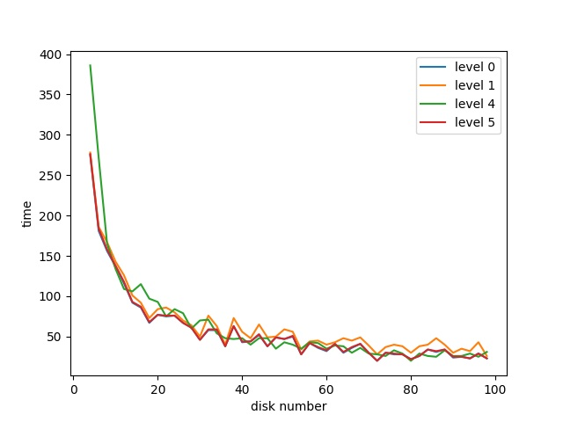

1. **RAID0，RAID1，RAID5总体趋势同上，RAID4由于本身架构（需要反复读取备份盘，效率受限）下降幅度不如前面三者。**

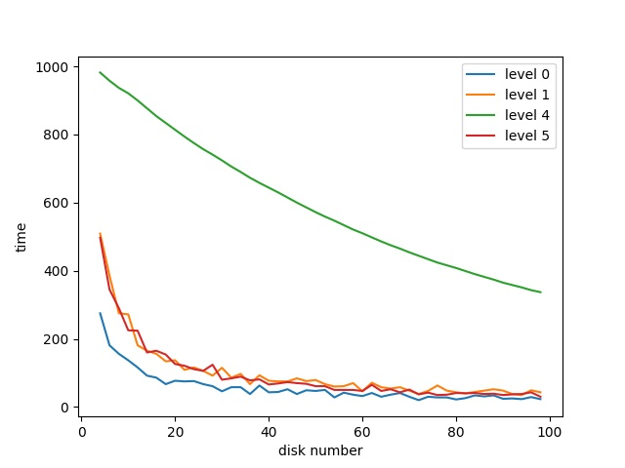

1. **对于顺序读取，增加磁盘个数可以快速降低时间，同时由于读取/写入请求均为顺序的，可以很快达到最大性能。对于RAID4，RAID5，写入大小应该为：可用磁盘数×磁盘块大小（全条带写入）**

**读取/写入图表见下：**

**读取：**

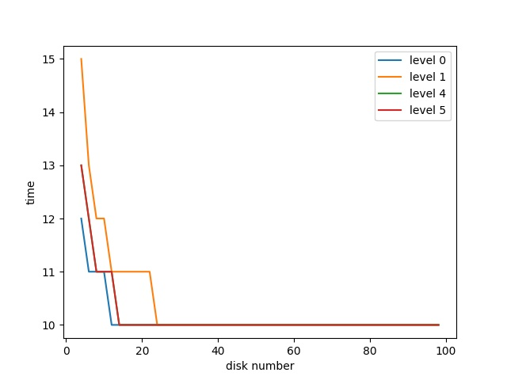

**写入：**

