OS 2022fall 12.1 hw12

20307140008 施君豪

运行环境：Linux（Ubuntu）

1. **第三十九章**
2. **第二题：**

**代码：**

#include<stdio.h>

#include<string.h>

#include<dirent.h>

#include<assert.h>

#include<sys/stat.h>

int main(int argc, char * argv[]) {

char * sdir = ".";

if(argc > 1)

sdir = argv[1];

int flag = 0;

if(argc > 2 && strcmp(argv[2], "-l") == 0)

flag = 1;

DIR * dp = opendir(sdir);

assert(dp != NULL);

struct dirent *d;

while((d = readdir(dp)) != NULL) {

printf("%s\n", d->d_name);

if(flag) {

char filestr[200] = "";

strcat(filestr, sdir);

strcat(filestr, "/");

strcat(filestr, d->d_name);

struct stat st;

stat(filestr, &st);

printf("inode: %d uid: %d mode: %d\n", st.st_ino, st.st_uid, st.st_mode);

}

}

return 0;

}

运行截图：

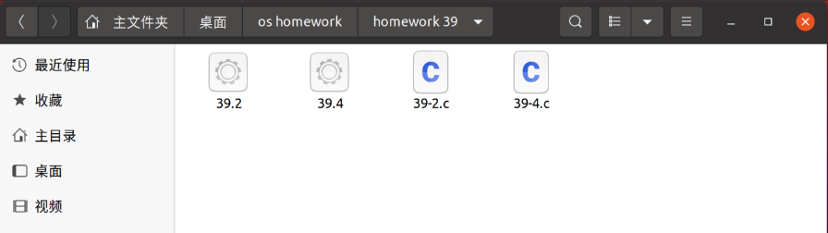

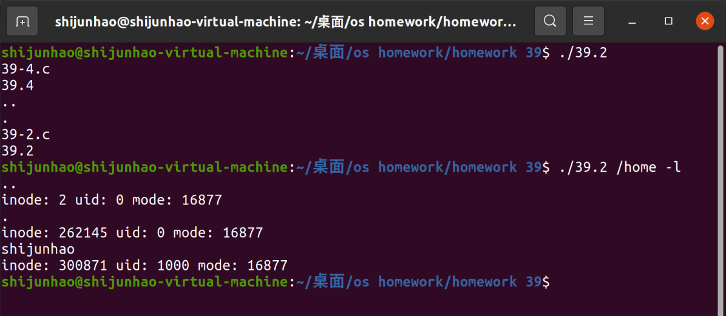

1. **第四题：**

**代码：**

#include<stdio.h>

#include<string.h>

#include<dirent.h>

#include<assert.h>

#include<sys/stat.h>

void readTotal(const char * sdir) {

DIR * dp = opendir(sdir);

assert(dp != NULL);

struct dirent *d;

while((d = readdir(dp)) != NULL) {

if(strcmp(d->d_name, ".") == 0 || strcmp(d->d_name, "..") == 0)

continue;

printf("%s/%s\n", sdir, d->d_name);

char filestr[200] = "";

strcat(filestr, sdir);

strcat(filestr, "/");

strcat(filestr, d->d_name);

struct stat st;

stat(filestr, &st);

if(S_ISDIR(st.st_mode))

readTotal(filestr);

}

}

int main(int argc, char * argv[]) {

char * sdir = ".";

if(argc > 1)

sdir = argv[1];

readTotal(sdir);

return 0;

}

运行截图：



