Introduction
You are tasked with designing an AI-assisted system that analyzes metrics and dependencies across interconnected microservices and recommends appropriate SLOs/SLAs for each service — while accounting for upstream/downstream dependencies, datastores, and infrastructure components.

Open Questions
Q1: Should we ask users to provide dependencies of services as part of onboarding? This can be problematic in long run as system architectures may change with time but onboard dependencies may not get updated by owners
[Ans]: We should consider both scenarios for our system and take an iterative approach.
- Iteration-1: System will expose an API for dependency management in platform. As part of onboarding, users will have to use this API and provide dependencies of services.
- Iteration-2: System will form dependencies by analyzing traces from API calls and will form dependency from it. We should still get it verified by users by sending them notifications in case dependency found by our system is different than the one onboarded by users.
Q2: Since each service may have different APIs and each API may have different dependencies. Should we consider SLO at service level or API level
[Ans]: This is totally possible, it’s better to recommend SLO at API level.
[Sumit] : Remove this: but for now, let’s divide the system into two categories:
- Micro Services: Single responsibility service with only one API. For such services, SLOs are same at Service and API level.
- Infrastructure: Multiple responsibilities and can be used in multiple workflows. Ex- DB, Message Queue, API Gateway.

Q3: Since some of the services in dependency graph may be more heavily used that others, should this factor be considered for recommending SLO of consumer services?
[Ans]: Yes, part of infrastructure such as database/message-queue etc may get shared by multiple services and may lead to resource constraints. Let’s try to address this in SLO calculations.
Q4: System may have dependency on external services (i.e. payment gateway) which will have its own SLA and it may impact SLO of dependent services. How should we get their SLO/SLA?
[Ans]: Let’s assume that services (internal/external) have provided us documentation regarding data contracts, tiers of services, SLAs of those tiers etc which may be in different formats(i.e. Html/pdf/md etc).
Q5: In order to recommend SLO, we need to gather SLIs for services in dependency graph. Is there an existing service which can do this job?
[Ans]: All services are emitting telemetry to a datastore but we don’t have a service which can provide SLIs.
Q6: Do we need to handle circular dependency?
[Ans]: Let’s take iterative approach here. For iteration-1, we will not allow it but we can be open to it in future iterations on user’s demand.

User Types
This system will have two types of Users:
- Platform teams (Admins): looking to onboard their services, understanding system performance and getting recommendations
- SRE/service owners: who want to understand the system performance, get SLO recommendations, impact analysis etc.

Functional Requirements
- Teams should be able to onboard their service topologies to SLO Recommendation platform.
- Teams should be able to update onboarded topology.
- Users should be able to view services and dependencies.
- Users should be able to get SLO Recommendations for services with details of dependencies, sli/slos of dependencies and reasoning behind this recommendation.
- Users should be able to accept these recommendations.
- Users should be able to perform impact analysis before making any SLO changes in system.

Non-Functional Requirements:
- Availability: System should be highly Availability
- Scalability: System should be highly scalable and should scale with increase in number of services and dependency.
- Latency: API latencies should be minimum. (within SLA)
- Security:
  - System should be secure at different layers (API/network etc).
  - Allow auditability in future by capturing audit logs.
  - Since AI/LLM is being used, proper guardrails should be put in place to follow compliance
- Auth: System should have some auth model to differentiate between admin users and normal users:
  - Admin users: Should be able to make Changes in system such as Add/Update services and dependencies. Accept/Update SLOs of services
  - Other users should be able to just get information from system (i.e. View services, get SLO recommendations, impact analysis etc.)
- Observability: System should have proper monitor/alerts for all resources.
- Compliance/Guardrails: Since AI/LLM is being used, proper guardrails should be put in place to follow compliance.

Assumptions

Service Level Objectives
Although there can be variety of SLOs, our system will recommend below SLOs:
- Availability = % time for which Service was up
- Latency (p95/p99) = latency of APIs in service
- Error Rate = %requests which failed
[Assumption]: We will choose above SLOs with a time window of 28 days for SLO calculations.

Service Topology
At a high level, there are two ways in which services interact with each other.
- Synchronous interactions: In this model, services interact synchronously. (i.e. using Rest APIs).

This can have different types of dependencies. APIs take linear dependence on each other. APIs can have dependency on multiple downstream APIs.
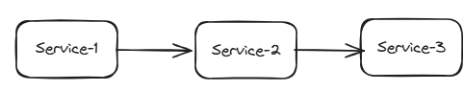
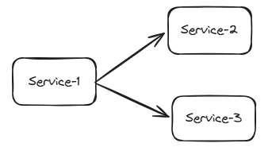
[Assumption]: We will assume that all these are STRICT dependencies.

- Asynchronous Interactions: Services are using message queue in between.
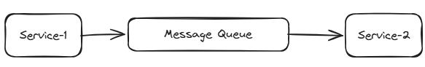
SLO of API can be derived at two levels:
  - Service API level: SLO of API at service-1 simply depends on interaction between Service-1 and Message Queue.
  - E2E level: SLO depends on Service-1 processing and producing, latency in Message Queue, latency in Service-2 for consuming and processing.

[Assumption]:
- For our system, we will derive SLO at service API level in iteration-1.
- System may contain other components like data pipelines, which will be covered in next iteration.

Scale
Users: 10,000 SRE/Service-owners
APIs/Services: 100,000 onboard on Day-1 with 500 services being onboarded daily from Day-2 onwards
Dependencies: On average, each API has 5 dependencies.

Requests

Admin traffic for Onboarding
- Services/APIs: 100,000 Services/APIs are onboarded on day 1 within a window of 1 hours
Assuming our system will expose batch api for onboarding with each API call allowing 10 service.
# Requests = 100,000 req/10 = 10,000 request
Req/sec = 10,000/3600 sec = 2.8 req/sec

Peak requests: All requests in a burst of 60 sec = 10,000/60sec = 167 req/sec

- Dependency: 5 dependencies per API per Service(average).
Assuming our system will expose batch api for onboarding with each API call allowing 10 dependencies
# Requests = 5*100,000 req/10 = 50,000 request
Req/sec = 50,000/* 3600 sec =~ 14 req/sec

Peak requests: All requests in a burst of 60 sec = 50,000/60sec = 834 req/sec

Rest of traffic
Users: 10,000 SREs/service owners
- GET Dashboard views for every team: 10000 req/sec
- GET SLO Recommendations for every service: 1000 req/sec
- GET Impact Analysis for every service: 1000 req/sec

Storage Estimates

Services and Dependencies
Assuming size of each services metadata (id, api, type, tier, category, owner..) of size 2KB
Assuming dependencies between each service APIs of size 1KB

Storage for Services:
Total Services in 10 years = 100,000 + 500*365*10 = 1,925,000 =~ 2 million
Storage needed = 2million * 2KB = 4GB

Storage of dependencies
Total dependencies in 10 years = 5*number of services = 10 million
Storage needed = 10 million * 1KB = 10 GB

SLI Data
Assuming 5 SLIs per service (availability, error rate, latency p95/99,..), collected every hour with each SLI data (id, sli_type, sli_unit, sli_value, time_window, timestamp,…) of size 1KB
Storage for SLI data: 2 million services * 5 sli * 24 hr * 365 * 10 = 876GB ~=1TB

SLO Recommendation with analysis
For 2 million service, assume unique analysis done 10 times per service and each output of size 100KB
Storage: 2 million services * 10 * 100KB = 2GB

System Components
In order to recommend SLO, we need to have the following:
- Service Dependency: We need to store and manage dependency between services.
- Service Level Indicators: We need to gather various SLIs from services: Availability, Latency, Error Rate.
- Knowledge Store: We need to create a knowledge store which will be storing SLA/SLO information for various internal as well as external services.
- SLO Generation Logic: We need to gather relevant information and then create a logic to derive SLO and back-test/finetune with SLIs.

Service Dependency (Iteration-1)
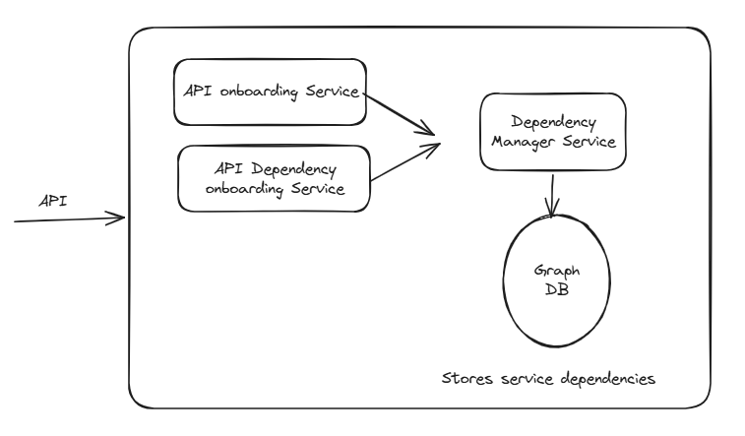

Resources
- API Onboarding Service: Exposes API to allow Admins to onboard Service APIs.
- API Dependency Service: Exposes APIs to allow Admins to onboards service APIs dependencies to system.
- Dependency Manager Service: Responsible for managing dependencies between services.
- Graph DB: It stores dependency between APIs.

Data Storage

- Service-API Dependency Graph: This will store service information and their dependencies. Each service may have multiple edges , thus it’s useful to store unique instances of each service and the relationship between them.

Operations on DB:
- Write: Create service nodes and dependencies
- Read: Perform traversal of neighbors and find those nodes. We will also have to traverse down/up depending on scenario.
Graph DB is an ideal candidate for storing such data for following reasons:
- Inbuilt functionality to traverse relationship in graphical way, which is needed here.
- Can be scaled horizontally to handle scale.

Service Telemetry and SLI Store
As per the assumptions made (Q5), all services are emitting telemetry to a telemetry collector datastore at API level.
For our system’s purpose, we need to define SLIs and derive those SLIs for every service from this datastore.
We will collect SLIs which can help us in recommending SLOs.
- Availability
- Latency
- Error Rate
SLI record will have following properties
- ServiceId
- API
- Timestamp //SLI generation time
- Sli_type //i.e. latency
- Sli_unit //i.e. p95
- Sli_value
- Sli_window: time window for given value. This property is really important for following reasons:

- Overall SLO/SLA per service is defined for a given time window. Ex- Availability of 99.9% over a month window
- Aggregation of smaller windows gives us better view of problematic window. Ex- if we aggregate every hour, in case overall SLO goes down for whole month, we can narrow it down to exact hours when issue happens.
We need to find a balance between having this time window way too small (i.e. 1 sec may need lot of processing).and way too big (i.e. 1 month may smoothen out lot of problematic time windows).

Sample SLI:
{
"serviceId": "Guid-1",
“api” : “api-1”
"sli_type": "latency",
"sli_unit": "p95",
"sli_window": "30d",
"timestamp": "2026-02-25T00:00:00Z",
"sli_value": “1sec”
}
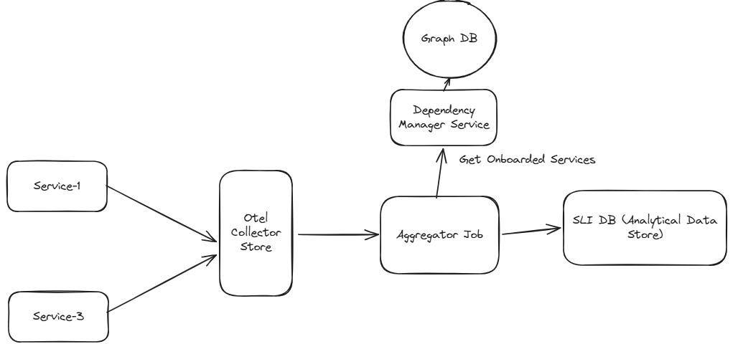

Resources
- Existing Infrastructure: Assuming that services are emitting telemetry using OpenTelemetry and those logs are being stored in Otel Collector Datastore.

- Aggregator Job: Responsible for aggregating data per services in last one hour. (Potential Solution – Azure Synapse)

- SLI Database: Storage for SLIs per service per time window. In this case, we would need a data store which supports following:
Ingestion:
- Batch ingestion of data
- Backfilling data in case something got missed.

Queries:
- Aggregate SLI by service.
- Aggregate data by window (28d)
- Allow filtering of data after/before given timestamp. (i.e. impact on average latency on Service-1 after timestamp-1)
Based on above, we can use an analytical data store. (i.e. Azure Data Explorer) for following reasons:
  - Support all above aggregation
  - It’s optimized to ingest/store large volume of data and run query on top of it.

Workflow
- Each service emits necessary metrics using existing open telemetry infrastructure and this is collected in Otel Collector Store
- Aggregator Job runs every hour and does following:
- find all the services onboarded to System from Dependency Manager Service.
- Generate different SLIs for these service by aggregating data over the period of last one hour
- Store this information in SLI DB.

Additional Factors

Handling Scale:
- Aggregator JOB can be scaled horizontally for enhancing processing
- SLI DB
  - Analytical DBs can be scaled horizontally.
  - Partitioning data on basis of API/Service will help improve read.

Handling Failures:
- Add retry logic in every API call with backoff strategy.
- Add monitors to capture these failures and create Alerts for Oncall person to look into.

Knowledge Store
SLO/SLA information of services may exist in different formats places, with different authority levels and freshness. Thus, we need to extract SLOs/SLAs from these resources, resolve conflicts and produce a usable SLO per service.
- Internal Service Documentation: Wiki pages, design docs, runbooks.
- External Service Documentation: Vendor-published SLAs/SLOs (e.g., payment gateway tiers).
Factors to consider:
- The documentation may be in different formats.
- Data may or may not be structured in those documents
  - There may or may not be separate sections of SLOs
  - SLOs might be mentioned as plain text as part of some paragraph in natural language.
- Size of documents may range from 1 page to multiple pages.

System Design

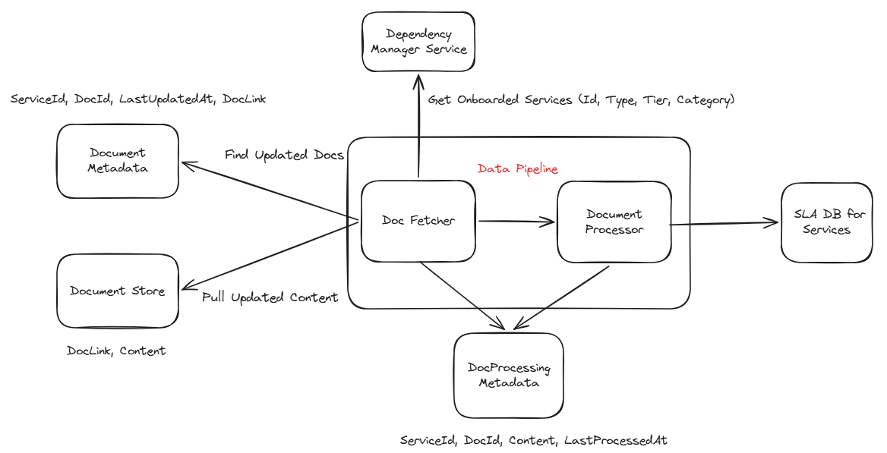

Resources
- Document Metadata: Existing database which stores metadata of documents of services.
- Document Store: Existing store which actually stores documentation of services.
- Data Pipeline: Responsible for finding updated documentation of services and extracting SLAs from them
- Doc Processing Metadata: Used to store metadata of documents processed for services and when they got last updated.
- SLA DB: Stores extracted SLA per service.

Data Storage
We will store SLAs of every service-API in a normalized way.
Sample Data:
    - ServiceId
    - API
    - Source: // Source of data (i.e. internal-doc, external-doc)
    - UpdatedAt //TimeStamp of last update
    - SLOs: //List of different SLOs/ SLAs
- Slo_type // (i.e.latency )
- Slo_unit //(i.e. p95)
- Slo_value
- Slo_windiw // (i.e. 30d)

Since, we already have document DB as part of infrastructure, we can use the same for this purpose.

Workflow
Data pipeline is run on a timely basis (i.e. every hour), depending on how frequently we expect documents to be updated and synced.
- Doc Fetcher:
  - Gets details of all services from Dependency Manager Service (Id, Type, Tier, Category).
  - Compare DocProcessing Metadata with Document Metadata and find documents which have been updated.
- Document Processor:
  - Extract SLAs from updated documents
  - Store SLAs in SLA DB.
  - Update DocProcessing Metadata with processed document details and timestamps

Document Processor
As per the answer of Q4, we can have different type of documentations and data may/may not be maintained properly in those documents.

Design option-1

Using Large/Small language model to extract relevant information from documents.
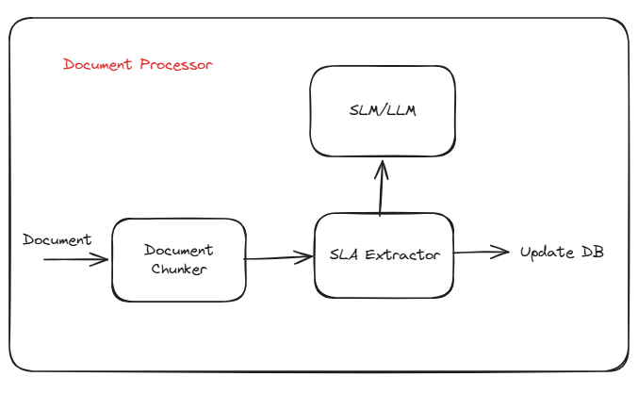
Workflow:
- Document Chunker chunks the document to contain tokens within a limit. We can use different chunking logic for different types of documents.
- SLA Extractor makes API call to LLM/SLM to extract SLA information. Validates response from LLM/SLM and then adds validated, normalized data to SLA DB.
- LLM/SLM: Since this is not a complicated operation, we should evaluate SLM first to check whether it can extract information for us. In case, it doesn’t work, then we should move towards using LLM.

Pros:
- It’s a very simple design as all documents are processed in similar way to produce output
- Easily process documents where data is not structured properly and SLOs need to be inferred from text/natural language.
- Less time/effort needed to develop this system.
Cons:
- Cost: Since each document may have large number of chunks, processing all the chunks can lead to huge cost.
- Non-deterministic: Different runs may lead to slightly different values of SLO and it’s possible that sometimes, it misses finding relevant SLO.

Design Option-2

Use a hybrid approach for extracting SLOs (library based extraction + SLM/LLM approach)
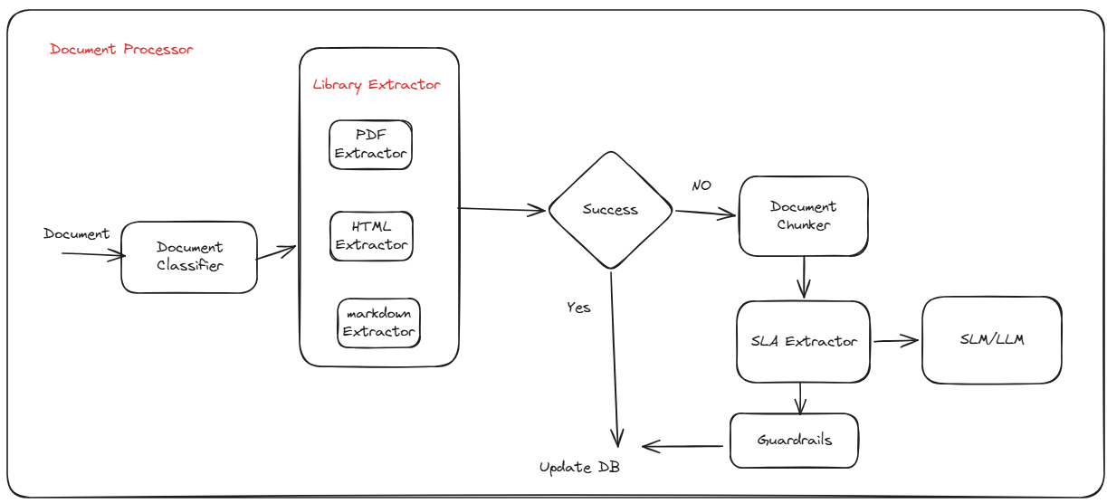
Workflow:
- Document classifier identifies the file format (md, pdf etc)
- Library extractor has different ways to extract file details based on file type (ex – markdown_analysis for md file)
- If SLOs are successfully extracted, values are simply stored in SLA DB
- Else, we fallback to use SLM/LLM to derive relevant SLO details from documents.
- Guardrails are added to system to make sure that we validate output of SLA extractor and make sure that we don’t store PII or other sensitive information in SLO DB.

Pros:
- Cost effective as system will be able to generate SLO details without using SLM/LLM.
- More deterministic in nature.
Cons:
- More time/effort needed to develop this solution.

Decision
Based on above analysis, it’s better to go with Design option-2 as it is more deterministic in nature and saves us lot of cost.
Option-1 may be a better option for POC purpose but not for production system.

Handling Scale:
- All services can be scaled horizontally for handling scale
- SLA DB
  - Document DBs can be scaled horizontally.
  - Partitioning data on basis of API/Service will help improve read operation.

Handling Failures:
- Add retry logic in every API call with backoff strategy.
- Add monitors to capture these failures and create Alerts for Oncall person to look into.

SLO Generation Logic

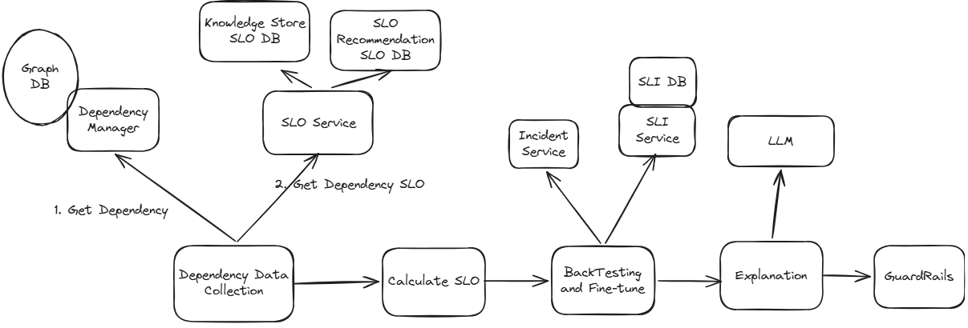

Dependency Data Collection
In order to provide recommendations of SLO for a service (i.e. Service-1), we need to gather following data

Dependency Services
All the services on which service-1 has dependency on (i.e. Sevice-2, Service-3, DB-1). This can be derived from dependency manager service which manages dependency graph.

SLIs
We need to gather relevant SLIs (i.e. availability, latency, error rate, volume of traffic) for Service-1 as well as dependency services. Since SLI DB is storing these SLIs per service, we can fetch this information from there.

SLOs
SLOs are being stored at multiple places
- SLOs generated from documentations are being stored in Knowledge Store SLA DB
- Since this system is also recommending SLO, which might be accepted by user, SLOs are also being stored in SLO Recommendation System DB.
Corner Case Scenarios: Same service may have SLOs in documentation as well as SLO Recommendation System DB. Thus, we need a mechanism to resolve this conflict.
[Decision]: We will use SLOs from SLO Recommendation System DB.

Calculate SLO

Algorithm Steps:
- Filter out external services
- Perform topological sort from dependency graph(process leaves first)
- For each service (bottom-up):
If external: use contracted SLO
If intermediate: calculate using inverse formulas
- Apply safety margin

Calculation of SLO will depend on these factors –

Service Type Filtering
- External service: we will simply read SLO from Knowledge Store documentation
- Internal service: we will calculate it based on our logic.

API dependencies processing
Consider this scenario: API1 -> API2 -> External Service. In order to generate SLO of API, we need to generate SLO of API2.
Thus, we need to perform Topological Sort of Graph and process it bottom up. (starting from leaves). In this case, we first derive SLO of API-2 first. API-2 will use SLO of external service as reference

Calculation
As per the assumption, there is strict dependencies between APIs.

Availability
Formula: A_total = A₁ × A₂ × A₃ × ... × Aₙ
Example: API Gateway (99.95%) → API1 (99.9%) → API2 (99.9%) → DB (99.99%)
Availability = 99.95 % * 99.9 % * 99.9 % * 99.99% = 99.74%
Assuming safety margin of 0.1%, Availability with safety margin = 99.64

Latency
Formula: L_total = L₁ + L₂ + ... + Lₙ + overhead
P95: L_total(P95) ≈ Σ L_i(P95) + overhead
Example: API Gateway (10ms) → API1 (80ms) → API2 (30ms) → DB (99.99%)
Latency = 10ms + 50ms + 80ms + 30ms + 10ms (overhead) = 180ms
Assuming safety margin of max latency in the chain (80ms), Latency = 260ms

Error rate
Formula: E_total = 1 - [(1 - E₁) × (1 - E₂) × ... × (1 - Eₙ)]
Example: API Gateway (0.05%) → API1 (0.1%) → API2 (0.1%) → DB (0.01%)
Error rate = 1 - [(1 – 0.05%) × (1 – 0.1%) × (1-0.1%) × (1 – 01%)] = 0.26%

Back-Testing and Fine-Tuning
We will compare calculated SLO with source of truth and make changes accordingly. (SLI data + Incident data).
Scenarios:
- SLI is consistently above SLO. (Ex- Availability SLI: 99.8%, SLO:99%)
It’s possible that SLO is too-conservative and can be tightened up. We can look into incidents data to decide.
  - If high severity incidents are rare, this means error budget has not been used. Thus, we can increase SLO higher.

- SLI is consistently below SLO. (Ex- Availability SLI: 99%, SLO:99.5%)
This might be either due to miscalculations of SLO from Service owner or any other reason. We can use incident data to decide.
  - If high severity incidents are rare, it means SLO was miscalculated and over-tightened, thus it needs to be relaxed.
  - If there are high severity incidents, SLO may be reasonable and there might be problem with dependency services.

- SLI is consistently above SLO by small margin. (Ex- Availability SLI: 99.6%, SLO:99.5%)
We don’t need to change SLO as of now.

LLM Powered Explanation

LLM Input Context:
Service name and current SLI metrics
Calculated recommended SLO with mathematical justification
Dependency list with SLO values and types
SLI and Incident history
Revised SLO based on back-testing and fine-tuning

LLM Output Components:
Explanation:
- Why this SLO is recommended
- Impact of downstream services in SLO of target services
- Identify bottlenecks based on SLO values of downstream services
- Comparison of calculated SLO with SLI

GuardRails
Guardrails are added to verify following
- LLM output is strictly in the expected format
- LLM output doesn’t contain any sensitive (i.e. PII) data

Impact Analysis
Any change in SLO of an API will impact all the upstream services. We will take a similar approach here as taken in SLO generation above.
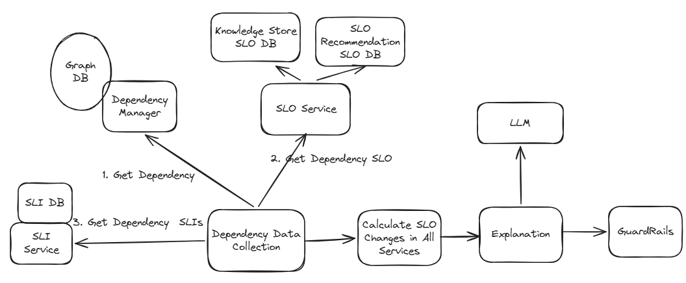

Workflow
- Find upstream services from Dependency Manager
- Find SLO of upstream services from SLO Service
- Find SLI of upstream services from SLI Service.
- Calculate updated SLO of upstream changes based on this change.
- Use LLM to generate impact, compare updated SLO with current SLO, compare updated SLO with SLIs and incident data and call out risks with explanation.
- Pass output through guardrails for validation and compliance.

Auth
As mentioned in the requirements, we have two types of Users (Admin/non-admin). We will create two separate Service Group add users to those groups accordingly.
All APIs will follow RBAC model. API roles will be assigned to respective Security Group.

E2E Working – API Driven

Onboarding
We will expose APIs for teams to onboard their services to this platform.
- API to manage Services (/api/services): Manage service objects in Config as well as Graph.
- API to manage Dependencies (/api/dependencies): Manage dependencies in Config as well as Graph.

System Design Option-1
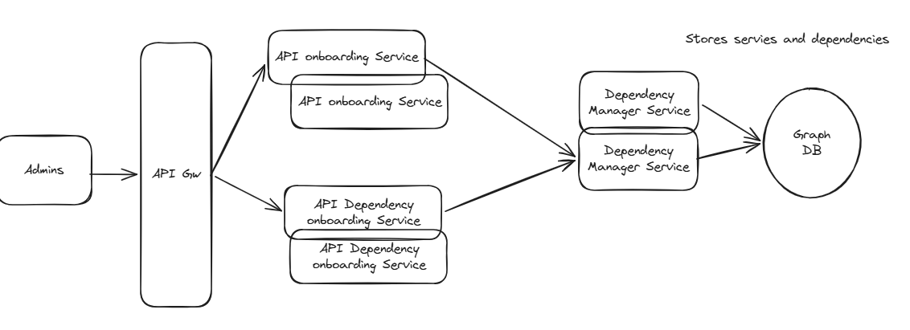

Resources
- API Gateway: Responsible for Authentication, rate limiting and load balancing the traffic.
- API onboarding service:
  - Exposes API to allow users to onboard their services/api to system
  - Validates data of services for critical information.
  - Calls Dependency Manager to create nodes per service.
- Dependency Onboarding service:
  - Exposes API to onboard dependencies between services.
  - Validates data and circular dependencies
  - Calls Dependency Manager to create nodes per service
- Dependency Manager Service:
  - Exposes API to be used by Onboarding services to onboard service and dependencies
  - Creates node per service/api.
  - For creating edge, first checks both nodes. If present, it creates edge between them.

- Document DB: It will store the configuration used by team to onboard to platform
- Graph DB: It will store dependency between services.

APIs

Batch Add Services (/api/services)
- User makes POST API call with details of services to be onboarded to system.
Sample Data:
    - Owning Team Name
    - Owning Team Contact
    - Services: List of services
- Id //Id of service
- API
- Type (i.e. WebApp/Database etc.)
- Category (i.e. Internal/External)
- Tier (i.e. Basic/Premium)

- API gateway does auth/rate-limiting and routes requests to one of dependency injection service instances.
- API onboarding service: Validates data and calls Dependency Manager to create nodes per service.
- Dependency Onboarding service: Validates data and calls Dependency Manager to create nodes per service
- Dependency Manager Service: Creates node per service/api.

Update Service (/api/services/id)
- User makes PUT API call with details of services
- Workflow is same as above

Delete Service (/api/services/id)
- User makes DEL API call with details of services
- Dependency Manager service : Delete node as well dependencies in graph

Get Service (/api/services/id)
- GET API call with service id

Add Dependencies (/api/dependencies)
- User makes POST API call with details of services dependencies.
Sample Data:
    - Dependencies: //List of dependency between services
- Id
- API
- DependsOn: [] (i.e. id1, id2 -> list of downstream dependencies)

- API gateway does auth/rate-limiting and routes requests to one of dependency injection services.
- Dependency onboarding validates input and calls dependency manager to update dependency graph service will do following:
- Dependency Manager service adds dependencies between nodes.

Update Dependencies (/api/dependencies/id)

Get Dependencies (/api/dependencies/id)
- GET API call with service id

GET (/api/dependencies/team-id)
- GET API which will return all the services together with dependencies of a given team

Workflow for onboarding
- Create services using /api/services.
- Create dependencies between service using /api/dependencies

Pros: Simpler design with rest-api based interaction between services.
Cons: This is a synchronous model where there is tight coupling between dependency injection service, (user facing service) and dependency manager service. This design works fine if we have small number of services, but once the scale increase it will start causing problems.:
  - API will take long time and user will have to wait for that duration.
  - Dependency Manager service may turn out to be bottleneck for end-to-end workflow in case it’s busy or Graph DB is slow. This will impact performance of user facing API.
  - In case of any issue, end to end API workflow will fail and users will have to come back later to perform onboarding

System Design Option-2

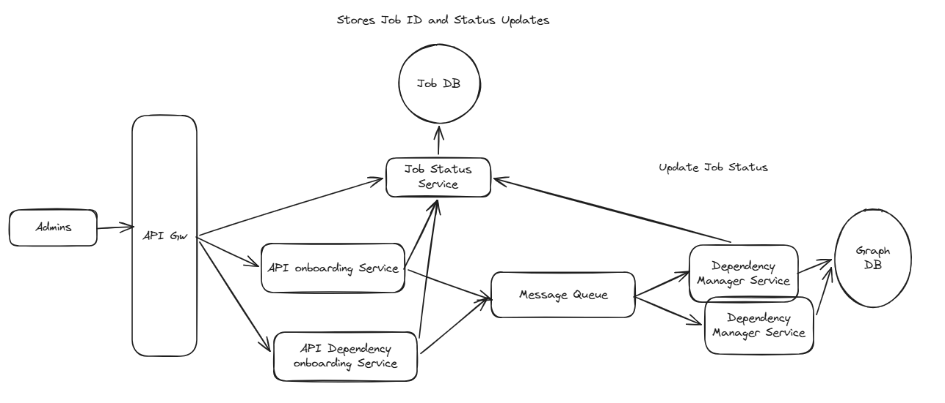

Resources
Same as option-1 with addition of:
- Message Queue: Decouples onboarding service with dependency manager service
- Job Service: Responsible for managing job status
- Get Job Status Service: Provide status of a job
Job Data: Job_id, status, progress_percentage, errors[]

Workflow
Using an asynchronous model.
- Onboarding services:
  - Create a Job_Id per request and return to User
  - Update status of job to “Queued”
  - Add {Job_Id, Request} to MQ.

- Dependency Manager service
  - Read Job_Id and request from MQ
  - Update Job status to “Processing”
  - Process requests in batch. (i.e. 10)
    - Update Graph DB
Update progress_percentage in DB
  - Update status to “Completed” once it’s done.
Pros: With decoupled system, option-1 cons will get addressed.
Cons:
- Additional infrastructure is added to system which may incur more cost.
- Additional delay in reflecting updates to Graph DB in comparison to synchronous updates.

Decision
Although option-2 adds some costs in terms of infrastructure, it improves reliability and scalability of overall system. Thus, option-2 should be preferred over option-2.
Option-1 will be preferred in case of lows-scale system.

Additional Factors

Handling Scale:
- Services: All services can be scaled horizontally on demand.
- Message Queue:
  - It can be scaled horizontally on demand
  - Data can be partitioned for distribution of traffic.
- Graph DB:
  - Graph DBs can be scaled horizontally.
  - Data can be partitioned on different factors for distribution and efficient queries. Partitioning on basis of team can help improve API performance, so that GET queries don’t have to run across cluster nodes.

Handling Failures:
- Add retry logic in every API call with backoff strategy.
- Add monitors to capture these failures and create Alerts for Oncall person to look into.

SLO Recommendation
SLO generation logic has been discussed in detail in section of SLO Generation Logic.

Design Option-1: API Driven SLO Generation

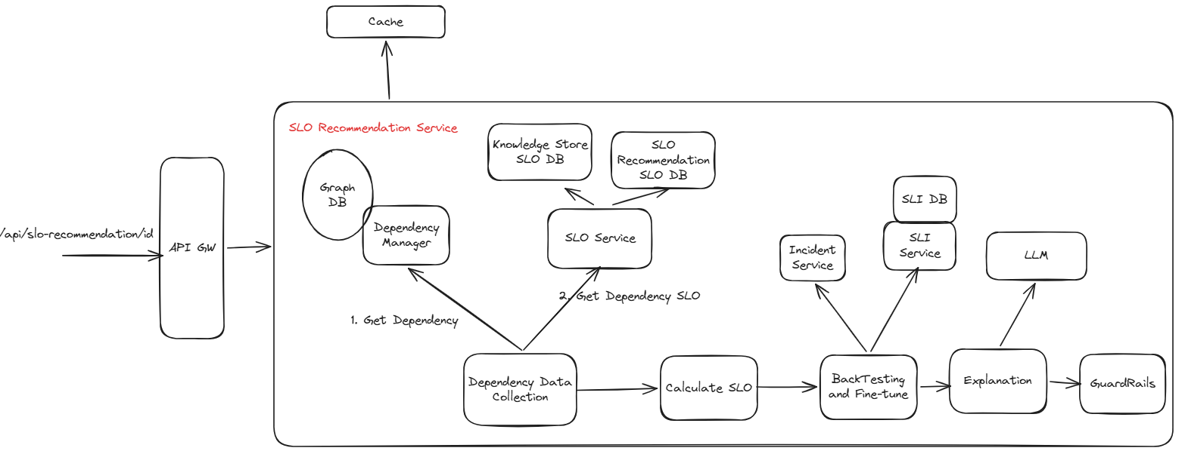

APIs
GET /api/slo-recommendation/service_id=X&api_id=Y

Workflow
- User makes GET API call to get slo recommendation
- SLO Generation logic is triggered, which generates SLO recommendation in below format.
- Cache output to be used for future GET requests with adequate timer_expiry.
Sample Format
    - API
    - Service
    - SLOs
      - Slo_type
      - Slo_unit
      - Slo_value
      - Slo_window
      - reasoning //generated by LLM

Pros: Simple Design for generating SLO
Cons:
- Since LLM operations are slow, it may take few seconds for whole workflow to complete, thus making API latency high.
- If SLO of downstream nodes are not calculated, we need to traverse graph and calculate SLO of leaf nodes and then do it for all downstream dependencies. This can add significant delay given that there can be lot of such dependencies.

Design Option-2: Pre-generation of SLO based on Events
Instead of generating SLO on API call, we can pre-generate SLO based on following factors
- Updated in dependency graph
- Updated in SLO of dependent services
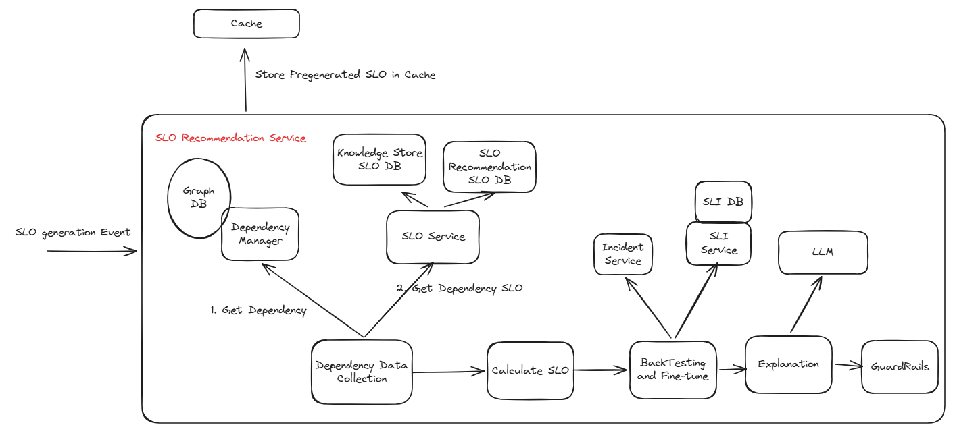

Workflow
- Pre-generate SLO on events and store it in Cache/DB.
- API calls: SLO Recommendation Service first check Cache
  - If SLO is pre-generated: Return it.
  - If SLO is not pre-generated: Trigger Calculation workflow

Pros:
- Improved API latency for /api/slo-generation as SLO of all nodes will be generated on events.
Cons:
- Need additional infrastructure for implementation, which may incur more cost and time/effort.

Decision
Given that we have assumed that every API Node can have 5 dependencies, slo generation of a node whose downstream nodes’s slo has not been generated can add significant delay to /api/slo-generation.
Thus, it’s better to go with option-2

SLO Crud Operations
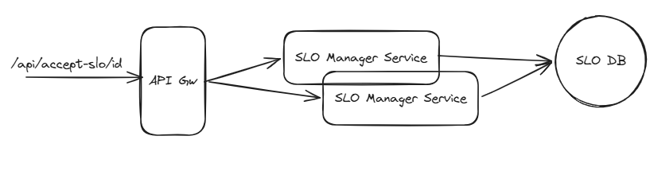

APIs
Add/Accept slo (POST /api/slo/)
Update slo (PUT /api/slo/id)
Remove slo (DEL /api/slo/id)

Resources
- SLO Manager Service manager SLO per API
- SLO DB: We can use same Document DB which has been used for other purposes here.
Sample Format
    - API
    - Service
    - SLOs
      - Slo_type
      - Slo_unit
      - Slo_value
      - Slo_window
      - reasoning //generated by LLM

Data Storage
We can reuse the same document db which has been used for other purposes in this system.

Additional Factors

Handling Scale:
- Aggregator JOB can be scaled horizontally for enhancing processing
- SLI DB
  - Analytical DBs can be scaled horizontally.
  - Partitioning data on basis of API/Service will help improve read.

Handling Failures:
- Add retry logic in every API call with backoff strategy.
- Add monitors to capture these failures and create Alerts for Oncall person to look into.

Impact Analysis
Detailed logic has been provided in System component section.
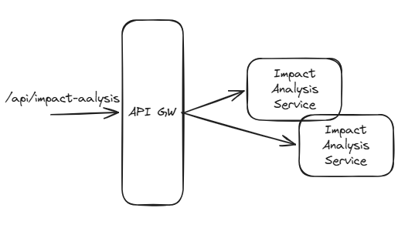
Workflow: API driven workflow where impact is generated by API and returned back to user
Since, LLM is used in this workflow, API may take some time but setting up right SLA should be helpful in such scenario.

E2E Working - Agentic System
API driven system has provided us all the building blocks, but it has limitations in terms of number of use cases it can solve.
Moving to an agentic system provides us the flexibility to solve many scenarios using the same infrastructure.
Some of additional Scenarios/Queries which can be solved using Agentic System
- Review and Recommendations queries
  - Review the SLOs for <service> and recommend changes.
  - Propose initial SLOs for this new service given its metadata.
  - Evaluate whether the current SLOs for <service> are too tight or too loose.
  - Generate a stricter SLO proposal that reduces user-visible errors by X% without exploding on-call load.
- Analysis queries
  - Summarize how <service> has been performing against its SLOs over the last 30/90 days
  - Explain why <service> keeps burning error budget.
  - Identify the main contributors to SLO violations for <service> (e.g., specific endpoints, regions, tenants)
  - Show me which dependencies are most correlated with SLO violations for <service>
  - Compare observed SLI distributions vs SLO targets and highlight mismatches
  - Find services which have been breaching SLO for last 1 month.
- Simulate impact analysis
  - Compare observed SLI distributions vs SLO targets and highlight mismatches
  - Simulate the impact of changing <service>’s availability SLO from 99.9% to 99.95% over the last 90 days.
Thus, we can create an agentic system on top of API services to make our system more intelligent.

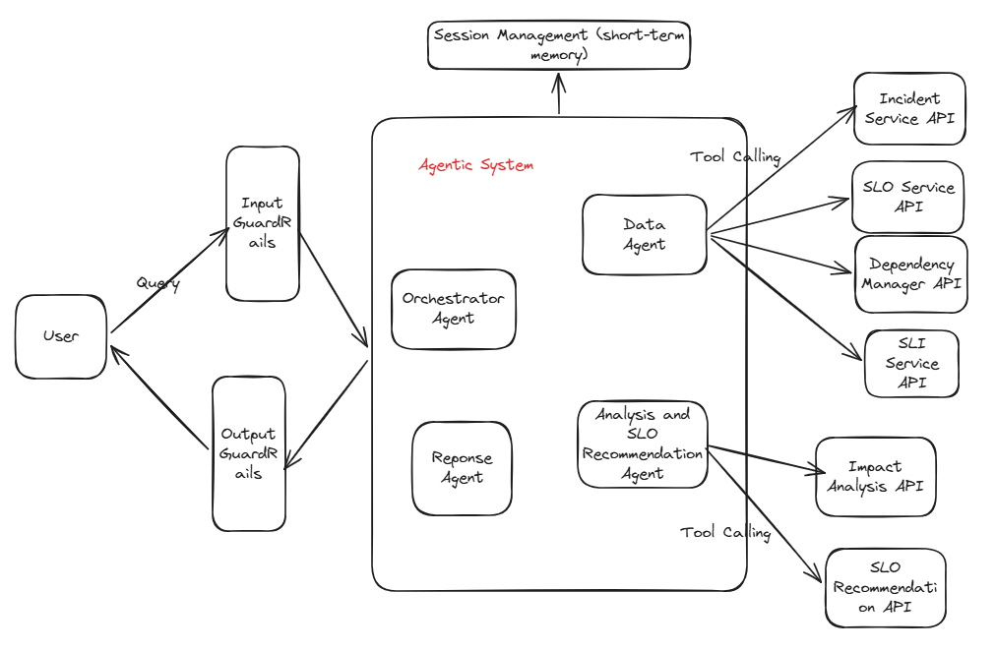

Agents
- Orchestrator Agent: Responsible for parsing user requests, route them to the correct specialist agent(s), and coordinate multi-step workflows.
- Data Agent: Responsible for gathering data from various sources for other agents. This agent has tools to make API calls to get access to SLO/SLI/Incidents/Dependency data.
  - “get_sli_data(service-api, sli_type, sli_unit, time_period)”
  - “get_slo_data(service-api, slo_type, slo_unit)”
  - “get_dependency_services(service-api)”
  - “get_incident_data(service-api, time_period)

- Analysis and ecommendation Agent – This agent would perform impact analysis, recommend SLO, perform what-if analysis (future iteration) by using data provided by data agent. This agent will also interact with existing Impact Analysis API and SLO recommendation API using tools.
- Reponse Agent- This is responsible for providing response to user in a consolidated way

Memory
- Short term - Used for maintaining context of conversation

GuardRails
- Input: Guardrails should be put in place to prevent prompt-injection for agents.
- Output: We need to make sure that Agents are not giving sensitive data in response.

Telemetry
- Logging for all the interactions with agents
- Input, tool calls, decisions, output etc should be logged

Monitor and Alerts

AppServices
Metrics
- Latency: p50/p95/p99 for key endpoints (per route / user journey).
- Errors: HTTP 5xx, 4xx (per route); JS errors on frontend.
- Traffic: requests/sec, active sessions.
- Saturation: CPU, memory, thread pool usage; queue length in worker pools.
Alerts
- p95 latency of critical APIs > X ms for Y minutes.
- Error rate (5xx) > 1% for 5 minutes.

Document DB
Metrics
- Latency: p95/p99 for read/write operations.
- Errors: failed queries, timeouts, connection failures.
- Traffic: queries/sec by service.
- Saturation: CPU, disk I/O, storage usage, connection pool usage, cache hit rate.
Alerts
- p99 read or write latency > threshold for Y minutes.
- Error rate > 0.5–1% for Y minutes.
- Disk utilization > 80–90%.
- Connection pool saturation from WebApp or Graph DB.

Graph DB
Similar to Document DB, plus:
Metrics
- Latency: p95/p99 for graph queries by query type (traversals, writes).
- Errors: query failures (syntax, timeouts, timeouts from long traversals).
- Traffic: queries/sec by calling service.
- Saturation: cluster CPU, memory, index cache hit, number of slow queries.
Alerts
- p99 query latency for critical graph queries above threshold.
- Growth in average query cost; number of slow queries per minute.

Message Queue (MQ)
Metrics
- Producer: Publish success rate and Publish latency.
- Consumer:
  - Processing latency (processed_time - produced_time)
  - Error rate in consumers (retries, DLQ pushes).
- Disk/CPU, network traffic.
Alerts
- Consumer lag (time) > X seconds for key topics for Y minutes.
- Producer failure rate > 0.1–1%.
- End-to-end event processing SLI (e.g., “events processed < 60s”) falls below SLO.
- DLQ rate rising.

LLM Resource
Assuming an external API or internal LLM service.
Metrics
- Latency: p95/p99 for completions.
- Errors: API failures (5xx, timeouts, quota errors).
- Traffic: requests/sec, tokens/sec (input + output).
- Saturation: rate limits/quota utilization, internal queue length.
Alerts
- Error rate > X% for LLM calls that are on user-critical paths.
- p95 latency above threshold when used synchronously in WebApp.
- Approaching quota limits.

Testing

Conventional Testing
- Unit test of all services
- Integration test of all services
- E2E test of user scenario

Evaluation Framework
Since we have LLM involved in the system, we use AI Evaluations frameworks for testing this aspect.
- Output Response Testing
We can test those responses on standard factors such as
- Coherence
- Relevance
- Groundedness
- Fluency
- GuardRails Testing: This test should also test whether LLMs are producing any sensitive data as part of output
Since we will use an evaluation framework, we will be using LLM as a judge. It’s better to have a jury based judgement (multiple LLM Judges) to have high confidence in test result.

Future Work
This iteration is laying up the groundwork to bring different pieces of system together. Below are some improvements which can be done in future iterations.

Dependency Graph from Trace
Current Limitation: System’s view of Service Dependencies is completely dependent on Admin users maintaining it properly. It’s totally possible that over time, Admin’s architecture evolves but dependencies in this system is not updated.
Future Work: We should enhance this system to consume trace logs and form dependency Graph from it directly.

SLOs and Calculation
Current Limitation: We have started with simple SLOs and Calculation.
Future Work:
We should re-evaluate SLOs, include more SLOs on need basis.
We should improve our model of SLO calculation

What-if Analysis
Allow users to perform what-if analysis of system
Ex- What if API latency of Service-1 becomes double. What if availability of Service-2 goes down by 0.1%

