Stephen Hanley  
Introduction to Web Design  
Prof. Stefka Hristova  
10/11/16

The HTML/HTML5 elements I foresee myself using are as follows: <div>, <nav>, <article>, <figure>, <h1> - <h6>, <p>, <head>, <footer>, <!-->, <button>, <img>, <style>, <title>, <strong>, and others will be discovered in the future. It’s impossible for me to know exactly what all I’m going to use until I dig into the actual coding of the website. For now, this gives me a good idea of what I’ll need to learn about to create my website. The wireframe is defined by the rest of this document.

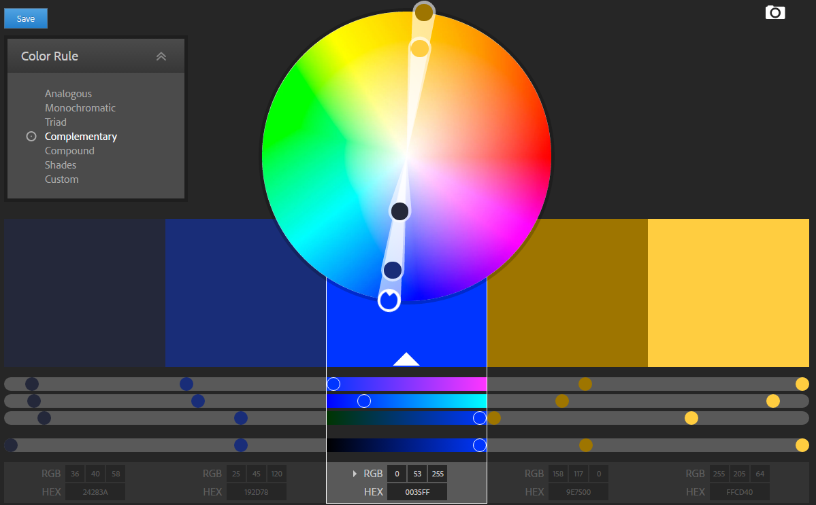

My color theme is complimentary with the following values: 24283A = Subordinate; 192D78 = Subordinate; 0035FF = Dominant; 9E7500 = Subordinate Accent; FFCD40 = Accent

All text is designed to be black with my current design. The chosen fonts are common fonts.