Generative Adversarial Networks (GANs)
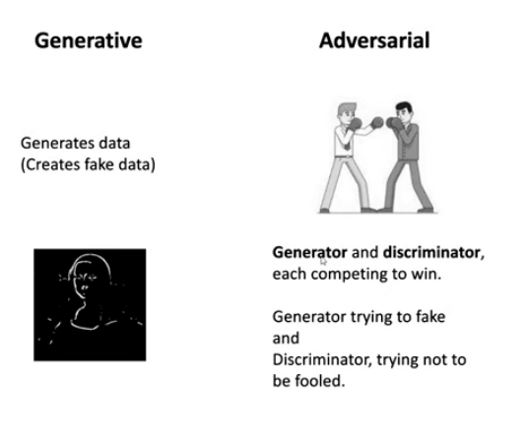

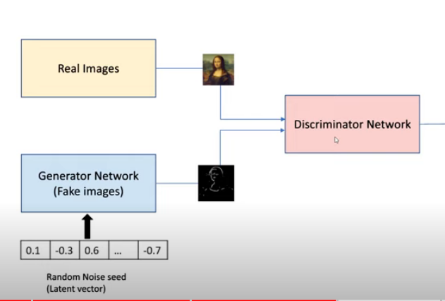

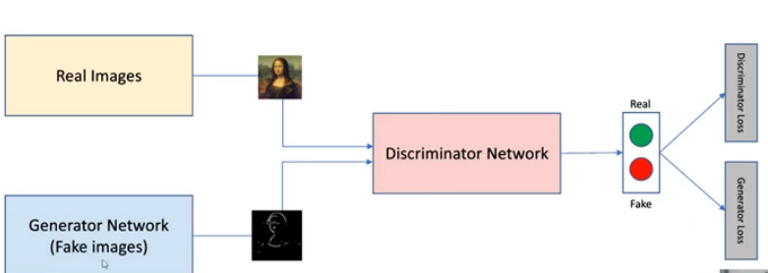

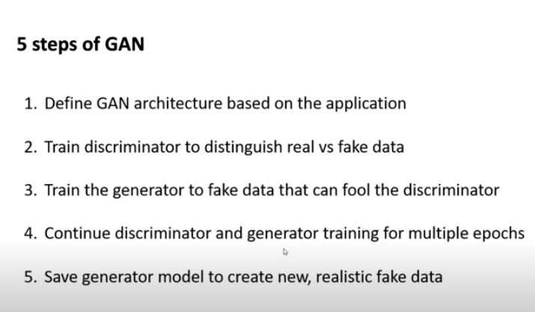
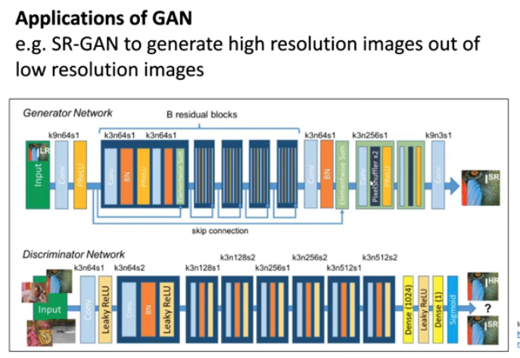

A celebrity-face probability distribution
Generating new faces can be expressed by a random variable generation problem. The face is described by random variables, represented through its RGB values, flatten into a vector of N numbers.
The celebrity faces are 218px height, 178px width with 3 color channels. Therefore each vector is 116412-dimensional.
If we build a space with 116412 (N) axes, each face will be a point in that space. A celebrity-face probability distribution function P(X) would map each face to a non-negative real number so that the sum of all these numbers for all faces equals 1.
Some points of that space are very likely to represent celebrity faces whereas it is highly unlikely for some others.

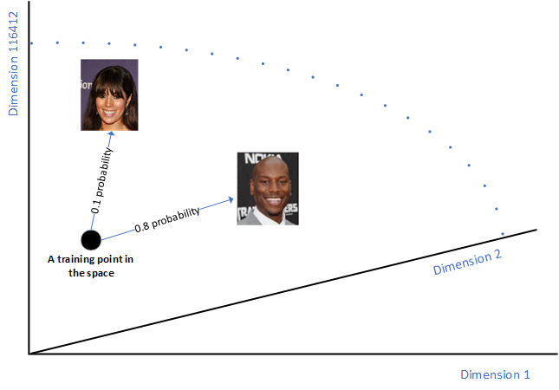
A GAN generates a new celebrity face by generating a new vector following the celebrity face probability distribution over the N-dimensional vector space.
In simple words, a GAN would generate a random variable with respect to a specific probability distribution.

