The Arclight Otoscope

An integrated, solar-rechargeable otoscope designed for primary care and low-resource settings, enabling combined eye and ear examinations.
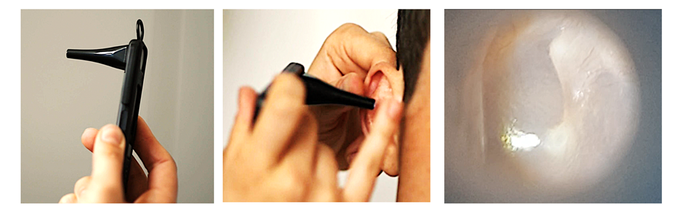

Hearing Loss & Ear Disease
Hearing loss is common and often preventable. Otitis media and impacted wax are leading causes of avoidable hearing impairment in low- and middle-income countries.
The Arclight otoscope and training enables primary health workers to:

- Recognise otitis media and impacted wax
- Distinguish normal from abnormal tympanic membranes
- Treat where appropriate and refer safely

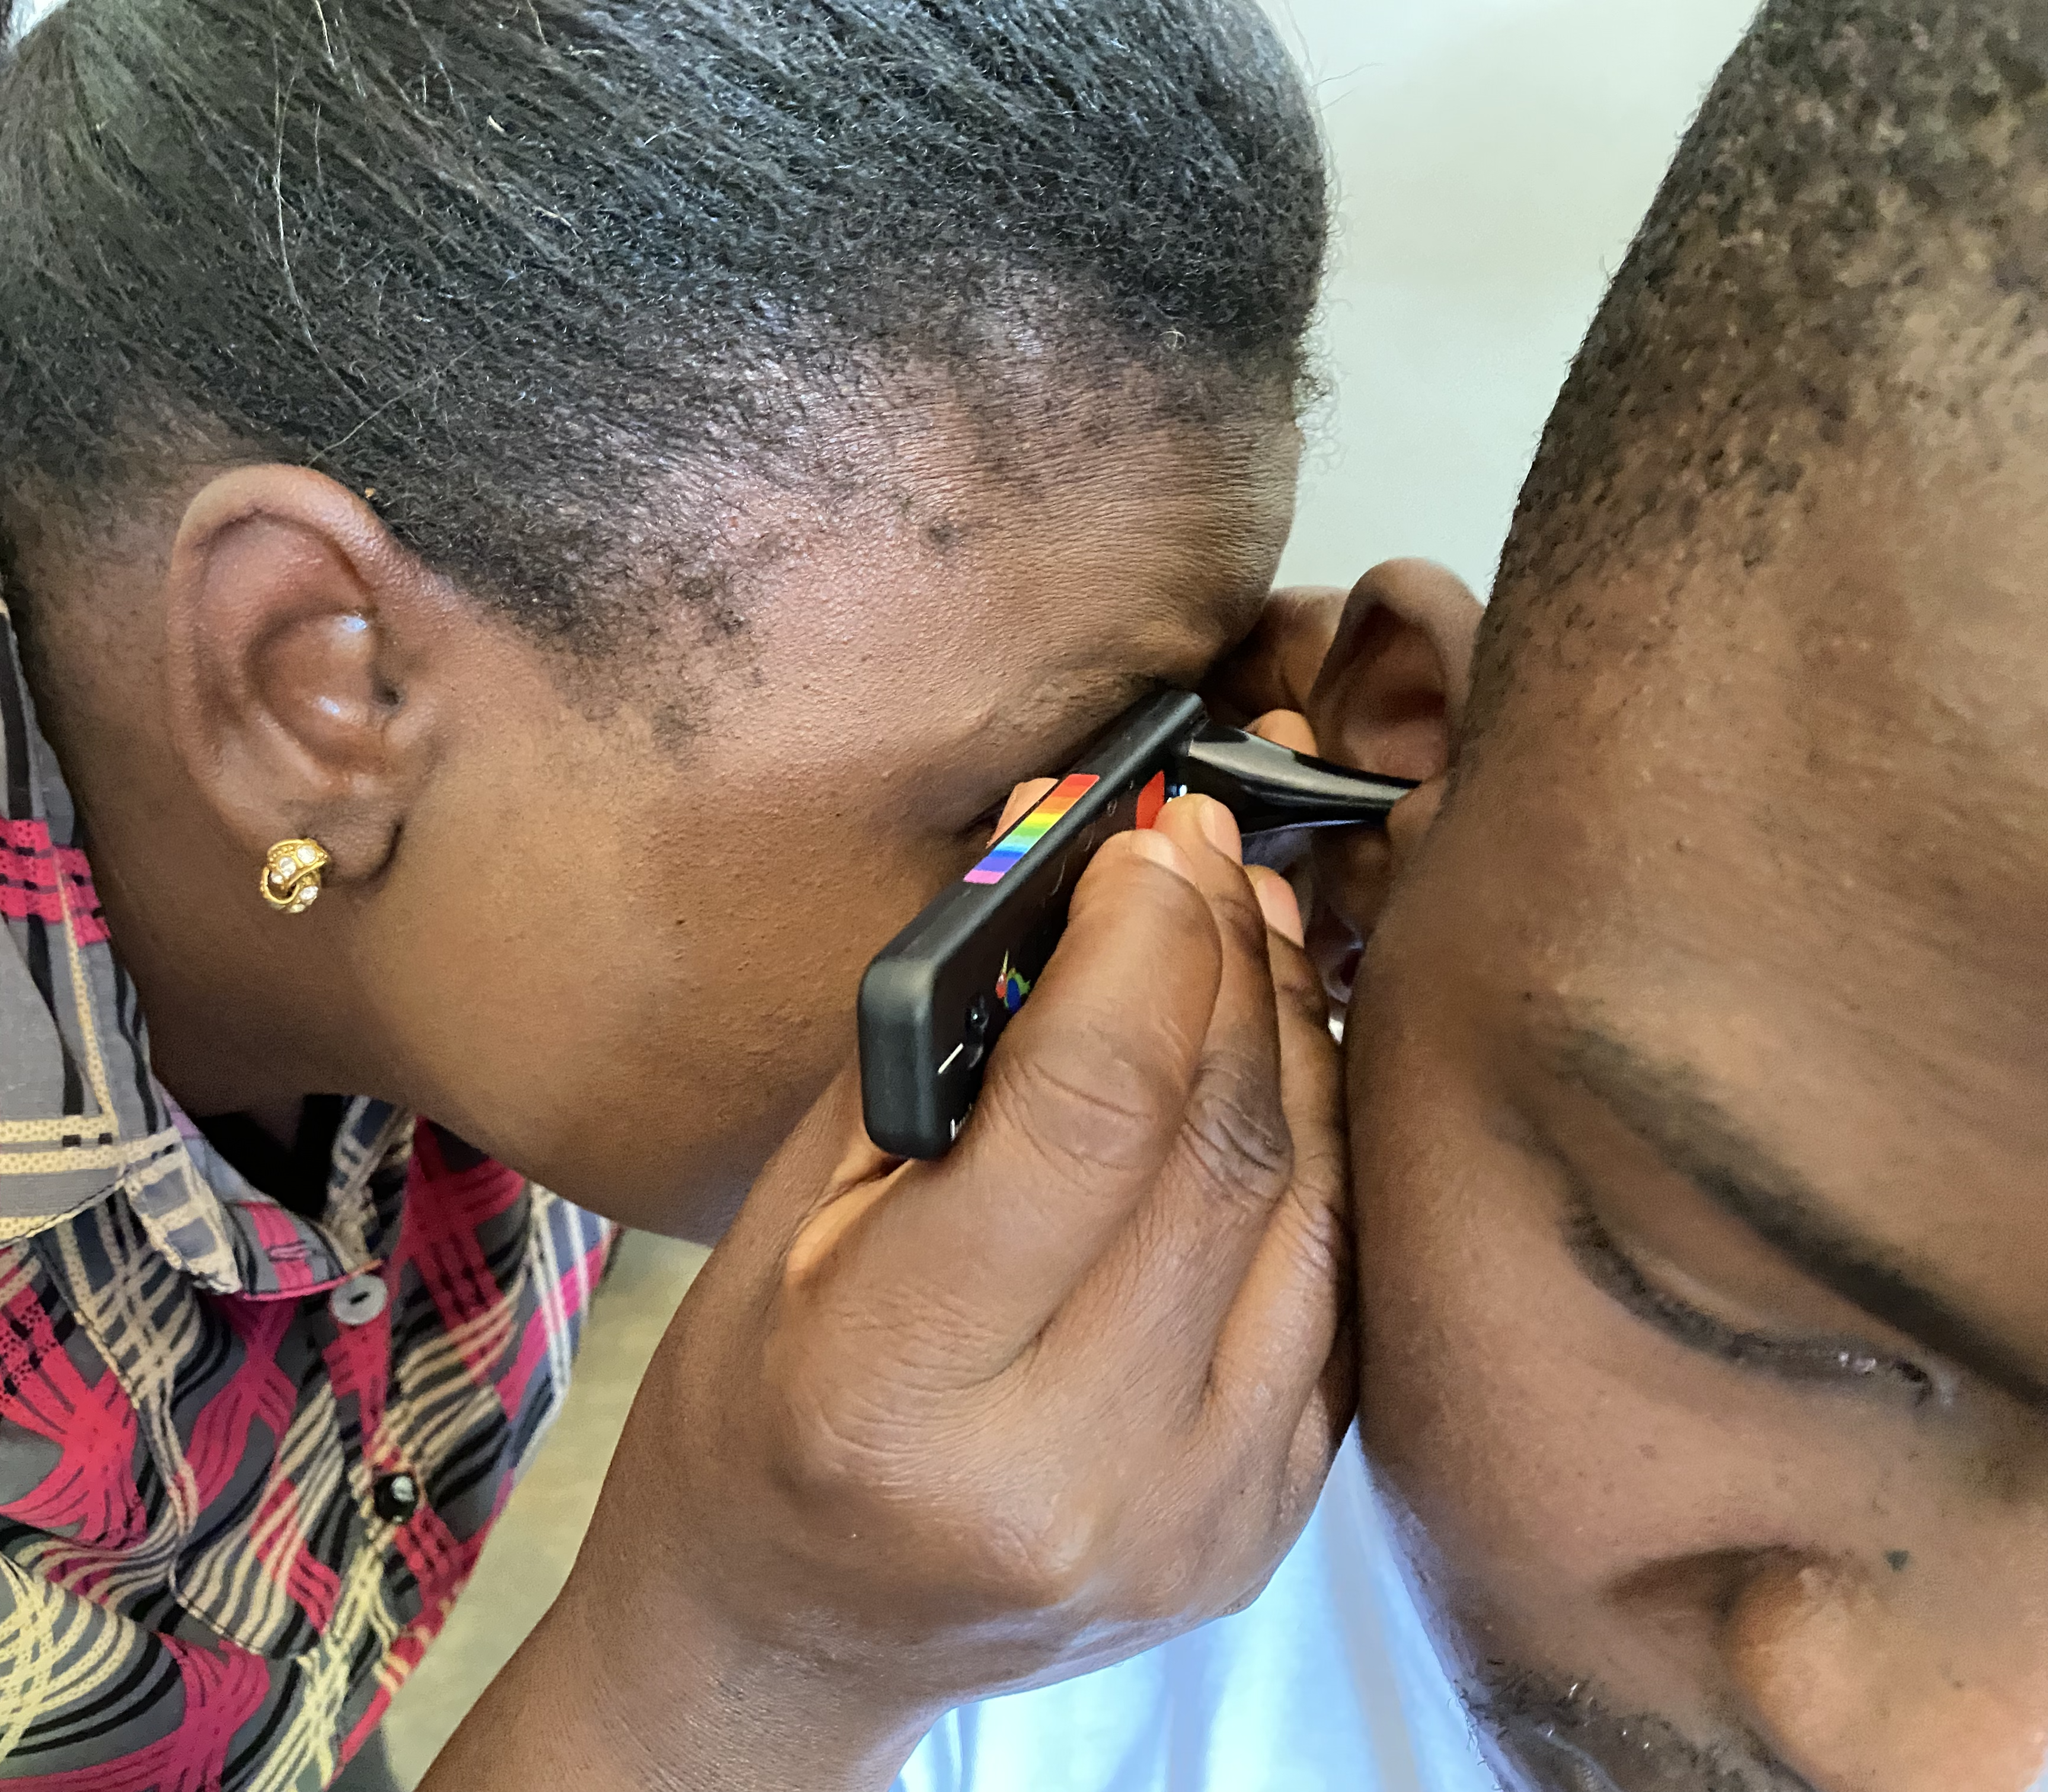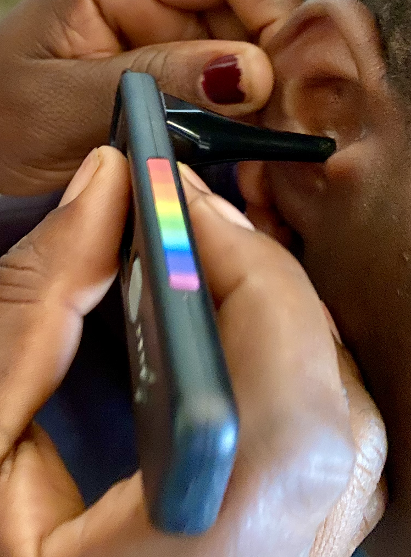

WHO-Aligned Training

Development of the Arclight otoscope and training materials align with the World Health Organisation (WHO) training materials. The device is highlighted in both the online TAP ear and hearing care modules as well as the ENT Training Manual, supporting integrated primary care globally.
https://whoacademy.org/coursewares/vision-hearing-screening-en?source=gateway&org=TAP&from=learning-space



https://www.who.int/publications/i/item/9789240069589


Training Resources

We have created a number of training resources to support effective implementation:
- Instructional otoscopy video.
- Simulation Ears
- Universal otoscopy handout
- Video Otoscopy
Instructional Video
https://drive.google.com/file/d/1xeM811Isb1uqT8pygt7UttT_Q9Wn76-f/view?usp=sharing
Universal Handout
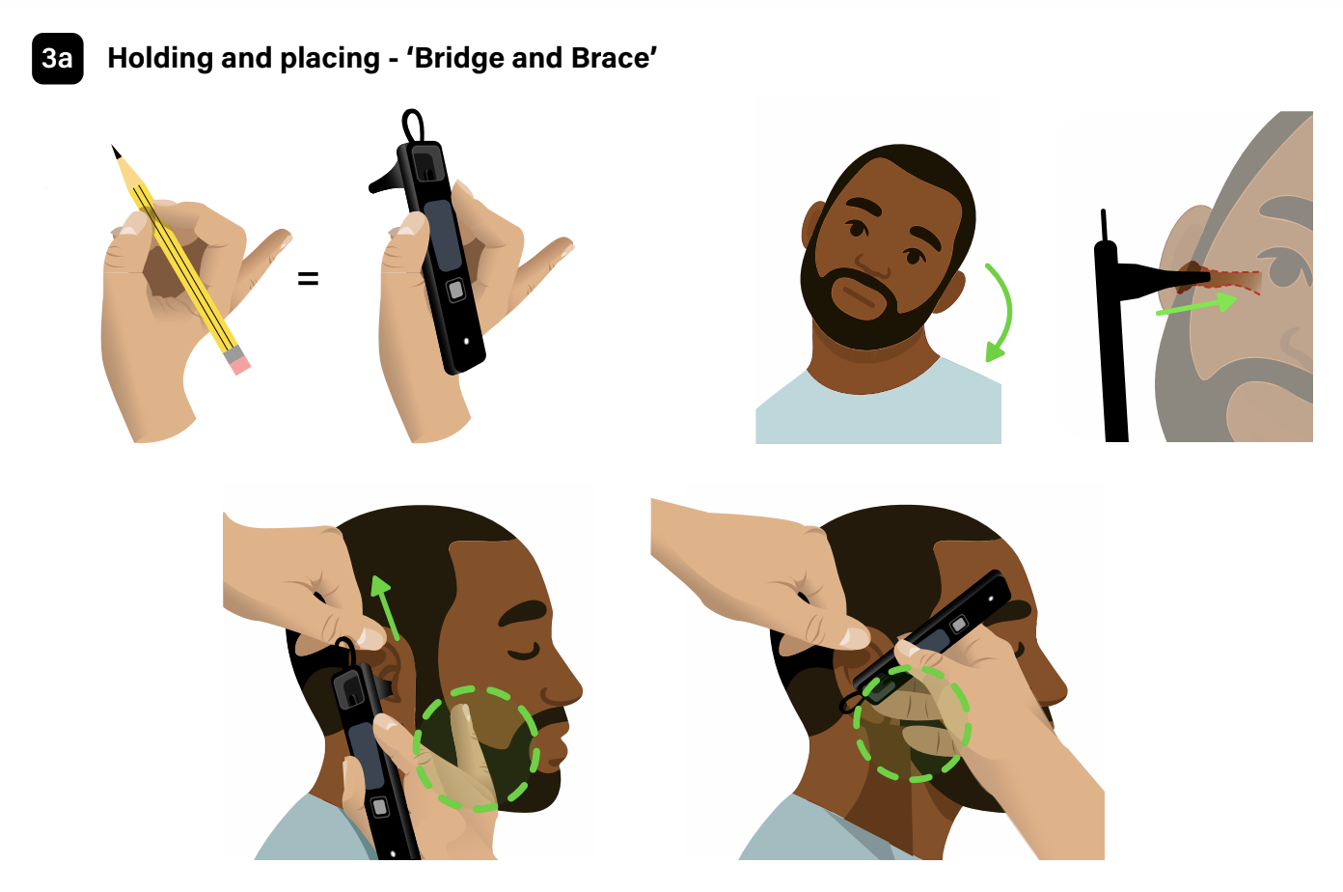
https://drive.google.com/file/d/1LRiwOOzXQw2FBoA8dyTRxrCwWdUveUab/view?usp=sharing
Simulation Ear
We have created a highly realistic simulation ear to train and test participants in workshops.

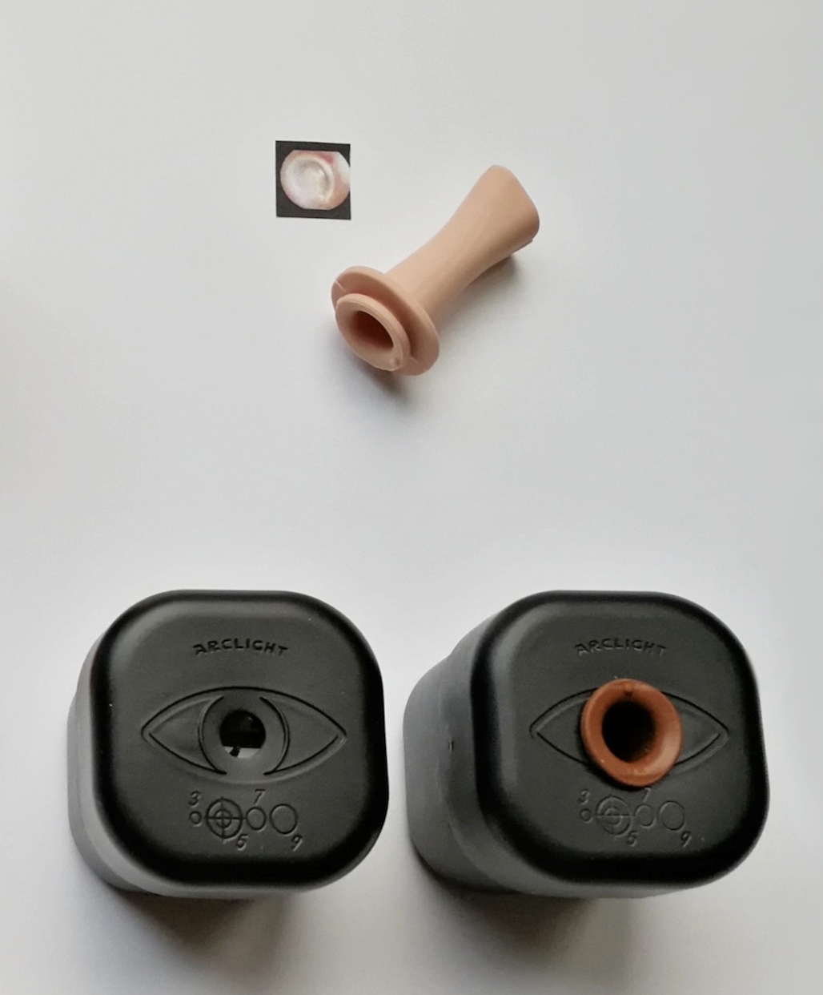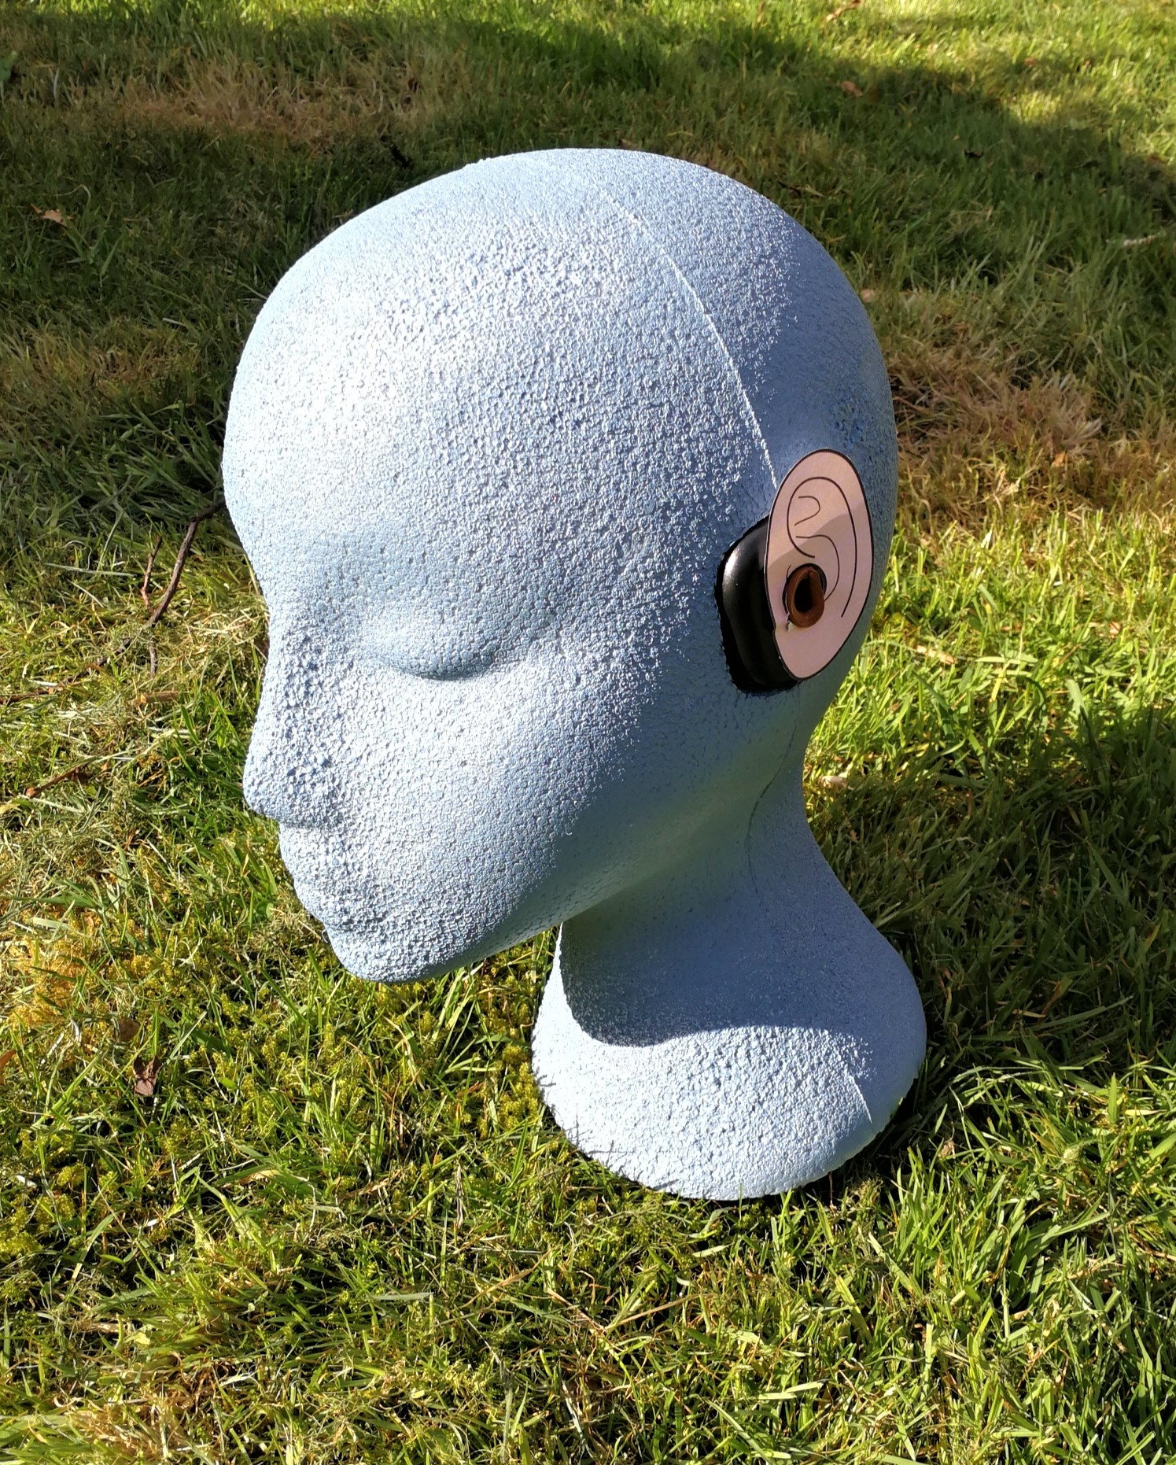
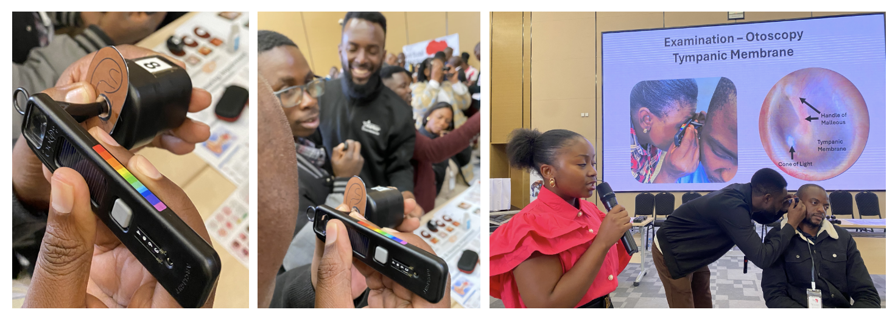
The simulation ear has a range of tympanic membrane options to train then test.
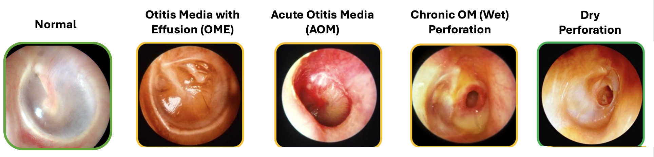
Video Otoscopy
The Arclight Otoscope is unique in being easily attached to the camera of a mobile phone to acquire video of the ear canal and tympanic membrane for teaching and telemedicine.
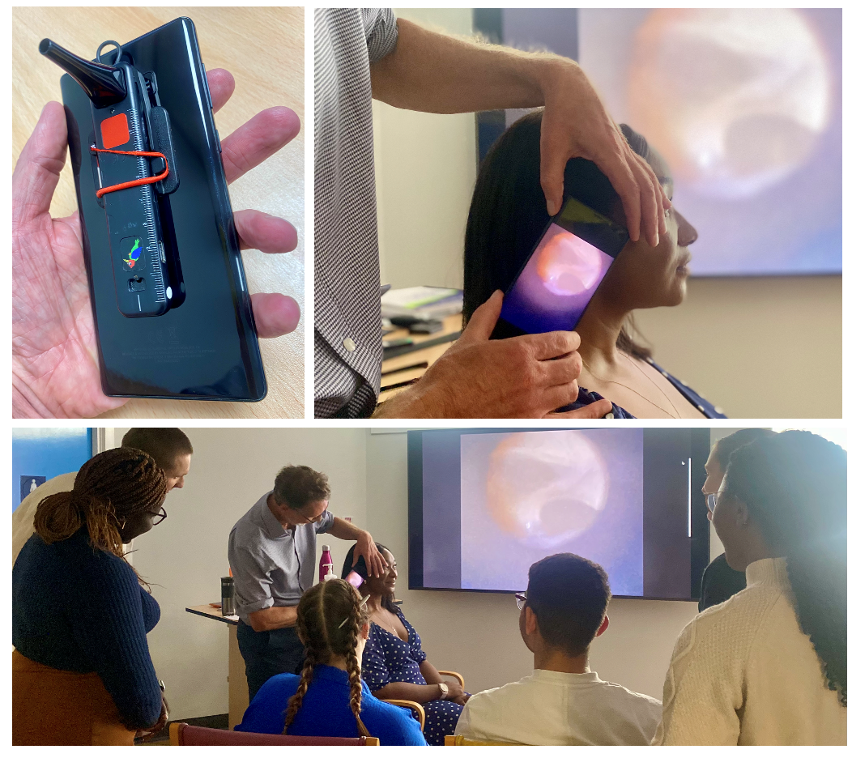

Research
A growing evidence base supports the Arclight otoscope and its widespread implementation. See the Research pages for more on the clinical validation and evidence of the Arclight device.
https://medicine.st-andrews.ac.uk/arclight/research/otoscopy/

