**Homework 1 - PPP Report**

**COSE242(00) – Data Communications**

**Module Leader: 민성기 교수님**



**Date: 2017/11/03**

**Student Number : 2016320256**

**Data Communications Homework #1**

Screenshots

Default option:

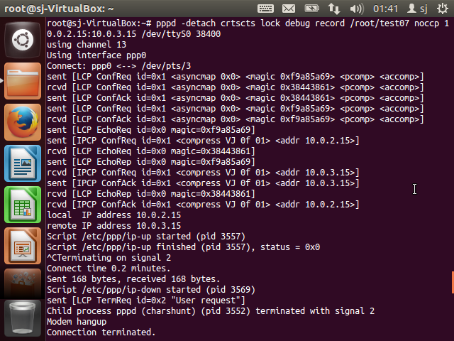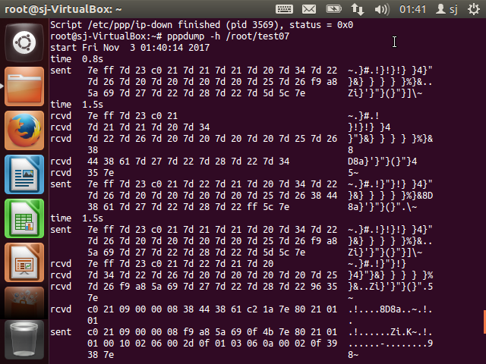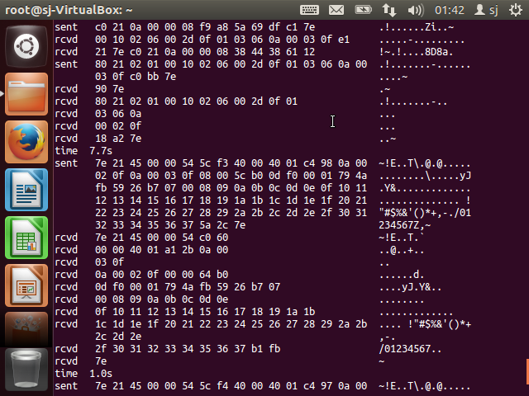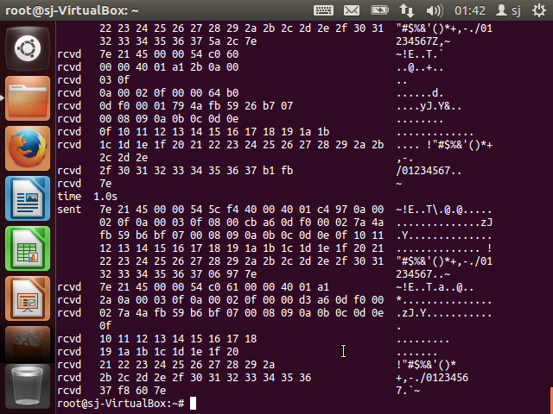

noaccomp, nopcomp, asyncmap 0xffffffff option:

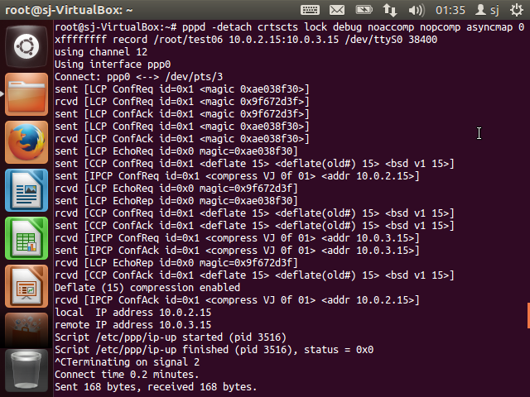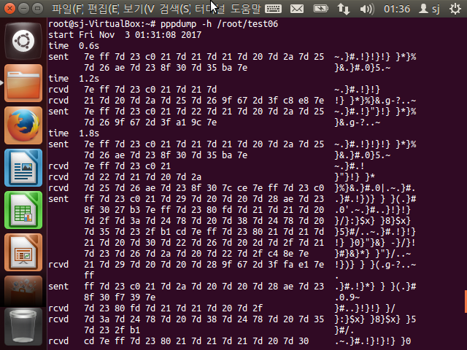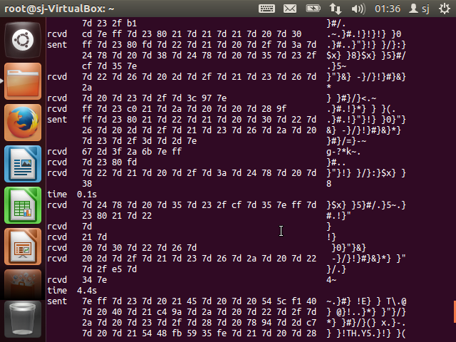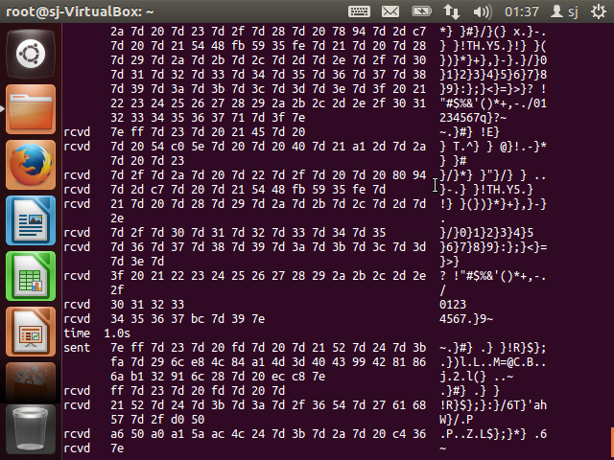

**Report**

PPP frame exchange order with reference to RFC documents

In the RFC 1661 document PPP stands for Point-to-Point Protocol which helps transport multi-protocol datagrams over point-to-point links. There are three main components in the PPP:

1. Encapsulation
2. Link Control Protocol (LCP)
3. Network Control Protocol (NCP)

The first component is encapsulating multi-protocol diagrams, the second component is a Link Control Protocol (LCP) for establishing, configuring and testing the data-link connection and the last component is a family of Network Control Protocols (NCPs) to establish and configure different network-layer protocols.

Encapsulation helps different protocols at the network layer can be supported simultaneously. Data is sent in frames which are the unit of transmission at the data link layer. The frame structure in PPP is shown below:

+----------+----------+----------+

| Flag | Address | Control |

| 01111110 | 11111111 | 00000011 |

+----------+----------+----------+

+----------+-------------+---------+

| Protocol | Information | Padding |

| 8/16 bits| * | * |

+----------+-------------+---------+

+----------+----------+-----------------

| FCS | Flag | Inter-frame Fill

|16/32 bits| 01111110 | or next Address

+----------+----------+-----------------

Each frame begins and ends with a Flag Sequence – 01111110 for binary and 0x7e for hexadecimal. All implementations and configurations check for this flag to synchronize.

Point-to-Point Protocol is for transporting packets between two peers. A simplified state diagram is shown below:

+------+ +-----------+ +--------------+

| | UP | | OPENED | | SUCCESS/NONE

| Dead |------->| Establish |---------->| Authenticate |--+

| | | | | | |

+------+ +-----------+ +--------------+ |

^ | | |

| FAIL | FAIL | |

+<--------------+ +----------+ |

| | |

| +-----------+ | +---------+ |

| DOWN | | | CLOSING | | |

+------------| Terminate |<---+<----------| Network |<-+

| | | |

+-----------+ +---------+

There are five phases shown in the diagram above. The Link Dead phase is where the link starts and stops. When a signal is detected the link will go to the next phase.

After the presence of another peer is detected the link is in the Link Establishment phase. For this point-to-point link to be established, both ends of the PPP link must send LCP packets by exchange configuration packets to configure and test the data link. After the configuration is consented Configure-Ack packets are sent and received. A Configure-Ack packet is in the format

0 1 2 3

0 1 2 3 4 5 6 7 8 9 0 1 2 3 4 5 6 7 8 9 0 1 2 3 4 5 6 7 8 9 0 1

+-+-+-+-+-+-+-+-+-+-+-+-+-+-+-+-+-+-+-+-+-+-+-+-+-+-+-+-+-+-+-+-+

| Code | Identifier | Length |

+-+-+-+-+-+-+-+-+-+-+-+-+-+-+-+-+-+-+-+-+-+-+-+-+-+-+-+-+-+-+-+-+

| Options ...

+-+-+-+-+

where the fields are transmitted from left to right. The configurations are in the default values unless instructed otherwise by the configuration exchange.

The authentication phase is optional. After establishing the link, it can then be authenticated. After successful authentication, this link will remain open until instructed to terminate.

Analyze pppdump output

When looking at my screenshots of the PPP frame analysis in the dump file output using the pppdump utility, you can notice the abundance of Flag Sequence. 7e appears at the start and end of the frames in order flag synchronization.

Most of my frames start with 7e ff 7d 23 c0 21 sequence in my screenshots to show that the control field byte escaped with an XOR. Also, this data frame has a value of 0x21 in the Protocol field, indicating it is an IP datagram.



The data frame after this sequence is the information then followed by the frame check sequence and finally the flag sequence (0x7e) again.