**Homework 2 - PPPoE Report**

**COSE242(00) – Data Communications**

**Module Leader: 민성기 교수님**



**Date: 2017/12/01**

**Student Number : 2016320256**

**Data Communications Homework #2**

PPP over Ethernet operation

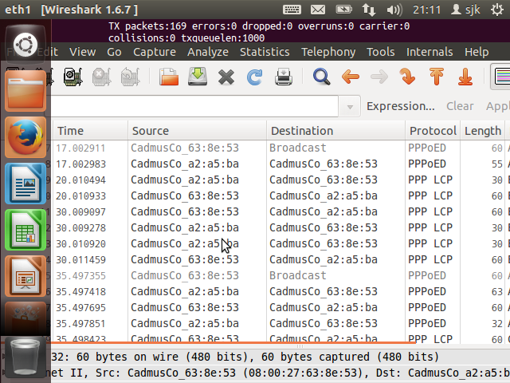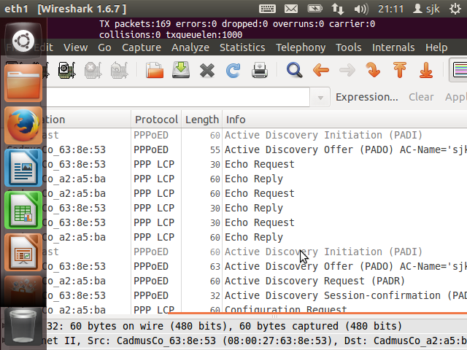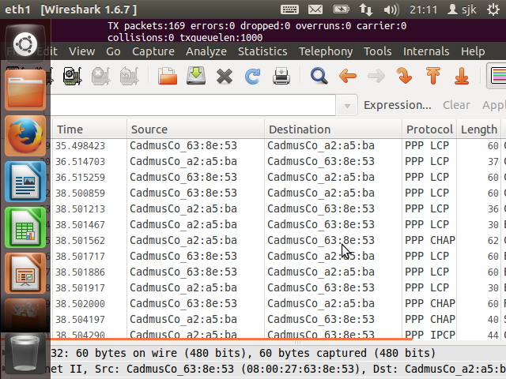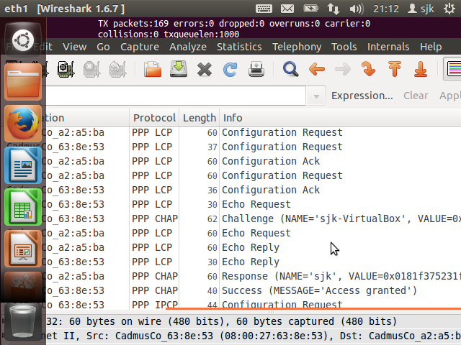

PPPoE is a network configuration used for establishing Point To Point Protocol connection over an Ethernet protocol. This means there is a point to point connection between two Ethernet ports. We set up the PPP connection and use it as a dial up connection between points on the network.

Here we see the initiation process as the client sends a PPPoE Active Discovery Initiation (PADI) packet to the server to initiate the session.

The server responds with a PPPoE Active Discovery Offer (PADO) packet.

Eventually the client responds with PPPoE Active Discovery Request (PADR) packet to the server. Finally we get the Active Discovery Session (PADS) confirmation and get prompted on the VM2 for the username and password we initially set in VM1.

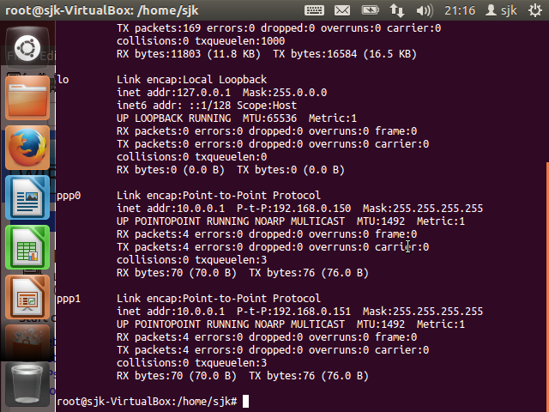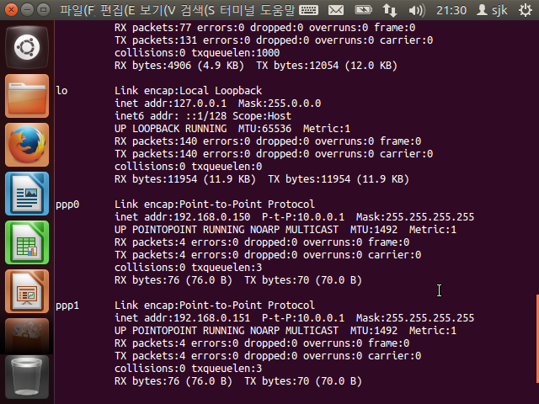

Here we can see the Point-to-Point Protocols set up on both VM1 (left) and VM2 (right).

1차 과제의 PPP와 여기서의 PPP connection frame 간의 차이점 기술

The connection frame from assignment one operates at the data link layer. In this assignment we see a point to point protocol set up which will operated at both the layer 2 and layer 3 which is the network layer.

Also in this assignment we can see that the PPP connection frame needs authentication, while the PPP in the previous assignment does not.

Ping sent from VM2 to VM1

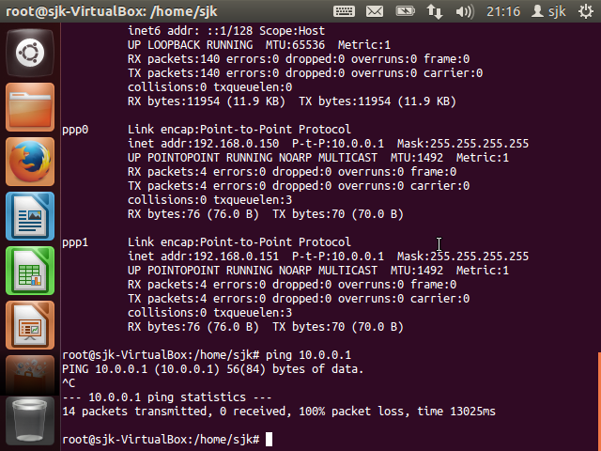

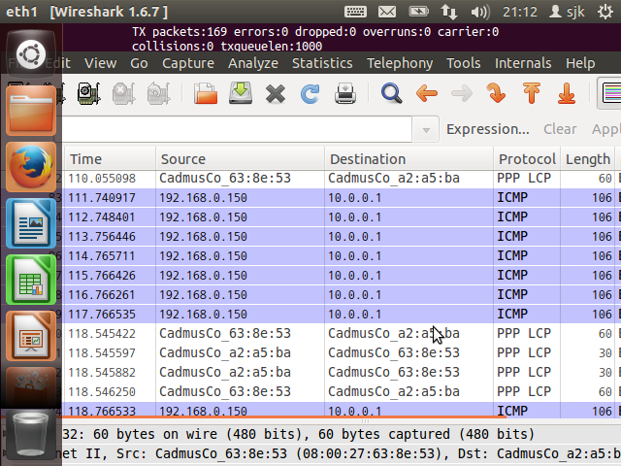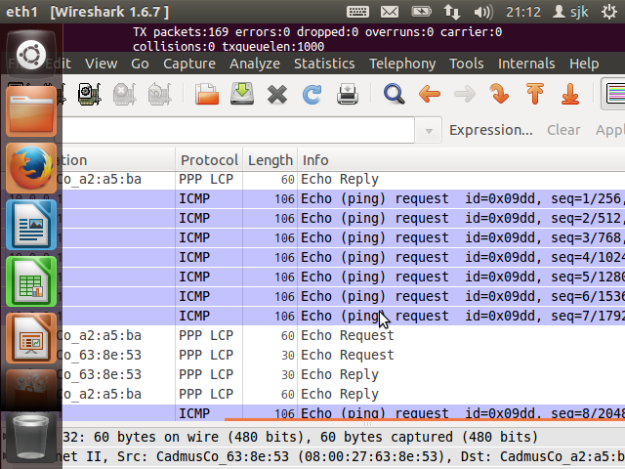

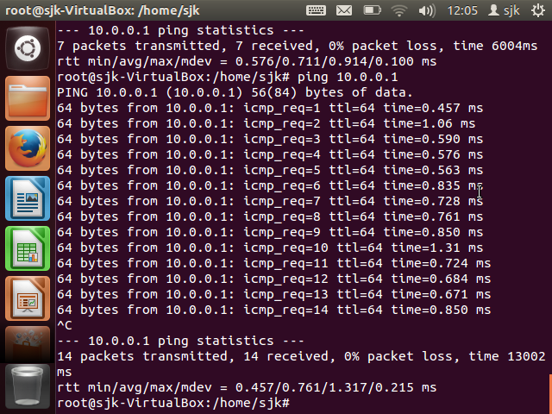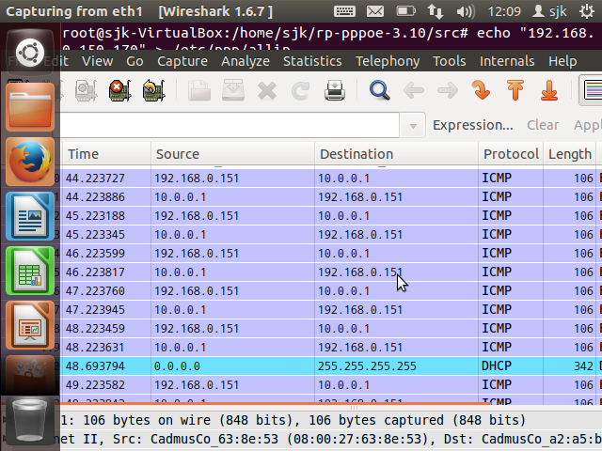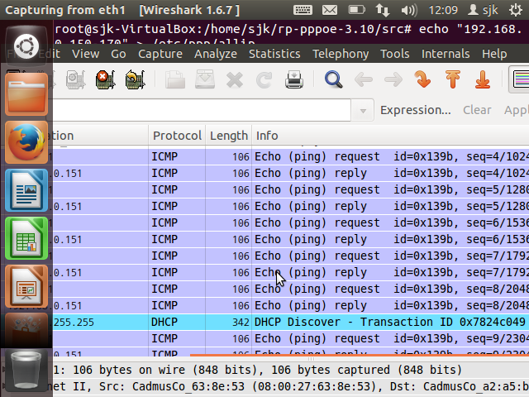

Here we can see the packets being transmitted and received very clearly. The previous assignment is not as profound. In addition, we see the exact percentage of packet loss.

VM1 <-> VM3 ping

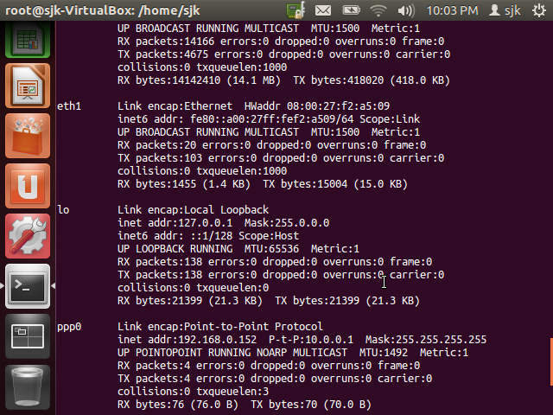

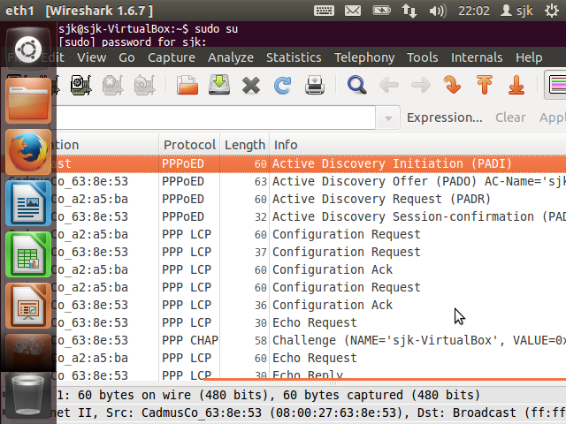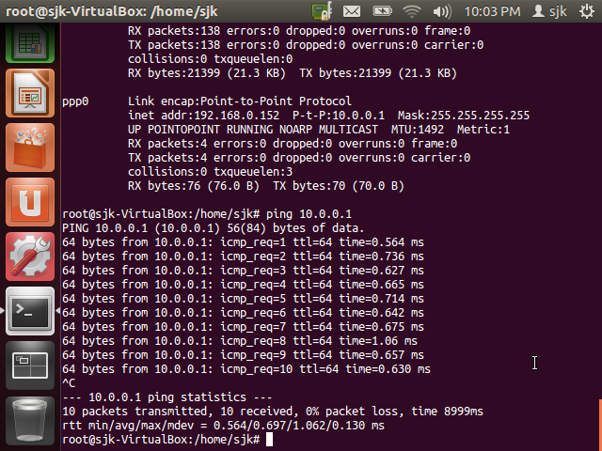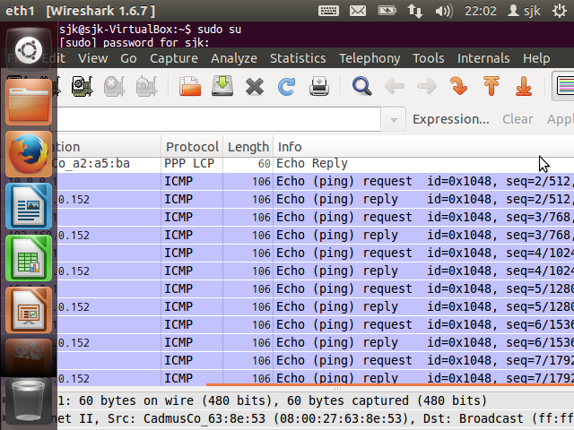

Here we see another Point to Point protocol being set up between VM1 and VM3. We see the initiation process of PADI, PADO, PADR, PADS to finish establishing this ppp connection.

VM2 <-> VM3 (no ppp connection) ping