**The Beatles**

**History**

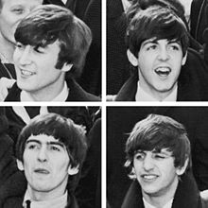The Beatles were an English rock band, formed in Liverpool in 1960, who became one of the most commercially successful and critically acclaimed acts in the history of popular music. In their heyday the group consisted of John Lennon (rhythm guitar, vocals), Paul McCartney (bass guitar, vocals), George Harrison (lead guitar, vocals) and Ringo Starr (drums, vocals). Rooted in skiffle and 1950s rock and roll, the group later worked in many genres ranging from folk rock to psychedelic pop, often incorporating classical and other elements in innovative ways. The nature of their enormous popularity, which first emerged as the "Beatlemania" fad, transformed as their song writing grew in sophistication. The group came to be perceived as the embodiment of progressive ideals, seeing their influence extend into the social and cultural revolutions of the 1960s.

**Formation and early years (1957–1962)**

Aged sixteen, singer and guitarist John Lennon formed the skiffle group The Quarrymen with some Liverpool school friends in March 1957. Fifteen-year-old Paul McCartney joined as a guitarist after he and Lennon met that July. When McCartney in turn invited George Harrison to watch the group the following February, the fourteen-year-old joined as lead guitarist. By 1960 Lennon's school friends had left the group, he had begun studies at the Liverpool College of Art and the three guitarists were playing rock and roll whenever they could get a drummer.

**Beatlemania and touring years (1963–66)**

**UK popularity, Please Please Me and With The Beatles**

In the wake of the moderate success of "Love Me Do", "Please Please Me" met with a more emphatic reception, reaching number two in the UK singles chart after its January 1963 release. Martin originally intended to record the band's debut LP live at The Cavern Club. Finding it had "the acoustic ambience of an oil tank", he elected to create a "live" album in one session at Abbey Road Studios.

**The British Invasion**

Beatles releases in the United States were initially delayed for nearly a year when Capitol Records, EMI's American subsidiary, declined to issue either "Please Please Me" or "From Me to You". Negotiations with independent US labels led to the release of some singles, but issues with royalties and derision of 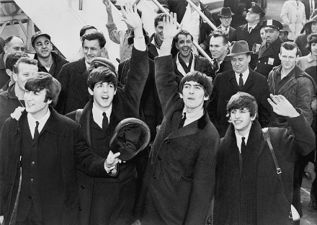The Beatles' "moptop" hairstyle posed further obstacles. Once Capitol did start to issue the material, rather than releasing the LPs in their original configuration, they compiled distinct US albums from an assortment of the band's recordings, and issued songs of their own choice as singles.

**Musical style and evolution**

**Influences**

The band's earliest influences include Elvis Presley, Little Richard and Chuck Berry, whose songs they covered more often than any other artist's in performances throughout their career. During their co-residency with Little Richard at the Star Club in Hamburg from April to May 1962, he advised them on the proper technique for performing his songs. Of Presley, Lennon said, "Nothing really affected me until I heard Elvis. If there hadn't been Elvis, there would not have been The Beatles". Other early influences include Buddy Holly, Eddie Cochran, Carl Perkins and Roy Orbison. The Beatles continued to absorb influences long after their initial success, often finding new musical and lyrical avenues by listening to their contemporaries, including Bob Dylan, Frank Zappa, The Byrds and The Beach Boys, whose 1966 album Pet Sounds amazed and inspired McCartney. Martin stated, "Without Pet Sounds, Sgt. Pepper wouldn't have happened... Pepper was an attempt to equal Pet Sounds."

**Genres**

Originating as a skiffle group, The Beatles soon embraced 1950s rock and roll. The band's repertoire ultimately expanded to include a broad variety of pop music. Reflecting the range of styles they explored, Lennon said of Beatles for Sale, "You could call our new one a Beatles country-and-western LP", while Allmusic credits the band, and Rubber Soul in particular, as a major influence on the folk rock movement. Beginning with the use of a string quartet on Help!'s "Yesterday", they also incorporated classical music elements. As Jonathan Gould points out however, it was not "even remotely the first pop record to make prominent use of strings—although it was the first Beatles recording to do so ... it was rather that the more traditional sound of strings allowed for a fresh appreciation of their talent as composers by listeners who were otherwise allergic to the din of drums and electric guitars." The group applied strings to various effect. Of "She's Leaving Home", for instance, recorded for Sgt. Pepper, Gould writes that it "is cast in the mold of a sentimental Victorian ballad, its words and music filled with the clichés of musical melodrama."

**Contribution of George Martin**

George Martin's close involvement with The Beatles in his role as producer made him one of the leading candidates for the informal title of "fifth Beatle". He brought his classical musical training to bear in various ways. The string quartet accompaniment to "Yesterday" was his idea—the band members were initially unenthusiastic about the concept, but the result was a revelation to them. Gould also describes how, "as Lennon and McCartney became progressively more ambitious in their songwriting, Martin began to function as an informal music teacher to them". This, coupled with his willingness to experiment in response to their suggestions—such as adding "something baroque" to a particular recording—facilitated their creative development. As well as scoring orchestral arrangements for Beatles recordings, Martin often performed, playing instruments including piano, organ and brass.

**In the studio**

The Beatles made innovative use of technology, treating the studio as an instrument in itself. They urged experimentation by Martin and their recording engineers, regularly demanding that something new be tried because "it might just sound good".

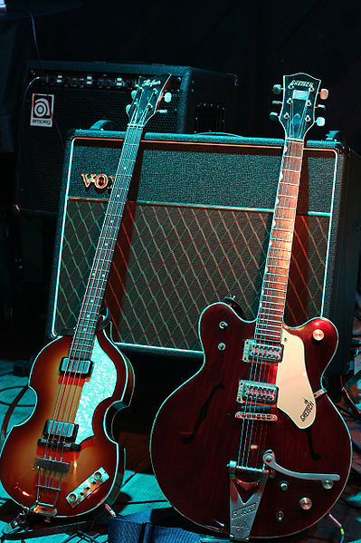**Instruments**

Many of the Beatles could play more than one instrument.

This photograph shows Paul McCartney's 4-stringed sunburst bass guitar on the left, and George Harrison's 6-string red guitar on the right.

The album "Help!" saw the band making increased use of vocal overdubs and incorporating classical instruments into their arrangements, notably the string quartet on the pop ballad "Yesterday".

**The Beatles and their instruments**

**Member Main instrument Other instruments**

**John Lennon** Guitar, piano Harmonica

**Paul McCartney** Bass Guitar, piano

**George Harrison** Guitar Bass, sitar, ukulele

**Ringo Starr** Drums Guitar, piano

**Members**

- John Lennon (born 9 October 1940, Liverpool, England)

- Paul McCartney (born 18 June 1942, Liverpool, England)

- George Harrison (born 25 February 1943, Liverpool, England)

- Ringo Starr (born 7 July 1940, Liverpool, England)

**Languages**

The Beatles sometimes used languages other than English in their songs. For example, the lyrics for Paul's song "Michelle" include the phrase, "sont des mots qui vont très bien ensemble". That phrase means, "are words that go together well."

**Website**

The Beatles' official website has more than 8,000 webpages. Go to http://www.thebeatles.com/ to see the website.

**Albums**

1. Please Please Me (1963)

2. With The Beatles (1963)

3. A Hard Day's Night (1964)

4. Beatles for Sale (1964)

5. Help! (1965)

6. Rubber Soul (1965)

7. Revolver (1966)

8. Sgt. Pepper's Lonely Hearts Club Band (1967)

9. The Beatles (aka White Album) (1968)

10. Yellow Submarine (1969)

11. Abbey Road (1969)

12. Let It Be (1970)