NITTE MEENAKSHI INSTITUTE OF TECHNOLOGY
Department of Electronics and Communication Engineering

OBJECT-ORIENTED PROGRAMMING USING C++ LAB
TASK 1 REPORT (WEEKS 1–6)
Submission deadline: 16 October 2026
Student Name | S J KEERTHANA
USN | NB25ECE153
Section / Batch | Batch C1
Task Title / Problem Statement | Implement a Student class using encapsulation, constructor, overloaded functions, static member, friend function and overloaded > operator to compare students based on their marks
GitHub Repository URL | https://github.com/sjkeerthana-10?tab=repositories

1. Aim / Objective
To implement a Student class in C++ that demonstrates encapsulation, a parameterized constructor, function overloading, a static member to count students, a friend function, and an overloaded > operator to compare students based on their marks.

2. Problem Statement
Design and implement a Student class that stores student details (name, USN, marks). The class should:
- Use encapsulation to protect the data (private members, public methods).
- Include a parameterized constructor.
- Include overloaded member functions.
- Maintain a static member to count the number of students created.
- Provide a friend function that can access private data.
- Overload the > operator to compare students based on marks.

3. Concepts Used
- Classes and Objects
- Encapsulation (private data members, public methods)
- Parameterized Constructor, Copy Constructor and Destructor
- Function Overloading (display, setMarks)
- Static Data Member and Static Member Function
- Friend Function
- Operator Overloading (>)
- Dynamic Memory Allocation (new / delete)

4. Algorithm / Steps
- Define a Student class with private attributes: name, usn, marks and a static member studentCount.
- Create a parameterized constructor to initialize the details and increase studentCount; the destructor decreases it.
- Write overloaded functions: display() / display(bool) and setMarks(float) / setMarks(float, float, float).
- Implement a friend function showPercentage() to access the private marks.
- Overload the > operator to compare two students based on marks.
- In main(), create multiple student objects, display their details, and call the overloaded functions.
- Compare students using >, print the student count, and create/delete one object dynamically with new and delete.

5. Source Code
#include <iostream>
#include <string>
using namespace std;

class Student {
private:
int id;
string fullName;
double percentage;
static int totalStudents;

public:

Student()
: id(0), fullName("Not Assigned"), percentage(0.0) {
++totalStudents;
}

Student(int i, const string& n, double p)
: id(i), fullName(n), percentage(p) {
++totalStudents;
}

~Student() {
--totalStudents;
}

void update(double p) {
percentage = p;
}

void update(const string& n) {
fullName = n;
}

void update(int i, const string& n, double p) {
id = i;
fullName = n;
percentage = p;
}

void show() const {
cout << "ID: " << id
<< " | Name: " << fullName
<< " | Percentage: " << percentage << "%"
<< endl;
}

const string& getName() const {
return fullName;
}

static int getTotalStudents() {
return totalStudents;
}

friend void printGrade(const Student& s);

bool operator>(const Student& other) const {
return percentage > other.percentage;
}
};

int Student::totalStudents = 0;

void printGrade(const Student& s) {
char grade;

if (s.percentage >= 75)
grade = 'A';
else if (s.percentage >= 60)
grade = 'B';
else if (s.percentage >= 40)
grade = 'C';
else
grade = 'F';

cout << s.fullName << " -> Grade " << grade << endl;
}

int main() {
Student a(201, "Meera", 91.5);
Student b(202, "Kabir", 78.25);
Student c;

c.update(203, "Ishaan", 64.0);
c.update(58.0);
c.update("Ishaan Verma");

cout << "=== Student Records ===" << endl;
a.show();
b.show();
c.show();

cout << "\n=== Grades (Friend Function) ===" << endl;
printGrade(a);
printGrade(b);
printGrade(c);

cout << "\n=== Comparison (Operator Overloading) ===" << endl;
if (a > b)
cout << a.getName() << " scores higher than "
<< b.getName() << endl;
else
cout << b.getName() << " scores higher than or equal to "
<< a.getName() << endl;

cout << "\n=== Static Member ===" << endl;
cout << "Students currently alive: "
<< Student::getTotalStudents() << endl;

cout << "\n=== Dynamic Memory Management ===" << endl;

Student* d = new Student(204, "Ananya", 88.5);

cout << "Count after dynamic creation: "
<< Student::getTotalStudents() << endl;

d->show();

delete d;
d = nullptr;

cout << "Count after deletion: "
<< Student::getTotalStudents() << endl;

cout << "\n=== Final Student Count ===" << endl;
cout << "Students currently alive: "
<< Student::getTotalStudents() << endl;

return 0;
}

6. Compilation and Execution
Compiler / IDE used: g++ compiler (GCC) with Visual Studio Code
Compilation status: Successful

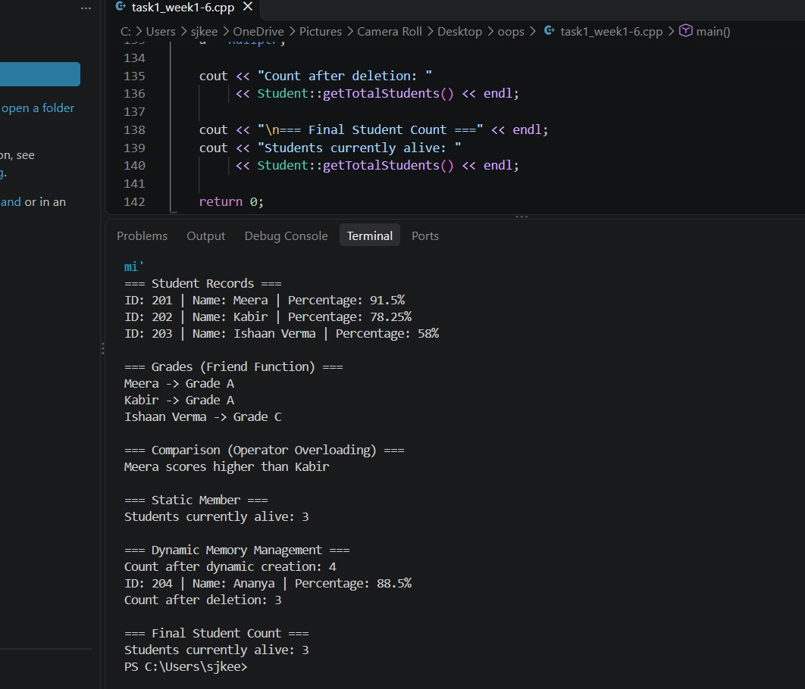

7. Output Screenshot(s)
[Insert clear screenshot(s) showing the program output. Add more if required.]

8. Result
The program compiled without errors or warnings and executed successfully. Four objects of the Student class were handled, the overloaded functions, friend function and overloaded > operator worked as expected, and the static counter correctly showed 3 students, 4 after dynamic allocation, and 3 again after delete.

9. Learning Outcome / Reflection
I learned how encapsulation protects data inside a class, how constructors and destructors manage the life of an object, and how a static member is shared by all objects. I also learned how a friend function can access private data and how operator overloading makes comparing objects as simple as comparing numbers. One issue I resolved was keeping the static student count correct: I added a copy constructor and a destructor so that the count stays right when objects are copied or deleted.
10. GitHub Submission Checklist ☐ Report prepared using this template
☐ Source code (.cpp) uploaded
☐ Output screenshot(s) uploaded
☐ Program compiled and executed successfully
☐ Files organized in the correct weekly/task repository
☐ GitHub repository URL included above
Student Declaration: I confirm that this report and program represent my own work.
Student Signature: ___KEERTHANA_S J______ Date: __16/10/26______________

