Operating Instructions for LB Five Feedings Machine

1. Functions and features of the machine
1) The five linkages mechanism and double enveloping worm gear transmission increase the arm’s travel speed， operation stability and productivity;
2) The machine is of one integrate box structure, which greatly improves the accuracy;
3) Arm forward/backward and fluid feeding/fetching of the machine are controlled by independent frequency converters, which improves the feeding speed and makes the operation easy;
4) The machine adopts linkage arm, which ensures the machine can be smoothly braked even at high speed, and the fluid aluminum does not easily overflow;
5) The machine uses the PLC control. The simple touch panel can set various functions, and it is easy to operate and can display fault code, which makes the repair easy.
2. Specification of the machine

Specification/Model |  | JSLB2 |  | JSLB4 | JSLB6 | JSLB8 | JSLBA | JSLBC
Applicable die-casting machine (unit：T) |  | 125～400 |  | 500～800 | 1000～1250 | 1600 | 2000～2250 | >3000T
Fluid feeding volume  (unit：Kg) |  | 1.0～3.5 |  | 3.5～6.0 | 8～15 | 12～20 | 15～25 | 25～35
Feeding precision |  | ±2%
Feeding speed  (Max) |  | 15sec |  | 18sec | 30sec | 35sec | 40sec | 50sce
Crucible’s inner diameter (Min) |  | 480mm |  | 550mm | 800mm | 850mm | 1000mm | 1100mm
Fetching depth  (Max) |  | 350mm |  | 450mm | 450mm | 450mm | 550mm | 650mm
Driving power | Arm | 750W 4P |  |  | 1.5KW 4P |  | 3.7KW 4P
Driving power | Ladle | 200W 4P |  |  | 400W 4P | 750W 4P
Main electric cabinet |  | 2Φ-380V 50-60Hz
Operating voltage |  | DC24V
Power capacity |  | 1.5 KVA |  |  | 3.0 KVA |  | 3.75 KVA
Weight of machine |  | 203KG | 214KG |  | 336KG | 510KG | 650KG | 700KG
3. Working principle and structural features (See the following diagrams.)
3.1 Working principle
After preheating the ladle, take the fluid with it. When it is the time to fetch the fluid, the arm rises to the material dropping position (The surplus melted aluminum drops to the furnace.). Until the dropping time is off, the ladle returns to its level position, and the arm moves forward to the forward limit and stops. After the die-casting machine completes the mould clamping, the fluid feeding signal is sent to the fluid fetching machine and feeding begins. After the fluid feeding is completed, injection delay time 1 begins to count. Until the time is over, the ladle begins to return to its level position and the injection delay time 2 begins to count. When the counting is over, injection signal will be sent to the die-casting machine and the arm retreats to the back low speed limit (i.e., furnace standby position). Then it begins to count the standby time, and the ladle rotates to the fluid cutting positions. When the standby time is over, the arm retreats to the fluid detection position and stops. Fluid fetching begins and enters the next cycle.
3.2 Structural features

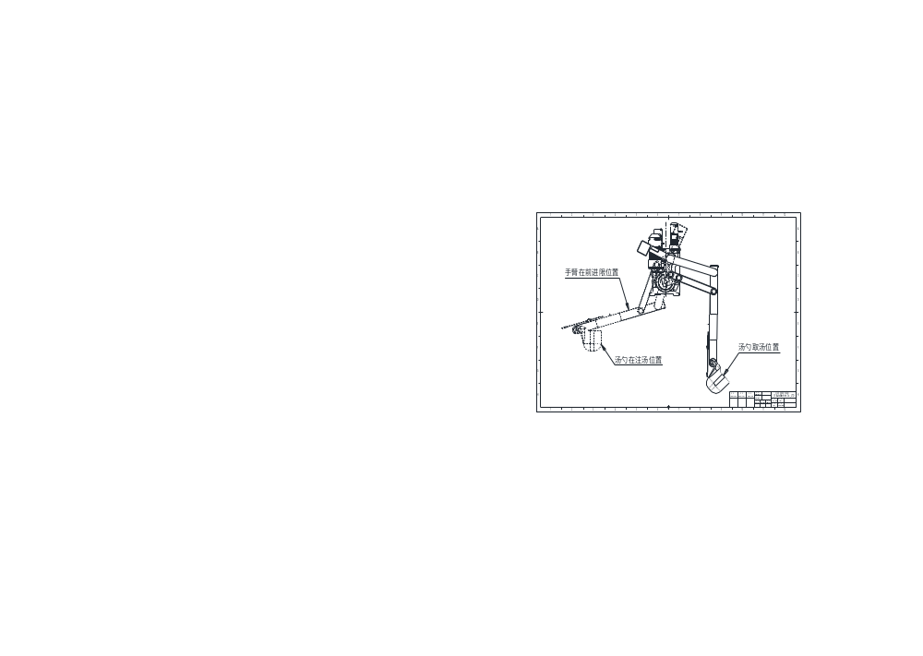
The arm is at the forward limit position.
The ladle is at the fluid feeding position.
Position of ladle taking fluid.

4. Quick-wear parts
1）Insulating piece and sense line
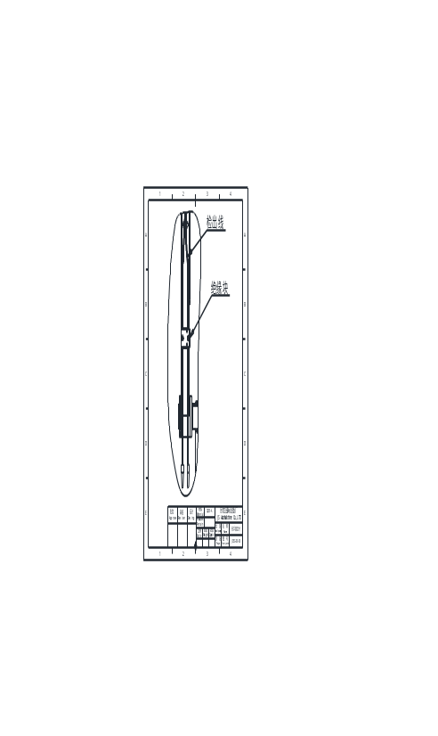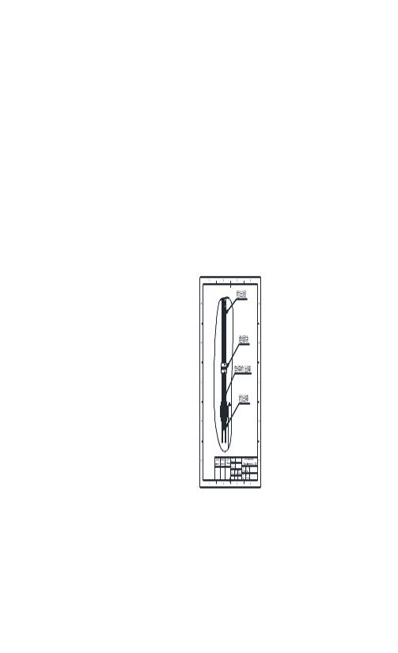
Sense line
Insulating piece
Emergency stop detection rod
Detection rod
Sense line
Insulating piece
2）fluid volume microswitch
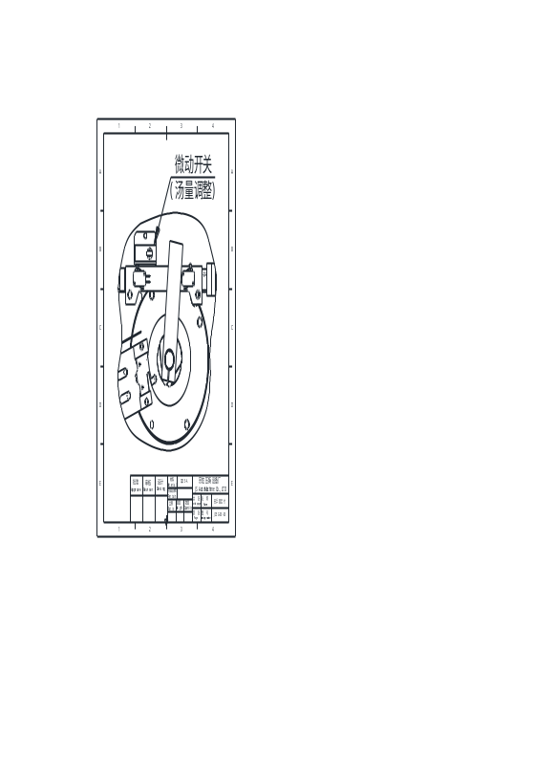
microswitch
(Fluid volume adjustment)

5. Lubrication of the machine
1) Please add the designated lubricating oil to the position of oil immersion lens. After the machine first works 300 hours, change the lubricating oil. Later replace the oil every 2500 hours;
2) Protect the shaft seal when cleaning and painting, so as to prevent the paint and solvents from infiltrating;
3) Check and replenish the lubricating oil regularly.
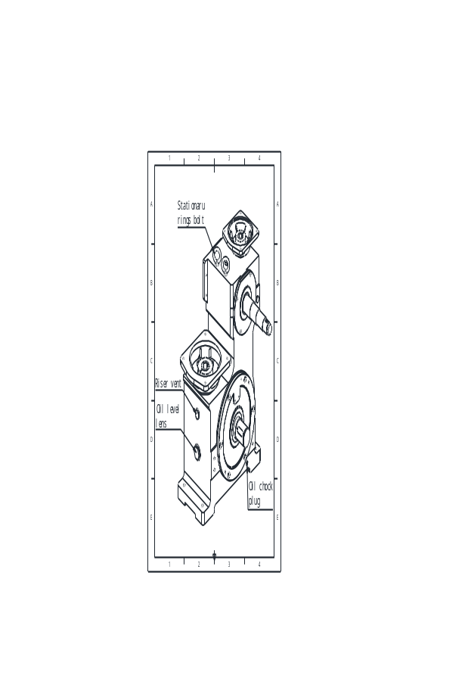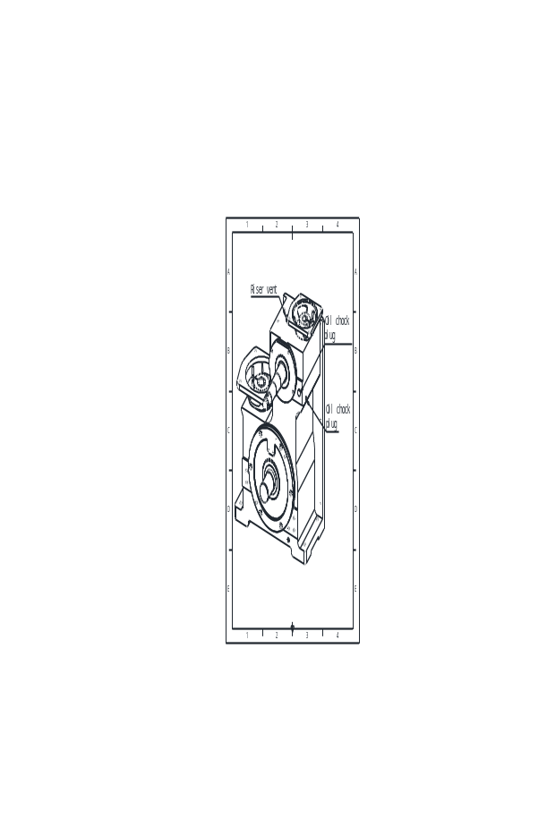

6. Installation, adjustment and test run of the machine
1) When the machine is to be lifted, the two eyebolts on the machine should be used;
2) Install the machine together with the lifting base, which can adjust the lifting height. After the adjustment is finished, fix the machine tightly with the screws;
3) Connect the electrical apparatus control system with the control system of the die-casting machine according to the requirements;
4) Debug and test run the machine. The debugging should be made under the manual mode. Only after the security is guaranteed can the automatic test run be performed.

7. General assembly drawing (with LB6 drawing as example)
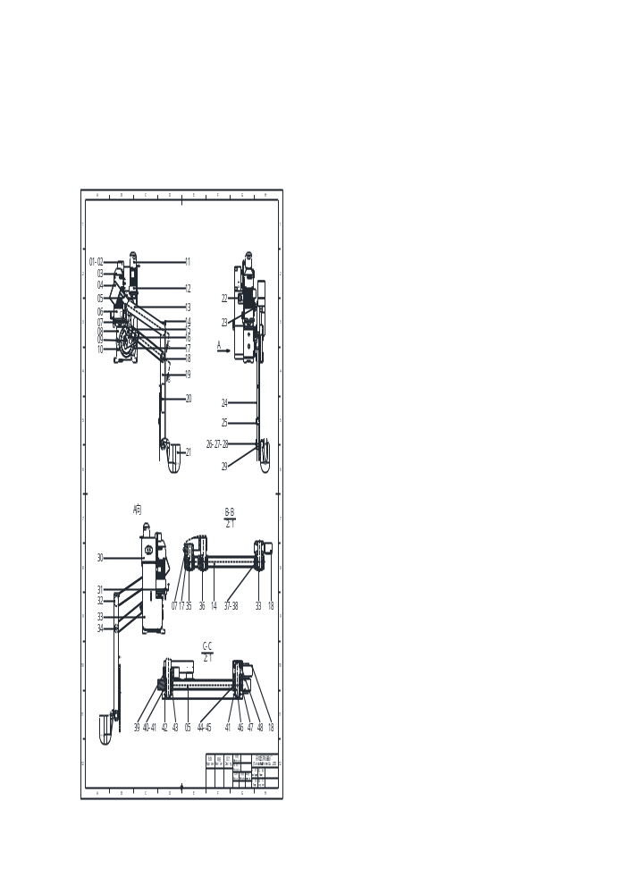
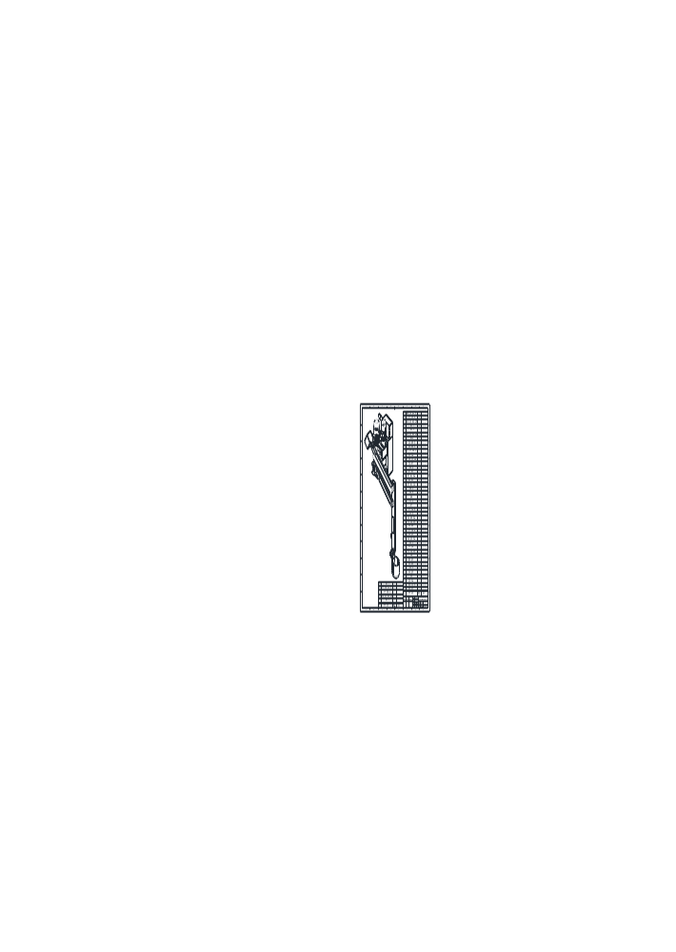
8. Diagram of installation dimension
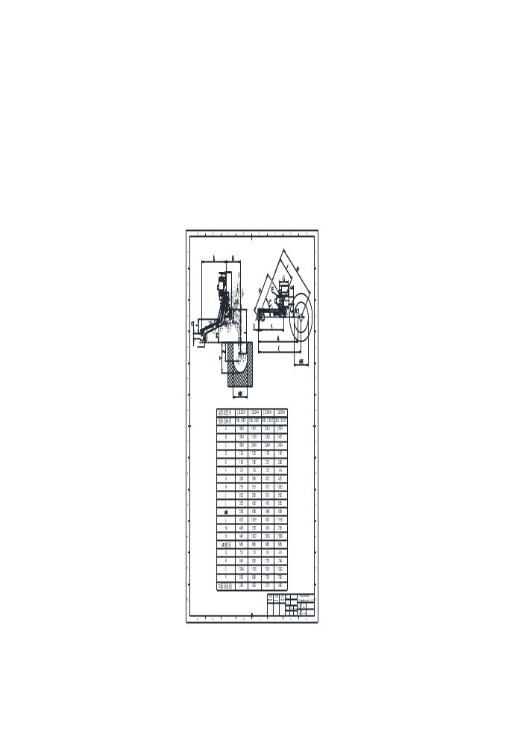
Model

