**Rich Voter, Poor Voter, Educated and Not: Education, Income and Redistribution in Canada**

Simon Kiss, Wilfrid Laurier University

Matthew Polacko, Université de Quebec á Montréal

Peter Graefe, McMaster University

*Abstract*

Piketty et al. have galvanized debates about the nature of class cleavages in advanced capitalist economies. They have argued, as have many political scientists before them, that the increasingly educated nature of left electorates have weakened impulses for redistribution.In contrast to most advanced democracies, class voting has largely been neglected in Canada, as it has traditionally been viewed as being comparatively weak in the face of strong linguistic, regional, and religious identities. UsingWe useUtilizing the entire series of the Canadian Election Study (1965–2019) and MARPOR data on party manifestos to apply the Piketty thesis to Canada.manifesto data, we find stronglink political demand with supply, to examine the education and income cleavages in Canada. We find significant support for a divergence between the effect that income and education have on party voting, as people with high incomes continue to vote for the right, while people with higher levels of education have shifted significantly to the left. However, we also find a strengthening class cleavage, whereby lower income individuals are increasingly supporting the New Democratic Party. Moreover, we show while the party system has gradually privileged saliency of the socio-cultural over the economic dimension, the Liberal Party stands out in adopting leftist policy offerings on the socio-cultural dimension, while remaining largely centrist on the economic dimension, which is out of sync with the economic preferences of its voters. The findings carry important implications for class-party relationships and reveal that Canada,despite a strengthening class cleavage, largely fits the mould of a multi-elite party system, which has weakened its focus on redistribution.

* Draft for the 2022 Canadian Political Science Association (held virtually May 30 to June 3) PLEASE DO NOT CITE OR SHARE WITHOUT THE PERMISSION OF THE AUTHORS

# INTRODUCTION

Studies of class voting in the Global North have taken a turn recently. The story of voting as a democratic class struggle between a manual working class voting for the left and the rich voting for the right becomes less convincing as participation in higher education increases, the traditional manual working class shrinks as a share of the electorate, and as cultural and moral issues grow in salience for voters. In this context, education emerges as a new type of class cleavage, which relates to the earlier income- and occupation-based ones in a complex ways. Parties of the left have had success in developing an electorate among the well-educated, who may variously appreciate their socially liberal or anti-authoritarian positions, their willingness to invest in human capital formation, or their commitments to expand the pool of public sector jobs requiring higher education (see Beramendi et al. 2015). However, there is concern that these new left voters denature the left by diluting its commitments to redistribution. Instead of emphasizing economic inequality and demanding redistribution in the here and now, the left comes to be led by a “Brahmin Left” more concerned with the cultural politics of interest to the better educated. For an author like Thomas Piketty (2020; also Gethin et al. 2022), this helps explain the paradox of redistribution, namely, why the rise of income inequality over the past few decades has not led to greater redistribution.

Such claims are obviously controversial and have produced counter-arguments. For instance, are the assumptions about the disinterest of the well-educated in redistribution well verified? For the purposes of this paper, a crucial debate has been on the linkage of different dimensions of class voting to non-redistributive policy outcomes. For Piketty and his followers, the presence of the cleavage is enough to spur this outcome. For others (e.g. Abou-Chadi and Hix 2021), this voting works through individual countries’ electoral and party systems. The institutional specificities of these systems produce more complicated dynamics that do not automatically lead to the loss of redistributive impulses. To talk of “left” and “right” blocs is to lose sight of the particularities of multi-party competition found in most political systems, and perhaps even to miscomprehend how this works in the Canadian two-and-a-half party system.

In the following, we review the current debates about the nature and consequences of class voting in international political science literature. Then we present an extended time series examining the evolution of class voting in Canada, as well as more in-depth examinations in order to investigate three questions. First, is the Canadian electorate now characterized by an educated left and a wealthy right? Second, does this pattern hold when we consider the parties within the left bloc, specifically the NDP and the Liberals, separately? Third, is there evidence that changed relationships affect the potential for redistribution? These questions work at the interface of the debate between Piketty and Abou-Chadi and Hix. Consistent with the latter, we expect that electoral and party systems are likely to mediate between class voting and redistributive outcomes. As such, analysis has to go beyond left and right blocs to consider dynamics within the left bloc. In so doing, we can go beyond limitations in Abou-Chadi and Hix’s work (e.g., not controlling for second dimension issues when testing support for redistribution; not considering party supply), and potentially find variable degrees of support for redistribution among the voters for parties in the left bloc. This study should also interest students of Canadian electoral behaviour for at least two reasons.

First, education and income are two highly inter-related yet distinct dimensions of social class whose effects are rarely analyzed together, especially in the Canadian context. Second, by pairing Canadian Election Study (CES) data set with party manifesto data we can best analyze the dynamic links between political demand and supply, which are rarely investigated together.

We develop five main conclusions. First, we find strong support for an increasing education cleavage, previously documented cross-nationally by (Gethin, Martínez-Toledano and Piketty 2022; Houtman, Achterberg, and Derks 2009; Kitschelt 1994; Piketty 2020). This has led to a striking divergence between the effect that education and income has on party voting. Now people with high incomes continue to vote for the right while people with higher levels of education have shifted to the left.

Second, we find Piketty et al.’s method of because neither parties nor their voters do not fit neatly into either bloc. While increasing party system fragmentation is a key reason for this incongruity, despite being a majoritarian system, the left/right bloc framework has always been ill-suited to Canada’s “two-and-a-half” party system (Johnston 2017). This paper shows that disaggregating the left bloc between the Liberal Party and NDP yields substantively different results for Canada. Both higher income and degree holders are much more likely to vote for the Liberals, whereas the NDP is increasingly attracting lower income voters. Third, we find evidence similar to Abou-Chadi and Hix (2021), that educated voters who vote for the left are supportive of redistribution. However, it is NDP voters that are driving this support, as redistributive degree holders are significantly more likely to vote NDP, but the same does not hold for the Liberals.

Fourth, Piketty et al.’s multi-elite party system thesis is motivated by a concern that the changing educational cleavage has had a weakening effect on the capacity of left parties to focus on redistribution. Building on this, we uncover evidence that the party system has gradually privileged socio-cultural issues over economic ones, and the Liberal Party stands out as adopting leftist policy offerings on the socio-cultural dimension, while remaining largely centrist on the economic dimension, which is out of sync with the economic preferences of its voters, including degree holders. Fifth, in line with the existing literature, we find support for the emergence of a multi-elite party system in Canada overall, although it differs in composition from the one detailed by Piketty et al., as disentangling the NDP from the Liberals when analyzing political demand and supply, reveals that the characterization holds well for the Liberals and right bloc, but not for the NDP, which is the essential “half,’ in Canada’s unique “two-and-a-half” party system.

# THEORY

In a number of recent publications, Thomas Piketty and his co-authors advance the argument that the nature of electoral politics has changed as a result of the development of an educational cleavage. While postwar politics in many countries involved alternation between the parties of the economic elite and pro-redistribution parties representing the low-paid and low-educated, the effects of income and education have since become disconnected. High income voters have continued to vote for the right, but the highly educated have shifted to the left. The result is to have alternation between parties of the economic elite and parties of the educated elite. Piketty and his co-authors consider this to be the emergence of a “multi-elite” system, which they sometimes characterize as the “Merchant right” and the “Brahmin Left” (e.g. Gethin, Martínez-Toledano and Piketty 2022: 3; Piketty 2020).

According to Piketty et al. this has consequences for the potential of redistributive politics because a Brahmin Left presumably embraces investments in human capital and meritocratic ideals of deservingness over redistribution *stricto sensu.* Less well-off voters come to see these parties as “defending primarily the winners of the higher education competition” and may defect to the right bloc (Gethin, Martínez-Toledano, and Piketty 2022: 4). In the process, the system ceases to offer a robust economic redistributive option: this is not a priority for a Brahmin Left, while the “Merchant Right” can ignore working-class preferences for redistribution if it succeeds on winning their votes with cultural or nativist appeals. In this story, the growing disconnection between income and education as determinants of vote choice is driven by political supply. While “the correlation between parties’ income gradient and their position on the economic-distributive dimension has remained very stable” over the past half century, the correlation “between the educational dimension and the parties’ position on the sociocultural axis has dramatically increased” (ibid).

In some ways, these arguments are not that novel. That Lipset’s (1960) “democratic class struggle” has been supplemented by a second dimension of cultural politics is a now well-worn argument reaching back to at least the 1990s (Kitschelt 1994; Houtman, Achterberg, and Derks 2009; Polacko, Kiss, and Graefe 2022). The change in the left electorate, with more highly educated voters coming to support left parties, as parts of the traditional working class migrated rightward, has also been well documented (Gingrich and Häusermann 2015; Rennwald 2020 Stubager 2010). Beramendi et al.’s (2015) work on electoral coalitions in contemporary capitalism beat Piketty to the punch in terms of the likely outcomes for egalitarianism. In their view, the preferences of new middle classes for social investment coupled with liberal cultural politics allows for a viable social democratic electoral coalition, but at the price of ignoring working-class preferences for redistribution. While Piketty’s conclusions may not be novel, the scope of his team’s project (50 countries over more than half a century) as well as the simplicity of the “dual elite” thesis (and its explicit joint focus on income and education), provide a way of concentrating attention on the topic. The fact that this argument helps account for why the political system has accommodated the increased wealth inequality observed in Piketty’s earlier work, likely also explains the attention given to it (see Gethin, Martínez-Toledano and Piketty 2022: 7; Piketty 2020).

That said, Piketty’s pessimistic conclusions about increased inequality are not shared by all analysts. For instance, Amable and Darcillon (2021) question whether a “brahmin left” in fact exists, or whether the well-educated sort by income, with the wealthiest joining the merchant right in a “bloc bourgeois” and the less well-paid supporting the traditional redistributive position of social democratic parties. Alternatively, Abou-Chadi and Hix (2021) raise questions about how methodological choices oversimplify the inequality dynamics. They note that Piketty’s analysis involves collapsing the range of parties operating in multi-party settings into a “left” and a “right” bloc. This has the impact of flattening distinctions between parties within a bloc in terms of their membership and receptivity to redistribution. In proportional systems, they argue that the impact of the influx of new generations of more highly educated voters has been to feed newer parties with more left-libertarian values such as Green parties, while the disaffected choose newer anti-immigration parties of the right. This has left the social composition of the mainstream right and left parties largely unchanged.

Moreover, they question whether it is accurate to assume that more educated leftists are less redistributive, especially given the crucial role of public sector professionals in the pro-welfare state coalition. After all, there is a strong degree of overlap between working-class voters and socio-cultural professionals on questions of redistribution (Hildebrandt and Jäckle 2021: 10). Indeed, Abou-Chadi and Hix (2021) provide some evidence that the well-educated who support left parties are as redistributive, if not more redistributive, than poorly educated leftist voters. Furthermore, they argue that even in majoritarian systems such as France and the United Kingdom, where the electoral institutions push the highly educated to support the mainstream left, rather than the mainstream right, the “mainstream left is not significantly stronger than the mainstream right among the most highly educated” (ibid: 85).

In the end, some of Abou-Chadi and Hix’ observations are substantive refutations of the Piketty thesis while others are more marginal. The finding that educated left voters are more committed to redistribution than uneducated left voters is good evidence against the basic Piketty thesis that an educated left imperils redistribution. Moreover, they document the importance of the way in which socio-demographic cleavages, transforming as they may be, interact with institutional variables such as the electoral and the party system. On the other hand, whether educated voters find a home in left-libertarian parties as they document, or in traditional social democratic parties as Piketty et al. imply, matters very little if both tend to support redistribution.

There are also limitations to Abou-Chadi and Hix’s finding. While their analyses show that left educated voters tend to support redistribution, they do not control or test for second dimension issues such as values, identity, order, and lifestyle. This is a curious omission as evidence from Denmark and the United Kingdom shows that cultural attitudes greatly reduce the magnitude of education’s effect on vote choice (Fieldhouse et al. 2019; Stubager 2013). Abou-Chadi and Hix’s analysis is also much more limited in scope than Piketty et al., covering only 11 West European countries from 2002 to 2018. Are the preferences expressed in surveys real motivations, or are they products of learning ‘what goes with what’ when identifying with or voting for a party? Furthermore, their analysis does not take into account party supply. It is one thing for voters to express preferences in the context of survey responses. But it also matters what party leaderships offer. Piketty et al. have gone some way to addressing this by identifying a significant relationship between the socio-cultural positioning of parties and the share of educated voters in their electorate. This suggests a possibility that educated voters in the left-bloc (via left-libertarian parties or not) may be paying lip-service to redistribution; what matters to them is second dimension, identity-based politics. Along these lines, Houtman, Achterberg and Derks (2009) found that working class egalitarianism went along with concerns about immigration’s effects on the viability of the welfare state while middle class egalitarianism was part and parcel of a more general progressive ideological framework (ibid: 116).

Amidst this acute debate, there is little doubt that Canada is unique. Abou-Chadi and Hix call for more attention to the finer-grained detail of electoral and party systems, but they understandably do not consider the anomalous Canadian case. Piketty et al. have assigned the Liberal Party to the “left bloc” in their analyses and yet, this presumably sits uneasily with most close observers of Canadian politics who would remember the Liberal Party’s close relationships with Canada’s business classes through the post-war period (Porter 1965). Moreover, Canada’s experience with the libertarian left is also unique. Its Green Party was late in gaining any significant support and it has a legacy of flirting with eco-conservatism. If anything, left-libertarian voters have had to choose between the business, brokerage Liberals and the stock standard social democratic party in the form of the NDP (Kiss 2005).

The Piketty group has begun a more closely grained examination of the specifics of Canada, New Zealand, and Australia in a recent chapter (Gethin 2021) in their *Political Cleavages and Social Inequalities* book. Gethin argues that: “historical specificities in the course of colonialist expansion” structured the Canada’s party system around a linguistic cleavage as compared to the religious one in Australia and the Māori-European one in New Zealand. In the latter two countries, class dislodged the earlier cleavage in the postwar period, but it failed to displace language in Canada (ibid: 2). Nevertheless, he notes that education has had a “growing impact on electoral behaviors” creating transformations within the Liberal and New Democratic parties (ibid: 192). As a result, despite a different starting point, Canada ends up with the rest in terms of having a “multi-elite” party system: high-income voters support the Conservatives and the more highly educated support the Liberals, NDP, and Greens.[1] However, in an interesting twist on the standard Piketty narrative, Gethin suggests that class voting (where class is measured by income) has if anything strengthened in Canada over the last quarter century, with the Liberals gradually gaining greater support among those with high incomes while NDP support “has become increasingly concentrated among low-income constituencies” (ibid: 216).

Accordingly, it is hard to fit this as a case of a redistributive left party falling into the hands of a less redistributive educated elite as Piketty might fear. Neither does it directly fit the Abou-Chadi and Hix (2021) story of new well-educated cohorts investing post-materialist green parties. Gethin (2021) notes that the Liberals in the past three elections have brought together a Macron-esque coalition of some of the high income and some of the highly educated, but it is hard to determine the impact on redistributive impulses in the party system as the Liberals were never necessarily all that redistributive. Indeed, Liberal governments have largely shifted rightward on matters of redistribution since the 1990s (Banting and Myles 2013). In sum, there is value in more closely understanding the education and income-based cleavages in Canada and their impact on party choice, and particularly how these affect competition between the Liberals and the NDP.

It is perhaps useful to compare Gethin et al.’s account of the Canadian party system in with one more familiar with Canadian history. Johnston’s (2017) analysis of the Canadian party system argues that the NDP’s success has primarily come at the expense of the Liberals, especially since a greater left-right ideological sortation took place in the wake of the 1988 election. Underlying this analysis is a Downsian unidimensional left-right spectrum (outside Quebec) along which voters and parties align themselves. However, if such a dimension exists, then the pressures of a single-member plurality electoral system, it is difficult to explain the continued viability of the NDP. Johnston has no conclusive answer to this question but suggests that federalism plays a role, allowing the NDP a base of support in provinces where it can form a majority, that the continued existence of a third party outside the Liberal Party results in shifting the position of the median voter to the left or that it facilitates leftist policies by strengthening the hand of the Liberal Party’s left-wing. But the Piketty thesis has a different diagnostic. It assumes a two-dimensional spectrum of social and economic issues with different preferences that emerge from educated, compared to rich voters.

Based on the foregoing we investigate the following questions. First, is the general Piketty thesis correct that the Canadian electorate is increasingly characterized by an educated left and a wealthy right? Second, is this pattern the same for parties within the left bloc, specifically the NDP and the Liberals? Third, is there evidence that changed relationships have any bearing on the potential for redistribution in Canada?

# DATA & METHODOLOGY

To examine the education and income cleavages in Canada, we rely on the entire series of the Canadian Election Study (CES) and MARPOR data on party positions. Our dataset comprises all 17 federal elections from 1965 to 2019, containing an average of roughly 3,000 respondents per election. For consistency, we use the telephone mode of interviews throughout.

To measure party voting, the dependent variable is the reported vote choice from the post-election wave of each CES. They are produced for each main party (Liberal, Conservative, NDP, and Bloc Québécois). Conservative vote is the amalgamated vote of right-wing parties that split off or merged with the Conservative Party – including Reform (1987–2000), Canadian Alliance (2000), and the People’s Party (2019). For analysis, we rely on separate OLS regression models using binary dependent variables to represent voters’ support for each party compared to all other parties.

Our key explanatory variables measure education and income. Prior to the 1980s, the CES inconsistently asked respondents about their education levels, therefore we measure education as a dummy variable coded 1 for *degree* holders and 0 for non-degree holders. Throughout the CES, respondents were typically given the option of providing total household income or identifying their placement within categories. The coding of *income* is complicated for this reason, due to the lack of consistency in the inclusion of either option for each wave, and due to the real value of the dollar changing substantially from 1965–2019. As a remedy, respondents are divided into roughly even quintiles (low to high) that come closest to matching the quintile boundaries provided by the nearest five-year census.

We rely on the standard demographic controls known to influence vote choice in Canada (Fournier et al. 2013; Gidengil et al. 2012; Johnston 2017; Nevitte et al. 2000). A binary *male* variable measures gender and *age* is included as a continuous variable.[2] To reflect Canada’s pronounced regional cleavage, *region* is coded as a 4-category variable (Atlantic, Ontario, Quebec, and West). Religion has historically featured prominently in Canadian vote determinants with a pronounced cleavage existing between Catholics and Protestants, although it has weakened in recent years with the cleavage now centring around secularism (Wilkins-Laflamme 2016). Thus, *religion* is a categorical variable (no religion, Catholic, Protestant, and other).

We also include core attitudinal values in our analysis. The CES did not begin to consistently measure attitudinal beliefs until the late 1980s, therefore, we construct these variables from 1993 onwards. We construct two indexes, one measuring the economic (state-market) sphere and another the socio-cultural (libertarian-authoritarian) sphere. *Market liberalism* measures the economic dimension via two questions: “the government should leave it to the private sector to create jobs” and “people who do not get ahead have only themselves to blame.” *Moral traditionalism* measures the libertarian-authoritarian dimension via a question pertaining to gender roles and another question on attitudes towards homosexuals.[3] We supplement the two indexes with a further key variable for each dimension. Most importantly for our hypotheses, we include respondent support for *redistribution*. The variable is based on variations of the question: “how much do you think should be done to reduce the gap between the rich and the poor in Canada.” Similarly, a respondent’s views on immigration are measured via answers to a question asking whether *immigration rates* should increase, stay the same, or decrease. Each of the attitudinal variables are re-scaled between 0–1 (left to right) for consistency. See Appendix A2 for the full questions utilized in the attitudinal variable composition.

The other key explanatory variables in the analyses are the policy offerings of political parties. We tabulate them from the most popular data for the study of political manifestos – MARPOR, which offers reliable estimates correlating highly with expert and mass surveys (Benoit and Laver 2006). MARPOR relies on party manifesto statements classified into 56 policy categories over seven domains. To measure a party’s position on each dimension, we follow Lowe et al. (2011). This method takes better account of the proportional changes on the left–right scale than the traditional Laver/Budge methodology. The left–right score of the parties is calculated by summing up the logged percentages of all the sentences in the left category and subtracting their total from the sum of the logged percentages of the sentences in the right category. [4] *Economic position* and *culture position* variables are then constructed based on this score involving the relevant categories (left–right from -100 to 100) for each party. The economic dimension involves 15 categories encompassing key aspects of the economy and the second dimension involves 17 socio-cultural categories. Appendix A3 outlines the composition of each, which are the recommended indicators provided by MARPOR for best capturing the economic (state-market) and socio-cultural (libertarian-authoritarian) dimensions.[5]

# RESULTS

## Socio-economic status cleavage

Following Gethin, Martínez-Toledano and Piketty (2022), we model the degree of support for Canadian left parties versus all others as a function of degree status and income, with controls for age, gender, region, and religion. The results of these OLS regressions are shown in Figure 1, which displays the probability of supporting the left block versus the right block.

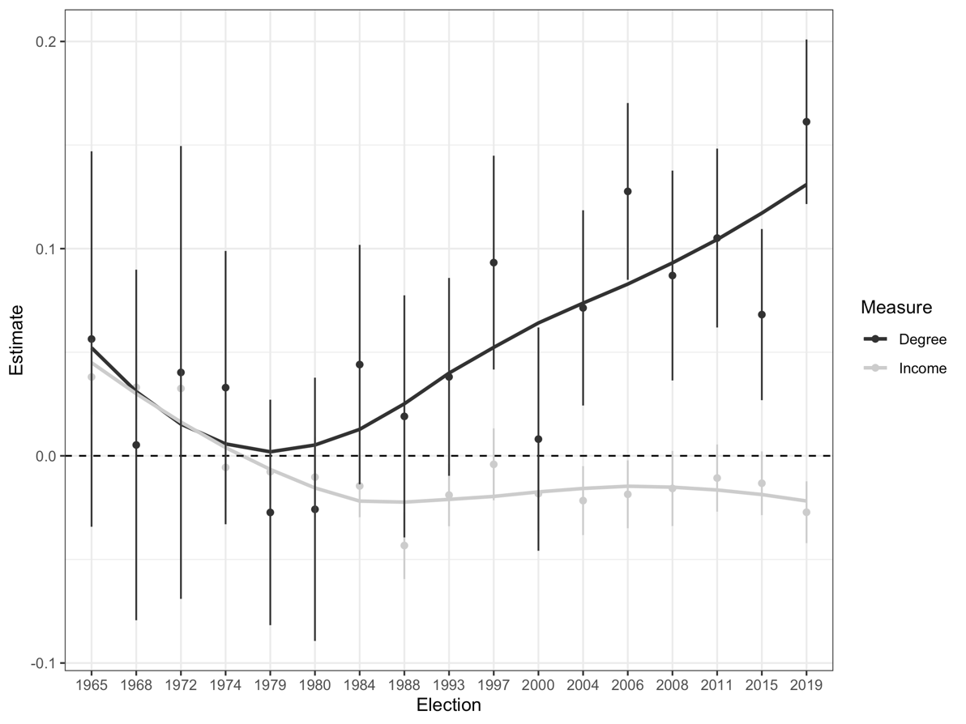

Figure 1: This shows the OLS coefficient of degree status and income on vote support for the left block (Greens, Liberals, and NDP) versus the right block (Canadian Alliance, Conservative Party, PCs, Reform Party, and People's Party).

Where Andersen (2013) found no education cleavage in his class voting analysis between 1965 and 2004, here we find a rather stark educational cleavage, where respondents with university degrees were more likely to support the NDP, Greens, or Liberals over conservative parties. Since 1979 the cleavage flips and a gradual increase occurs, save for the 2000 election. But at the same time, there is a slower, less dramatic decline in support for left parties by wealthier voters. Overall, this analysis largely supports the pattern identified by the Piketty group.

However, as identified in the introduction, this analysis lumps the Liberals in with the NDP, which is a debatable proposition. Even a passing familiarity with Canadian political history will take note that the Liberals and the NDP come from different traditions. Do the two parties draw support equally from educated voters? We unpack this pattern more in the next section with Figure 2. This figure takes the coefficients from OLS models fit to each of the three largest parties’ vote from 1965 to 2019. The key variables of interest here are a dichotomous variable indicating degree status and one indicating income. The underlying models contain controls for age, gender, region, and religion. For simplicity, the models are not broken up between Canada and Quebec. It should be noted that degree, coded as a binary variable, displays stronger effects than income, due to income being a five-category variable. Nevertheless, from 1965 to 1974 we can see that degree holders significantly preferred the Liberals before reversing in the 1979-80 elections. This is followed by a rather astonishing increase in the importance of degree status for both the Conservative and Liberal parties. The education cleavage seems to have opened permanently between the Liberals and the Conservatives starting in the 1980s, with an NDP cleavage starting in 1979 and expanding in 1997. Non-degree holders have increasingly turned to the Conservatives, while degree holders have turned to the Liberals, followed by the NDP to a lesser extent. However, the income trends differ. Overall, income has not been a strong predictor of Liberal support. Although the higher earners gravitated to the Liberals from 1965 to 1972, they did not do so again until the financial crisis of 2008. By contrast, high earners have increasingly turned to the Conservatives and away from the NDP over time, which has gradually gained significant support from low-income earners.

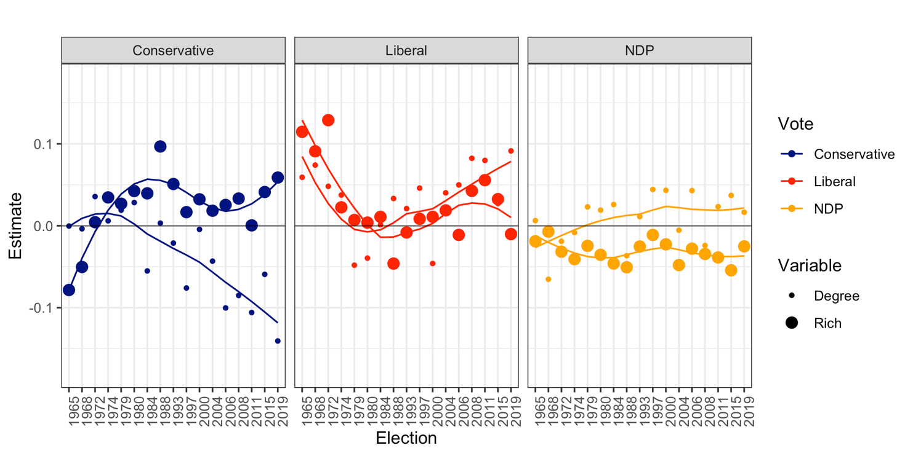

bloc*Figure 2: This shows the OLS coefficients of degree status and income on vote support for the right block (Canadian Alliance, Conservative Party, PCs, Reform Party, and People's Party), the Liberals, and the NDP.*

Thus, underlying the “Brahmin left” and “Merchant right” thesis, there is a vastly different socio-demographic profile to the parties that make up the two large blocs in Canada that is largely ignored by the Piketty group. But what motivates these voters? Are highly educated left-bloc block voters motivated by the same concerns as low income left voters? Are highly educated Liberal voters motivated by the same concerns as highly educated NDP voters? Previous comparative research leads in different directions. One of the earliest attempts to investigate the pattern of the educated left, non-educated right, found it essential to examine voters’ motivations by distinguishing between class and cultural voting (Houtman, Achterberg, and Derks 2009). These researchers did find that the links between educated voters and the left, and non-educated voters and the right, were largely motivated by issues on the second dimension. By contrast, using European Social Survey data from 2002 to 2018, Abou-Chadi and Hix (2021) document that educated leftist voters do support redistribution, although their models crucially do not control for second-dimension issues of libertarian-authoritarian attitudes and individual identities. So, what is the story in Canada? Is the increasing education cleavage that exists between the Conservatives and the other parties a threat to redistribution?

Below, we examine the policy differences that characterize this new type of class cleavage. First, we present the policy preferences by degree and income in Figures 3 and 4 below, on several measures in the CES implicated in the literature on class realignment. Specifically, we include commitments to moral traditionalism, immigration, redistribution, and market liberalism.

In general, Canadians have moved leftwards on the economic dimension since the turn of the century, and considerably leftwards on both moral traditionalism and immigration since the data became available in the 1990s. Figure 3 shows that degree holders retain considerably more left-wing positions on immigration and moral traditionalism throughout the period, but also on market liberalism. Notably, however, there is a change in preferences for redistribution: non-degree holders were more in favour of redistribution than degree holders, but this gap has disappeared since 2011, and they are roughly equal today.

Figure 3: Mean attitudinal preferences over time for degree vs non-degree holders. Scaled from left-right (0-1).

As for income, Figure 4 displays similar patterns to the education cleavage on the cultural dimension but substantial differences on the economic dimension. High earners are significantly more left wing than low earners on immigration and especially moral traditionalism. The gap has remained consistent over time on immigration, whereas it more than doubled for moral traditionalism in the 2000 to 2015 period, when compared to the 1990s, before narrowing considerably in 2019. Low earners have been slightly more pro-market than high earners until 2019, when they moved significantly more leftward than high earners, surpassing them entirely. However, the most telling finding is that low earners have consistently been considerably more pro-redistribution than high earners. The gap was reduced nearly by half at the turn of the century, as high earners became much more pro-redistribution since then, but the gap widened again somewhat in 2019.

Figure 4: Mean attitudinal preferences over time for high income vs low income earners. Scaled from left-right (0-1).

Next, we test the way in which these preferences are linked to party vote in the following section. Table 2 presents the pooled results of nine OLS regression models fit for each major national party. We fit each model by decade 1993 to 2019, with year fixed effects. Each model includes controls for degree status, income, age, gender, region, and religion.

**OLS Logistic Regression of Party Vote, 1993-2019**

|  |  |  |  |  |  |  |  |  |  |
| --- | --- | --- | --- | --- | --- | --- | --- | --- | --- |
|  | NDP | | | Liberal | | | Conservative | | |
|  | 1990s | 2000s | 2010s | 1990s | 2000s | 2010s | 1990s | 2000s | 2010s |
|  | (1) | (2) | (3) | (4) | (5) | (6) | (7) | (8) | (9) |
| (Region) East | *(ref)* | *(ref)* | *(ref)* | *(ref)* | *(ref)* | *(ref)* | *(ref)* | *(ref)* | *(ref)* |
|  |  |  |  |  |  |  |  |  |  |
| (Region) Que. | -0.125*** | -0.111*** | 0.085*** | -0.228*** | -0.191*** | -0.180*** | -0.114*** | -0.135*** | -0.104*** |
|  | (0.020) | (0.015) | (0.017) | (0.033) | (0.019) | (0.018) | (0.031) | (0.018) | (0.017) |
| (Region) Ont. | -0.047* | -0.003 | -0.003 | 0.034 | -0.019 | -0.058*** | -0.003 | 0.012 | 0.069*** |
|  | (0.019) | (0.014) | (0.015) | (0.032) | (0.018) | (0.017) | (0.030) | (0.017) | (0.015) |
| (Region) West | 0.001 | 0.056*** | 0.079*** | -0.179*** | -0.197*** | -0.220*** | 0.155*** | 0.113*** | 0.146*** |
|  | (0.018) | (0.014) | (0.015) | (0.031) | (0.018) | (0.016) | (0.029) | (0.017) | (0.015) |
| Age | 0.001** | -0.000 | -0.002*** | 0.001* | 0.003*** | 0.002*** | -0.001* | -0.001** | -0.001 |
|  | (0.000) | (0.000) | (0.000) | (0.001) | (0.000) | (0.000) | (0.001) | (0.000) | (0.000) |
| Male | -0.021 | -0.009 | 0.012 | -0.018 | -0.017 | -0.036** | 0.028 | 0.021* | 0.019 |
|  | (0.011) | (0.008) | (0.010) | (0.018) | (0.010) | (0.011) | (0.017) | (0.010) | (0.010) |
| Income | -0.005 | -0.019*** | -0.021*** | -0.006 | 0.001 | 0.009* | 0.008 | 0.018*** | 0.019*** |
|  | (0.004) | (0.003) | (0.004) | (0.007) | (0.004) | (0.004) | (0.007) | (0.004) | (0.004) |
| Degree | 0.001 | -0.011 | 0.001 | 0.026 | 0.022 | 0.036** | -0.016 | -0.014 | -0.045*** |
|  | (0.013) | (0.009) | (0.011) | (0.022) | (0.012) | (0.012) | (0.021) | (0.011) | (0.011) |
| (Religion) None | *(ref)* | *(ref)* | *(ref)* | *(ref)* | *(ref)* | *(ref)* | *(ref)* | *(ref)* | *(ref)* |
|  |  |  |  |  |  |  |  |  |  |
| (Religion) Cath. | -0.037* | -0.081*** | -0.033* | 0.059* | 0.061*** | 0.041** | -0.060* | 0.024 | 0.060*** |
|  | (0.018) | (0.012) | (0.014) | (0.030) | (0.016) | (0.015) | (0.028) | (0.015) | (0.014) |
| (Religion) Prot. | -0.023 | -0.084*** | -0.041** | -0.030 | -0.041** | -0.010 | 0.061* | 0.148*** | 0.110*** |
|  | (0.017) | (0.012) | (0.013) | (0.029) | (0.015) | (0.015) | (0.027) | (0.015) | (0.013) |
| (Religion) Other | 0.004 | -0.078*** | -0.021 | 0.083 | 0.154*** | 0.093*** | -0.024 | -0.021 | 0.033 |
|  | (0.028) | (0.021) | (0.024) | (0.047) | (0.027) | (0.026) | (0.044) | (0.026) | (0.024) |
| Redistribution | -0.098*** | -0.162*** | -0.235*** | -0.048 | 0.030 | -0.083** | 0.206*** | 0.229*** | 0.389*** |
|  | (0.018) | (0.018) | (0.024) | (0.030) | (0.023) | (0.025) | (0.028) | (0.022) | (0.024) |
| Market Lib. | -0.148*** | -0.181*** | -0.219*** | -0.123*** | -0.040* | -0.033 | 0.296*** | 0.249*** | 0.296*** |
|  | (0.021) | (0.016) | (0.021) | (0.036) | (0.020) | (0.022) | (0.033) | (0.019) | (0.020) |
| Immigration | -0.028 | -0.033* | -0.026 | -0.072** | -0.051** | -0.133*** | 0.075** | 0.073*** | 0.153*** |
|  | (0.015) | (0.013) | (0.016) | (0.025) | (0.017) | (0.017) | (0.023) | (0.016) | (0.016) |
| Traditionalism | -0.096*** | -0.146*** | -0.122*** | 0.012 | -0.059*** | -0.150*** | 0.127*** | 0.296*** | 0.309*** |
|  | (0.019) | (0.014) | (0.021) | (0.032) | (0.018) | (0.023) | (0.030) | (0.017) | (0.021) |
| Constant | 0.248*** | 0.401*** | 0.262*** | 0.477*** | 0.306*** | 0.339*** | 0.281*** | 0.187*** | 0.229*** |
|  | (0.037) | (0.031) | (0.037) | (0.063) | (0.040) | (0.040) | (0.059) | (0.038) | (0.037) |
| *Fixed Effects* | Year | Year | Year | Year | Year | Year | Year | Year | Year |
| *N* | 2901 | 7818 | 6772 | 2901 | 7818 | 6772 | 2901 | 7818 | 6772 |
| *R2* | 0.09 | 0.12 | 0.11 | 0.07 | 0.07 | 0.12 | 0.18 | 0.20 | 0.28 |
| * *p* < 0.05, ** *p* < 0.01, *** *p* < 0.001 | | | | | | | | | |

Table 1: OLS logistic models predicting party vote, with key controls for age, degree, gender, income, region, and religion, and attitudinal preferences.

We emphasize the following four findings. First, there is a significant sorting occurring on the socio-cultural dimension between the Liberals and the Conservatives. In the 1990s, moral traditionalism had a marginal but positively related relationship to support for the Liberals, which has since reversed and become significantly negatively related post-2000. The Conservative parties have increasingly won over morally traditional voters. Similarly, the immigration coefficient sizes have roughly doubled for each party over time (negative for the Liberals and positive for the Conservatives). Second, Liberal voters are predominantly mobilized along the second dimension in recent years, as its voters are increasingly socially progressive on moral traditionalism and immigration, in comparison to the economic dimension. Second, income has become a much stronger cleavage and it has reversed in direction for the Liberals. In the 1990s income was not a significant predictor for any party but by the 2010s it reaches statistical significance for both the NDP and Conservatives at (p<0.001), and for the Liberals at (p<0.05). We can see that lower income individuals are increasingly voting for the NDP, while higher earners are increasingly voting for the Liberals and Conservatives. Third, education is also becoming a stronger cleavage but only for the Liberals and Conservatives. It exhibits a negative effect in the 2000s but little effect in the 1990s and 2010s. Whereas degree holders are significantly more likely to vote Liberal and non-degree holders significantly more likely to vote Conservative. Last, greater partisan sorting is occurring over redistribution. Liberal voters’ redistributionist preferences remained fairly centrist until the 2010s, where it has now become significant and positively related. Meanwhile NDP and Conservative voters demonstrate much stronger and significantly increasing (or decreasing in the latter’s case) commitments to redistribution over time.

However, these findings do not clarify whether the increasing educational cleavage that we have documented, has consequences for commitments to the welfare state. Following Abou-Chadi and Hix (2021), we fit additional models that include interactions between degree status and a measure of redistribution. However, we test a more complex set of models. On the one hand, we include controls for second-dimension issues of moral traditionalism and immigration. Thus, in contrast to Abou-Chadi and Hix (2021), these interactions between degree and the first and second-dimension issues control for each other. Moreover, we pull the left bloc apart to test whether both components are attracting educated leftists committed to redistribution. Lastly, we also fit models by decade to test whether there are changes in the way that degree status interacts with preferences in relation to vote choice. To simplify the findings, the interaction coefficients are visualized in Figure 5.

Figure 5: Average marginal effects of degree x redistribution interaction on party vote by decade. From OLS regressions controlling for age, degree, gender, income, region, and religion, and attitudinal preferences, which extends Table 1. To ease interpretation higher redistribution levels indicate more positive redistribution sentiment, as recoded (R-L). See Appendix A4 for table.

We note the following. First, there were no significant interactions between redistribution and degree status in relation to Liberal voting, instead, there is a consistently small negative effect. Similarly, the interaction is consistently negative for the Conservatives, but it becomes statistically significant post-2000. However, the interactions are significant for the NDP in each period and the coefficient roughly doubles in size over time. This suggests that those with degrees who vote for the NDP have become increasingly strongly motivated by redistributionist preferences, controlling for both dimensions. By contrast, both Liberal and Conservative degree holders are less likely to be in favour of redistribution, compared to the average. Moreover, we also ran degree interactions with immigration and moral traditionalism as a comparison. We see much reduced effects and is only significant for the NDP in the 2000 to 2009 period.

These findings have two consequences for the existing literature. On the one hand, these findings offer a corrective to Abou-Chadi and Hix (2021) who argue that that the Brahmin Left is capable of sustained support for redistribution because educated leftist voters are more redistributive than uneducated voters. But this finding did not distinguish between parties of the left bloc. Here, we note that educated leftists *who vote for the NDP* are committed to redistribution but educated voters who vote for the Liberals are less so. This raises the question of who dominates inside the broader NDP-Liberal universe in Canada. Moreover, this demonstrates something distinct again from the “cultural” voting identified by Houtman, Achterberg, and Derks (2009). These scholars identified a pattern whereby those with high levels of education were led to support the left out of second-dimension concerns for individual liberty. We find that *not* to be the case; instead, we find that voters with high levels of education who choose the NDP are led to do so more so out of commitments to redistribution, than out of commitments to individual liberty. That said, the increased commitments to redistribution by degree holding voters who vote for the left, is only demonstrated by voters for the NDP, not by voters for the Liberals. This fits with what we know of the Liberal Party as a highly unusual, amorphous, and anti-ideological party of the center (Cochrane, 2010; Johnston 2017). Thus, comparative scholars should be cautious interpreting the Liberal Party as a party of the left.

Although there is widespread support for redistribution across degree and income status, it is Canadian efforts at addressing income gaps have not followed public preferences. If anything, the shift to neoliberal macroeconomic policy that has allowed inequality to grow has increased support for redistribution (Sealey and Andersen 2015). Instead, it appears that party offerings are essential to get voters preferences for redistribution to shape policy (Polacko 2020). Thus, the finding that educated leftists support redistribution at greater rates (albeit slightly) is not enough, on its own, to demonstrate that the increasing educational cleavage documented in Canada and elsewhere, is not implicated in worsening problems of income inequality. Much more goes into public policy than voter preferences. In the next section, we investigate the links between political demand and supply, through the actual policy offerings of the parties.

## Party Supply

To investigate the interaction of party supply and voter demand on economic and social dimensions, we drew data from the Manifesto Project (MARPOR). At a first cut, we examine the relative volume each party has dedicated to first and second-dimension issues in its manifestos. We used two scales of economic and social issues that have been used in the literature (see Appendix 3 for details). The volume of attention dedicated to particular issues can be an essential way to understand the relationships between voters and parties. The entire literature on agenda-setting emphasizes the way in which the amount of attention dedicated to any given policy issue is an essential feature of power and its exercise (Bachrach and Baratz 1962; Baumgartner and Jones 2010; Manheim and Albritton 1984). Petry (2014) found, using MARPOR data, that as soon as Canadian federal election legislation cut off trade unions and corporations from financing federal political parties, the NDP stopped references to unions in its platform. The insight in this case, is that moderation can be achieved not just by shifting position (from offering pro- or anti-labour union policies) but also by ignoring labour unions. Recent studies in both Europe (Ares 2022) and the United States (2020), also show that greater saliency and politicization of redistribution by political parties significantly activates class over socio-cultural preferences in voters, thereby strengthening the class cleavage. However, Carnes (2016) and O’Grady (2019) have found that the internal leadership of Western parties is increasingly being dominated by those with higher education. Thus, even if political leaders do indeed commit to redistribution in pre-election platform formation, will they follow through in post-election platform implementation?

Indeed, Figure 6 tells a fairly remarkable story about the transformation of the Canadian policy agenda, as seen in party platforms. Reflecting the nature of industrial society prior to the 1970s, party platforms emphasized economic issues at a minimum of 2.5 times more than they emphasized social issues. Unsurprisingly, both the smaller NDP and Social Credit Party stand out as particularly dedicated to economic issues. This is largely consistent with Porter’s (1965) portrayal of a Canadian party system dominated by business-friendly brokerage parties, which outside insurgent parties have tried to challenge (Johnston 2017). However, by the 1980s, the system had completely transformed such that now, only on a few occasions did parties emphasize economic issues more than 2.5 times as social issues. The party system has gradually become more focused on social issues, as since 2006, only the NDP has given greater saliency to economic, over social issues.

And if we look more specifically at each party, there are some important patterns. On the one hand, the NDP has gone the furthest with an extremely steep decline in emphasis in economic issues, such that in recent campaigns, it is emphasizing social and economic issues at roughly the same rate. However, the conservative parties (represented in one line), and the Liberals have also shown a significant transformation from presenting business-friendly brokerage manifestos to emphasizing social issues in recent years.

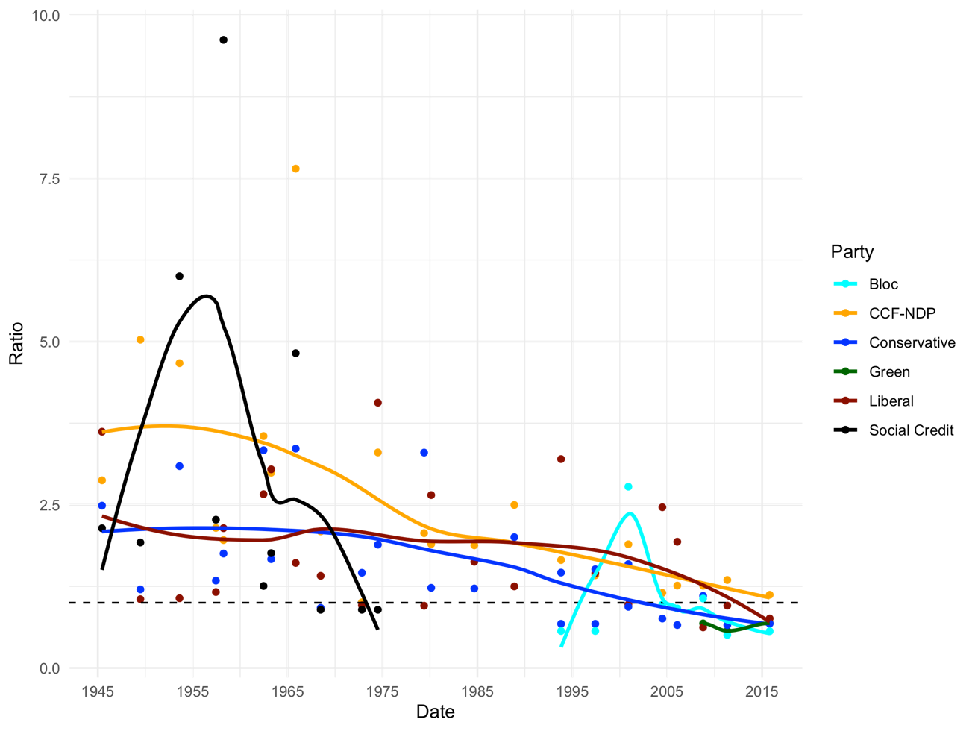

Figure 6: Ratio of economic to socio-cultural issue mentions in Canadian party manifestos, 1945-2015.

As a next step, we examine the actual left-right ideological *position* by the major parties and compare it with voter positions on both the economic and socio-cultural dimensions. The results are displayed in Figure 7. The top panel shows the parties’ policy positions on economic and social issues from MARPOR (scaled left–right from -100 to 100) (Volkens et al. 2020). The bottom panel shows the position of each party on the attitudinal preferences for both the economic and social dimensions from the CES (scaled left–right from 0 to 1).[6]

We draw the reader’s attention to the way in which the Liberals and Conservative platforms overlapped to a large degree on economic and social issues up until 2011 and 2015. However, Liberal voters had a more centre-left skew. This suggests that Liberal voters may have had an unmet more center-left economic position that the party has only recently shifted to address. At the same time, on social issues, where Liberal voters once occupied a space in between the NDP and the Conservatives, the voters of the “Brahmin Left” have coalesced to demonstrate virtually no gap on social issues.

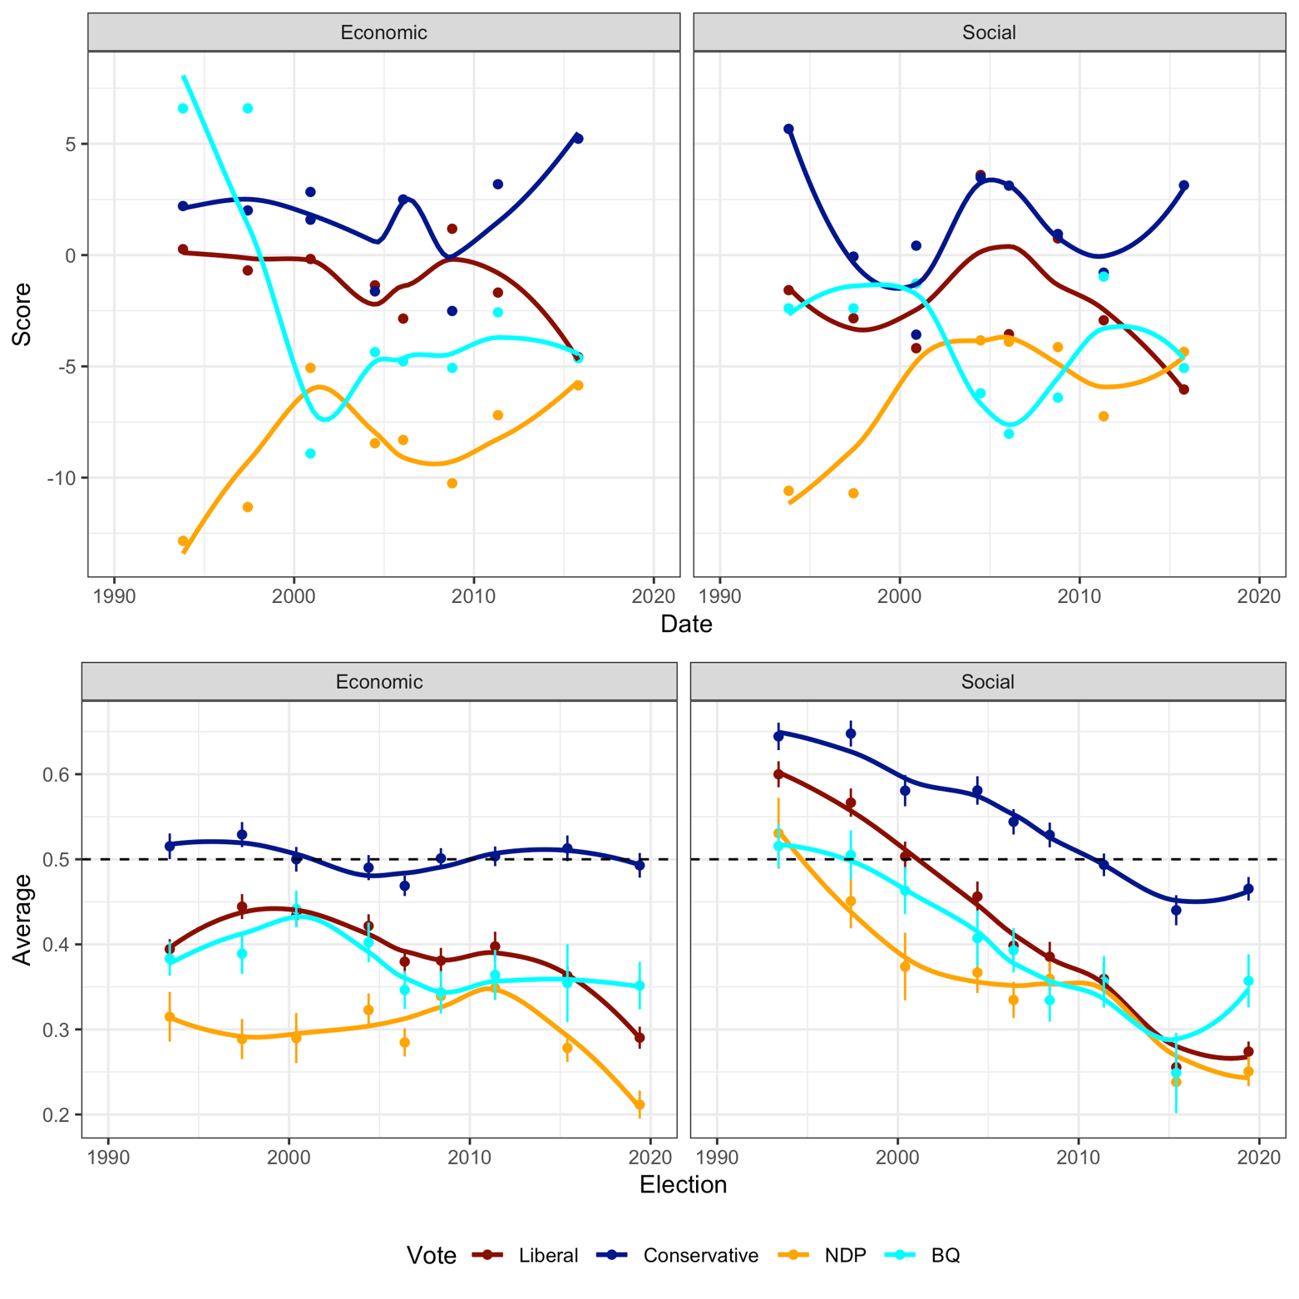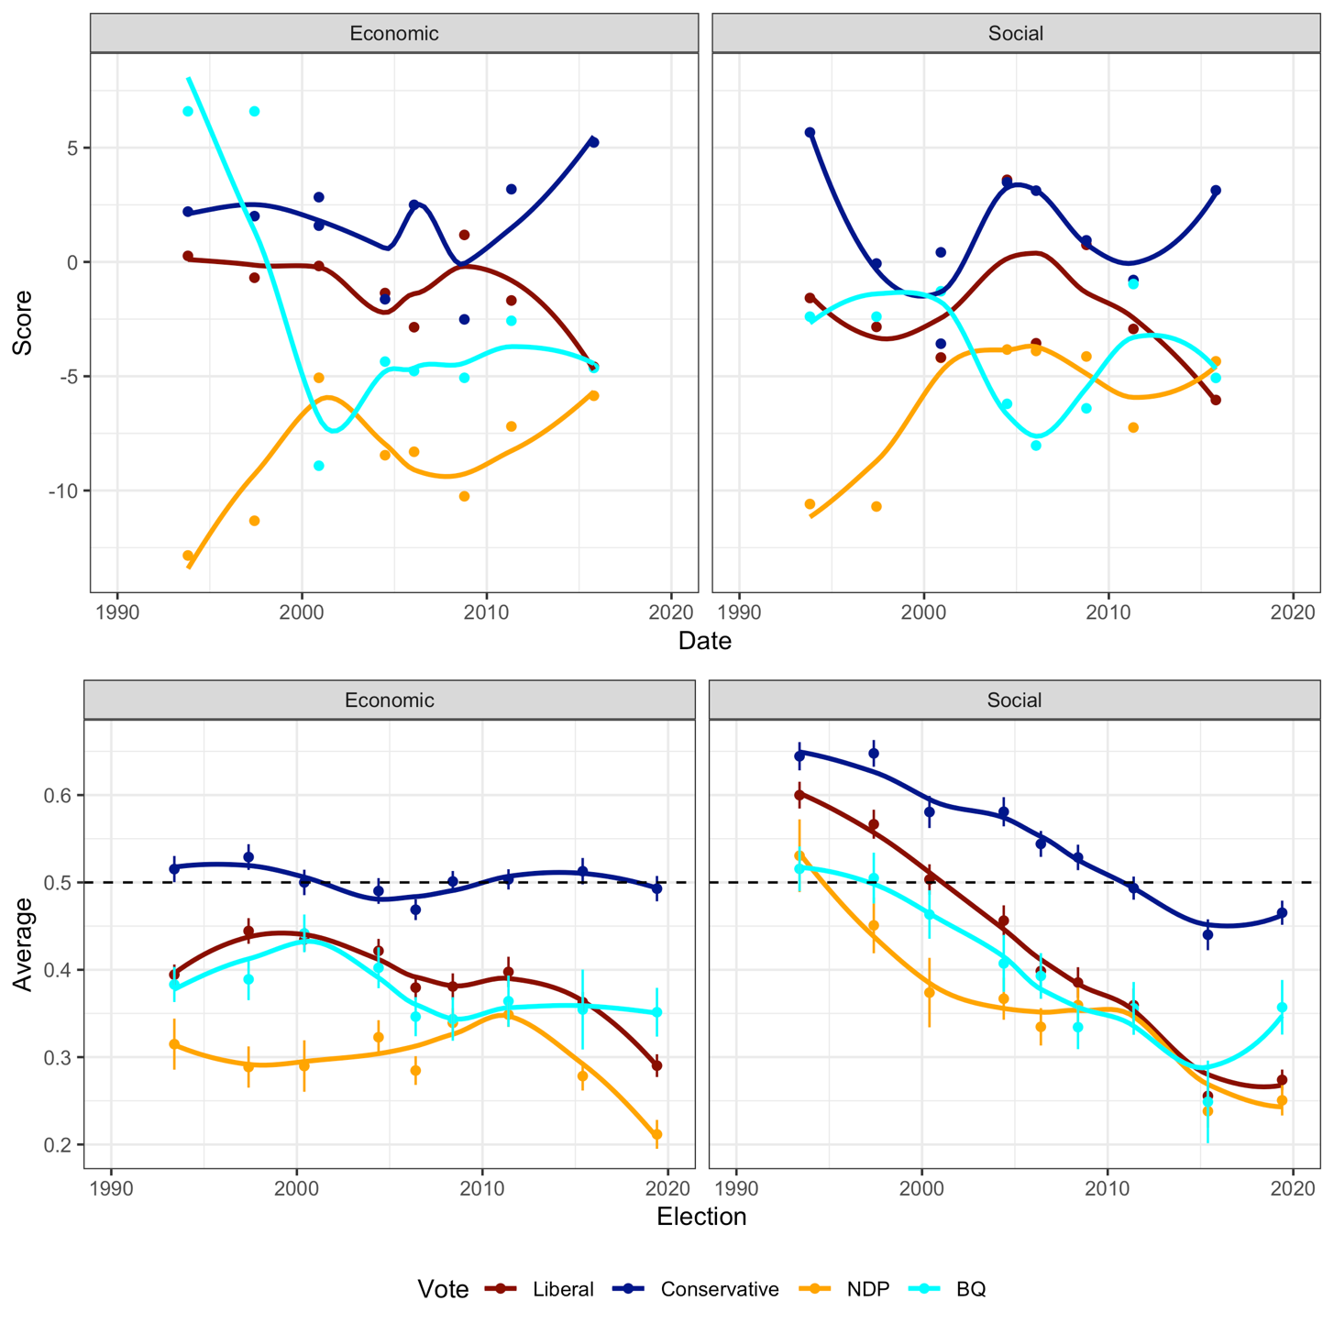

*Figure 3: Comparison of mean voter (L-R) policy positions on economic and socio-cultural issues by party voted for (top panel), with party positions on economic and socio-cultural issues (bottom panel).*

We suggest this introduces a complicated set of dynamics. The left bloc parties have largely offered leftist socio-cultural positions, except for the Liberals in 2004 and 2008, while the Conservatives have largely expectedly not. Thus, there is mostly internal consistency on social issues. But there remain significant gaps between some parties and their voters on economic issues. In particular, Liberal voters are quite leftist economically, averaging around 0.4 on the (0-1) scale, and have increasingly moved left since 2015. However, the Liberal party has largely remained centrist on the economy up until 2015, when Trudeau then moved the party substantially leftward to outflank the NDP and attain a majority government. Unfortunately, the 2019 election has not yet been coded by MARPOR, but an examination of Varieties of Democracy (V-Dem) data confirms that the party moved back towards a more centrist position in 2019 (Lührmann et al. 2020). Might this lay the groundwork for a type of competition on economic issues in a “progressive primary” between the Liberals and the NDP followed by a general election fought on social issues? If so, this might mean that the overall finding of a “Brahmin Left” dominated by educated voters might still generate serious proposals for redistribution that can periodically prevail if the conditions are right, largely because of the pressure inside the left bloc provided by the NDP, dominated by pro-redistribution and poorer voters.

# CONCLUSION

In examining the competing impact of education and income on vote choice, we find clear evidence that the Canadian electorate is dominated by an increasingly disconnected education and income cleavage, whereby degree holders are more likely to support the NDP and Liberals, and less likely to support the Conservatives. This is entirely consistent with the development of a “Brahmin Left” and a “Merchant Right” thesis. However, the consequences of this are not entirely clear. First, when we pull apart the left bloc, we find that education and income are working in different ways for the NDP and the Liberals. Educated voters are increasingly flocking to the Liberals, while poorer voters are increasingly turning to the NDP. The Conservatives, by contrast, are taking poorly educated and richer voters. This dynamic offers something of a complication for the general Piketty thesis that the transformation of the left is a culprit in increasing income inequality. In Canada, at least, a significant part of the left bloc features a relatively poorer (and increasingly so) electorate.

We documented the importance of picking apart the left bloc when we followed Abou-Chadi and Hix (2021) and examined the interaction of redistributive preferences and education for the individual parties. There, we found that *NDP* degree voters – but not Liberal degree voters – were more redistributive than those without degrees. This raises some doubts about the overall commitment of the broad “Brahmin Left” bloc in Canada to make commitments to redistribution.

Lastly, turning to the question of party platforms and their interactions with voter preferences, we find some evidence of the impacts of the changing nature of the class cleavage in Canada. Most clearly, the party system, as seen in campaign platforms, is increasingly about social issues and less about economic issues. This has had the largest impact on the NDP and the conservative parties. In terms of actual positioning, Liberal voters have demonstrated a leftist bias on the economy, which is out of step with the centrist positioning of the party. As the Liberals have attracted increasingly educated voters, their electorate has also demonstrated a significant shift to the left on social issues, leaving almost no gap between NDP and Liberal voters on social issues. The party also appears to be catering to its increasingly educated and wealthier voters on the economy, while ignoring the large segment of its base that is leftist on the economy.

The dynamics laid out here might help to explain some of the significant moments of the period between 2019 and 2021. On the one hand, the Liberal Party of Justin Trudeau excels at a kind of progressive performativity, lowering Canadian flags – indefinitely – in the wake of news about unmarked graves at Canadian residential schools, then jetting off for a surfing vacation on a day set aside for Truth and Reconciliation. Meanwhile, the leader of Canada’s Green Party invited the leader of the Bloc Québecois to “educate himself” in the 2021 leader’s debate as a way of criticizing the party’s support of Quebec’s Bill 21. At the same time, on the right-side of the spectrum, the bulk of the Conservative Party fell over itself to support a national protest convoy of “truckers” many of whom were business owners, with the means to spend weeks on the road protesting policies and a quixotic understanding of Canadian constitutional principles. If the “Brahmin Left / Merchant Right” thesis does not necessarily explain policy outcomes, it might at least tell us much about political styles. And yet equally, in the middle of that noise, it is worth pointing out that the recent supply and confidence agreement negotiated by the NDP, a party increasingly dominated by a poorer pro-redistribution electorate, was almost entirely about economic and redistributive issues.

# REFERENCES

Abou-Chadi, Tarik and Simon Hix. (2021). “Brahmin Left versus Merchant Right? Education, Class, Multiparty Competition, and Redistribution in Western Europe.” *The British Journal of Sociology*. 72(1): 79–92.

Amable, Bruno and Thibault Darcillon. (2021). “The brahmin left, the merchant right and the *bloc bourgeois*.” *Review of International Political Economy*. [Online]. <https://doi.org/10.1080/09692290.2021.1913440>.

Andersen, Robert. (2013). “The Class-Party Relationship in Canada, 1965–2004.” In Nan Dirk De Graaf and Geoffrey Evans(eds), *Political Choice Matters: Explaining the Strength of Class and Religious Cleavages in Cross-National Perspective* (pp. 165–184). Oxford University Press.

Ares, Macarena. (2022). “Issue politicization and social class: How the electoral supply activates class divides in political preferences.” *European Journal of Political Research*. 61(2): 503–523.

Bachrach, Peter and Morton Baratz. (1962). “Two Faces of Power.” *American Political Science Review*. 56(4): 947-952.

Banting, Keith and John Myles. (2013). *Inequality and the Fading of Redistributive Politics*. UBC Press.

Baumgartner, Frank R, and Bryan D. Jones. *Agendas and Instability in American Politics*. Second Edition. University of Chicago Press, 2010.

Benoit, Kenneth and Michael Laver. *Party policy in modern democracies*. London: Routledge, 2006.

Beramendi, Pablo, Silja Häusermann, Herbert Kitschelt and Hanspeter Kriesi. (2015). *The Politics of Advanced Capitalism*. Cambridge University Press.

Bonomi, Giampaolo, Nicola Gennaioli and Guido Tabellini. (2020). “Identity, Beliefs, and Political Conflict.” *Quarterly Journal of Economics*. 136(4): 2371–2411.

Carnes, Nicholas. (2016). “Why are There so few Working-Class People in Political Office? Evidence from State Legislatures.” *Politics, Groups, and Identities*. 4(1): 84–109.

Cochrane, Christopher. (2010). “Left/Right Ideology and Canadian Politics.” *Canadian Journal of Political Science*. 43(3): 583–605.

Fieldhouse, Edward, Jane Green, Geoffrey Evans, Jonathan Mellon, Christopher Prosser, Hermann Schmitt, and Cees van der Eijk. (2019). *Electoral Shocks: The Volatile Voter in a Turbulent World*. Oxford: Oxford University Press.

Fournier, Patrick, Fred Cutler, Stuart Soroka, Dietlind Stolle and Éric Bélanger. (2013). “Riding the Orange Wave: Leadership, Values, Issues, and the 2011 Canadian Election.” *Canadian Journal of Political Science*. 46(3): 863–897.

Gethin, Amory, Clara Martínez-Toledano and Thomas Piketty. (2022). *Brahmin Left Versus Merchant Right: Changing Political Cleavages in 21 Western Democracies, 1948-2020*. *Quarterly Journal of Economics*. 137(1): 1–48.

Gethin, Amory. (2021). “Political Cleavages, Class Structures and the Politics of Old and New Minorities in Australia, Canada and New Zealand.” In Amory Gethin, Clara Martinez Toledano and Thomas Piketty (eds.), *Political Cleavages and Social Inequalities: A Study of Fifty Democracies, 1948-2020* (pp. 191–220). Harvard University Press

Gidengil, Elisabeth, Neil Neville, André Blais, Joanna Everitt and Patrick Fournier. (2012). *Dominance and Decline: Making Sense of Recent Canadian Elections*. University of Toronto Press.

Gingrich, Jane and Silja Häusermann. (2015). “The Decline of the Working-Class Vote, the Reconfiguration of the Welfare Support Coalition and Consequences for the Welfare State.” *Journal of European Social Policy*. 25(1): 50–75.

Hildebrandt, Achim and Sebastian Jäckle. (2021). “The shifting class-base of social democratic parties in Western Europe.” *European Politics and Society*. <https://doi.org/10.1080/23745118.2021.1909806>.

Houtman, Dick, Peter Achterberg and Anton Derks. (2009). *Farewell to the Leftist Working Class*. Transaction Publishers.

Johnston, Richard. (2017). *The Canadian Party System: An Analytic History*. UBC Press.

Kiss, Simon. (2005). “New Politics in Old Parties: A Comparison of New Politics Party Innovation in Canada and Germany.” MA Thesis. Queen’s University: Kingston, ON.

Kitschelt, Herbert. (1994). *The Transformation of European Social Democracy*. Cambridge University Press.

Lipset, Seymour Martin. (1960). Political Man: The Social Bases of Politics. New York: Doubleday.

Lowe, Will, Kenneth Benoit, Slava Mikhaylov and Michael Laver. “Scaling Policy Preferences from Coded Political Texts.” *Legislative Studies Quarterly*. 36, no. 1 (2011): 123–155.

Lührmann, Anna, et al. (2020). Varieties of Party Identity and Organization (V-Party) Dataset V1. Varieties of Democracy (V-Dem) Project.

Manheim, Jarol and Robert Albritton. (1984). “Changing National Images: International Public Relations and Media Agenda Setting.” The American Political Science Review 78(3): 641–657.

Nevitte, Neil, André Blais, Elisabeth Gidengil and Richard Nadeau. (2000). *Unsteady State: The 1997 Canadian Federal Election*. Oxford University Press.

O’Grady, Tom. (2019). “Careerists Versus Coal-Miners: Welfare Reforms and the Substantive Representation of Social Groups in the British Labour Party.” *Comparative Political Studies*.” 52(4): 544–578.

Petry, François. (2014). “Ideological Evolution of the Federal NDP, As Seen Through Its Election Campaign Manifestos.” In David Laycock and Lynda Erickson (eds.), *Reviving Social Democracy: The Near Death and Surprising Rise of the Federal NDP* (pp. 140–164). UBC Press

Piketty, Thomas. (2020). *Capital and Ideology*. Harvard University Press.

Polacko, Matthew. (2020). “Party Positions, Income Inequality, and Voter Turnout in Canada, 1984–2015.” *American Behavioral Scientist*. 64(9): 1324–1347.

Polacko, Matthew, Simon Kiss and Peter Graefe. (2020). “The Changing Nature of Class Voting in Canada, 1965–2019.” *Canadian Journal of Political Science*. [In Press].

Porter, John. (1965). *The Vertical Mosaic: An Analysis of Social Class and Power in Canada*. University of Toronto Press.

Rennwald, Line. (2020). *Social Democratic Parties and the Working Class: New Voting Patterns*. Palgrave Macmillan.

Sealey, Anthony and Robert Andersen. (2015). “Income Inequality and Popular Support for Redistributive Policies in Canada, 1993-2008.” *Canadian Public Policy.* 41(1): 51–64.

Stubager, Rune. (2010). “The Development of the Education Cleavage: Denmark as a Critical Case.” *West European Politics*. 33(3): 505–533.

Stubager, Rune. (2013). “The Changing Basis of Party Competition: Education, Authoritarian–Libertarian Values and Voting.” *Government and Opposition*. 48(3): 372-397.

Wilkins-Laflamme, Sarah. (2016). “The Changing Religious Cleavage in Canadians’ Voting Behaviour.” *Canadian Journal of Political Science*. 49(3): 499–518.

Volkens, Andrea, Tobias Burst, Werner Krause, Pola Lehmann, Theres Matthieß, Nicolas Merz, Sven Regel, Bernhard Weßels and Lisa Zehnter. (2020). The Manifesto Data Collection. Manifesto Project (MRG/CMP/MARPOR). Version 2020b. Berlin: Wissenschaftszentrum Berlin für Sozialforschung (WZB). 2020. <https://doi.org/10.25522/manifesto.mpds.2020b>.

**APPENDIX**

**Rich Voter, Poor Voter, Educated and Not: Education, Income and Redistribution in Canada**

**Appendix**

**A1 Descriptive Statistics**

**A2 Attitudinal Policy Variable Questions**

**A3 Coding Party Policy Variables**

**A4 Results of Interactions for Figure X: Regressions of Party Vote, 1993-2019**

**A1 Descriptive Statistics**

|  |  |  |  |  |  |
| --- | --- | --- | --- | --- | --- |
| **Variable** | **Observations** | **Mean** | **Std. Dev.** | **Min** | **Max** |
| Election | 52,829 | 1995.217 | 16.08544 | 1965 | 2019 |
| Age | 51,583 | 47.53169 | 17.07638 | 18 | 115 |
| Male | 52,808 | 0.481329 | 0.499656 | 0 | 1 |
| Degree | 51,015 | 0.235029 | 0.424021 | 0 | 1 |
| Religion | 50,421 | 1.331886 | 0.7867687 | 0 | 3 |
| Region | 52,829 | 2.678207 | 1.005338 | 1 | 4 |
| Income | 48,000 | 3.053083 | 1.389639 | 1 | 5 |
| Redistribution | 29,517 | 0.774367 | 0.2472087 | 0 | 1 |
| Market Liberalism | 32,352 | 0.497624 | 0.2800456 | 0 | 1 |
| Moral Traditionalism | 33,729 | 0.401253 | 0.3249821 | 0 | 1 |
| Immigration Rates | 34,754 | 0.584753 | 0.3510003 | 0 | 1 |
| NDP | 38,122 | 0.163134 | 0.3694929 | 0 | 1 |
| Liberal | 38,122 | 0.362284 | 0.4806667 | 0 | 1 |
| Conservative | 38,122 | 0.374141 | 0.4839066 | 0 | 1 |
| Bloc | 38,122 | 0.053775 | 0.2255756 | 0 | 1 |

**A2 Attitudinal Policy Variable Questions**

|  |  |  |
| --- | --- | --- |
| Variable | Question(s) | Year(s) |
| Market Liberalism | * Government should leave it entirely to the private sector to create jobs. | 1993–2019 |
|  | * People who don't get ahead should blame themselves not the system. | 1993–2019 |
| Moral Traditionalism | * Society would be better off if more women stayed home with their children. | 1993–2019 |
|  | * Gays and lesbians should be allowed to get married | 1993–2015 |
|  | * How much do you think should be done for Gays & Lesbians | 2019 |
| Redistribution | * How much should be done to reduce the gap between the rich and the poor in Canada | 1993–2019 |
| Immigration  Rates | * Do you think Canada should admit: more immigrants, fewer immigrants, or about the same | 1993–2019 |

**A3 Coding Party Policy Variables**

Economic and socio-cultural policy positions were constructed using the state-market (economic) and (progressive-conservative) society dimensions, which comprise the following components from MARPOR (Volkens et al. 2020):

|  |  |  |  |
| --- | --- | --- | --- |
| **Economic (State-Market) Dimension** | | | |
| **Left-Wing** | | **Right-Wing** | |
| per403 | Market Regulation | per401 | Free Market Economy |
| per404 | Economic Planning | per402 | Incentives: Positive |
| per405 | Corporatism/Mixed Economy | per407 | Protectionism: Negative |
| per406 | Protectionism: Positive | per414 | Economic Orthodoxy |
| per409 | Keynesian Demand Management | per505 | Welfare State Limitation |
| per412 | Controlled Economy |  |  |
| per413 | Nationalisation |  |  |
| per415 | Marxist Analysis |  |  |
| per416 | Anti-Growth Economy: Positive |  |  |
| per504 | Welfare State Expansion |  |  |
|  | | | |
| **Society (Libertarian-Authoritarian) Dimension** | | | |
| **Left-Wing** | | **Right-Wing** | |
| per105 | Military: Negative | per104 | Military: Positive |
| per106 | Peace | per109 | Internationalism: Negative |
| per107 | Internationalism: Positive | per110 | European Community/Union: Negative |
| per108 | European Community/Union: Positive | per601 | National Way of Life: Positive |
| per501 | Environmental Protection | per603 | Traditional Morality: Positive |
| per503 | Equality: Positive | per605 | Law and Order: Positive |
| per602 | National Way of Life: Negative | per608 | Multiculturalism: Negative |
| per604 | Traditional Morality: Negative |  |  |
| per607 | Multiculturalism: Positive |  |  |
| per705 | Underprivileged Minority Groups |  |  |

**A4 Results of Interactions for Figure 5: Regressions of Party Vote, 1993-2019**

|  |  |  |  |  |  |  |  |  |  |
| --- | --- | --- | --- | --- | --- | --- | --- | --- | --- |
|  | NDP | | | Liberal | | | Conservative | | |
|  | 1990s | 2000s | 2010s | 1990s | 2000s | 2010s | 1990s | 2000s | 2010s |
|  | (1) | (2) | (3) | (4) | (5) | (6) | (7) | (8) | (9) |
| (Region) East | *(ref)* | *(ref)* | *(ref)* | *(ref)* | *(ref)* | *(ref)* | *(ref)* | *(ref)* | *(ref)* |
|  |  |  |  |  |  |  |  |  |  |
| (Region) Que. | -0.127*** | -0.112*** | 0.084*** | -0.226*** | -0.190*** | -0.180*** | -0.114*** | -0.134*** | -0.104*** |
|  | (0.020) | (0.015) | (0.017) | (0.033) | (0.019) | (0.018) | (0.031) | (0.018) | (0.017) |
| (Region) Ont. | -0.048* | -0.004 | -0.004 | 0.035 | -0.019 | -0.058*** | -0.003 | 0.012 | 0.069*** |
|  | (0.019) | (0.014) | (0.015) | (0.032) | (0.018) | (0.017) | (0.030) | (0.017) | (0.015) |
| (Region) West | -0.001 | 0.056*** | 0.079*** | -0.178*** | -0.197*** | -0.220*** | 0.156*** | 0.114*** | 0.147*** |
|  | (0.018) | (0.014) | (0.015) | (0.031) | (0.018) | (0.016) | (0.029) | (0.017) | (0.015) |
| Age | 0.001** | -0.000 | -0.002*** | 0.001* | 0.003*** | 0.002*** | -0.001* | -0.001** | -0.001 |
|  | (0.000) | (0.000) | (0.000) | (0.001) | (0.000) | (0.000) | (0.001) | (0.000) | (0.000) |
| Male | -0.021 | -0.008 | 0.011 | -0.017 | -0.018 | -0.036** | 0.028 | 0.020* | 0.019 |
|  | (0.011) | (0.008) | (0.010) | (0.018) | (0.010) | (0.011) | (0.017) | (0.010) | (0.010) |
| Income | -0.005 | -0.019*** | -0.021*** | -0.006 | 0.001 | 0.009* | 0.008 | 0.018*** | 0.019*** |
|  | (0.004) | (0.003) | (0.004) | (0.007) | (0.004) | (0.004) | (0.007) | (0.004) | (0.004) |
| Degree | -0.049 | -0.102*** | -0.122*** | 0.067 | 0.047 | 0.082* | 0.000 | 0.100** | 0.011 |
|  | (0.027) | (0.029) | (0.035) | (0.046) | (0.038) | (0.038) | (0.043) | (0.036) | (0.035) |
| (Religion) None | *(ref)* | *(ref)* | *(ref)* | *(ref)* | *(ref)* | *(ref)* | *(ref)* | *(ref)* | *(ref)* |
|  |  |  |  |  |  |  |  |  |  |
| (Religion) Cath. | -0.037* | -0.080*** | -0.031* | 0.059* | 0.061*** | 0.040** | -0.060* | 0.023 | 0.059*** |
|  | (0.018) | (0.012) | (0.014) | (0.030) | (0.016) | (0.015) | (0.028) | (0.015) | (0.014) |
| (Religion) Prot. | -0.024 | -0.084*** | -0.039** | -0.029 | -0.041** | -0.011 | 0.061* | 0.148*** | 0.109*** |
|  | (0.017) | (0.012) | (0.013) | (0.029) | (0.015) | (0.015) | (0.027) | (0.015) | (0.013) |
| (Religion) Other | 0.003 | -0.079*** | -0.019 | 0.084 | 0.155*** | 0.093*** | -0.024 | -0.020 | 0.032 |
|  | (0.028) | (0.021) | (0.024) | (0.047) | (0.027) | (0.026) | (0.044) | (0.026) | (0.024) |
| Redistribution | -0.078*** | -0.121*** | -0.171*** | -0.065 | 0.019 | -0.106*** | 0.199*** | 0.179*** | 0.360*** |
|  | (0.020) | (0.022) | (0.029) | (0.034) | (0.028) | (0.032) | (0.032) | (0.027) | (0.029) |
| Degree x Redist | 0.077* | 0.119*** | 0.161*** | -0.064 | -0.032 | -0.059 | -0.025 | -0.149*** | -0.073 |
|  | (0.037) | (0.036) | (0.044) | (0.062) | (0.046) | (0.048) | (0.058) | (0.044) | (0.044) |
| Market Lib. | -0.146*** | -0.176*** | -0.214*** | -0.125*** | -0.042* | -0.035 | 0.296*** | 0.243*** | 0.294*** |
|  | (0.021) | (0.016) | (0.021) | (0.036) | (0.020) | (0.022) | (0.033) | (0.019) | (0.021) |
| Immigration | -0.027 | -0.031* | -0.024 | -0.072** | -0.052** | -0.133*** | 0.075** | 0.071*** | 0.152*** |
|  | (0.015) | (0.013) | (0.016) | (0.025) | (0.017) | (0.017) | (0.024) | (0.016) | (0.016) |
| Traditionalism | -0.095*** | -0.146*** | -0.120*** | 0.011 | -0.059*** | -0.150*** | 0.127*** | 0.295*** | 0.308*** |
|  | (0.019) | (0.014) | (0.021) | (0.032) | (0.018) | (0.023) | (0.030) | (0.017) | (0.021) |
| Constant | 0.264*** | 0.430*** | 0.310*** | 0.464*** | 0.298*** | 0.321*** | 0.276*** | 0.150*** | 0.208*** |
|  | (0.038) | (0.032) | (0.039) | (0.064) | (0.041) | (0.042) | (0.060) | (0.040) | (0.039) |
| *Fixed Effects* | Year | Year | Year | Year | Year | Year | Year | Year | Year |
| *N* | 2901 | 7818 | 6772 | 2901 | 7818 | 6772 | 2901 | 7818 | 6772 |
| *R2* | 0.10 | 0.12 | 0.11 | 0.07 | 0.07 | 0.12 | 0.18 | 0.20 | 0.28 |
| * *p* < 0.05, ** *p* < 0.01, *** *p* < 0.001 | | | | | | | | | |

Table A4: OLS logistic models predicting party vote, with key controls for age, degree, gender, income, region, religion, and attitudinal preferences

1. “Regionalization and linguistic identities may explain why class politics in Canada differed significantly from most Western countries in the early postwar decades, but this is not the case today” (Gethin 2021: 218)
2. For 1972 *age* is only included as 11 categories, therefore all respondents within a category are assigned the median of their respective category.
3. The gender roles question used throughout is “society would be better off if more women stayed home with their children.” From 1993 to 2015, the same question on same-sex marriage is used, whereas in 2019 it is based on a thermometer rating of gays and lesbians.
4. MARPOR position computations assume that the marginal effect of an additional sentence is constant. However, a shift from zero to one would matter more for a policy position than a shift from 9 to 10 due to the diminishing impact of repeated emphasis. Hence, Lowe’s (2011) logged method addresses this by applying a ratio approach to the raw number of sentences, so that the relative balance and proportion of change on the left-right scale are accounted for, rather than just the quantity of sentences.
5. MARPOR dimension construction: <https://manifesto-project.wzb.eu/information/documents/visualizations> (Volkens et al 2020).
6. Our *market liberalism* and *moral traditionalism* indexes each comprise two questions, thus we combine them with *redistribution* and *immigration rates* into respective economic and social indexes. We then provide equal weighting to each question (3 for each index) to arrive at a (0-1) left–right position.