pg默认端口

5432

pg插件有3个：

geos-3.5.0

proj-4.7.0

postgis-1.5.2

windows测试机器的密码

Adminstrator

Welcome8881234

# 1. psql: FATAL: database “<user>” does not exist

**参考文章：**

<https://stackoverflow.com/questions/17633422/psql-fatal-database-user-does-not-exist>

**问题原因：**

没有通过-d指定数据库的话，默认会连接到与用户名同名的数据库，而此数据库不存在，所以报了这个错误。

**解决方案：**

通过-d 参数指定要连接的数据库，否则默认会连接与用户名同名的数据库。

|  |
| --- |
| psql -d template1 |

# 2. **删除postgresql数据库时报错database xxx is being accessed by other users**

**参考文章：**

<https://blog.csdn.net/qq_24095055/article/details/90713678>

**问题原因：**

有其他session正在连接着这个数据库，因此不让删。

**解决方案：**

执行如下语句

|  |
| --- |
| SELECT pg_terminate_backend(pg_stat_activity.pid)  FROM pg_stat_activity  WHERE datname='emap' AND pid<>pg_backend_pid();  -再删除库  drop database emap; |

# 3. psql 导入数据报错 invalid command \N

**参考文章：**<https://www.cnblogs.com/abclife/p/15104748.html>

**问题原因：**

由于源端和目标数据库的权限设置可能不一致，在数据导入过程当中可能会出现一些与权限相关的 WARNING 或 ERROR，可以忽略。

**解决方案：**

通过-v ON_ERROR_STOP=1 参数，只要导入一遇到ERROR就会停止了，而且能看到具体什么原因导致导入数据报错，根据具体错误查找解决办法。

|  |
| --- |
| /usr/local/postgresql/bin/psql -v ON_ERROR_STOP=1 -U root -h 10.225.67.145 -p 5432 -d emap -f emap.dmp |

如下图所示：

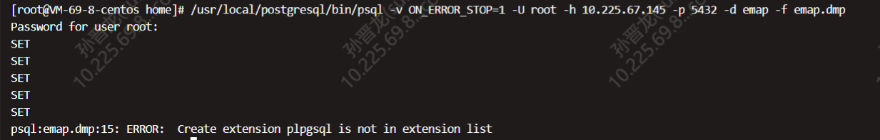

# 4. ERROR: Create extension plpgsql is not in extension list

这个跟咱们后端核实了下 是创建插件 可以忽略的。----来自腾讯云售后群

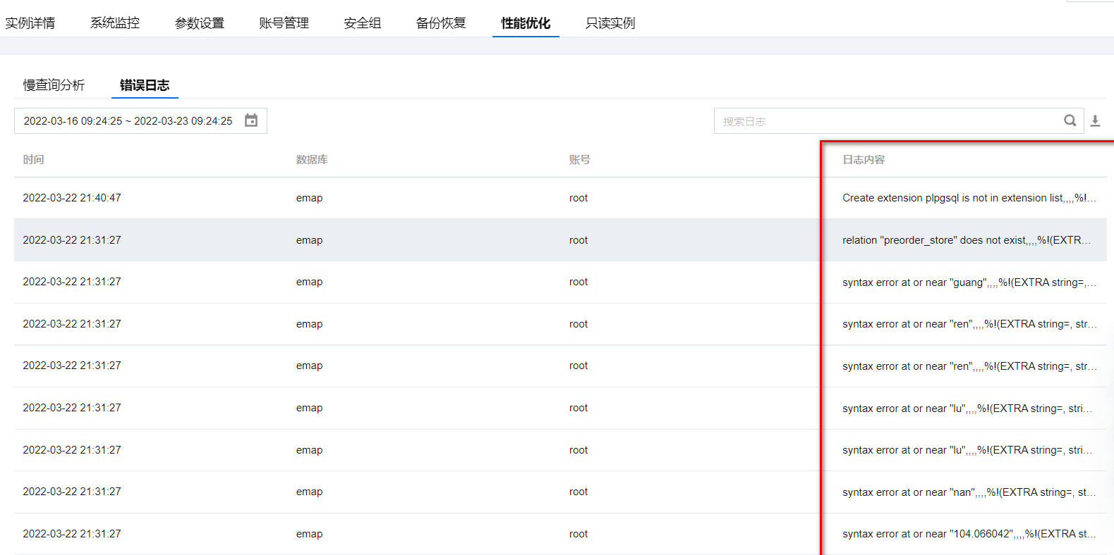

在腾讯云rds的postgresql中的日志中出现的这些ERROR也是可以忽略的，主要是权限的问题。

# 5. psql导入pg_dump导出的数据文件之后，发现少了几个表

目标端：

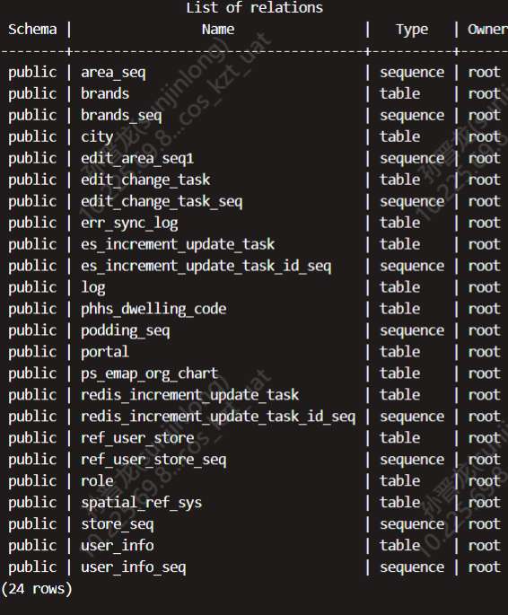

源端：

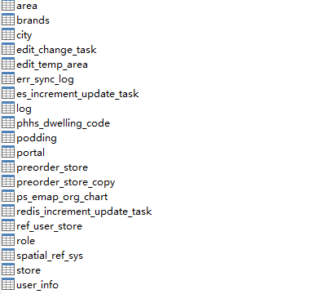

问题原因：

|  |
| --- |
| 这种数据迁移的方式实际是通过逻辑备份（我理解就是建表/建type/建function等语句建立对应的table/type/function，）然后在目标库执行这些语句来实现的。  由于源库和目标库owner的不同，以及目标库没有指定type，权限等问题，导致create table的时候报错，创建表失败，因此少了很多表。 |

解决方案：

|  |
| --- |
| 手动搞  1. 在阿里云源端导出用户信息  pg_dumpall -g -h 172.16.4.81 -p 5432 -U postgres > pg_user_dump.sql  在腾讯云目标端创建用户，随意命名（因为原来用的postgres用户，与腾讯云上paas冲突，需要在腾讯云paas上重新用一个用户），如pguser  CREATE ROLE pguser;  ALTER ROLE pguser WITH tencent_superuser INHERIT CREATEROLE CREATEDB LOGIN REPLICATION;  alter user pguser with password 'pguser';  2. 从源库pg_dump -t 导出所有的table,view, sequence  pg_dump -U postgres -t area -t brands -t city -t edit_change_task -t edit_temp_area -t err_sync_log -t es_increment_update_task -t geography_columns -t geometry_columns -t log -t phhs_dwelling_code -t podding -t portal -t preorder_store -t preorder_store_copy -t ps_emap_org_chart -t redis_increment_update_task -t ref_user_store -t role -t spatial_ref_sys -t store -t user_info -t area_seq -t brands_seq -t edit_area_seq1 -t edit_change_task_seq -t es_increment_update_task_id_seq -t podding_seq -t redis_increment_update_task_id_seq -t ref_user_store_seq -t store_seq -t user_info_seq emap > ./emap2.dmp    pg_dump -U postgres -t area -t area_seq -t brands -t brands_seq -t city -t edit_area_seq1 -t edit_change_task -t edit_change_task_seq -t edit_temp_area -t err_sync_log -t es_increment_update_task -t es_increment_update_task_id_seq -t geography_columns -t geometry_columns -t log -t phhs_dwelling_code -t podding -t podding_seq -t portal -t preorder_store -t ps_emap_org_chart -t redis_increment_update_task -t redis_increment_update_task_id_seq -t ref_user_store -t ref_user_store_seq -t role -t spatial_ref_sys -t store -t store_seq -t user_info -t user_info_seq emap_ksf > ./emap_ksf.dmp    pg_dump -U postgres -t area -t area_seq -t brands -t brands_seq -t city -t edit_area_seq1 -t edit_change_task -t edit_change_task_seq -t edit_temp_area -t err_sync_log -t es_increment_update_task -t es_increment_update_task_id_seq -t geography_columns -t geometry_columns -t log -t phhs_dwelling_code -t podding -t podding_seq -t portal -t preorder_store -t preorder_store_copy -t ps_emap_org_chart -t redis_increment_update_task -t redis_increment_update_task_id_seq -t ref_user_store -t ref_user_store_seq -t role -t spatial_ref_sys -t store -t store_seq -t user_info -t user_info_seq emap_npls > ./emap_npls.dmp  3. 向目标端pg导入数据  jumpserver登录10.225.69.8    /usr/local/postgresql/bin/psql -U pguser -h 10.225.67.145 -p 5432 -d template1  --创建数据库  create database emap;  --进入数据库  \c emap;  --创建插件  create extension postgis;    cd /home  vim emap2.dmp  :%s/postgres/pguser/g  :%s/readaccess/pguser/g    nohup /usr/local/postgresql/bin/psql -U pguser -h 10.225.67.145 -p 5432 -d emap -f emap2.dmp > load_emap.log 2>&1    4. 手动创建function  从日志文件中找到报错的function，在 emap.dmp 中找到此function的建立语句和trigger的语句，在目标端pg执行即可    psql:emap2.dmp:6834012: ERROR: function adddelareatask() does not exist  psql:emap2.dmp:6834019: ERROR: function adddelpoddingtask() does not exist  psql:emap2.dmp:6834026: ERROR: function adddelportaltask() does not exist  psql:emap2.dmp:6834033: ERROR: function adddelpreorderstoretask() does not exist  psql:emap2.dmp:6834040: ERROR: function adddelpreorderstoretask() does not exist  psql:emap2.dmp:6834047: ERROR: function adddelstoretask() does not exist  psql:emap2.dmp:6834054: ERROR: function addinsertareatask() does not exist  psql:emap2.dmp:6834061: ERROR: function addinsertpoddingtask() does not exist  psql:emap2.dmp:6834068: ERROR: function addinsertportaltask() does not exist  psql:emap2.dmp:6834075: ERROR: function addinsertpreorderstoretask() does not exist  psql:emap2.dmp:6834082: ERROR: function addinsertpreorderstoretask() does not exist  psql:emap2.dmp:6834089: ERROR: function addinsertstoretask() does not exist  psql:emap2.dmp:6834096: ERROR: function addupdareatask() does not exist  psql:emap2.dmp:6834103: ERROR: function addupdpoddingtask() does not exist  psql:emap2.dmp:6834110: ERROR: function addupdportaltask() does not exist  psql:emap2.dmp:6834117: ERROR: function addupdpreorderstoretask() does not exist  psql:emap2.dmp:6834124: ERROR: function addupdpreorderstoretask() does not exist  psql:emap2.dmp:6834131: ERROR: function addupdstoretask() does not exist  psql:emap2.dmp:6834138: ERROR: function updatexy() does not exist        CREATE FUNCTION adddelareatask() RETURNS trigger  LANGUAGE plpgsql  AS $$  DECLARE  recodeCount integer :=1;  BEGIN  INSERT INTO es_increment_update_task(table_name,table_id,operate) values('area',OLD.area_id,'del');  return OLD;  END;  $$;  CREATE TRIGGER adddelareatasktrigger BEFORE DELETE ON area FOR EACH ROW EXECUTE PROCEDURE adddelareatask();      CREATE FUNCTION adddelpoddingtask() RETURNS trigger  LANGUAGE plpgsql  AS $$  DECLARE  recodeCount integer :=1;  BEGIN  INSERT INTO redis_increment_update_task(table_name,table_id,operate) values('area',OLD.area_id,'upd');  INSERT INTO es_increment_update_task(table_name,table_id,operate) values('podding',OLD.podding_id,'del');  return OLD;  END;  $$;  CREATE TRIGGER adddelpoddingtasktrigger BEFORE DELETE ON podding FOR EACH ROW EXECUTE PROCEDURE adddelpoddingtask();      CREATE FUNCTION adddelportaltask() RETURNS trigger  LANGUAGE plpgsql  AS $$  BEGIN  INSERT INTO redis_increment_update_task(table_name,table_id,operate) values('portal',OLD.portal_source,'del');  return OLD;  END;  $$;  CREATE TRIGGER adddelportaltasktrigger BEFORE DELETE ON portal FOR EACH ROW EXECUTE PROCEDURE adddelportaltask();      CREATE FUNCTION adddelpreorderstoretask() RETURNS trigger  LANGUAGE plpgsql  AS $$  BEGIN  INSERT INTO es_increment_update_task(table_name,table_id,operate) values('preorder_store',OLD.store_code,'del');  INSERT INTO redis_increment_update_task(table_name,table_id,operate) values('preorder_store',OLD.store_code,'del');  return OLD;  END;  $$;  CREATE TRIGGER adddelpreorderstoretasktrigger BEFORE DELETE ON preorder_store FOR EACH ROW EXECUTE PROCEDURE adddelpreorderstoretask();  CREATE TRIGGER adddelpreorderstoretasktrigger BEFORE DELETE ON preorder_store_copy FOR EACH ROW EXECUTE PROCEDURE adddelpreorderstoretask();      CREATE FUNCTION adddelstoretask() RETURNS trigger  LANGUAGE plpgsql  AS $$  BEGIN  INSERT INTO es_increment_update_task(table_name,table_id,operate) values('store',OLD.store_id,'del');  INSERT INTO redis_increment_update_task(table_name,table_id,operate) values('store',OLD.store_id,'del');  return OLD;  END;  $$;  CREATE TRIGGER adddelstoretasktrigger BEFORE DELETE ON store FOR EACH ROW EXECUTE PROCEDURE adddelstoretask();      CREATE FUNCTION addinsertareatask() RETURNS trigger  LANGUAGE plpgsql  AS $$  DECLARE  recodeCount integer :=1;  BEGIN  INSERT INTO es_increment_update_task(table_name,table_id,operate) values('area',NEW.area_id,'add');  return NEW;  END;  $$;  CREATE TRIGGER addinsertareatasktrigger AFTER INSERT ON area FOR EACH ROW EXECUTE PROCEDURE addinsertareatask();      CREATE FUNCTION addinsertpoddingtask() RETURNS trigger  LANGUAGE plpgsql  AS $$  DECLARE  recodeCount integer :=1;  BEGIN  INSERT INTO redis_increment_update_task(table_name,table_id,operate) values('area',NEW.area_id,'upd');  INSERT INTO es_increment_update_task(table_name,table_id,operate) values('podding',NEW.podding_id,'add');  return NEW;  END;  $$;  CREATE TRIGGER addinsertpoddingtasktrigger AFTER INSERT ON podding FOR EACH ROW EXECUTE PROCEDURE addinsertpoddingtask();      CREATE FUNCTION addinsertportaltask() RETURNS trigger  LANGUAGE plpgsql  AS $$  BEGIN  INSERT INTO redis_increment_update_task(table_name,table_id,operate) values('portal',NEW.portal_source,'add');  return NEW;  END;  $$;  CREATE TRIGGER addinsertportaltasktrigger AFTER INSERT ON portal FOR EACH ROW EXECUTE PROCEDURE addinsertportaltask();      CREATE FUNCTION addinsertpreorderstoretask() RETURNS trigger  LANGUAGE plpgsql  AS $$  BEGIN  INSERT INTO es_increment_update_task(table_name,table_id,operate) values('preorder_store',NEW.store_code,'add');  INSERT INTO redis_increment_update_task(table_name,table_id,operate) values('preorder_store',NEW.store_code,'add');  return NEW;  END;  $$;  CREATE TRIGGER addinsertpreorderstoretasktrigger AFTER INSERT ON preorder_store FOR EACH ROW EXECUTE PROCEDURE addinsertpreorderstoretask();  CREATE TRIGGER addinsertpreorderstoretasktrigger AFTER INSERT ON preorder_store_copy FOR EACH ROW EXECUTE PROCEDURE addinsertpreorderstoretask();      CREATE FUNCTION addinsertstoretask() RETURNS trigger  LANGUAGE plpgsql  AS $$  BEGIN  INSERT INTO es_increment_update_task(table_name,table_id,operate) values('store',NEW.store_id,'add');  INSERT INTO redis_increment_update_task(table_name,table_id,operate) values('store',NEW.store_id,'add');  return NEW;  END;  $$;  CREATE TRIGGER addinsertstoretasktrigger AFTER INSERT ON store FOR EACH ROW EXECUTE PROCEDURE addinsertstoretask();        CREATE FUNCTION addupdareatask() RETURNS trigger  LANGUAGE plpgsql  AS $$  BEGIN  INSERT INTO es_increment_update_task(table_name,table_id,operate) values('area',NEW.area_id,'upd');  INSERT INTO redis_increment_update_task(table_name,table_id,operate) values('area',NEW.area_id,'upd');  NEW.updatetime := current_timestamp;  return NEW;  END;  $$;  CREATE TRIGGER addupdareatasktrigger BEFORE UPDATE ON area FOR EACH ROW EXECUTE PROCEDURE addupdareatask();      CREATE FUNCTION addupdpoddingtask() RETURNS trigger  LANGUAGE plpgsql  AS $$  BEGIN  INSERT INTO es_increment_update_task(table_name,table_id,operate) values('podding',NEW.podding_id,'upd');  INSERT INTO redis_increment_update_task(table_name,table_id,operate) values('area',NEW.area_id,'upd');  NEW.updatetime := current_timestamp;  return NEW;  END;  $$;  CREATE TRIGGER addupdpoddingtasktrigger BEFORE UPDATE ON podding FOR EACH ROW EXECUTE PROCEDURE addupdpoddingtask();      CREATE FUNCTION addupdportaltask() RETURNS trigger  LANGUAGE plpgsql  AS $$  BEGIN  INSERT INTO redis_increment_update_task(table_name,table_id,operate) values('portal',NEW.portal_source,'upd');  return NEW;  END;  $$;  CREATE TRIGGER addupdportaltasktrigger AFTER UPDATE ON portal FOR EACH ROW EXECUTE PROCEDURE addupdportaltask();      CREATE FUNCTION addupdpreorderstoretask() RETURNS trigger  LANGUAGE plpgsql  AS $$  BEGIN  INSERT INTO es_increment_update_task(table_name,table_id,operate) values('preorder_store',NEW.store_code,'upd');  INSERT INTO redis_increment_update_task(table_name,table_id,operate) values('preorder_store',NEW.store_code,'upd');  NEW.updatetime := current_timestamp;  return NEW;  END;  $$;  CREATE TRIGGER addupdpreorderstoretasktrigger BEFORE UPDATE ON preorder_store FOR EACH ROW EXECUTE PROCEDURE addupdpreorderstoretask();  CREATE TRIGGER addupdpreorderstoretasktrigger BEFORE UPDATE ON preorder_store_copy FOR EACH ROW EXECUTE PROCEDURE addupdpreorderstoretask();      CREATE FUNCTION addupdstoretask() RETURNS trigger  LANGUAGE plpgsql  AS $$  BEGIN  INSERT INTO es_increment_update_task(table_name,table_id,operate) values('store',NEW.store_id,'upd');  INSERT INTO redis_increment_update_task(table_name,table_id,operate) values('store',NEW.store_id,'upd');  NEW.updatetime := current_timestamp;  return NEW;  END;  $$;  CREATE TRIGGER addupdstoretasktrigger BEFORE UPDATE ON store FOR EACH ROW EXECUTE PROCEDURE addupdstoretask();      CREATE FUNCTION updatexy() RETURNS trigger  LANGUAGE plpgsql  AS $$  BEGIN  UPDATE preorder_store set the_geom=NEW.the_geom,longitude=ST_X(NEW.the_geom),latitude=ST_Y(NEW.the_geom) where upper(preorder_store.store_code)=upper(NEW.store_code);  RETURN NEW;  END;  $$;  CREATE TRIGGER updatexytrigger AFTER UPDATE OF the_geom ON store FOR EACH ROW EXECUTE PROCEDURE updatexy(); |

emap_ksf.dmp和emap_npls.dmp也是同样的做法