Z5186809 Jianlong Sun

TASK1:

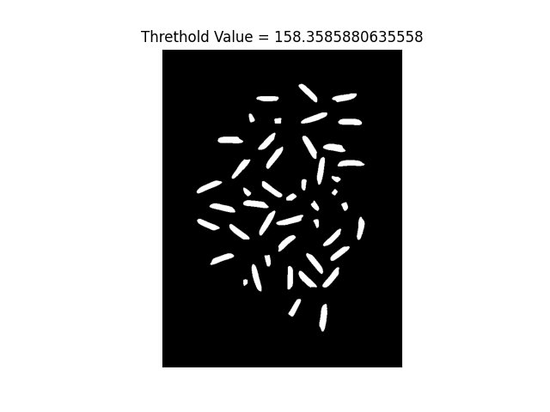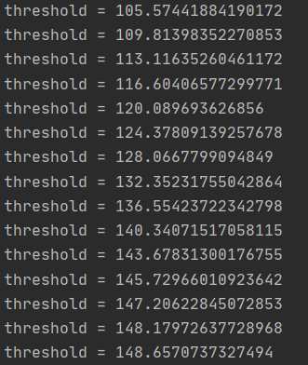

In the image “rice_img1_Task1.png”, I set the parameters as(threshold = 100epst = 0.01).

In the image6 and image7, we cannot set the initial threshold too small such as 0.5. Because this will lead some error. You can find that in the picture bellow. If you set the threshold as 1, we cant find correct image.

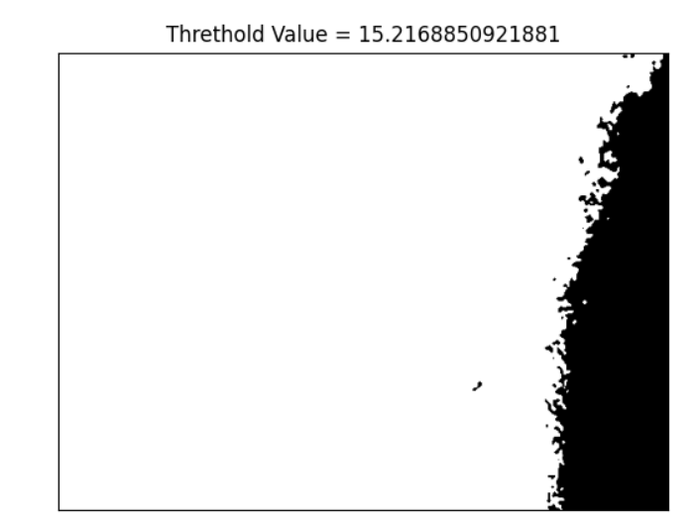

After we change the parameter to 100, we can get the correct answer.

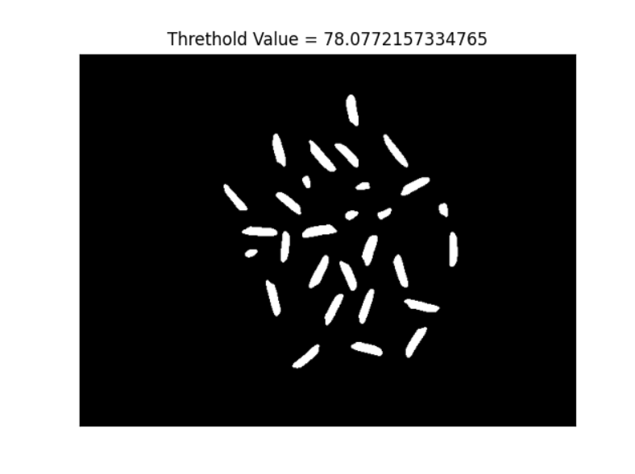

Task2

 





These four image is my result from task2. The number of kernels will be shown below.

number of kernels in image1: 45number of kernels in image2: 45

number of kernels in image3: 29number of kernels in image4: 34

The second round of searching is the difficulty of this problem. When I was doing this experiment, I was thinking about whether I can get the same result if searching in reverse order. The final answer shows that the corresponding result can also be obtained.

Task3

In the absence of min_area, I used the average value for this experiment and finally got good results in all four graphs.

The method I use is to traverse all the grids, the grids with the same color will be sorted into a dictionary. But we must remove the maximum value because the background will also be calculated.

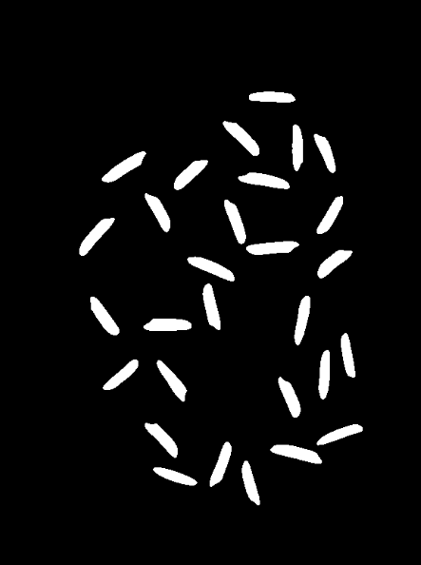

This is the result of image2. The percentage of damage kernels: 0.6590909090909091, when min_area = average value = 685.

Through this assignment, I realized the importance of adjusting parameters for image recognition.