*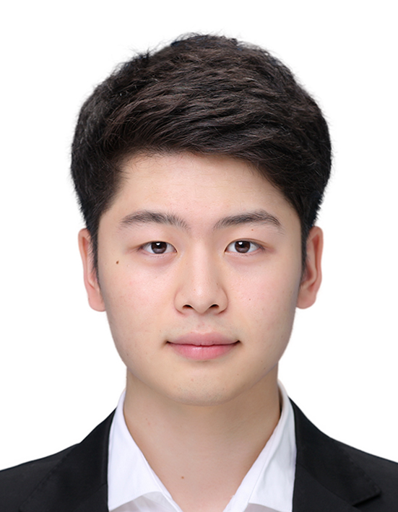***SEUNGJUN LEE**

*Curriculum Vitae*

**PERSONAL DETAILS**

*Birth* November 25, 1993

*Address* 851 PARR ROAD, WENTZVILLE, MO

*Phone*  (314) 295-0209

*Mail*  daekwan6@naver.com

**EDUCATION**

**Bachelor of Arts in Business Administration 2017 ~**

*Midwest University*

Now, I’m exchange student of Midwest University with j1 visa. And I’m studying Principles of Economics and Database Design & Management and ESL

**Bachelor of Arts in Media 2012 ~ 2017**

*Ajou University in korea*

In korea, I majored in Media at Ajou University. Especially, I learned illustrator and computer programming like web and android

**SKILLS**

*Languages* Korean (mother tongue)

English

*Computer related* c, java, android, jsp, html, css, javascript, php, illustrator

**CLASSES**

*Spring 2012* – Basic Design

*Spring 2015* – Computer Program Design

Computer Programming

*Fall 2015* – Game Programming

Social Media Programming

Object-oriented Programming

Graphic Design

*Spring 2016* – Mobile Programming

Web App Programming

Data Structures

*Fall 2016* – Operating System

Social App Project

**PROJECTS**

Android Game – My app development team made an app that children play. The app is game of learning letters. It helps children write and read letters on tablet pc

Android App – We made an app that informs tourist attractions in korea. The app informs users of the tourist attractions and check where they have been using the gps

HTML & PHP – I’m making webpage that manages academic things like student, subject… using html and php. It helps users check their student and register courses and manage grade