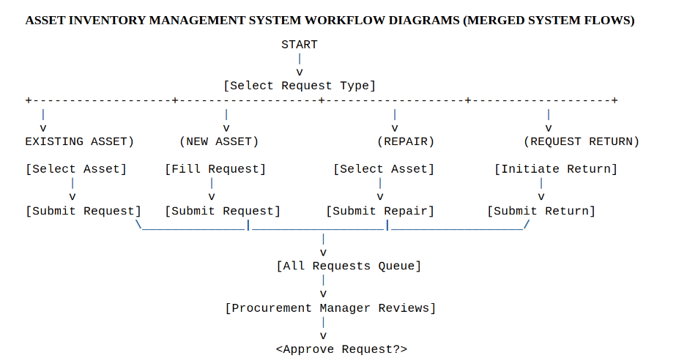
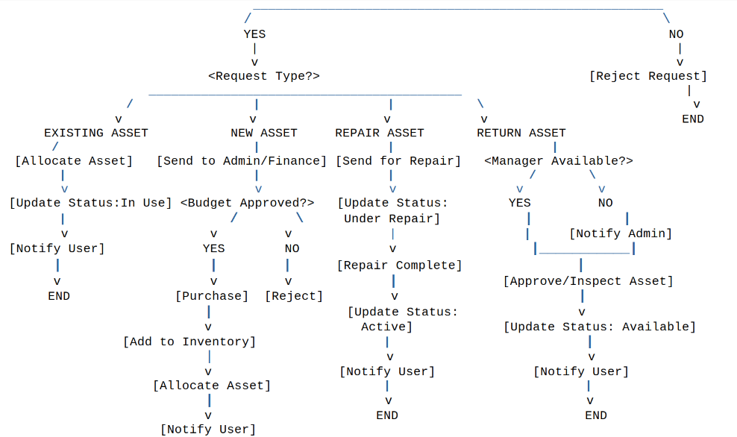


1. Overview
This document presents the unified workflows for the Asset Inventory Management System. It includes four key processes:
- Existing Asset Request for Use
- New Asset Request
- Asset Repair Request
- Asset Return
All workflows are integrated into a central approval process handled by the Procurement Manager.

2. Notes
- All requests pass through a centralized approval system.
- Only Procurement Managers approve or reject requests.
- Admin/ Finance approval is required only for new asset purchases.
- Admin acts as a fallback during asset returns.
- Each workflow ends with user notification and system update.

3. Diagram Legend
- [Process] → Action/Task
- <Decision?> → Decision point
- Arrows (↓) → Flow direction
- START / END → Workflow boundaries

2.

