1012ICT Assignment 2 – User Guide
Student Name: Scott Joseph McMullan

Student No: s2916255

Minesweeper X
2916255-BAC
Minesweeper X User Guide
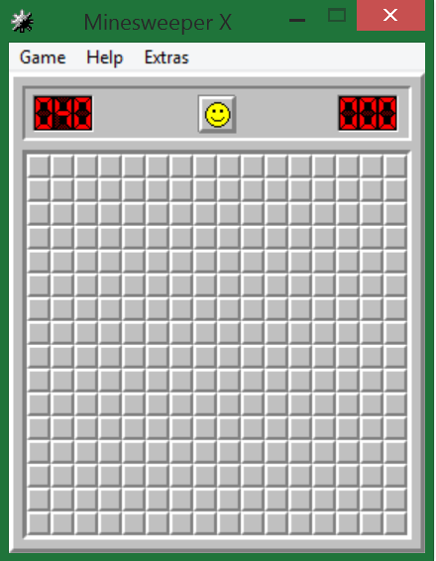

2916255 - BAC
Version 1.0
Approved by Scott Joseph McMullan
8th May, 2015.
Status – Approved.

Preface

Document information – This manual was written by members of The IT Dudes LLC., headed by John Smith, user project operations manager.
J. Smith mobile: 0401285696
Fax: +61 1300 881 674
The software was produced by Curtis Bright.
C. Bright email: cbright@gmail.com¹
Authors name – The main author of this document is Scott Joseph McMullan, with thanks to John Smith and John Hancock for assisting in the creation and distribution of this software user manual. Editing by Jane Doe.
Curtis Bright was the creator of the Minesweeper X program. All queries regarding the software aspect of this project is to be directed at Curtis Bright.
Revision history – The current version of this document is version 1.0, which was issued for release on the 8th of May, 2015. The main author of this document is Scott Joseph McMullan in co-operation with John Smith, John Hancock and Jane Doe.
Software Packages – Software packages used to produce this manual include the following;
- Microsoft Word 2010
Used to write up the digital document and incorporate the images and suitable formatting of the text.
- Minesweeper X
Used as the main focus for the user manual. This program supplied the suitable screenshots present in this document.

Copyright © The IT Dudes, LLC, 2011. This publication is copyright and contains information which is the property The IT Dudes, LLC. No part of this document may be copied or stored in a retrieval system without the written permission of The IT Dudes, LLC.

Contents
Preface 2
1. Introduction 2
1.1. Audience description 2
1.2. Applicability statement 2
1.3. Purpose statement 3
1.4. Document usage description 3
1.5. Related documents list or information 5
1.6. Conventions description 6
1.7. Problem reporting instructions 6
2. Using Minesweeper X 7
2.1. Scope 7
2.2. Materials 8
2.3. Preparations 9
2.4. Cautions and Warnings 10
2.5. Method 11
2.6. Related Information 14
2.7. Error messages, known problems & error recovery 14
3. Appendixes 15
4. Bibliography 15
5. Glossary 16
6. Index 17

Introduction
This document contains various topics of information regarding the use of the program “Minesweeper X”.
Entailed throughout this document are specific sections of information which clearly and efficiently lays out the essential information to help inform the user of the Minesweeper X program.
The document is split up into two main sections;
- Introduction
- Contains information to do with this document itself and the documentation of the program.
- Using Minesweeper X
- Contains essential information to do with the program itself, how to play, various warnings and error messages.

Audience description
The intended audience for the game is designed for people of all ages, but is more specifically for those over the age of 10 who have some problem solving abilities. Minesweeper X requires the users to have no specific experience level. The audience are not expected to have any assumed knowledge in the area of the game, only basic knowledge of external computer peripherals such as the mouse. Minesweeper X is designed for anyone to play and learn the game; it does not specifically include or exclude any particular set of people.

Applicability statement
The current software version of Minesweeper X being documented is; version 1.15²
Hardware is very basic and is accepted if you have the windows Operating system of Windows XP or higher.
Windows XP or higher is required to play.

Purpose statement
The software was originally written as a standard basic game, included in Microsoft Windows 3.1. The purpose of the software was to include a set of basic games with the release of the Microsoft operating system. Typical intended use of the software include recreational and competitive. Minesweeper X is seen as a recreational game due to its addictive and interesting concept, which is seen to be entertaining to the user. Minesweeper X can be used as a competitive element as the counter provides users with a ranking system on who has the better score, which ultimately decides who is better. The option to record gameplay and statistics further enhances this competitive level.

Document usage description
This manual is divided into six sections. Section 1: Introduction The introduction section of this manual is all about the basic information regarding the documentation of the program. It includes topics such as;
- Audience description
- Applicability statement
- Purpose statement
- Document usage description
- Related documents list or information
- Conventions description
- Problem reporting instructions

Section 2: Using Minesweeper X;
The ‘Using Minesweeper X’ section of the manual entails the information regarding how the program runs and how to play it. It also includes all relative information regarding the practicality of the game.
It includes topics such as;
- Scope
- Materials
- Preparations
- Cautions and Warnings
- Method
- Related Information
- Error Messages, known problems and error recovery.

Section 3: Appendixes;
The appendixes section of the manual includes any material which supports or augments the information given in the main part of the manual.
Section 4: Bibliography;
The bibliography section of the manual includes a list of any publications that may have been quoted or referenced in the manual. Where applicable, other sources containing related information can also be included to point a curious reader in the direction of further information.
Section 5: Glossary;
The glossary section of the manual includes a definition for all terms, acronyms and abbreviations used in the manual with which the read may be unfamiliar with.
Section 6: Index;
This section of this manual incorporates an index, based on key words and concepts, for any user document greater than eight pages in length.

Related documents list or information
Minesweeper X includes a .hlp file which is a related document that aids to this document in providing information and development logs on the program.
The .hlp file includes;
- Descriptions;
- Menu options
- Game menu
- Extras menu
- Custom
- Marks
- Best times
- Exit
- Information on the ‘help Menu’
- Objectives of the game
- How to play the game
- Strategies and tips
- About
- Version History

Minesweeper X also includes a website which includes topics on the program such as;
- Features of the game
- System requirements
- Minesweeper X skins
- Minesweeper X high scores

Conventions description
Symbols – All listed information which falls under a subsequent heading in the text is indicated by a simple bullet point.
Information covered under a simple bullet point is indicated by a dash.
Information enclosed in ‘ ’ tags relates to the naming of specific sections or name of the program.
Style - All major headings are stylised as 16pt. font with 0 tab index and underlined.
All major subheadings are stylised as having 16pt. font a tab index of 1 and underlined.
Basic text is stylised as having a 12pt. font and a tab index of 2.
Menus will have a tab index of 1 and include the various headings-to-text ratios regarding text size, 3-2-1 and bold font face for the headings. An extended ellipsis will accompany menus such as the context page to indicate a page number for each heading and subheading.
Text which is highlighted in bold is to be considered relative and important text, possibly for headings or to be taken note of.

Problem reporting instructions
Reporting problems is an essential part of being a software user. Listed below are various instructions which can help you report problems if they arise in the program.
Reporting software problems requires you to e-Mail the creator of Minesweeper X, cbright@gmail.com.
In the e-Mail description, reference when the problem occurred and what happened, be as detailed as you can.
The reader can also use the e-Mail function to submit suggestions for changes in the software or the document. The reader can also suggest and send ‘skins’ for the visual layout of the program.
The contact information for the person responsible for responding to reports and suggestions for improvement is Curtis Bright. cbright@gmail.com.

Using Minesweeper X
The ‘using Minesweeper X’ segment of this document is technically the body of the document. This segment contains various subheadings of information which contain subsequent information relating to aspects of the program itself and the operation/error messages.
The various subheadings and topics discussed in detail of this segment include the following:
- Scope: Scope involves getting information required to start a project, and the features the product would have that would meet its stakeholder’s requirements.
- Materials: This section includes the materials the user will need to complete the task.
- Preparations: Involves any action, technical or administrative, that should be done before starting the task
- Cautions and Warnings: Describes any general cautions and warnings that apply to the execution of the program.
- Related Information: Includes any useful information about the task.
- Error messages, known problems, & error recovery: Provides a list of error messages as well as their causes and fixes.

Scope
Project justification information
The justification for this particular user manual is to inform the user about the program Minesweeper X. Business need and customer request are two project justifications allocated to this manual.
Project Product
With the release of this document, users of the program ‘Minesweeper X’ will effectively be able to use the program for its correct functions. The users will also be able to efficiently partake in the updating and maintaining of Minesweeper X due to the ‘feedback’ and error reporting functions.
Project Deliverables
The project is to deliver a completed user manual for the use of Minesweeper X users. This user manual includes information on the documentation and purpose side of the program as well as how to actually use the program and it’s various functions.
Project Objectives
The main objectives of this document, is to allow the users of Minesweeper X to efficiently use the program and understand warning and error signs, if they occur. Ultimately, the user is expected to have gained a further understanding in the

Materials
The materials section of this document is quite simplistic. All the materials required to the complete the tasks are very general.
The primary requirements include;
- A computer with Windows XP or higher
These OS’s are needed for the program to run.
- The program Minesweeper X
This is the program used to play the game.
- Computer peripherals
- Mouse
- Keyboard
- Monitor
Used to effectively run, use and view the program.
- Minesweeper X user manual
Used to help the user with various elements relating to the software.

The secondary requirements include;
- An active email account.

Preparations
Before usage can commence on the program, some preparations are to be made in order to ensure the program can actually run and be it as efficiently as possible.
Firstly, an appropriate amount of disk space is required to run the program. Without a suitable about of hard drive space, they program will unable to be loaded onto the computer, therefore not allowing a program to exist on the machine to execute. 223KB’s is considered to be the minimum about of disk space required to execute the game.
Secondly, an administrator’s account access is requested to be able to execute the program. Depending on the account setup on your computer, an administrator’s password may be requested before you can execute and run the game.
Finally, suitable computer peripherals are to be expected already. Suitable peripherals include;
- Mouse
- Keyboard
- Monitor

Cautions and Warnings
Through thorough testing of the software file and subsequently 15 different versions2 of the programs, cautions and warnings are almost non-detected.
The only two cautions/warnings to be detected are detailed below:
- Play recordings: When the user is prompted to locate the .mvr (Minesweeper X Video Recording file) if they choose a file which is not an .mvr, a warning message is produced to remind the user that their selection wasn’t an .mvr file. (As shown in figure 1.0)
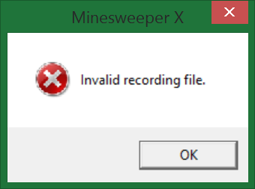
Figure: 1.0
- Custom skins: When the user is prompted for the selection of a custom skin for the layout of the program, if the user chooses a file which is not an appropriate .bmp file, the user is prompted with a similar warning message indicating their selection was not appropriate. (As shown in figure 1.1)
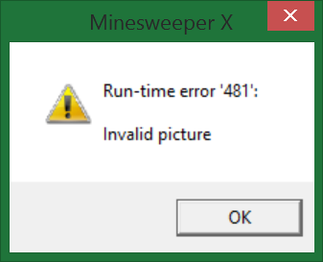
Figure: 1.1

Method
The aim of the game is to determine the location of a set amount of ‘mines’ located throughout the square grid of the screen³. If a hidden square is clicked that contains a mine, the game will be terminated with a failure indication.
A random left-click anywhere on the playing field will initiate the location of the mines and clear some space to reveal some numbers.
These said numbers indicate the amount of mines immediately surrounding that individual square, top, bottom, left, right and all diagonals. (As indicated by figure 2.1)
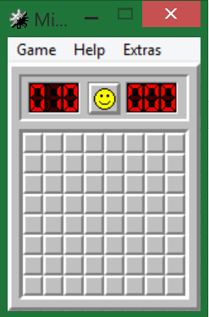 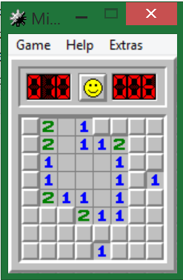
Figure: 2.1
If you suspect a hidden square to contain a mine, a simple right-click will ‘flag’ the square as containing a suspected mine. (As indicated by figure 2.2) That square will then be protected from accidental miss-clicks which will cause the game to end.
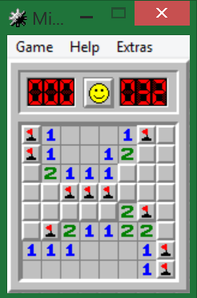
Figure: 2.2
If a mine has been left-clicked before it has been flagged, the game is over and you lose. (As indicated by figure 2.3) Immediately, the remaining mines are then exposed to show the user where the locations of the mines were and which ones you had flagged.
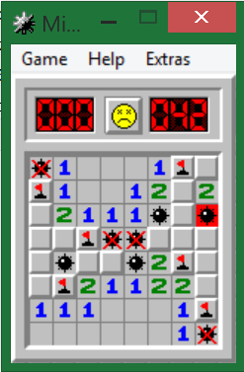
Figure 2.3
Once all of the mines have been successfully flagged, the smiley face at the top centre of the window will change to one with sunglasses on. This is indication that you have successfully completed the level and have swept the mine field without casualty. (As indicated by figure 2.4)
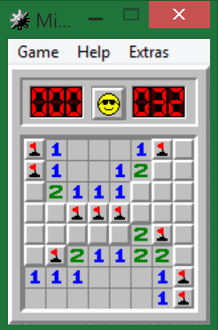
Figure 2.4

Termination
There are multiple ways to terminate the game. Terminating the game doesn’t always mean you lose. Different ways to terminate the game include;
- Starting a new game: By pressing F2 a new game is created, terminating the previous one. The game before was neither lost nor won.
- Closing the window and terminating the program: By selecting the red X in the top right hand corner, the game is terminated and the program is shut down. Alternatively, selecting ‘Exit’ from the ‘Game’ drop down menu yields the same results.
- Losing the game: If you left-click a mine, before it is flagged, the game is over and you lose. Ultimately the game is terminated and your choice to start a new one, exit the program or check your stats is to be made.
- Winning the game: If you successfully flag all of the mines, the game is terminated and you win. The program then awaits your decision to create a new game, terminate the program or check your stats.
Errors
Through extensive testing of this program, no errors were found.
The only possible error which could be initiated is an improper operating system.
For this to occur, the user must be trying to execute the program on an operating system other than Windows 95 or higher, or alternatively on Wine and Linux/Mac. In order to solve this problem, executing the problem on an operating system which is windows 95 or older will enable the program to run unhindered.
Results
Executing the program on an operating system such as windows 95 or older will see the program running efficiently and as listed above in the method segment.
Executing the program on an operating system earlier than Windows 95 will see it unable to execute.

Related Information
Throughout the execution of this program, there are little tasks done frequently together. The only task done in some form of relative manner is the act of revealing blank squares to reveal wither a mine, blank square or a number and the act of right-clicking a square to flag it. These two tasks are considered to be frequently done together in fashion.

Error messages, known problems & error recovery
Errors and known problems are minimal in Minesweeper X, being only one. The only known error is detailed below:
The error
Executing the program from a computer which does not have Windows 95 or higher installed as the primary operating system installation.
Recovery
Executing the program from an operating system such as Windows 95 or older will enable the safe and efficient execution.
Actions
The actions required to clear the error include executing the program from an operating system such as Windows 95 or older.
Known software problems
There are no known software problems; however, if any are encountered by users, they should direct an email to Curtis Bright, the creator of Minesweeper X. cbright@gmail.com¹

Appendixes
1. e-Mail supplied by Curtis Bright. http://www.curtisbright.com/msx/
2. Version history supplied by Curtis Bright. http://www.curtisbright.com/msx/
Help file txt
3. Aim of the game, supplied by Curtis Bright.
Help file txt

Bibliography
These publications below have been quoted or referenced in the manual. Also included in the publications below are sources of further information for curious readers:
Bright, C. (2003). Minesweeper X. Curtisbright.com. Retrieved 8th May 2015, from http://www.curtisbright.com/msx/
Bright, C. (2011). Minesweeper X (Version 1.15). MinesweeperXhelp.txt. (2015) (15th ed., p. All). Retrieved from http://www.curtisbright.com/msx/

Glossary
All terms, acronyms and abbreviations used in the manual with which the read may be unfamiliar.
User manual: A document created by the manufacturer of a device that provides detailed installation and operation instructions.
Execution: Execution in computer and software engineering is the process by which a computer or a virtual machine performs the instructions of a computer program.
OS: An operating system (OS) is a collection of software that manages computer hardware resources and provides common services for computer programs.
Windows: a GUI operating system for personal computers.
Wine: Wine is a free and open source software application that aims to allow applications designed for Microsoft Windows to run on Unix-like operating systems.
.hlp: Microsoft WinHelp is a proprietary format for online help files that can be displayed by the Microsoft Help browser winhelp.exe or winhlp32.exe. The file format is based on Rich Text Format.
KB: The kilobyte (KB) is a multiple of the unit byte for digital information used in storage.
Administrator: An administrator account is a user account that lets you make changes that will affect other users.

Index
Version 1, 2, 5, 11, 15.
Mine 12.
Flagged 12, 13.
Warning 1, 2, 3, 8, 9, 11.
Error 1, 2, 4, 8, 9, 13, 14.
Windows 2, 3, 9, 13, 14.
Curtis Bright 2, 7, 14. 15.
Disk space 10.
Peripherals 2, 9, 10.
Termination 13.
Administrator 8, 10.

