Group:3.10

# Relational:

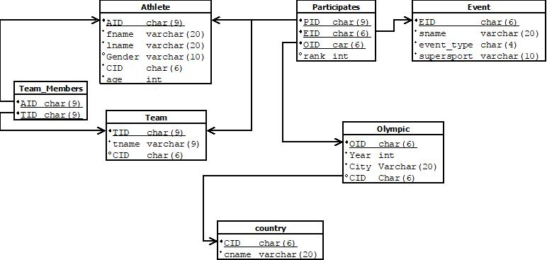

# ER:

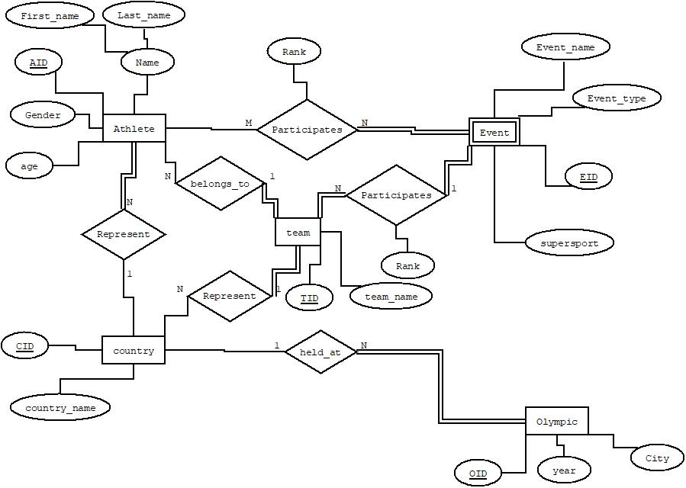

**Functional Dependencies:**

* **Olympic:**

OID -> {year, city, country_name}

key : OID

Normal Form : BCNF

* **Country:**

CID -> {country_name}

key : CID

Normal Form : BCNF

* **Athlete:**

AID -> {Gender, age, name, country_name}

Key : AID

Normal Form : BCNF

* **Event:**

EID -> {Event_name, supersports , Event_type}

Key : EID

Normal Form : BCNF

* **Team:**

TID ->{tname}

key : TID

Normal Form : BCNF

* **Participates:**

{AID, EID, OID} ->{rank}

key : {AID, EID, OID}

Normal Form : BCNF

* **Team_member:**

key : {AID,TID}

Normal Form : BCNF