CSE423: Fall ’24

Hill Climb Racing (Simplified)
Group 02 - Section 05: Project

Members

ID | Name
21101096 | A.B.M DANIAL
22101671 (NewID: 24241257) | SHAFAAT JAMIL NAKIB
22101728 | RABAYA FARZANA SIKDER

Game Specifications:
Drawing Mechanics:
- The entire game world, including the car, hills, collectibles, and the environment, must be drawn using the Midpoint Line and Midpoint Circle Drawing Algorithms, with only the GL_POINTS primitive type allowed.
Car Mechanics:
- The car consists of a rectangular body and two circular wheels, which move horizontally based on user input ('a' and 'd' keys for left and right movement, respectively).
- Gravity and collision physics are applied to the car, ensuring it adheres to the terrain and does not fall through the hills.
Terrain Generation:
- The terrain (hills) is procedurally generated as a sinusoidal wave using a set of points. Hills have varying heights and smoothly connect to simulate a natural, rolling terrain.
Collectibles and Scoring:
- Coins and fuel cans are placed along the terrain as collectibles.
- Coins provide points, while fuel cans extend the game session by replenishing the car's fuel supply.
- Players must navigate the terrain to collect items without tipping over or running out of fuel.
- Score will be rendered on the screen GL_BITMAP and also logged in the console.
Game Rules and Objectives:
- The objective is to drive as far as possible, collecting coins and fuel while navigating the terrain.
- Collision detection ensures that the car interacts with hills and collectibles correctly. Missing fuel cans can cause the game to end when fuel runs out.
- The game ends if the car flips upside down or runs out of fuel.
Restart and Pause/Resume:
- Players can pause the game using the spacebar (' '), halting all animations and inputs.
- The game resumes from the same state when unpaused.
- Pressing the ‘r’ key will restart the game, printing the final score on the screen

Project Inspiration:

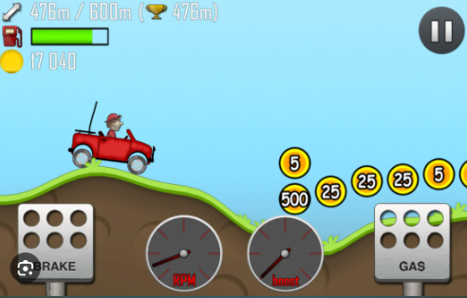

Gameplay Video: Hill Climb Racing - Gameplay Walkthrough Part 1 - Jeep (iOS, Android)

