CHASM and QuEStA code development and application

GRAPHICS – GUI DESIGN

Just ideas so far…

Menus

File
New
Open
Save
Close
Export image | JPEG, PNG etc. for reports
Properties | When simulations were run, and by whom.

View
Tile windows | If there are more than 2 slope windows open
Zoom | For the slope windows
Show scale | Show the scale (for the slope windows)
Slope Parameters…
 Soil strata | Options correspond to the buttons on the toolbar (see 1.2). For the active slope window the user can chose which parameters to display
Water table
 Slip circle
Geometry
Moisture content
Pore water pressure

Tools
Create snap-shot | Initial conditions
Create movie | Save for presentations etc.
…

Help
Viewer help
QuEStA Manual | pdf
…

Tools

The user can use buttons to decide which aspects of the slope they want to see (same as selecting slope parameters in 'view' menu):

Mesh: Soils
OR Pore-water pressure
OR Moisture Content

Overlay: Nothing
OR Slip Circle
AND/OR Water Table

Vectors: Slope sections (coordinates and vectors with no mesh) and no overlay

Other tools: 'Movie player' and zoom buttons

Dashboard

This allows the user to see specific slope and cell parameters and model results from the active slope window. Because there are lots of parameters they need to choose which of the following themes to view (column 1 = parameters to view; column 2 = comments):

Navigator (always open)
Time (h) | timestep
FoS | Factor of Safety for that timestep
Column | user-selected col/cell for viewing cell-specific parameters (see 'cell parameters', below)
Cell

Geometry
Section | slope section selected by user (type section number in)
Height (m) | section height
Surface (m) | section surface length
Angle (deg) | section angle

Rainfall
Intensity | hourly intensity for hour selected in navigator
Storm type | scenario/real/design
Storm probability
24 hr total | cumulative rainfall
x hour total | eg. user might want to see total rainfall for previous 72 hrs

Cell parameters
c'
phi' (deg)
Ksat (ms⁻¹)
theta (m³m⁻³)
u (KNm⁻²)

Slip Circle
Centre | (x,y)
Crest | (x,y)
Toe | (x,y)
Radius (m)

Landslide
Depth (m)
Runout dist.(m)
Runout vol (m³)
Clear vol (m³)
Cut vol (m³)

GUI prototype:  1 slope window  Rainfall window  Menus  Toolbar with buttons?  Navigator | 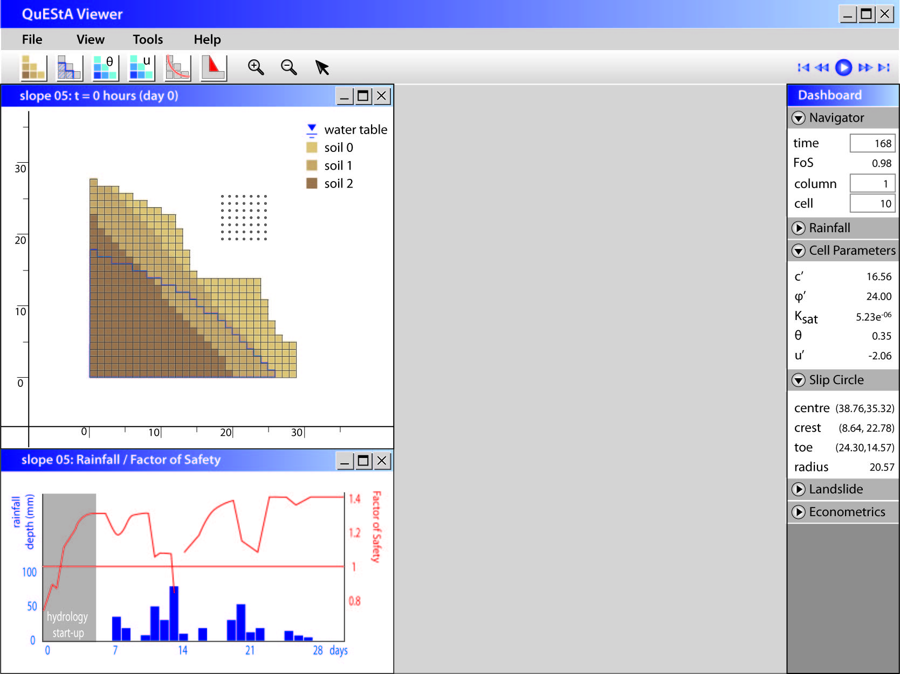
GUI Final version  Prototype plus…  Multiple slope windows (room for 2 at a time in a 800x600 pixel screen)  Zoom on rainfall for long simulations  … | 