CHASM and QuEStA introduction

CHASM (Combined Hydrology and Stability Model)
Integrated slope hydrology/slope stability software package that aids the assessment of slope stability conditions. It is designed to help the user estimate the effects on slope stability of selected storm events, surface covers, slope plan curvatures and other important slope and material properties.

CHASM development:
- Original code written by Malcolm Anderson about 15 years ago – the first slope stability code to incorporate dynamic hydrology
- Finite difference forward explicit solution of unsaturated and saturated slope hydrology (weathered materials rather than rock)
- Additional features added in research and commercial codes: research code only: stochastic soil properties; both versions: reinforcement, vegetation, slope divergence/convergence, seismic acceleration; commercial code: landslide runout, loading and point water-sources.

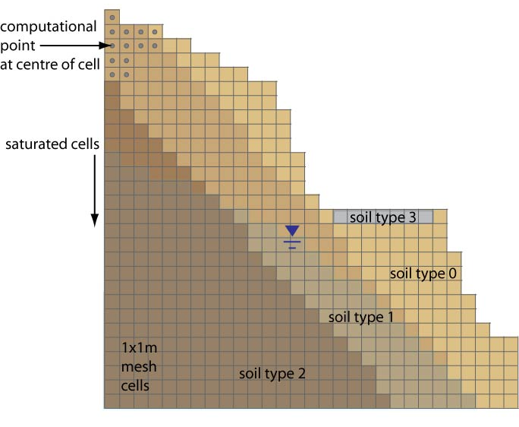
CHASM mesh – slope geometry, soil strata and water table

QuEStA (Quantitative Econometric and slope Stability Analysis)
QuEStA integrates CHASM with four new model components to allow the simulation of cut slopes on a road network over their engineering or budget-cycle lifetime. So far 30 slopes have been modelled on a road network on the island of St Lucia. The code currently models each slope separately (independently from the rest). Condor has been used to batch process these model runs (from a few minutes to a couple of days per simulation).

QuEStA model components:
- Slope model: automated generation of CHASM input files (initial slope geometry, landslide remedial measure, soil strata and initial watertable) at beginning of project lifetime and after every landslide predicted by CHASM.
- CHASM (called by QuEStA)
- Engineering Cost Model: cost and time to clear landslide from road and reinstate slope; and the cost of remediation measures if required.
- Road User Cost Model: Road Network and Traffic Assignment Model to determine volume of traffic delayed and diverted (thus, the cost incurred to road users).
- NEPV Cost Model: To enable Cost Benefit Analysis of proposed landslide remediation measures the Net Expected Present Value of all landslide and remediation costs is calculated.

Remote access to QuEStA (Quantitative Econometric and Slope Stability Analysis)

Aim: to enable engineers and technical officers in developing countries to have access to the QuEStA software as part of the MoSSaiC
programme.
- Providing a decision-making and landslide hazard assessment tool in an environment where such capabilities do not currently exist
- Providing this tool in an accessible way – without the need for extensive computing and software ‘know-how’ or maintenance in such countries.

Method:
- Develop a QuEStA website and webform (Dr Jon Wakelin).
- Develop a GUI for post-processing results

Step 1 – the user logs in to the QuEStA Online website and uses the web form to enter field data for a specific slope
Step 2 – the web form generates QuEStA input files for that slope
Step 3 – the input files are submitted, along with the QuEStA executable, to a UoB condor cluster (Dept. Physics)
Step 4 – the simulation results are made available on the website for the user to download as text files
Step 5 – the text files are processed locally using a bespoke GUI to generate graphics for easy analysis of the results

Example screen-shots from the prototype website

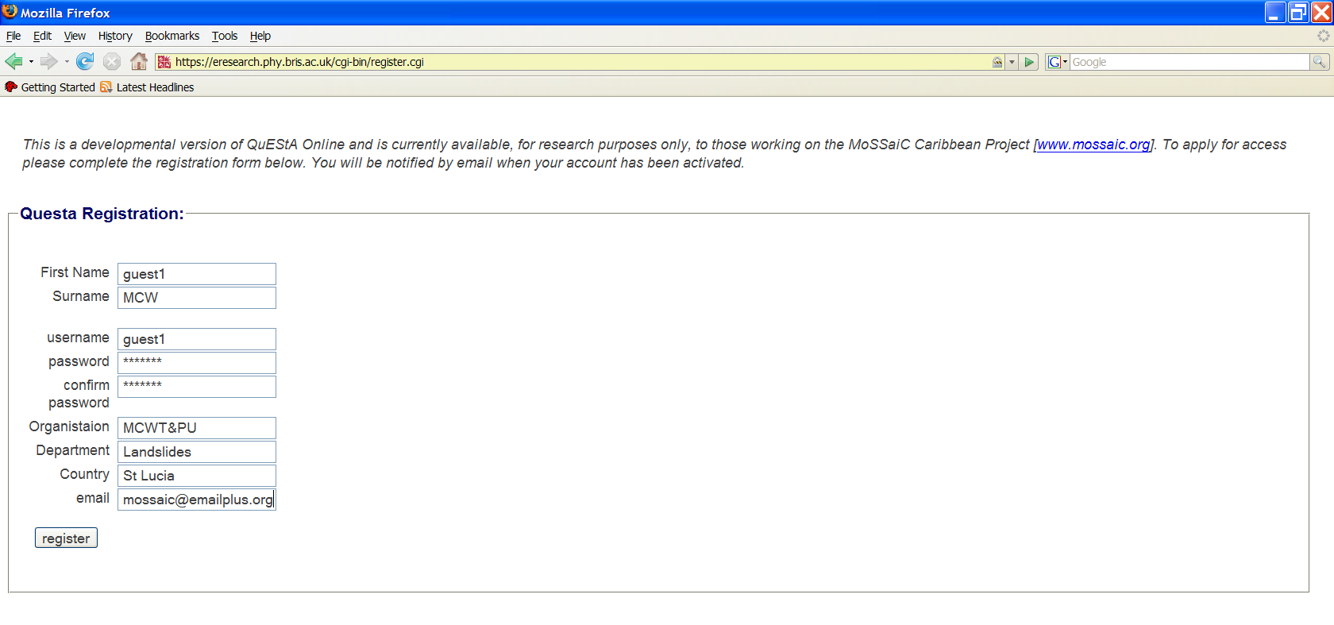

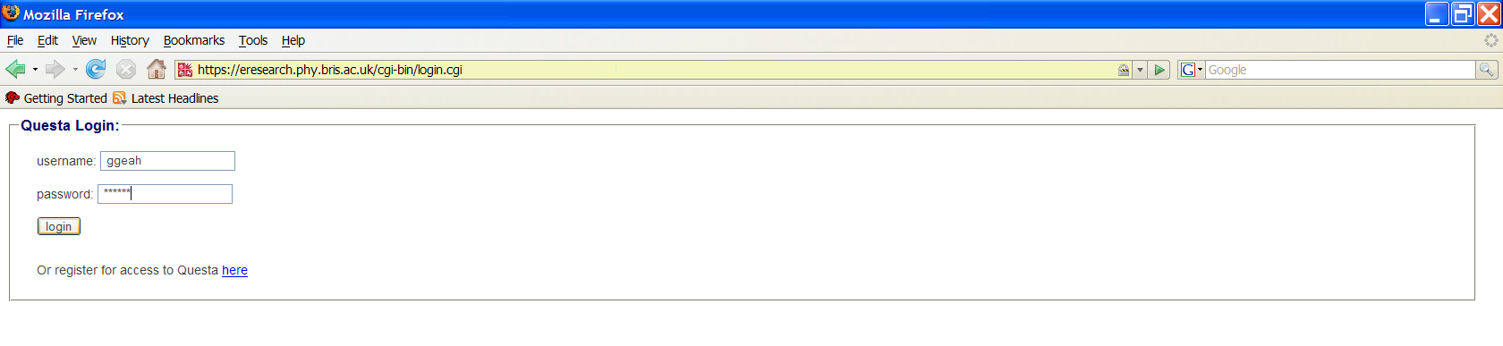

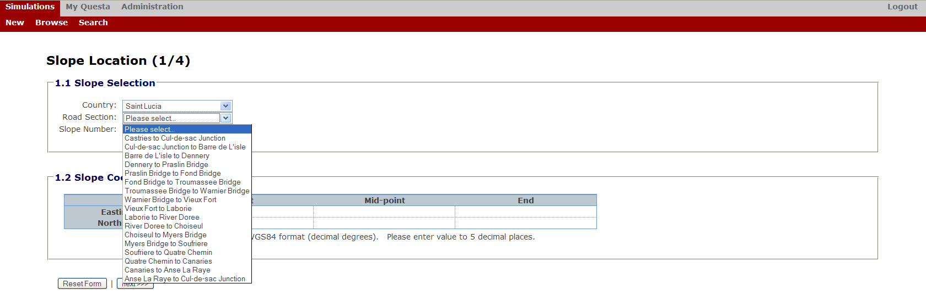

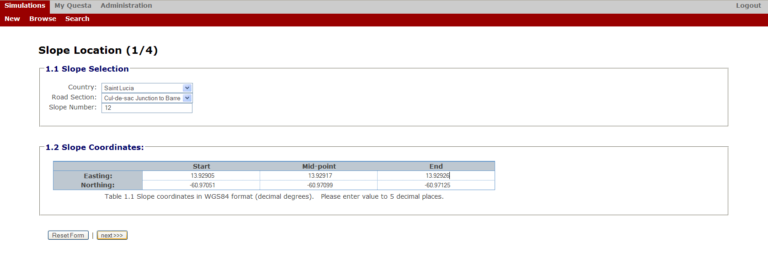

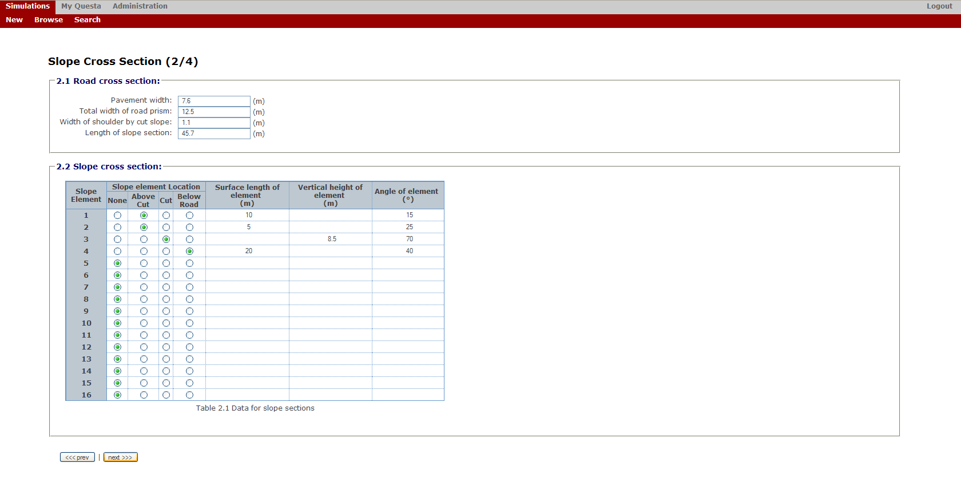

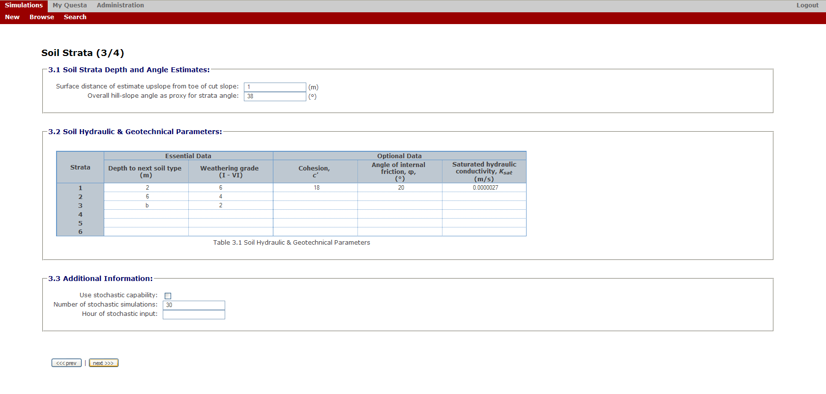

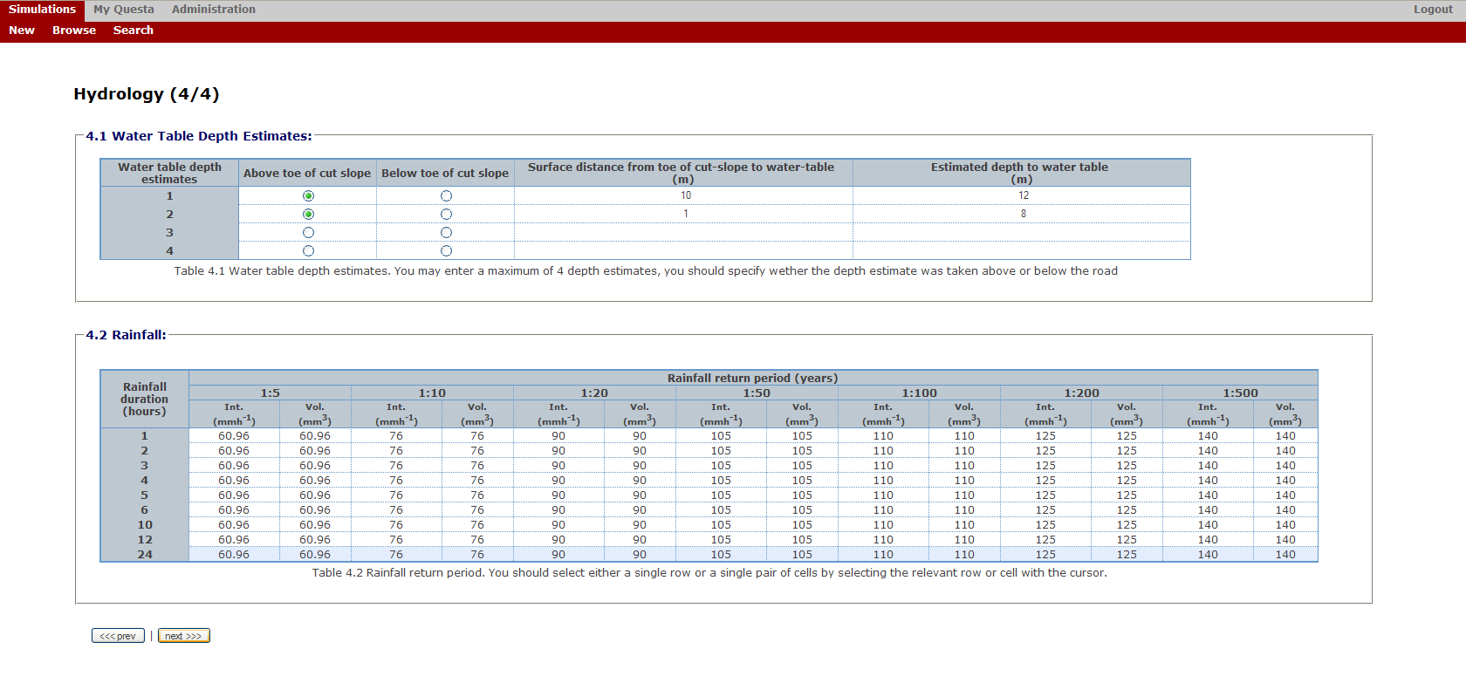

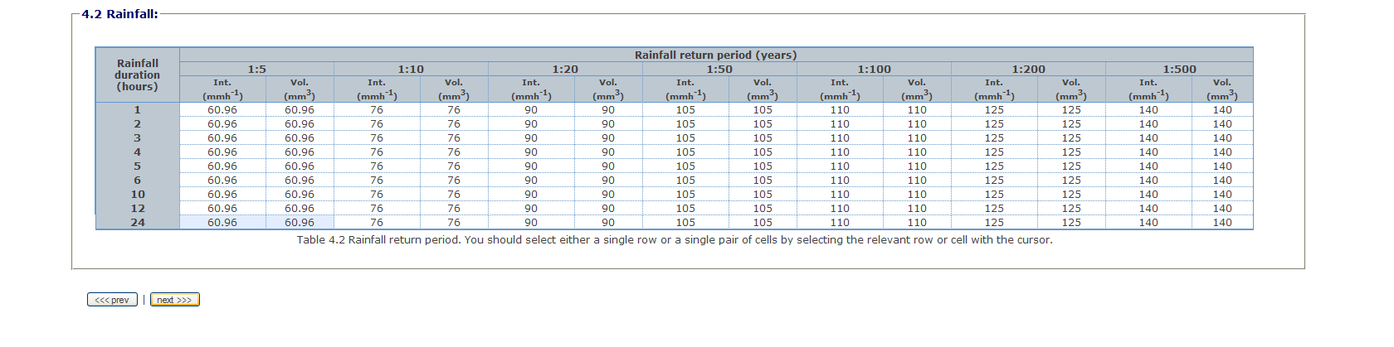

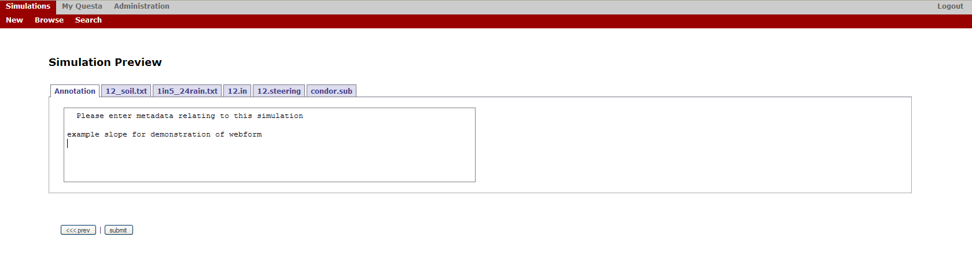

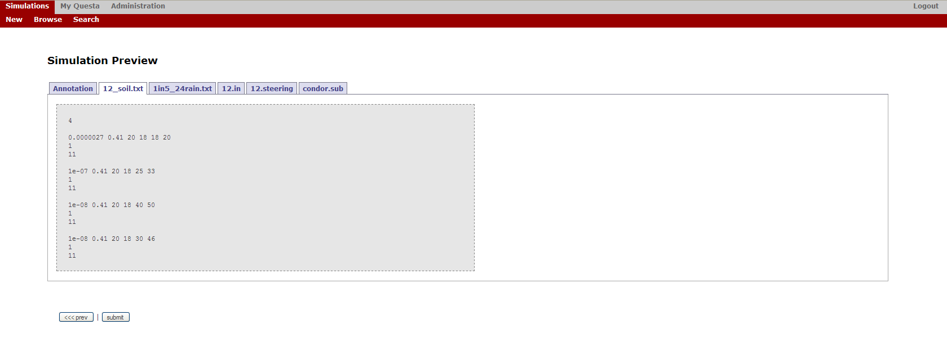

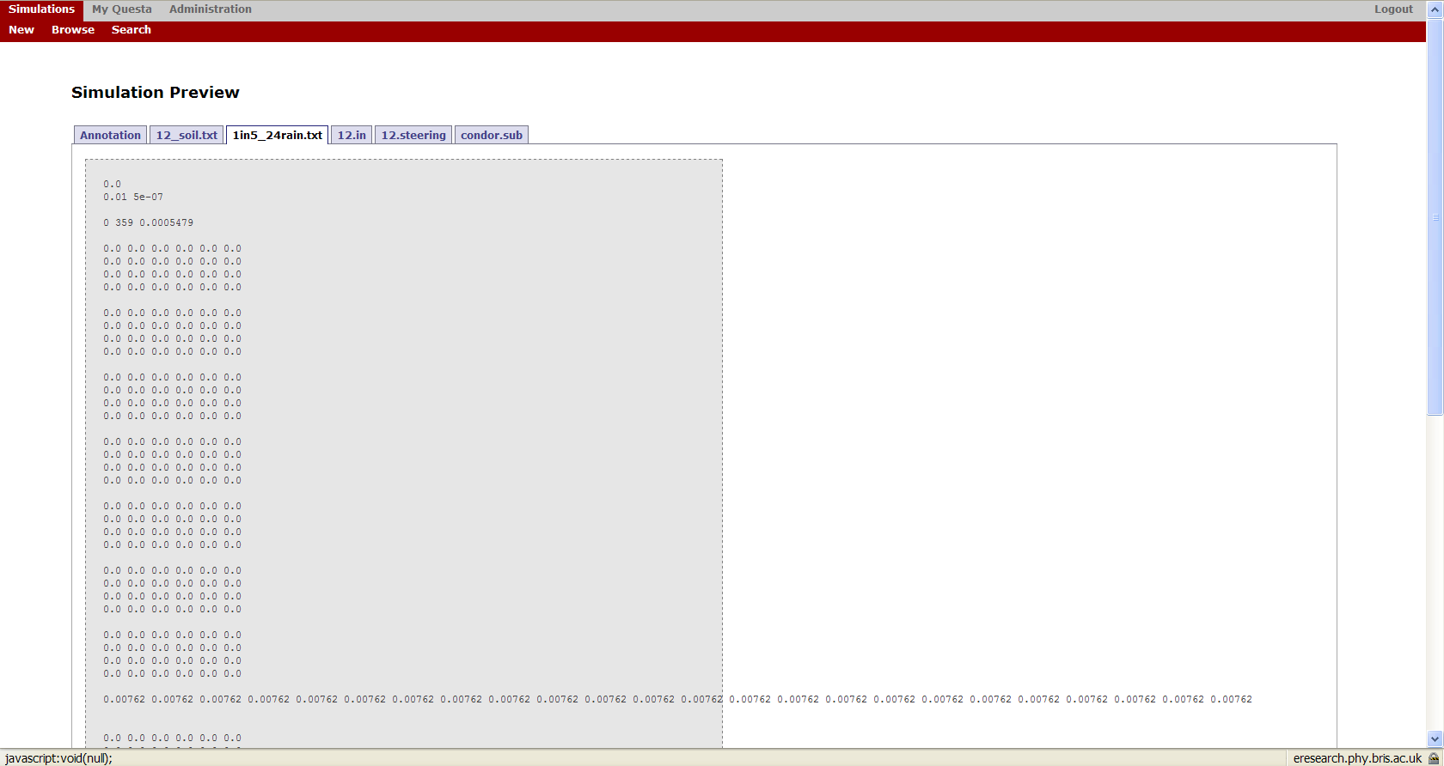

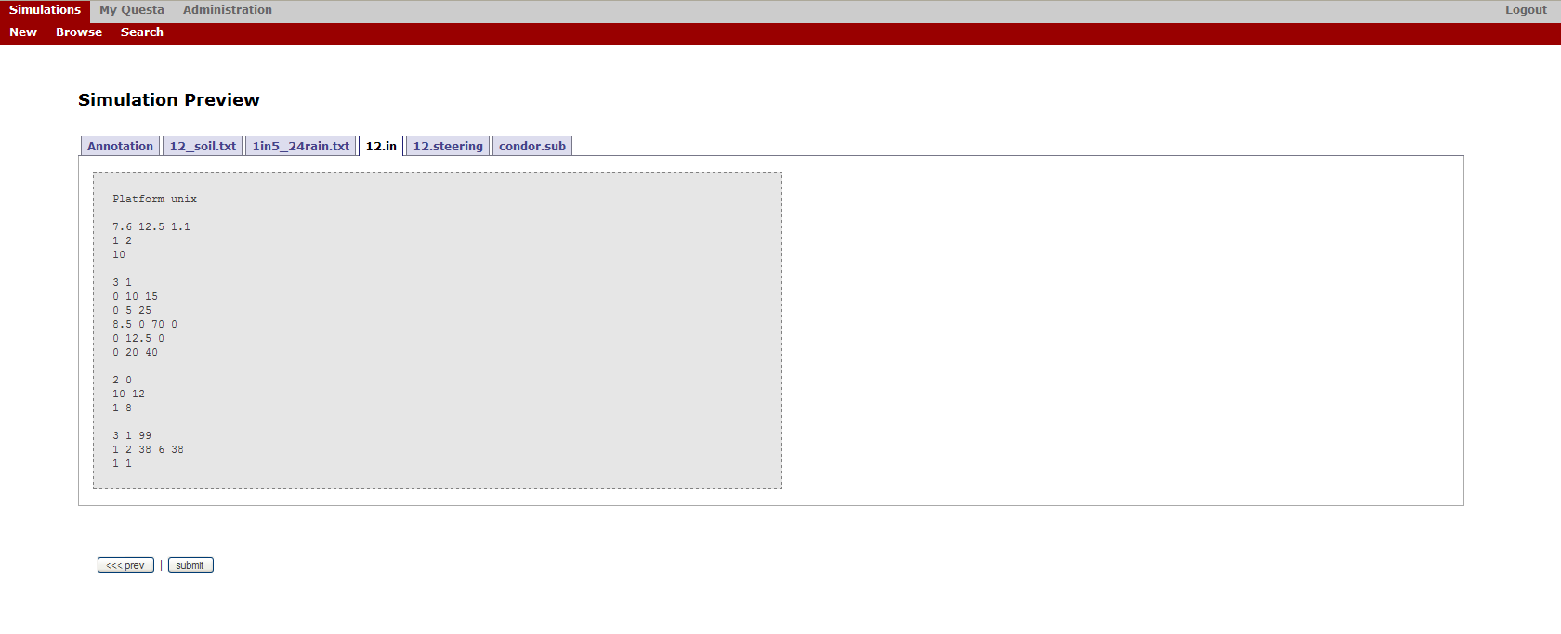

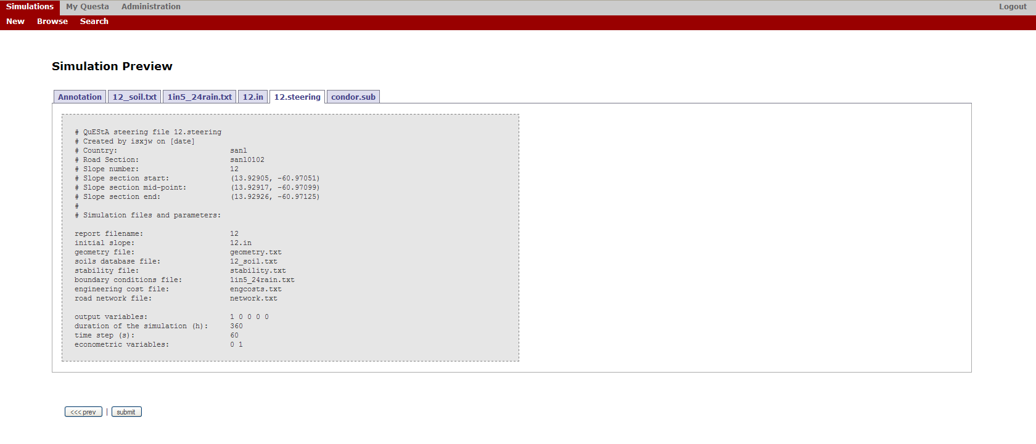

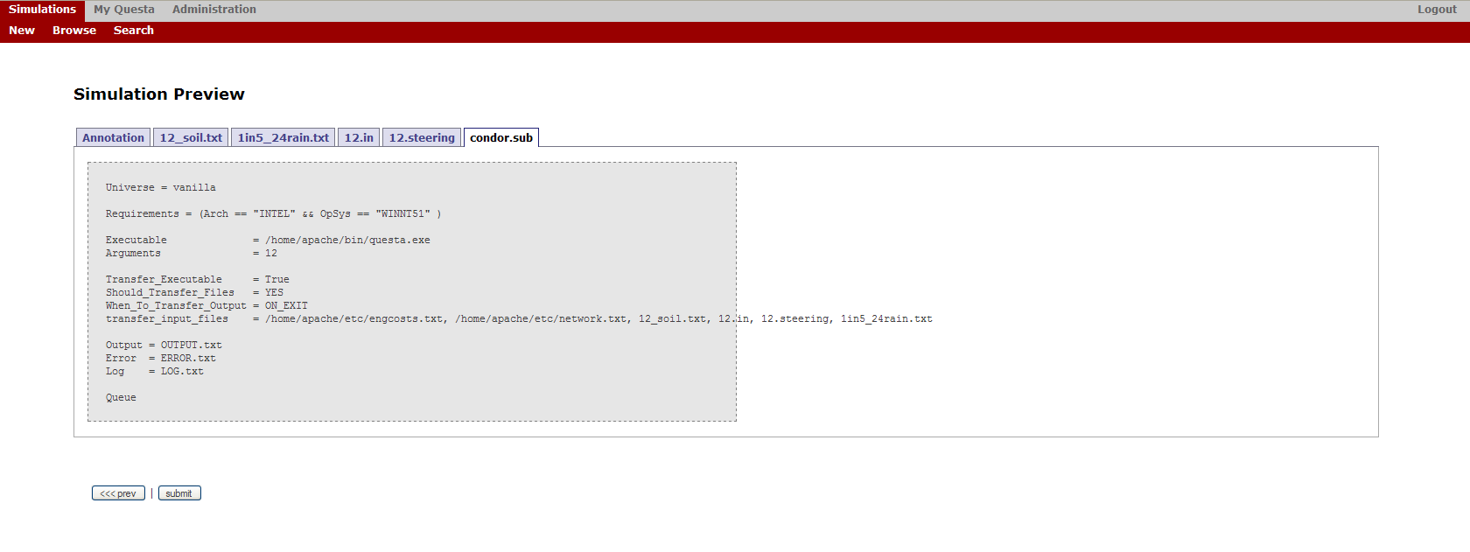

Review results



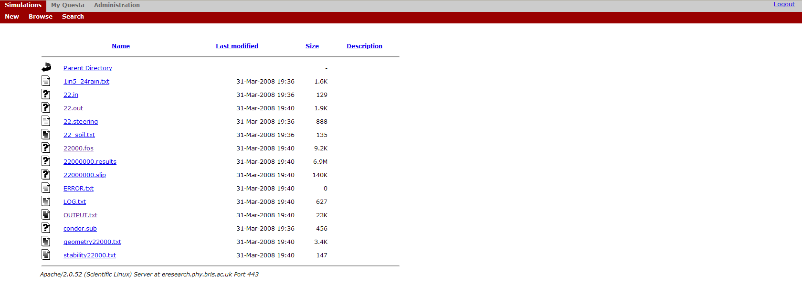

(Management of Slope Stability in Communities – initiated and managed by Prof. Malcolm Anderson and Dr Liz Holcombe for developing countries in the Caribbean)

