CHASM and QuEStA code development and application

GRAPHICS

Development of CHASM and QuEStA remote access and visualisation

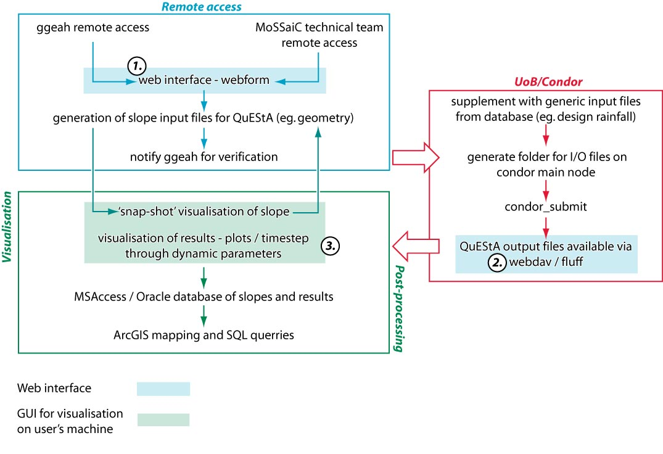

Visualisation requirements

Pre-processing snap-shot

User needs to check that the slope profile they have generated for processing is correct in terms of its geometry, soil strata and water-table.
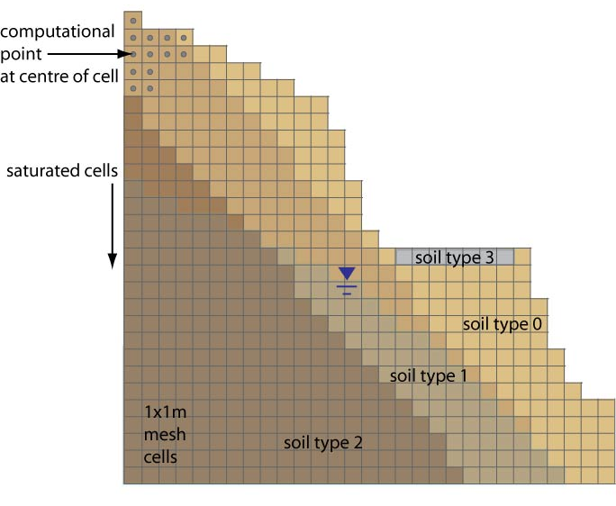
CHASM mesh – slope geometry, soil strata and water table

Post-processing analysis of results

Line / scatter plots

Data:
- Factor of safety (scale: 0.5 - 4) vs time (hours)
- Rainfall (mm) vs time (daily = default mode, or daily + cumulative = zoom mode)
- Combined FoS and daily rainfall plot over time

Timescales:
- 1 week to 2 months…default view with ability toggle cumulative rainfall on or off
- 2 months – 10 years…select up to 2 month period from FoS / rainfall graph in order to get zoom view of cumulative rainfall, and to select slope profile data for step-wise visualisation

Concept diagrams:
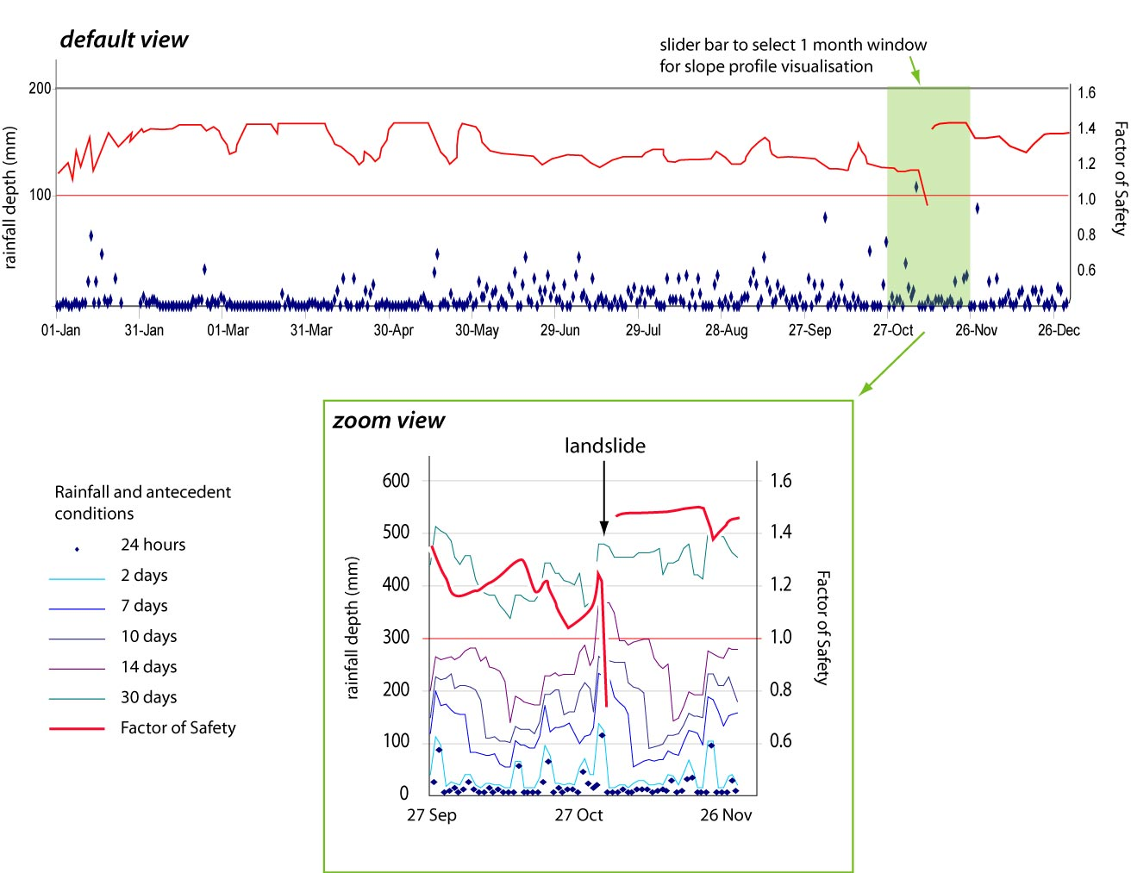

Interactive time-step graphic of slope profile

Static:
- Soil strata

Quasi-static:
- Slope geometry (changes after landslide)

Dynamic (hourly):
- Soil moisture per cell
- Pore water pressure per cell
- Location of water table
- Location of slip surface

Slope profile (step-wise visualisation)…concept diagrams:

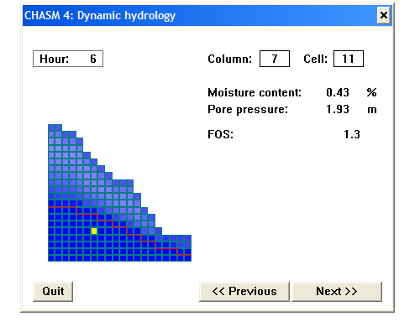
Results viewed using GUI of CHASM commercial version

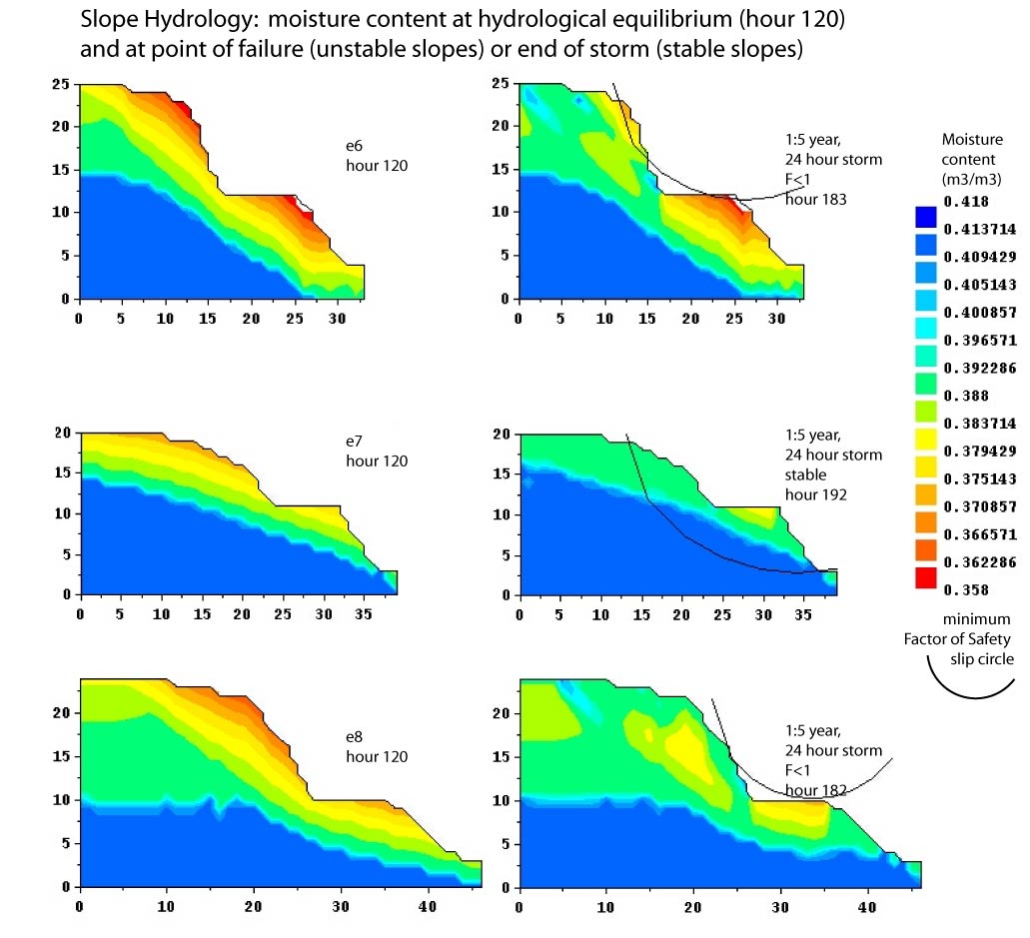

Results visualised using Rubens

