Slope 06 – user inputs

User input: tab 1 (Info)

Name | 06
Latitude | -61.67856
Longitude | 13.54678

Nb. we might need to come up with a naming system which allows the user to enter a descriptive name for the slope (e.g. Arundel Hill community, slope 1), as well as creating a two digit slope id for the simulation file names.

User input: tab 2 (profile)

 | Height (m) | Length (m) | Angle (m) | Calculated horizontal length | Gradient of line | Intercept of line
1 | 0 | 8 | 0 | 8.00 | 0 | 60
2 | 9 | 24.03 | 22 | 22.28 | -0.40403 | 63.23221
3 | 17 | 34.00 | 30 | 29.44 | -0.57735 | 68.47973
4 | 11 | 21.36 | 31 | 18.31 | -0.60086 | 69.88378
5 | 10 | 24.59 | 24 | 22.46 | -0.44523 | 57.74018
6 | 1 | 1.56 | 40 | 1.19 | -0.8391 | 97.31952
7 | 0 | 8 | 0 | 8.00 | 0 | 12
Total user-defined slope dimensions | 48 |  |  | 109.68
+15% of user-defined horizontal length | 0 | 16.45 | 0 | 16.45 | 0 | 12
+25% of user-defined height | 12 | 0.00 | 90 | 0
New total slope dimensions for generating input | 60 |  |  | 126.13

For calculations to determine additional slope segments, slope coordinates, equations of lines for slope segments and conversion to 1m x 1m mesh please see accompanying MSExcel spreadsheet.

User input: tab 3 (soil)

 | Strata 1 | Strata 2 | Strata 3
Soil type | VI | IV | II
c | 10 (nb user-defined) | 25 | 40
Phi | 23 | 33 | 50
Ksat | 5e-5 | 5e-6 (nb user-defined) | 1e-8
Soil depth (m)
x1 | 3 | 4 | Nb. there will always be one less strata interface than the number of strata
x2 | 5 | 6
x3 | 6 | 8
x4 | 7 | 10
x5 | 8 | 12
x6 | 10 | 14
x7 | 9.5 | 13.5
x8 | 11 | 16
x9 | 14 | 20

User input: tab 4 (water)

Enter water table depths
x1 | 20
x2 | 20
x3 | 15
x4 | 8
x5 | 4
x6 | 4
x7 | 3
x8 | 3
x9 | 3
Upslope recharge | 0

User input: tab 5 (rain)

Frequency (years) | Duration (hours) | Volume (mm)
1 in 100 | 24

Notes on calculating the slope dimensions and CHASM mesh

To create the correct CHASM input files a spreadsheet has been used to determine the correct equations of lines for the slope profile, water table location, and soil strata interfaces. Please refer to ‘creating_slope06.xls’.

In particular once the user has defined the slope profile, two extra slope segments should be added:
- Horizontal segment at end of slope (add segment which is another 15% of the user-defined horizontal slope length)
- Vertical boundary at end of slope (add 25% of user-defined slope height)

Note that there will always be one more pair of coordinates than there are segments

Note that there will always be one less soil strata interface than there are soil types

Notes on creating the other input files

To create the stability input file I’ve assumed that the bottom left hand coordinate of the slip search grid according to the following rules:
- The x coord is 75% of the horizontal distance along the initial user-defined slope profile (i.e. not including the extra slope segments): 109.68 * 0.7 = 77 (to nearest integer)
- The y coord is 75% of the height of the final total slope profile (i.e. including the extra slope segments): 60 * 0.7 = 42

The number of points in both the x and y dimensions of the slip search grid is one third of the initial user-defined slope height: 48 / 3 = 16

The rainfall input files should have:
- 7 days (168 hours) of zero rainfall before the rainfall event selected by the user.
- If the selected storm is less than 24 hours, the remaining hours of that day should have zero rainfall,
- then a further 7 days of zero rainfall after.
- This should add up to 360 hours of simulation time in total.

(I think we discussed allowing users to create their own rainfall patterns, but my version of the interface doesn’t have this function yet)

If you are opening the text files I’ve created on a linux machine you may need to get rid of hidden characters as this sometimes causes problems.

List of files in slope 06 .zip file

geometry file: geometry06.txt
soils database file: soil06.txt
stability file: stability06.txt
boundary conditions file: 1in100_24rain.txt
steering file: 06.steering
output files: 06_000.results, .slip and .fos
slope profile calculations: creating_slope06.xls

Resulting slope graph
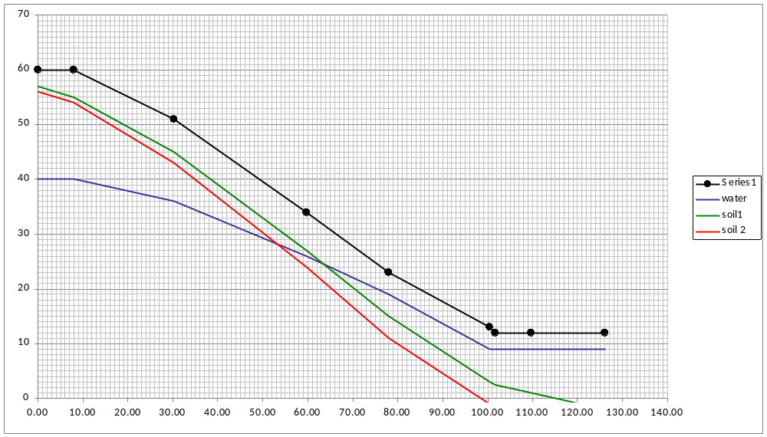

Viewing the results
