

PDR

Sjoerd Halmans – S67



# Summary

In this document I will be explaining my personal development throughout the semester. I will be doing this using the different learning outcomes that have been put forth by fontys, and explaining how my development has been doing regarding the different learning outcomes.

Each one of these outcomes will have their own chapter which will go more in dept into what it means and what I have done to master them. We will begin with a summary of the project I will be making this semester and how I intend to make them, and then continue with the learning outcomes. After all these have been explained you will find a retrospective written by me explain how I think the semester has gone for me and what could have gone better and what went perfectly well.

Inhoud

Summary 1

Introduction 4

Group Project 4

Individual Project 4

Learning Outcomes 5

Learning outcome 1 – Development and Deployment of Enterprise Software 5

First Evaluation 5

First Self-Assessment 5

Second Evaluation 5

Second Self-Assessment 5

Learning Outcome 2 – Context Based Research 7

First Evaluation 7

First Self-Assessment 7

Second Evaluation 7

Second Self-Assessment 7

Learning Outcome 3 – Preparation for Life-Long Learning 8

First Evaluation 8

First Self-Assessment 8

Second Evaluation 8

Second Self-Assessment 8

Learning Outcome 4 – Scalable Architectures 10

First Evaluation 10

First Self-Assessment 10

Second Evaluation 10

Second Self-Assessment 10

Learning Outcome 5 – Development and Operations (DevOps) 12

First Evaluation 12

First Self-Assessment 12

Second Evaluation 12

Second Self-Assessment 12

Learning Outcome 6 – Cloud Services 13

First Evaluation 13

First Self-Assessment 13

Second Evaluation 13

Second Self-Assessment 13

Learning Outcome 7 – Security by Design 14

First Evaluation 14

First Self-Assessment 14

Second Evaluation 14

Second Self-Assessment 14

Learning Outcome 8 – Distributed Data 15

First Evaluation 15

First Self-Assessment 15

Second Evaluation 15

Second Self-Assessment 15

Retrospect 16

Conclusion 17

Appendixes 18

# Introduction

As explained before, in this document I will be documenting my development this semester and explain the different things I have done to develop the different learning outcomes. The ultimate goal is to have all of this documented in one singular place, so I can properly see what I learned this semester and how I did it. This way I can look back and use this document to improve my learning capabilities in future project, and show my teachers how I have grown this semester and prove I have a satisfactory level of understanding to pass this semester.

Another objective of this document is to explain how the work I have done actually fits in with the learning outcomes for this semester, my individual project will be the main contributor to my learning outcomes because all of the work will be done by myself in that project, but I expect to also learn a lot from the group project we are setting up.

To give you an understanding of how I will be proving this, I will now give a quick summary of the group project and the individual project that I will be working on this semester, I will begin with the group project :

## Group Project

For our group project we have been tasked to work on vitality living labs. Our task will be to create a platform that allows users to compare and share data sets (and much more). We will be doing this project with 27 people in total, divided into groups of six and five. My group in particular will be focussing mostly on building the project service in which a lot of the core features of the application will reside.

In short this means we will be tasked in writing the entire service, it’s integration with the frontend systems and any applicable external systems, maybe a small part of the actual frontend application and last but not least one or more other services depending on the time we have left and the decisions made by the class as a whole. Personally I have been assigned as an all-round developers meaning I will be working on all the different aspects of the service instead of focussing on only it’s architecture for instance.

## Individual Project

For my individual project I had the choice between choosing the default case or making up one of my own, I chose to make one myself. It is called Productio, and I will now be explain what it is and how it works :

Productio will be an online dashboard for a fictional company that operates factories and sells it’s products as well. The idea behind the platform is that all online tasks can be done in one system, this way all the company’s data can be used to make decisions for the different departments, this will allow employees their work to be done more quickly and make more educated decisions using their fellow employee’s data.

And example of this would be the production department deciding to close one production line due to sales being lower, or increasing production because of a higher demand for products.

# Learning Outcomes

This chapter will be the main focus of the PDR. Here I will introduce the learning outcomes, self-evaluate myself and explain my learning process.

## Learning outcome 1 – Development and Deployment of Enterprise Software

This learning outcome focusses on my ability to develop and deploy enterprise software. This will be a semester-long learning road for me seeing as I have not yet worked with it so far and will be gaining experience through building throughout the semester.

### First Evaluation

After the first sprint I have done a great amount of research into enterprise software and how it works in and out. I have also done a few case studies with my group and gained a lot of knowledge about enterprise software from that. These case studies have been reviewed by teacher and apart from a few pieces of feedback about the document itself, the research was deemed valid.

### First Self-Assessment

Because of the research I have done for the subject so far. I would say I am **Beginning** within this learning outcome. However I do believe I will reach Proficient by the end of the next sprint.

### Second Evaluation

Since the last evaluation I have done a lot of work on the application and I am happy to say that I do think that I have improved in this learning outcome. I have worked on making the application flow from frontend to backend and I have managed to set up a nice beginning.

A big part of enterprise software is of course that it will be used by large amounts of people. This has been taking into account while developing both security and load balancing within the application.

### Second Self-Assessment

I personally think that I have reached the **Proficient** level for this learning outcome. Looking at the work I have done in both deployment and development and the knowledge I have gained from it I would definitely say that I have the work to support my claim.

### Third Evaluation

Since the last evaluation, a lot of work has been done. The group project now has an MVP, and my own project almost has all of it’s services up and running. Looking at my individual project we can see that it is almost possible to use all of the planned services and use the data from different services to make decisions on the other ones.

Developing multiple services after my CI/CD was already running has also showed me that expanding the application is not a lot of work, and can be easily done. (adding a new service to the gateway has taken approximately 4 minutes tops in my experience, that is including their security)

Apart from that, the development has gone quite well and all of the user stories and (non)functional requirements that were set up at the beginning of the semester are almost done. I am positive that if I continue working at this speed, all of the must haves will be completed along with a bunch of the should/could haves. The grand scale of the applications I am writing for both my individual project and the group project were quite new to me, however I think that I have done a good job in building enterprise software in this semester.

### Third Self-Assessment

I personally think that I have reached **Proficient** in this learning outcome, I have worked hard for both projects and made sure to think about the scale of things and all the finer details that come with developing a platform that has a wide variety of users with different permission. Planning out the different user stories and must haves during my development have been a large operation, but I think that I have managed to do some very good work despite the circumstances we find ourselves in due to the global pandemic and restrictions at school.

### Fourth Evaluation

After the last period I am happy to say that all of my projects are now done and the semester has come to an end, looking back at this last period I will say that it has been the least productive one seeing as most of it has been fixing bugs and writing/rewriting documentation.

But nonetheless, I am happy with the work that has been done and think I can be proud of my achievements this semester.

### Fourth Self-Assessment

Ending this semester, I think that I have attained the level of **Proficient.** I think that the work I have put down this semester was very good, but maybe my teamwork ability could be improved in the future and some more initiative. But the actual development of the application has gone very well.

## Learning Outcome 2 – Context Based Research

This learning outcome focusses on my ability to make the decisions within my project with great care and backed by research. This one will be quite easy for me seeing as I have been using these techniques for quite some time and know how to use them.

### First Evaluation

After having done about four different case studies and working on a research document for my personal project, I can say that I am very happy with my progress so far. The research I have done for my group has been reviewed and accepted and I plan on showing my personal research at the next meeting with my teachers.

Using the DOT framework and using enough methods per research question has not been a problem so far and I do not expect it to become a problem later on in the project.

### First Self-Assessment

I personally think that I am currently **Proficient** in this learning outcome taking in consideration my current experience. The only thing that I still need to do to get this official is getting my teacher’s their confirmation. I am happy with the research I have done so far and quite intrigued by my findings.

### Second Evaluation

After having done several more case studies over the last few weeks, I can definitely say that not only have my skills improved, but the case studies have also become more useful for me.

I am glad to say that the case studies done over the last few weeks have gone quite well and that the knowledge gained from them has most certainly helped me make decisions for my own project, and discuss choices with my colleagues in the group project.

### Second Self-Assessment

Just like the last self-Assessment, I think that so far I am still **Proficient** in this learning outcome, the main reason for this being that I personally believe that I can still improve in the ways that I use the different research methods at our disposal.

### Third Evaluation

Not much research has been going since the last evaluation, this is due to the stage that our projects are in currently, next to the traditional research that we needed to do for our group I have however started a little research for my own project. It talks about the different security aspects looking at social engineering, and will result in a protocol that users should follow to make sure social engineering is less likely to happen within Productio. This research will be finished before the next PDR evaluation.

### Third Self-Assessment

I think that I am currently proficient in this learning outcome. After talking to Marcel as well, he mentioned that the research we have done as a group is also good, and should be enough for a proficient. (All of this research can be found in canvas in their respective assignments.)

### Fourth Evaluation

In the last period no research has been done anymore. However I am very content with all of the work done this semester.

### Fourth Self-Assessment

I still think I have attained the level of **Proficient.**

## Learning Outcome 3 – Preparation for Life-Long Learning

This Learning outcome might be one of the most important learning outcomes that any software engineer might ever have to deal with. Life-Long learning is very important as the industry keeps evolving and changing.

### First Evaluation

I have been thinking about where I want to go with my career ever since I started my education at fontys, and feel like I am doing quite a good job at preparing myself for every next step in my education and career. As of writing this I have already applied and been accepted for a minor abroad at Dongguk University in South-Korea for my next semester, I have been planning this since I first heard of the program in my first year. And I am happy to have been accepted.

I feel this puts me in a very good position within this learning outcome, furthermore I have worked on networking the last few years and have gotten enough contacts to start planning my graduation project soon.

While I have not yet decided what I want to do after I finish my HBO-ICT, I feel like I know what my options are and I am capable of making an educated decision.

### First Self-Assessment

Looking at the work I have already done for this learning outcome this semester, I feel I am in the **Proficient** scale on this one. I feel like I still have things to learn and do to prepare myself even more, but I also feel like I have made a very good first foundation for myself.

### Second Evaluation

I am proud to say that as of writing this evaluation, I am one step closer to realizing my goal of going abroad to study in Korea. Over the past few weeks I have been working on my application and the administrative work needed for the minor abroad, and it has been going quite nicely.

Another big plus is that I have already found an internship for semester 8. While not official due to company guidelines, my interview with AMPLEXOR went very well and I was told that the chance they would allow me to do my final internship at their company was very big. (Even going as far as making a new assignment for me if the existing ones did not fit) Sadly this can not be made official until November due to the company not officially scouting for interns yet for 2022.

### Second Self-Assessment

While I think I am very close to **Advanced** I do believe I have a little ways to go until I can call myself that, therefore I am putting myself in **Proficient** for now and waiting until I fully finish up my administrative work for my minor abroad. I am however very happy that my final internship seems to have already been taken care of (with a few plan B’s in place as well)

### Third Evaluation

This period has been very helpful for me, I have realised my full CI/CD pipeline and researched multiple technologies that enabled me to make a good choice in which CI/CD providers to use. Doing this exposed me to a lot of technologies that might not be useful in this project, but have allowed me to at least come in contact with them and keep them in consideration for the following projects in my career

Apart from that, I have also attended the Alten career day and spoken with a lot of the different employees there asking them questions about their work and the different tools they use. Talking to these professionals allowed me to find out many things that I was wondering about why a company chooses a technology and how they operate.

Next to this, I have also started a little research called “Uncanny valley within chatbots” in which I have started researching if the uncanny valley theory holds up when applied to chatbots and not only physical robots.

### Third Self-Assessment

I think that the research I have done throughout the semester, my interviews at Alten, and the little researches I have been doing on the side have really helped me prepare for a life long of learning. I therefore think that I am **Proficient** as of now.

### Fourth Evaluation

I think that in the end I have learned a lot this semester, I have done a lot of work to show my learning outcomes, but have also done a lot of extracurricular work in my spare time like learning how to do 3D modelling and making low end chatbots. This last period has however not been a very big learning experience as most of it has been fixing bugs and finishing up documentation.

### Fourth Self-Assessment

I think that in the end of this semester, I have definitely reached the level of **Proficient** and will keep it at that, while close to **Advanced** in my opinion, there are extra things I could have done.

## Learning Outcome 4 – Scalable Architectures

This learning outcome has been one that I have been working on for a long time, it focusses on building an architecture that in itself is easily scaled up. And as microservices are something I have been working on for about two years now, it should be fun diving a little deeper into them.

### First Evaluation

For my first sprint I have been mostly working on architecture and documentation, this means I have a good idea as to what I want and how I want it to look when it is done. My current architecture resolves around microservices that a completely separate from each other, only being connected by a common gateway. I am planning on adding Kafka to the equation to increase my knowledge of that, and think that the project will be a great success with the knowledge I possess.

### First Self-Assessment

Even though I think I am already proficient in microservice architecture itself, I think that all the aspects combined in this learning outcome puts me **in between Proficient and Beginning** but closer to Proficient. I think my main learning experience this semester will be using microservices in enterprise software.

### Second Evaluation

Since the last evaluation, a lot of work was put into this learning outcome I think. I have set up a full application flow from frontend to backend with a gateway and message queue in place.

This means that from now on I will be able to get on with making more microservices and scaling the application. I have already tried making multiple services, and I am happy to say that the system I have set up makes it so that it is very easy to add more services.

### Second Self-Assessment

I am willing to say that due to the progress I have made in the previous few weeks, I think that I am now **Proficient** within this learning outcome. I think that designing and realizing the entire application flow that I have so far have taught me a lot, and that all of it combined proves my current proficiency with this learning outcome.

### Third Evaluation

I am very happy with the progress made in this period, and can happily say that my approach to the architecture has made sure that adding new services to the fray was very easy and fast. Over the last weeks I have fully set up my CI/CD, and added a few new services to the project. Doing this was no quick task perse, but I am happy to say that it took significantly less time due to the fact that my architecture is set up in a way that enables quick growth and working with components.

Adding a new service to my architecture took almost no time, in the frontend nothing had to change as all of the their requests is send to the gateway. And in the gateway it took approximately 4 minutes to add a new service and fully secure it with my built in security.

### Third Self-Assessment

As development has moved on to the final services within the project, it has become apparent to me that the architecture that I have set up and designed was the right way to go, and has really improved my ability to quickly add new parts. Due to the quality of this architecture I am confident to say that I am **Proficient** in this learning outcome.

### Fourth Evaluation

No further work has gone into scalable architecture this period.

### Fourth Self-Assessment

While no further work has gone into this learning outcome this period, I do think that at the end of this semester I have reached **Advanced** as now that all of the services are up and running, it has become apparent that the architecture I have created works and is scalable as well.

Apart from just using this architecture for functional requirements or making sure I follow the rules of microservice etc, it has also allowed me to increase the security of the application by allowing me to host it in a way that allows for most of the services to be run locally without being exposed to the open web.

## Learning Outcome 5 – Development and Operations (DevOps)

This learning outcome might be my favourite this semester, this outcome focusses on setting up and maintaining development environments and maintaining things like CI/CD pipelines.

### First Evaluation

While I have worked with DevOps before and set up CI/CD pipelines, I feel like the scale of this project will make it very interesting to dive deeper into it. So far I have not really set up a CI/CD yet, but I have set up a Taiga and filled it up.

While I have not set them up yet, I do already have my plans made for what pipelines I plan on using and checked their compatibility with the tools I plan on using next to them.

### First Self-Assessment

I think my previous experience in this topic places me in the **Beginner** class. I have a lot to learn but I have set up a good amount of successful pipelines so think I have a strong foundation already.

### Second Evaluation

This learning outcome has not been worked on a lot these past few weeks, this is due to the fact that I wanted to have a basic setup before I started running tests on all the different features in the application.

Though I have been using my taiga to organize my tasks and make sure I know what I should be doing.

### Second Self-Assessment

Like the last Self-assessment, I think I am still **Beginner** looking at this learning outcome. My plan is to change this the following few sprints though.

### Third Evaluation

This sprint has mostly been about working on my CI/CD pipeline, and I am very happy to say that at the end of it, I now have a working pipeline that goes from testing to deployment of the application onto a raspberry pi.

The code is first tested by Travis, then uploaded to docker hub. I then easily deploy it on the raspberry using a script and running them as docker containers (while then connecting them to each other on a singular docker network)

### Third Self-Assessment

After the work I have done this sprint, I am confident in saying that I think I am now **Proficient** in this learning outcome, and while the work I have done was nothing too hard. I must say I am very proud to have a full pipeline up and running in such a small window of time.

### Fourth Evaluation

No more work has gone into this learning outcome.

### Fourth Self-Assessment

After all of the work I have done for this, I still think I have earned the **Proficient** level.

## Learning Outcome 6 – Cloud Services

This learning outcome will be quite important for me this semester, it focusses on using the different cloud services companies like google allow developers to use. And knowing when to use them and when to make your own code. (taking into consideration costs as well)

### First Evaluation

I have not yet done a lot of work on researching cloud services yet this sprint, but the research I have done has come out with some interesting conclusions. I have a clear vision as to what services I plan on using and how I want to integrate them with the code I am planning to write myself.

The following sprints will go further into this subject, though for now a lot of the stuff I have done is still theoretical.

### First Self-Assessment

I feel like I am still in the **Beginner** class for this learning outcome, and while I have done some research, there is still a lot left to learn and do. I am however confident that this will also not be a problem for the semester and working on it should be fun and informative.

### Second Evaluation

These last few weeks have allowed to work a lot on the cloud aspects of my application. While I am not sure if it will be the only cloud service I will be using, auth0 has been very useful for authenticating users and keeping track of their permissions.

Using the auth0 cloud services have allowed me to focus on making my first application flow, leaving the permissions and authentication to auth0 was a good choice in my opinion, and it works very nicely so far.

### Second Self-Assessment

While I have definitely improved since the last self-assessment, I still think that more research is in order. And while I have no intention of using any other cloud services as of yet, I am sure that if I do some more research I will either find them, or reasons against using them in my current situation.

Therefore I think I am still a **Beginner**

### Third Evaluation

I have come to the conclusion that I do not need more cloud services than I am already using now. After extensive brainstorming and thought about the project, all of the functions that I wanted to outsource to another platform are done.

The final cloud services I will be using, are Travis for testing, docker hub for storing and retrieving production images, Github for version control, and Auth0 for my user management and security. I am very happy with how I was able to incorporate all of these services, and I am happy that I chose to.

### Third Self-Assessment

After all of the work I have done on the cloud services within my project, I am confident enough to say that I am **Proficient** in this learning outcome.

### Fourth Evaluation

No further work has gone into Cloud services this period.

### Fourth Self-Assessment

I still think I have reached the level of **Proficient.**

## Learning Outcome 7 – Security by Design

This learning outcome focusses on the security of my application and how I design my application taking security in consideration while doing it. This will be interesting as I have not yet done this for an enterprise application.

### First Evaluation

I have already done quite some work on the security for this application and done research on how I want to handle it. The application will be used by a lot of different users with different clearance levels, this means security will be important as enforcing these clearance levels will become very important.

I plan on using an OWASP report to see where the vulnerabilities lie within my application and using my cybersecurity knowledge to also pen test my own application.

### First Self-Assessment

I have done a lot of security already in my career at Fontys seeing as I followed the cyber security specialisation and also worked on securing all the projects I made during and after that course. I think that my knowledge in the subject puts me in the **Proficient** class, I am confident that I will reach advanced at the end of this project and that the application will be well defended against all of the basic attacks and some advanced techniques as well.

### Second Evaluation

While I have paid attention to security in my previous semesters, I must say that the past few weeks have been very big for me in terms of security. Using auth0 I was able to make a central gateway that takes care of all the authentication and security for the backend.

So far it has been able to work in all tests, and I am very happy with the techniques I used while making it. Apart from that, I have also been working on making sure the different OWASP top10 risks are taken care of within the application.

### Second Self-Assessment

While I have improved since the last self-assessment in my opinion, I would say that I am still **Proficient** in security. Reaching **Advanced** would require me finishing more microservices and making sure my app is fully secure against the top 10 risks.

### Third Evaluation

This last period, I have not put much extra work into the security, apart from maintaining the security level I already had. However with my Production environment up and running, I am happy to say that the security I had designed works there as well, apart from that my services are also not reachable outside of the network and can only be reached via the gateway, which is defended by Auth0.

### Third Self-Assessment

I still think I am **Proficient** in this learning outcome looking at the current developments.

### Fourth Evaluation

This last period, I have written a short document on social engineering and how a Productio user can protect themselves against it.

### Fourth Self-Assessment

After finishing up my research on social engineering and hosting the application on my raspberry pi, I believe I have reached the level of **Advanced** for this learning outcome. I have written an OWASP report, hosted my application in a very secure way, implemented a host of different security measures in the application and written an extra research on how to protect against a less technical way of hacking. Therefore I think that after this semester I have reached this level.

## Learning Outcome 8 – Distributed Data

This learning outcome focusses on handling distributed data and the different privacy and ethical issues that are connected to it. This will be mostly focussed on best practices and when to use which tools.

### First Evaluation

This learning outcome has not been looked at yet this sprint, I plan on working on this learning outcome more and more as the project expands, but for now the project is still focussed on more functional learning outcomes and implementing them in the project.

### First Self-Assessment

I think my choice of not focussing on this one too much has been a good idea, however it does mean that I am still in the **Orienting** class for this learning outcome. As said earlier, this will change the further I go into the project and finish in advanced if all goes according to plan.

### Second Evaluation

While I did not pay much attention to this learning outcome in the first evaluation moment, I am happy to say that since then, more thought has gone into it.

I have thought about the different privacy/ethical issues that might arise in my application and thought of solutions for them. But the biggest thing I have done a lot of might be the attention to best practices these past few weeks. Every decision made for the application these past few weeks have been thoroughly researched and best practices have been used while developing.

### Second Self-Assessment

I am confident in saying that I am now **Beginning** regarding this learning outcome. I have worked on the basics of this learning outcome and I have planned to do more research and work to become **Proficient** by next assessment.

### Third Evaluation

This period, I have put some time into the ethics and privacy of applications, I did this mainly by brainstorming, reading articles online and talking to professionals in the field. I am confident enough to say that the knowledge I got from all of this has allowed me to make an application where all data is secured and handled with respect.

While there is not a lot of physical work I have put into this learning outcome, I have put a lot of though into it and I am happy that I did.

### Third Self-Assessment

I think I am **Proficient** in this learning outcome, I have spent a lot of time thinking on how I save the data and maintain the privacy of my users, and I think that together with the security aspect of the application, I have managed this.

### Fourth Evaluation

No further work has gone into this learning outcome this period.

### Fourth Self-Assessment

I still believe that I am **Proficient** in this learning outcome.

# Retrospect

Looking back at this interesting semester to say the least, I believe I have learned a lot of different things but also gotten the chance to perfect some other things. I have learned how to work more independently at home, but also how to stay focused in a team, even when you haven’t seen each other for over a year.

I have loved following the different workshops we had on Wednesdays, and really enjoyed seeing my classmates again on Tuesdays after not having seen them for over a year (partially due to my internship and of course the pandemic).

And while maybe not everything went right the first time, there are no decisions that I now look back on that I would have done the other way around.

# Conclusion

To conclude this document, I would like to thank my teachers and classmates for this semester, I personally think 2 of my learning outcomes are now on **Advanced** while 6 of them are **Proficient.** And while this semester has been very helpful in one of the last preparations for becoming a fully fledged and graduated software engineer, I am looking forward even more to my next semester where I will study in South-Korea for one semester and hopefully be working with machine learning.

# Appendixes



**The frontend as seen in the auth0 dashboard**

**My user database as seen in the auth0 dashboard**

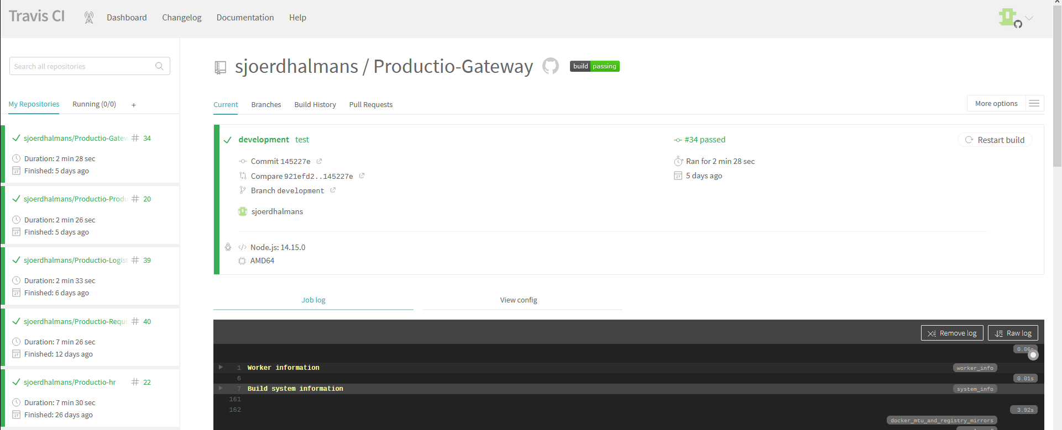

**My travis dashboard displaying the different services**

Roles with description as used in the application to manage permissions

[**2FA Showcase**](https://drive.google.com/file/d/17wLzJ6PVmVQ7_C0sIXsPvM9-HNO2UevG/view?usp=sharing)

[**Docker Showcase**](https://drive.google.com/file/d/1G9KFPXA4MvSdweVn-12arBxhkbUokNJo/view?usp=sharing)

**Network Diagram**

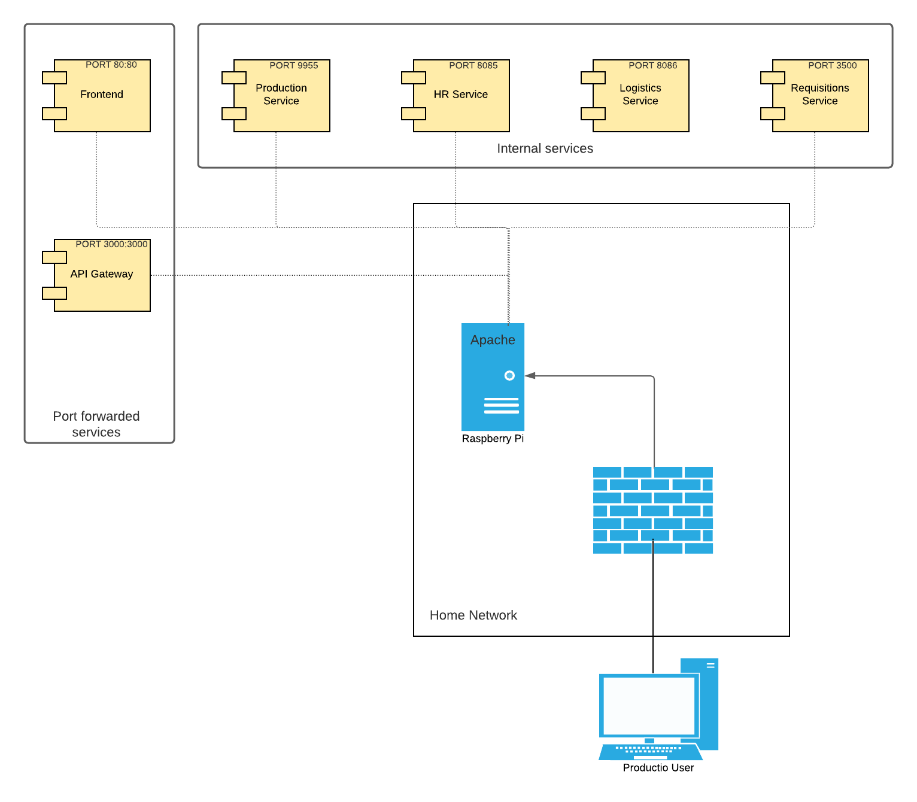

**Docker hub**

**Example of gateway handling permissions**

**A few screenshots from a personal project I hosted on Heroku cloud**

[**Watching a presentation about working as a consultant at Alten Career day**](https://drive.google.com/file/d/1ncRkMOJGsjwweqB7qK_8svOpJzBaLg81/view?usp=sharing)

[**Talk I had with a software quality service expert at Alten Career day**](https://drive.google.com/file/d/1ZiT52SlCr8G_xpnyXNVLPk9Tx6EANkTQ/view?usp=sharing)

More videos were made, however these were to long to properly upload (and with the amount of people joining in and out of the conversation I am not sure if all of them would like to be recorded and shared like this)

The conversations I had with 2 other departments were first about the different cloud techniques that are used at Alten and how these techniques are chosen.

Another one was with the data analysis team of Alten, and was about the cultural differences in managing data and how Alten made sure that all the data that should stay confidential stays confidential.

The information I got out of these conversations were very useful in building my mindset and also developing Productio this semester.

**My travis CI bot notifying me of build status in my discord server**

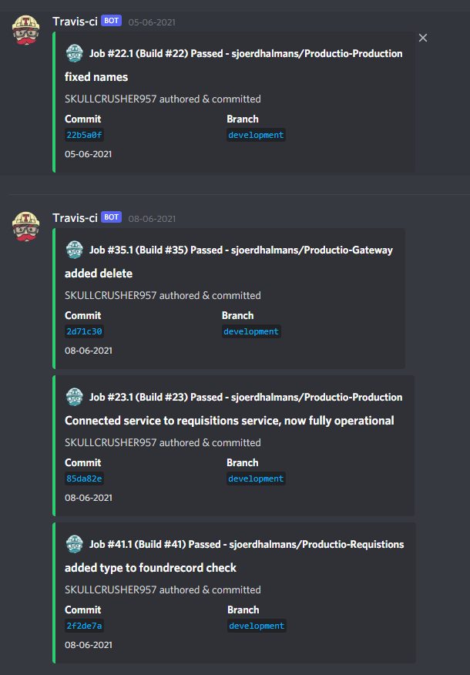

# Additional documents

For any additional documents I have made (including but not limited to my security report and social engineering research) please look in the final code/documentation assignment posted by Nico and uploaded on Monday 21/06/2021

Thank you for joining me in this semester.