**Week 2; Questions**

**The difference between the == operator and the === operator.**

=== is used as a stricted comparison operator. This means that the values you compare must be of the same type as well. While, with the == operator this is not the case. For example, if two values are not of the same type, === will return false, while the == operator would return true.

**Closure**

Within in JavaScript, and I think in any other programming language, you can declare local and global variables. Global variables could be made local, by closures. Inner functions could hold variables and keep them alive, if the outer function is returned. Closure has some common grounds with objected oriented programming. where objects give the opportunity to manipulate some data with different methods.

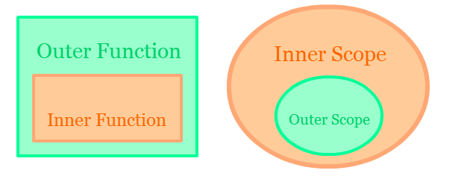

**Higher order function**

A higher order function is able to take multiple functions as arguments and it could also return a whole function as a result.

**Query selector**

The query selector, returns the first element that fits for example an id , class or tag within CSS. I wrote the following lines to illustrate :

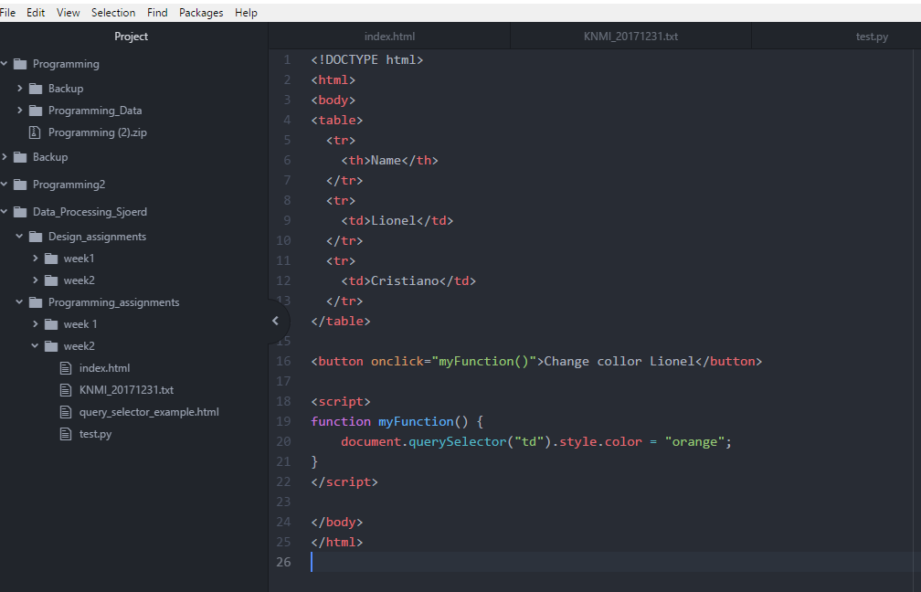

In this example, when you click on the button, the name “Lionel” will consist of orange letters, because it is the first <td> within the document.