Codebook for top10_girlnm

Autogenerated data summary from dataMaid

2019-02-11 17:51:08

# Data report overview

The dataset examined has the following dimensions:

|  |  |
| --- | --- |
| Feature | Result |
| Number of observations | 10 |
| Number of variables | 5 |

# Codebook summary table

|  |  |  |  |  |  |
| --- | --- | --- | --- | --- | --- |
| Label | Variable | Class | # unique values | Missing | Description |
|  | **Name** | character | 10 | 0.00 % |  |
|  | **Sex** | character | 1 | 0.00 % |  |
|  | **Count2015** | numeric | 10 | 0.00 % |  |
|  | **Count2016** | numeric | 10 | 0.00 % |  |
|  | **total** | numeric | 10 | 0.00 % |  |

# Variable list

## Name

* The variable is a key (distinct values for each observation).

## Sex

* The variable only takes one (non-missing) value: "F". The variable contains 0 % missing observations.

## Count2015

|  |  |
| --- | --- |
| Feature | Result |
| Variable type | numeric |
| Number of missing obs. | 0 (0 %) |
| Number of unique values | 10 |
| Median | 15222.5 |
| 1st and 3rd quartiles | 11917.25; 17120.75 |
| Min. and max. | 10283; 20415 |

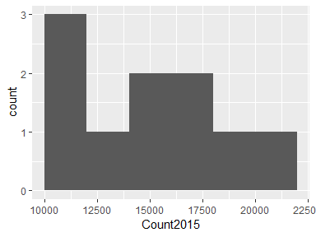

## Count2016

|  |  |
| --- | --- |
| Feature | Result |
| Variable type | numeric |
| Number of missing obs. | 0 (0 %) |
| Number of unique values | 10 |
| Median | 14544 |
| 1st and 3rd quartiles | 12031.75; 16195.25 |
| Min. and max. | 10733; 19414 |

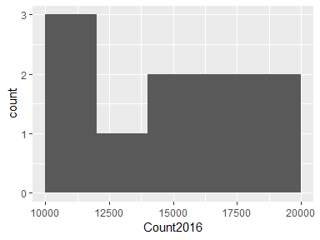

## total

|  |  |
| --- | --- |
| Feature | Result |
| Variable type | numeric |
| Number of missing obs. | 0 (0 %) |
| Number of unique values | 10 |
| Median | 29766.5 |
| 1st and 3rd quartiles | 24155.25; 33232.5 |
| Min. and max. | 21016; 39829 |

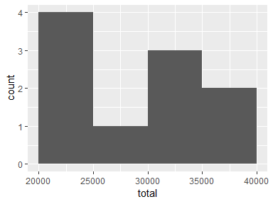

Report generation information:

* Created by sjohnson1039 (username: sj103).
* Report creation time: Mon Feb 11 2019 17:51:08
* Report was run from directory: C:/Users/sj103/OneDrive/Documents/MSDS_Working/Assignment_05
* dataMaid v1.2.0 [Pkg: 2018-10-03 from CRAN (R 3.5.2)]
* R version 3.5.2 (2018-12-20).
* Platform: x86_64-w64-mingw32/x64 (64-bit)(Windows >= 8 x64 (build 9200)).
* Function call: makeDataReport(data = top10_girlnm, mode = c("summarize", "visualize", "check"), smartNum = FALSE, file = "codebook_top10_girlnm.Rmd", checks = list(character = "showAllFactorLevels", factor = "showAllFactorLevels", labelled = "showAllFactorLevels", haven_labelled = "showAllFactorLevels", numeric = NULL, integer = NULL, logical = NULL, Date = NULL), listChecks = FALSE, maxProbVals = Inf, codebook = TRUE, reportTitle = "Codebook for top10_girlnm")