Site Name: Wise Weather Man

Domain: wiseweather.net ($12 per year)

Site Purpose: The main purpose of this site is to be informational about the current weather conditions, forecast, and storm watch for anyone who is interested in those topics for the three towns.

A secondary purpose of the site is to have related stories for each town and have an interesting weather gallery for each town for basic viewing purposes.

Target Audience:

The target audience of the wiseweather.net web site is described below:

Who: People who are interested in the weather of the three towns that are covered by the site.

Age: 10 and up.

Motivation: To inform people of the weather conditions, related stories, and storm watch for the three cities that are covered by the site.

Personas:

Scenarios:

Site Map:

This section describes the basic structure of the wiseweather.net website.

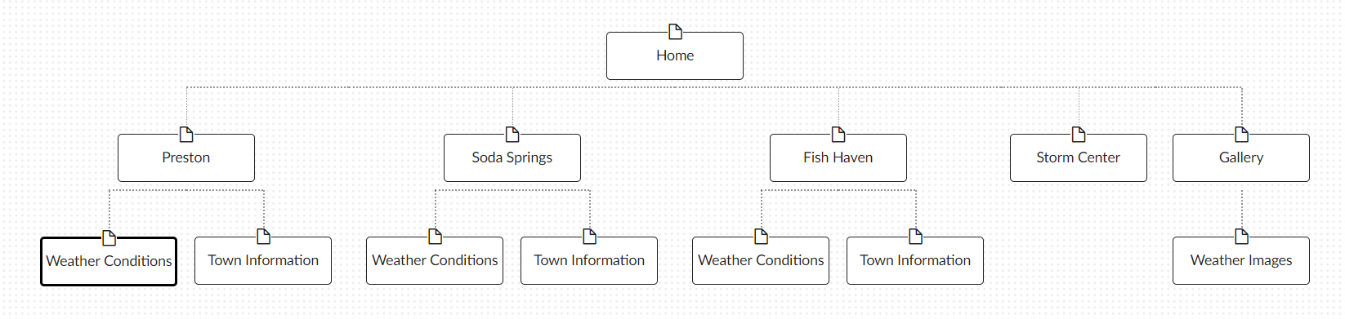

Color Scheme:

Describes the background, text, links, accent(s), and logos of the wiseweather.net website.

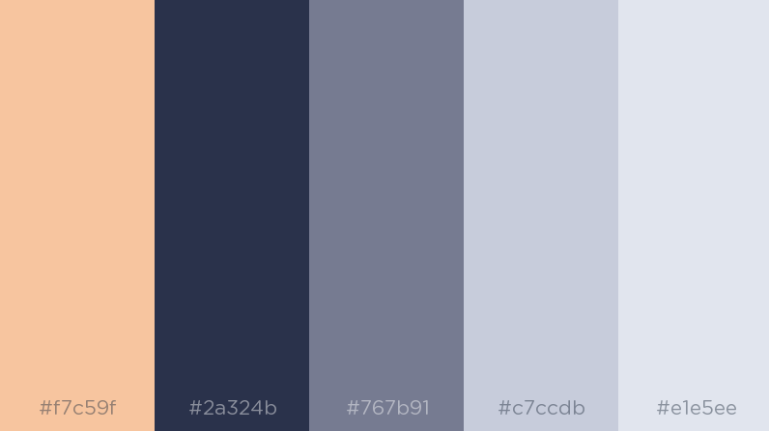

Accent color.

Navigation bar links upon hover font color.

Body font color.

Navigation bar links and headings font color

Header and footer background color.

Typography:

|  |  |  |  |
| --- | --- | --- | --- |
| Object/Item | Font | Size | Color |
| Paragraph | Concert One | 12px | #2a324b |
| Heading Level 1 | Cairo | 18px; weight: bold | #767b91 |
| Heaving Level 2 | Chakra+Petch | 16px | #767b91 |
| Navigation Elements | Concert One | 14px | #767b91 |