Site Name: Temple Inn & Suites

Domain: **templeinnandsuites**.org ($12/year)

Site Purpose: The main purpose of this site is to promote and provide information about the specialized services that this hotel chain offers to meet the needs of temple patrons who come to serve in the temple or who participate in events such as sealings, weddings, receptions, and youth trips.

Target Audience:

The target audience of the **templeinnandsuites**.org web site is described below:

Who: People who are going to attend a session(s) at a temple that is far enough away from their home that they need to plan accommodations at a hotel.

Age: 18+

Motivation: Needing to book a hotel while out of town for temple attendance.

Personas:

Kacey Jones

Occupation: Marketing Tech

Demographics and Education: Female, age 32, married, Bachelor’s degree in Business.

Goals and motivation for using the site: Has a lot of friends that are in the “getting married” stage that live all over the country. She needs to find accommodations when she inevitably gets invited to another sealing out of town.

Social: Incredibly social people person who makes good friends easily.

James Godiva

Occupation: Call Center Employee

Demographics and Education: Male, age 23, single, junior in college pursuing a law degree.

Goals and motivation for using the site: Recently returned missionary, he enjoys going to the temple often and has a goal to visit a new temple every other month. He needs better accommodations when he travels.

Social: Very social, yet enjoys his personal time. Sometimes he will invite friends on the temple trips but generally he goes on his own.

Scenarios:

What services are offered by Temple Inn & Suites?

What is the cost of long-term accommodations for temple missionaries?

What are the amenities of the hotel?

Are there food services?

Does Temple Inn & Suites have childcare accommodations?

Is Temple Inn & Suites cheaper than other hotels close by?

Does Temple Inn & Suites accommodate the families of temple workers/attendees?

Site Map:

This section describes the basic structure of the **templeinnandsuites**.org website.

Color Scheme:

Describes the background, text, links, accent(s), and logos of the **templeinnandsuites**.org website.

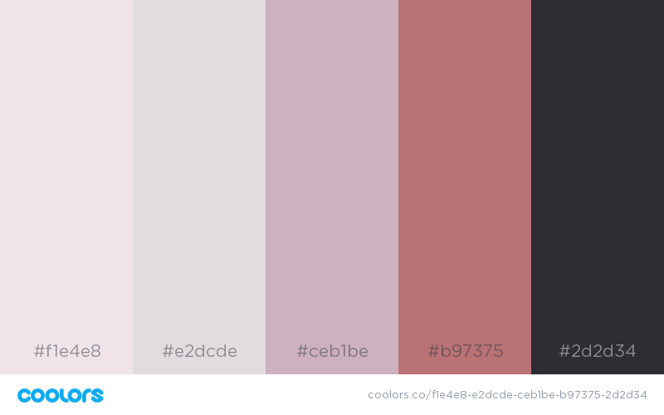

Paragraph and navigation link font color

Navigation links hover color

Header and footer background color

Accent colors

Body background color

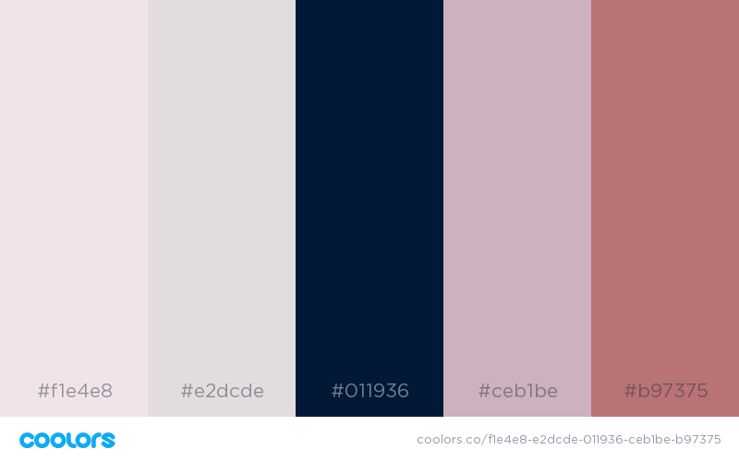

Headings font color

Typography:

|  |  |  |  |
| --- | --- | --- | --- |
| Object/Item | Font | Size | Color |
| H1 | Bree Serif | 28 | #011936 |
| H2 | Bree Serif | 24 | #011936 |
| Paragraph | Raleway | 14 | #2d2d34 |
| Navigation links | Arvo | 12 | #2d2d34 |

Wireframes:

Large and Medium:

<https://wireframe.cc/HsofcA>

Small:

<https://wireframe.cc/l73j5T>