Grazioso Salvare Rescue Dashboard
CS-340 Client/Server Development
Developer: Shelby Joiner
Overview
The Grazioso Salvare Rescue Dashboard is an interactive web-based application designed to help rescue organizations identify dogs suited for specialized rescue operations. Using real animal shelter data, the dashboard allows users to filter, visualize, and analyze animals based on predefined rescue criteria.

Why Use This Application
Rescue operations require fast and informed decision-making. This dashboard simplifies that process by presenting complex shelter data through an intuitive interface with real-time filtering, visual charts, and geolocation mapping.

Key Features
- Interactive rescue-type filtering
- Dynamic data table with sorting and filtering
- Breed distribution visualization
- Geolocation map linked to table selection
- Clear branding and identification

Dashboard Screenshots
Initial Dashboard Load (Reset All)
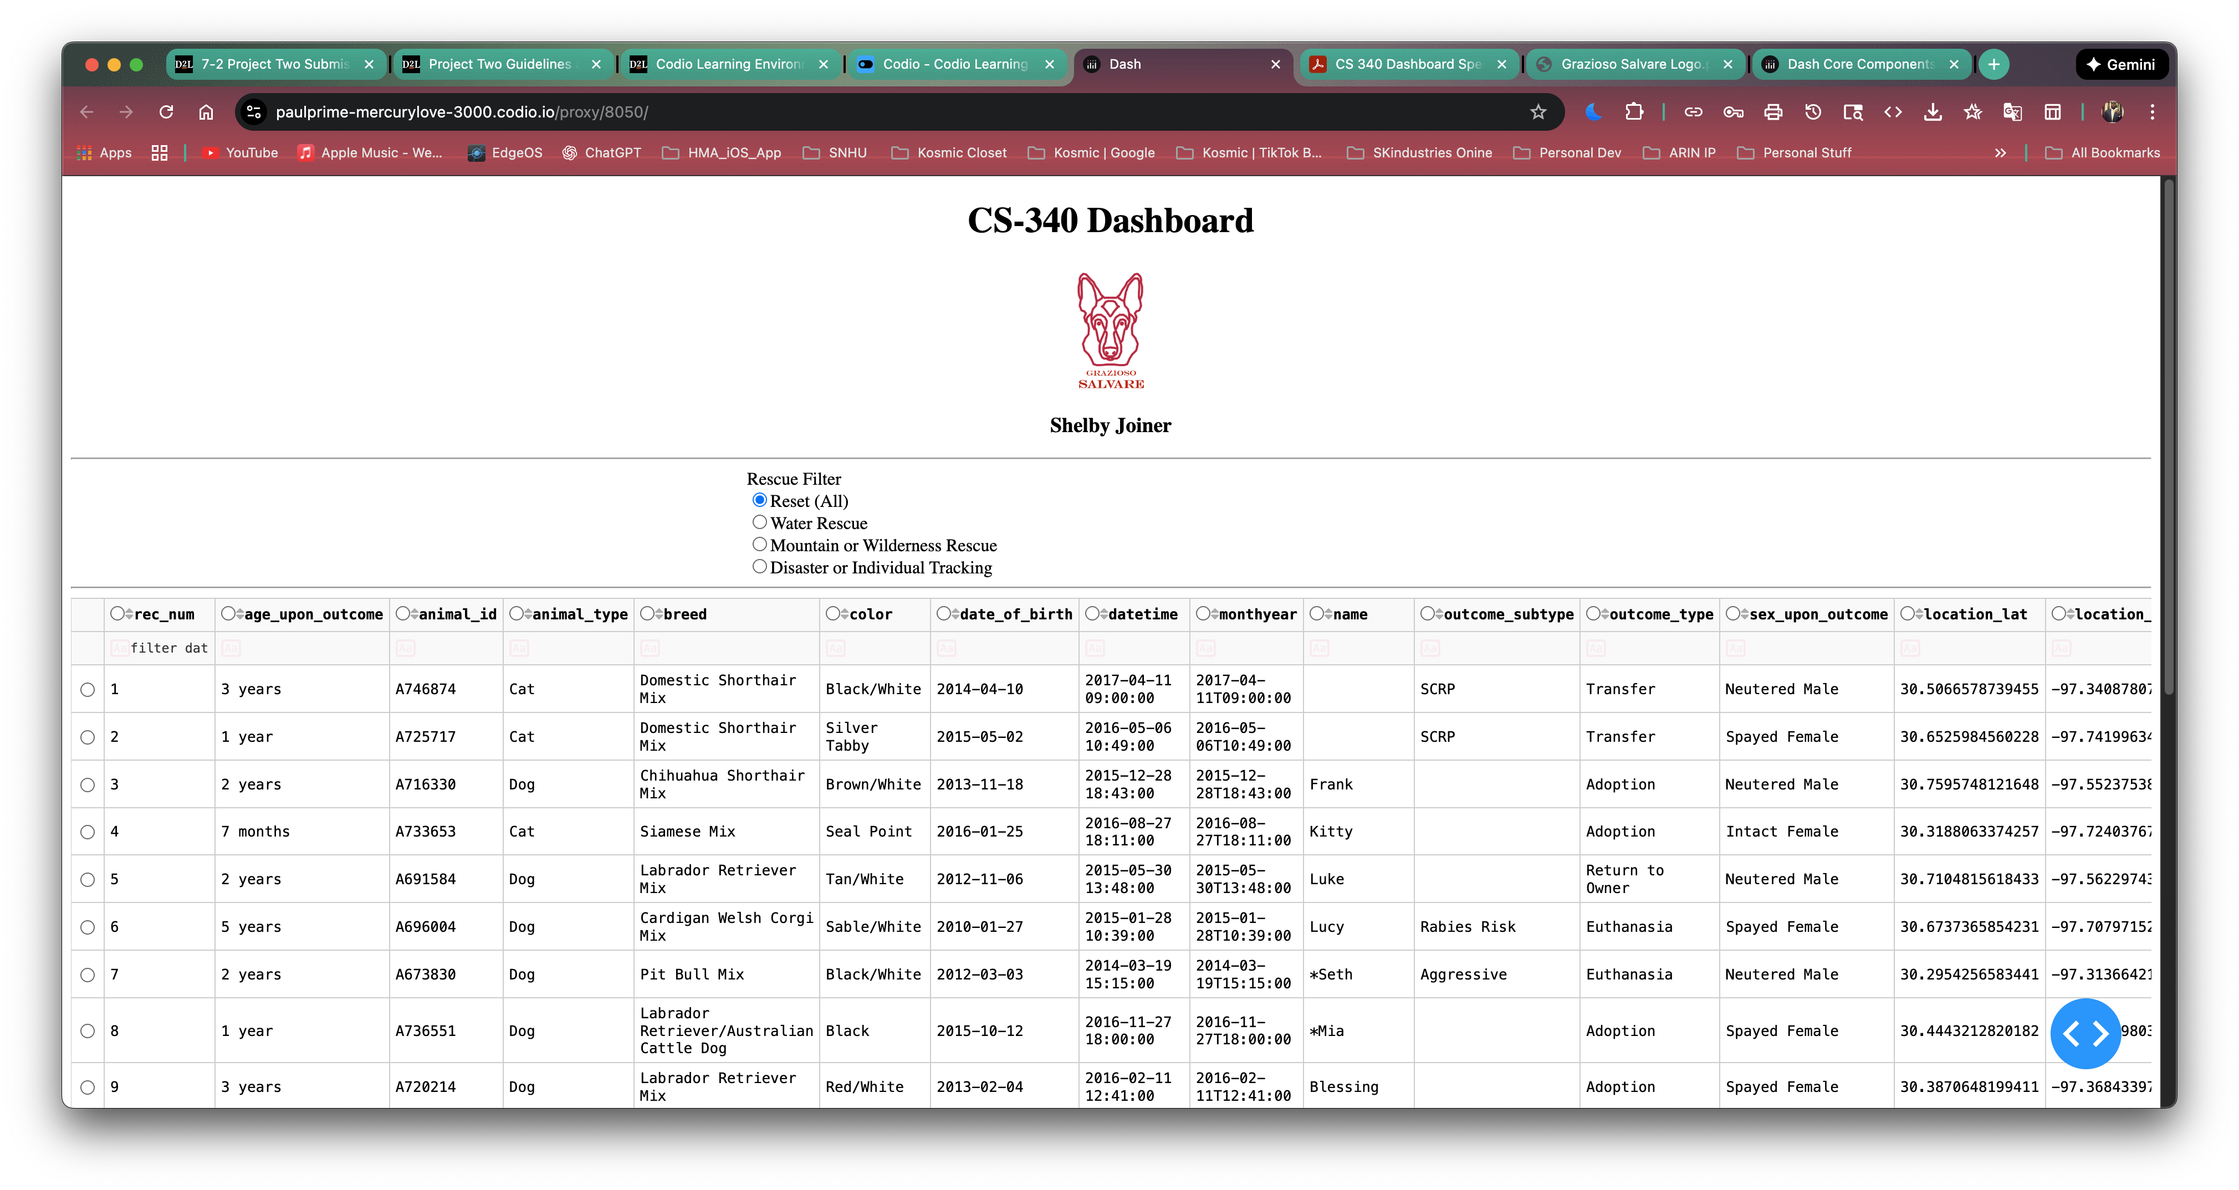Water Rescue Selected
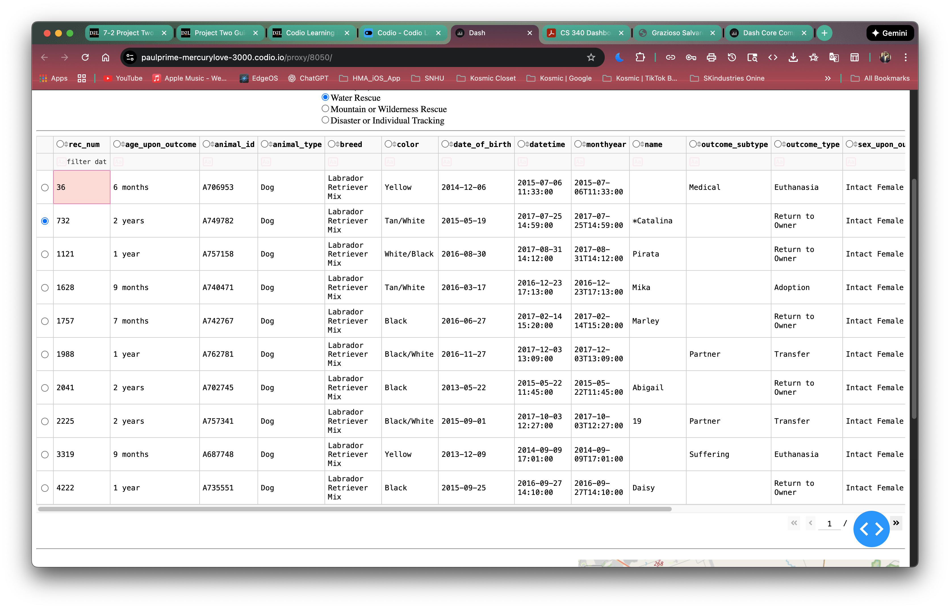Mountain or Wilderness Rescue Selected
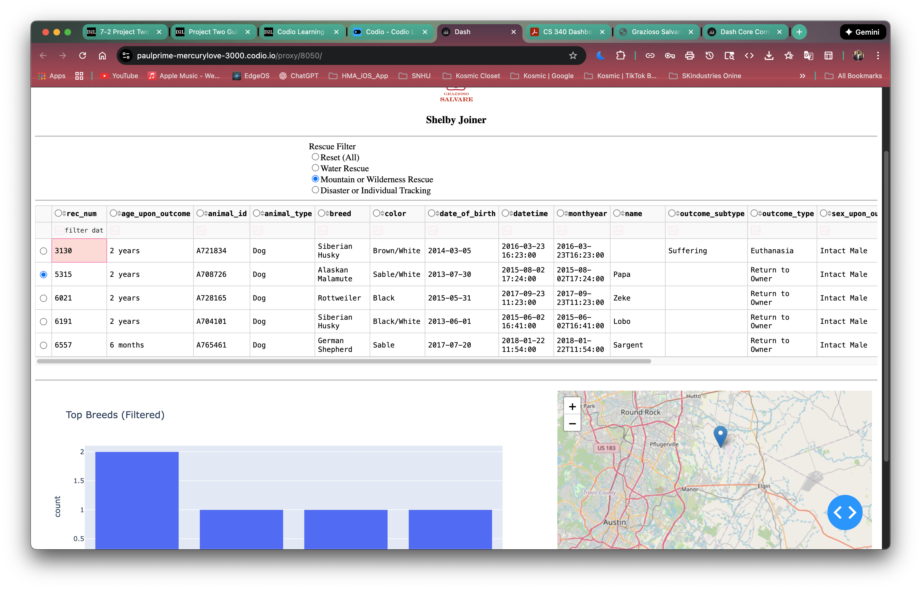Disaster or Individual Tracking Selected
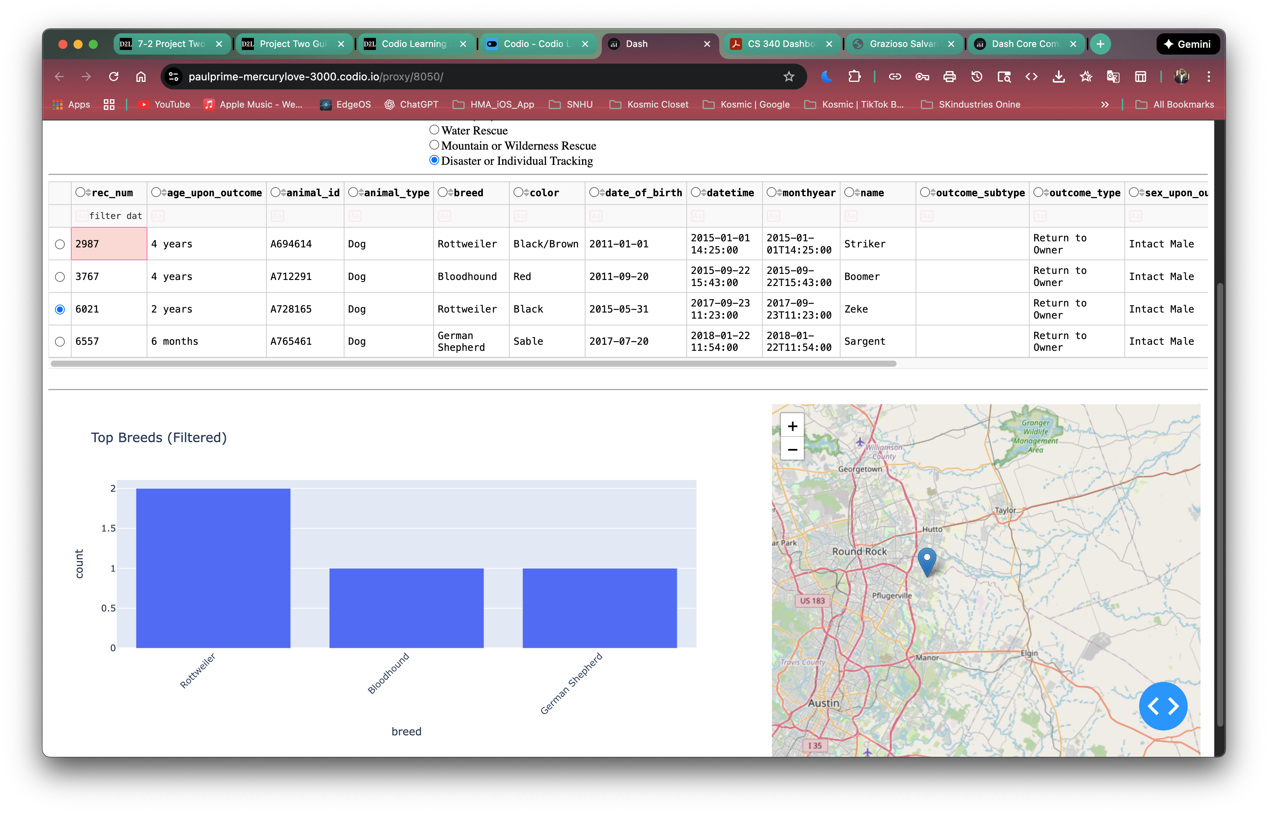

Reset All Reapplied

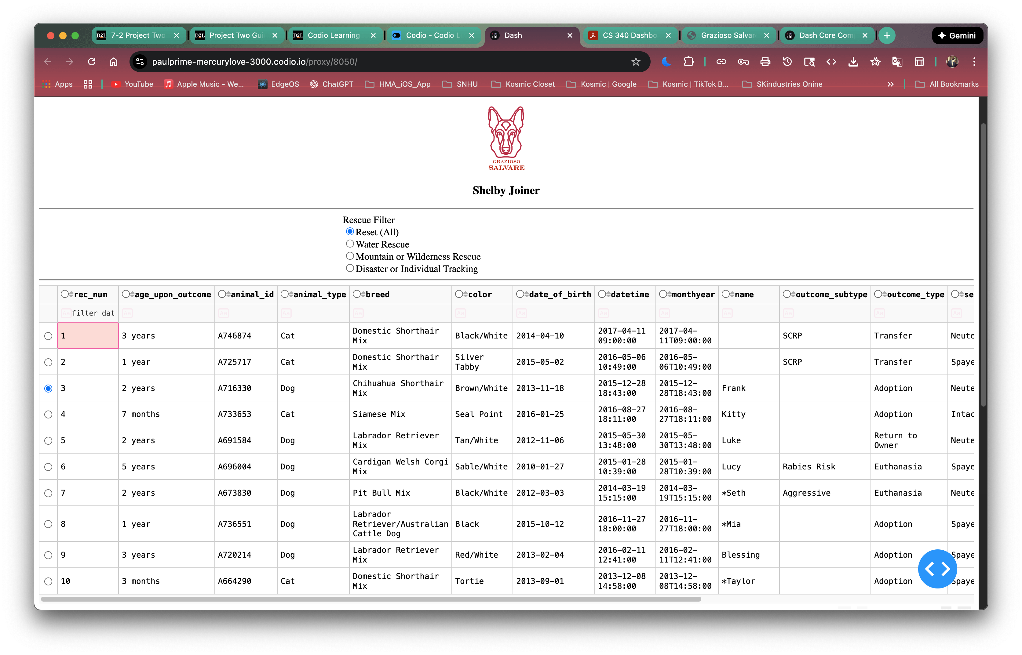How to Run the Application
1. Ensure MongoDB is running and the AAC dataset is loaded.
2. Place ProjectTwoDashboard.ipynb and crud.py in the same directory.
3. Run all cells in the notebook.
4. Access the dashboard via the JupyterDash link.
5. Use the rescue filter controls to explore the data.

Conclusion
The Grazioso Salvare Rescue Dashboard demonstrates how client/server development and data visualization can be combined to create meaningful, real-world applications. The dashboard provides a powerful yet easy-to-use tool for analyzing rescue-ready animals.

