Olivea Website Analytics Report

Students Name & IDs
Lama Hamoud Al-Anazi – 44611380
Linda Almajnooni – 446002770
Joud Alhamrmi – 44610611
Jomanh Mahmood Alturki - 44610952

Course Name
Web Data Analysis

Dr. Abrar Turkestani
Umm AL-Qura University
College of Computing
2026

Olivea Website Analytics Report

Olivea Website Project Report
In this project, our group developed a dynamic website called Olivea as part of the Web Data Analysis course. We worked together on designing the website, implementing backend functionality, deploying the project online, and analyzing user traffic using Google Analytics.

Phase 1 – Website Development
• We designed and developed the Olivea website using HTML and CSS.
• We created multiple pages with a simple and responsive design.
• We added interactive forms for user interaction and registrations.
• We implemented client-side validation to improve data accuracy.
• We developed backend functionality using Python Flask.
• We connected the website to a database to store form submissions and user data.

Phase 2 – Deployment
• We tested the website locally before deployment.
• We uploaded and deployed the website using PythonAnywhere.
• We configured the project to run online successfully.
• We generated a public link so users could access the website.

Phase 3 – Analytics Setup
• We integrated Google Analytics into the Olivea website.
• We added the Google tracking code using gtag.js.
• We defined website goals such as page visits and form submissions.
• We tracked user activities including page views, sessions, and form interactions.

Phase 4 – Data Analysis
Business Goals :
Sales Goal: Attracting customers interested in Boho style and encouraging them to browse and buy products (Dresses, Bags, Accessories) via the "Shop Now" button.
Lead Generation: Building a customer database through the "Join Olivea" sign-up form to collect user names, emails, and style preferences.
User Engagement: Keeping visitors interacting with the website content, as proven by the 190 scroll events and 52 form submissions.

Q1 — How many visitors are coming?
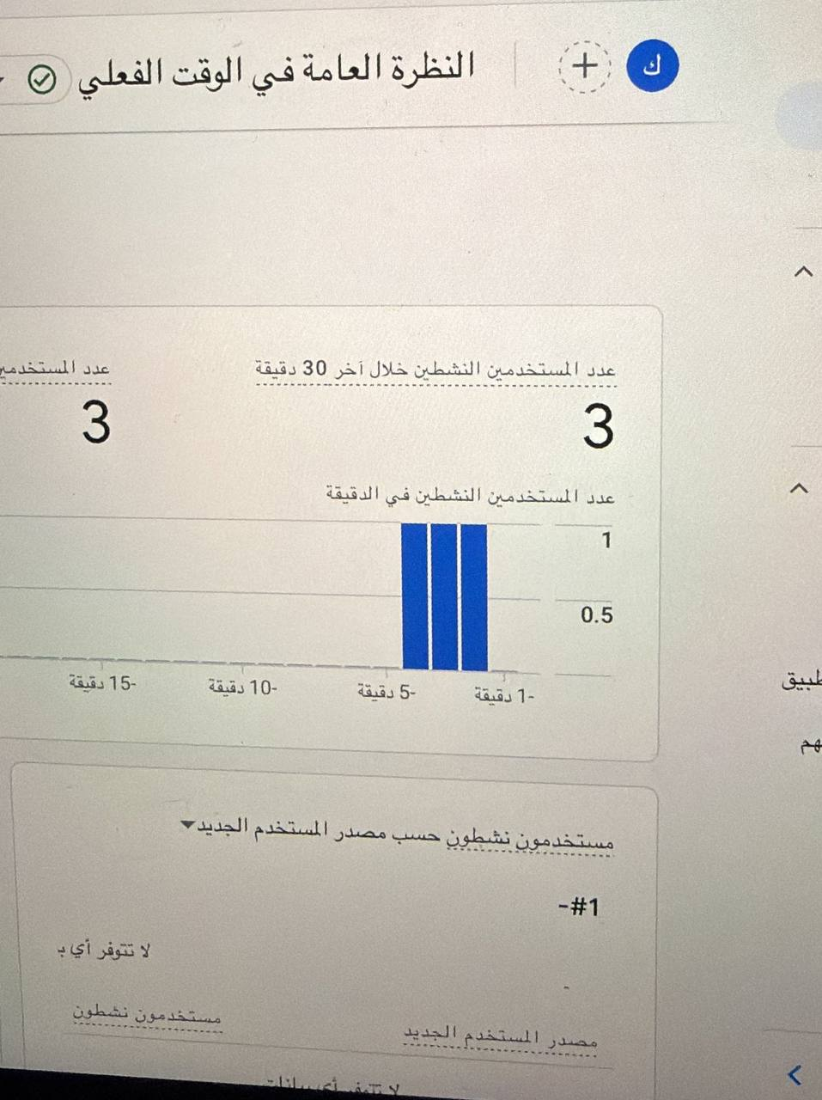

Q2 — Where are visitors coming from?
Most visitors came from Saudi Arabia, especially Riyadh and Jeddah.
The analytics also showed a small number of visitors from other locations, demonstrating that the website successfully reached multiple regions.
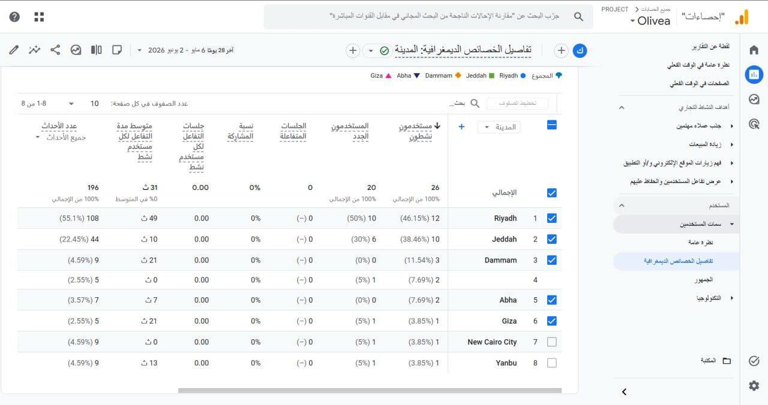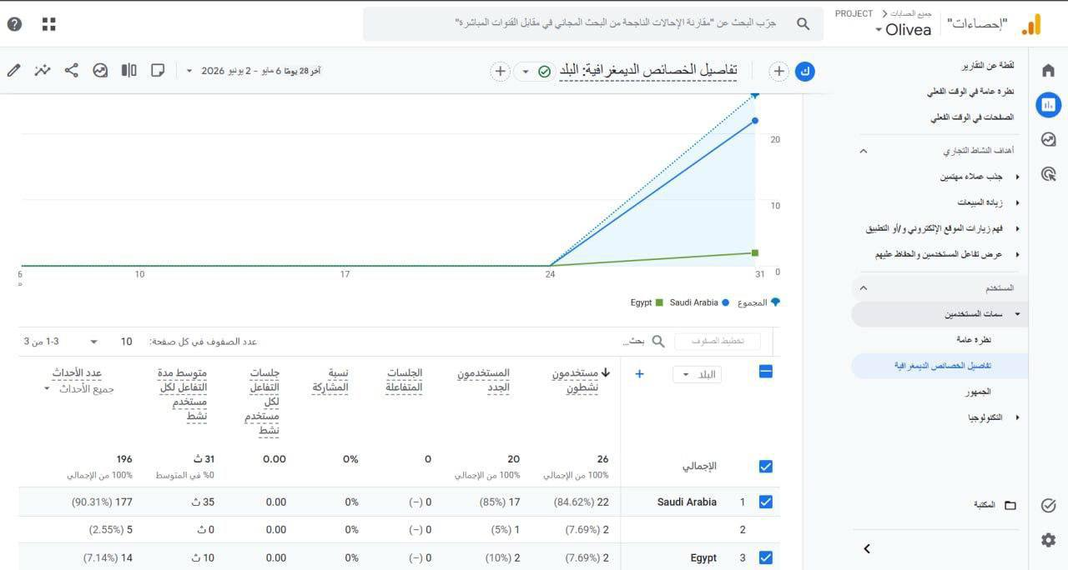

Q3 — What do we want visitors to do?
Desired actions:
• Browse products
• Submit the form
• Contact the website
• Interact with the pages.

Q4 — What are visitors actually doing?
Users actively viewed pages and interacted with the website form.
The analytics showed successful engagement through form submissions and page visits.
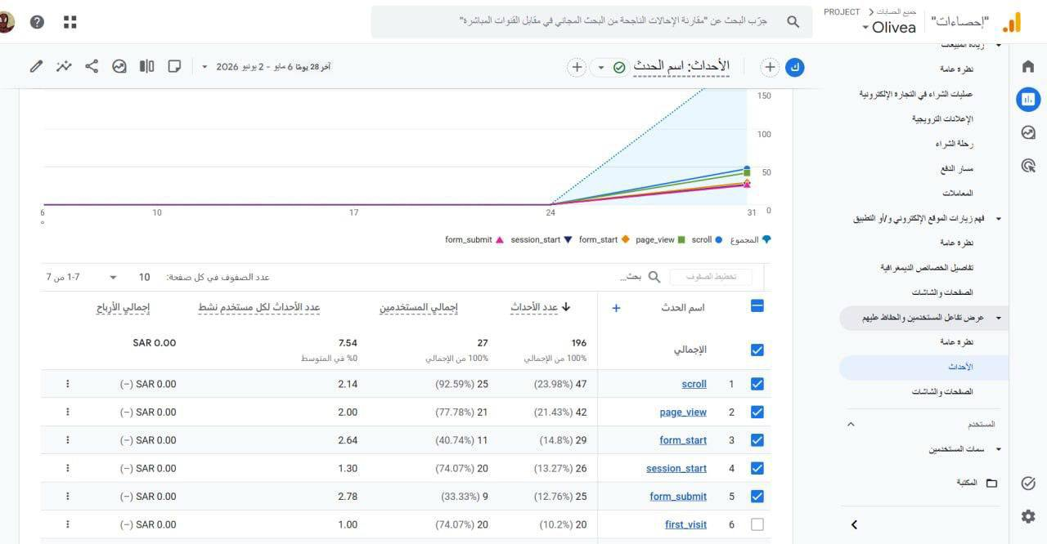

5- Outcomes by Traffic Source
Most users accessed the website using mobile devices, particularly through the Safari browser.
This indicates that the website is mobile-friendly and performs effectively across different platforms and operating systems.
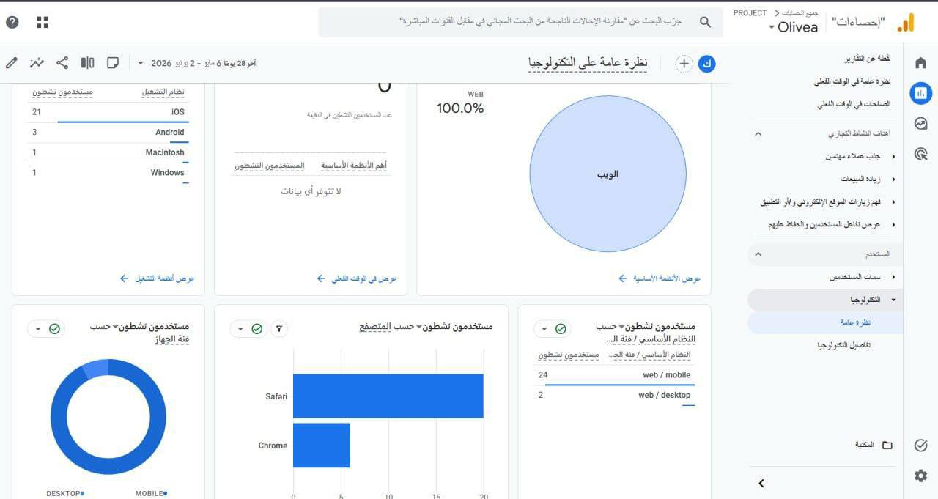

Final Insights
• The website successfully tracked user activity.
• Users interacted with the website forms.
• Page views increased during testing.
• Google Analytics provided useful performance insights.
• Real-time monitoring helped evaluate website engagement.

Recommendations for Improvement
1. Improve website responsiveness for all screen sizes.
2. Add more interactive website features.
3. Improve navigation and page loading performance.
4. Continue monitoring user activity using Google Analytics.

Enhanced Phase 4 Analytics Details
Data Collection Period
User Behavior Analysis
Most visitors explored multiple pages and interacted with the website through scrolling and form submissions.
The analytics showed that users were interested in:
- Viewing products
- Browsing categories
- Filling out the sign-up form
- Exploring the website pages
This demonstrates successful user engagement and interest in the website content.
Device and Browser Analysis
Most users accessed the website using mobile devices, especially through the Safari browser.
This suggests that the website is mobile-friendly and performs well across different operating systems and screen sizes.
Traffic Source Analysis
Most website visitors came from Saudi Arabia, especially from Riyadh and Jeddah.
This indicates that the website successfully reached the target audience in multiple regions.
Conversion Analysis
The website achieved successful engagement through user interactions and form submissions.
The sign-up form received multiple submissions, which supports the website’s lead generation goal.
The interaction metrics demonstrate that visitors were actively engaging with the website content and features.
Conclusion
The website successfully achieved its primary analytics goals by attracting visitors, encouraging interaction, and collecting engagement data.
Google Analytics helped monitor user behavior, traffic sources, and visitor activity effectively during the testing period.
Data Collection Period: From May 27, 2026 to June 2, 2026

