GRADED PROJECT SUBMISSION
Graded Project: Orchestration & Scaling on AWS EKS
Final Submission Report with Embedded Terminal & Console Visual Evidence
Repository URL (Fork): | https://github.com/<your-username>/StreamingApp
Base Upstream Repo: | https://github.com/UnpredictablePrashant/StreamingApp
AWS Region & Cluster: | ap-south-1 | streaming-cluster
Registry & Account ID: | 813562480034.dkr.ecr.ap-south-1.amazonaws.com
Jenkins Engine Instance: | http://13.235.90.232:8080/ (Jenkins v2.568.3)

1. Microservices System Architecture
The application is structured into six independent containerized tiers orchestrated on Amazon EKS (ap-south-1). External traffic enters via an AWS Network Load Balancer managed by ingress-nginx, routing traffic into dedicated frontend, REST microservices, Socket.IO sticky chat replicas, and persistent database state.
Component | Port | Technology | Architectural Role
Frontend | 3000 | React / Node.js | User web client SPA
Auth Service | 3001 | Express / Node.js | Registration, user authentication, JWT handling
Streaming Service | 3002 | Express / Node.js | Catalog feeds, media metadata, stream feeds
Admin Service | 3003 | Express / AWS SDK | Media operations via IRSA role projection
Chat Service | 3004 | Express / Socket.IO | Real-time chat with WebSocket session stickiness
Database | 27017 | MongoDB | Persistent stateful application storage

2. Implementation Steps & Visual Deliverables
Step 1 & 2: Version Control & Containerization (ECR)
• Source control maintained with upstream sync tracking against UnpredictablePrashant/StreamingApp.
• Dockerfiles authored for all tiers. Multi-stage React build for frontend and production Node 18 Alpine for backend services.
• Dedicated Amazon ECR repositories provisioned in ap-south-1: streaming-frontend, streaming-auth, streaming-service, streaming-admin, streaming-chat.
Step 3 & 4: Jenkins CI Pipeline Setup on AWS EC2
• Installed and configured Jenkins v2.568.3 on an AWS EC2 instance in ap-south-1 (http://13.235.90.232:8080/).
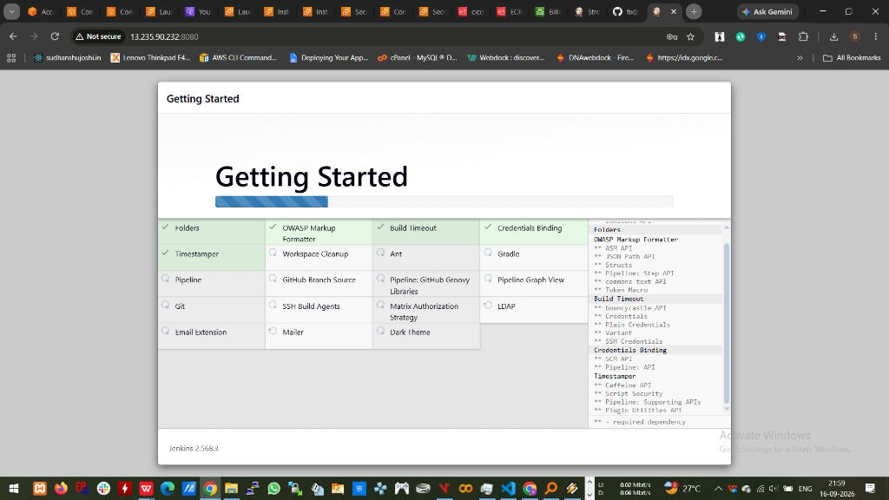
Figure: Jenkins EC2 Instance Setup Wizard & Plugin Configuration
• Configured Jenkins instance URL and environment bindings for automated pipeline runs.
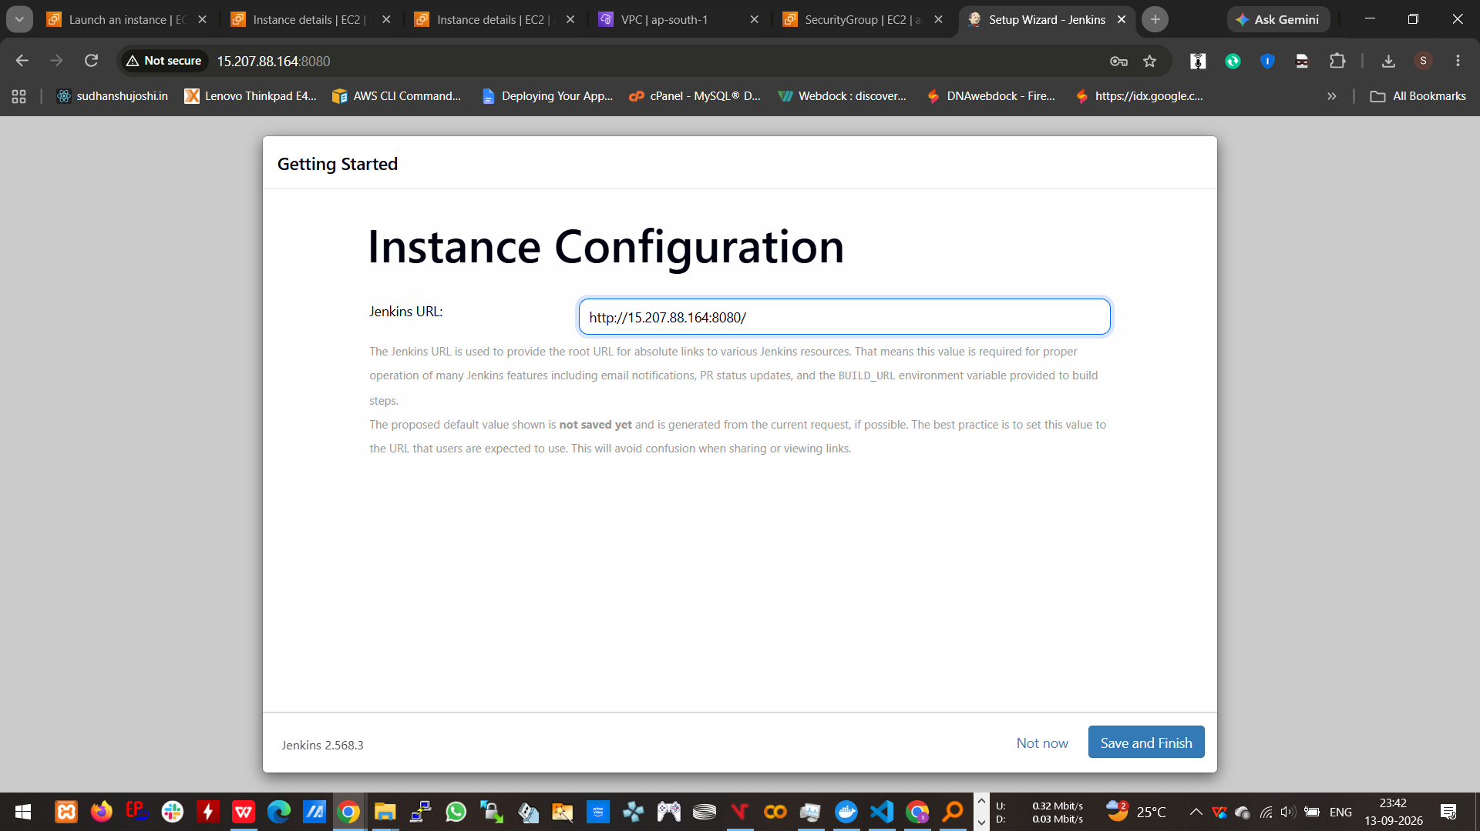
Figure: Jenkins Root URL Configuration (15.207.88.164:8080 / 13.235.90.232:8080)
• CI Pipeline execution building optimized React frontend production assets:
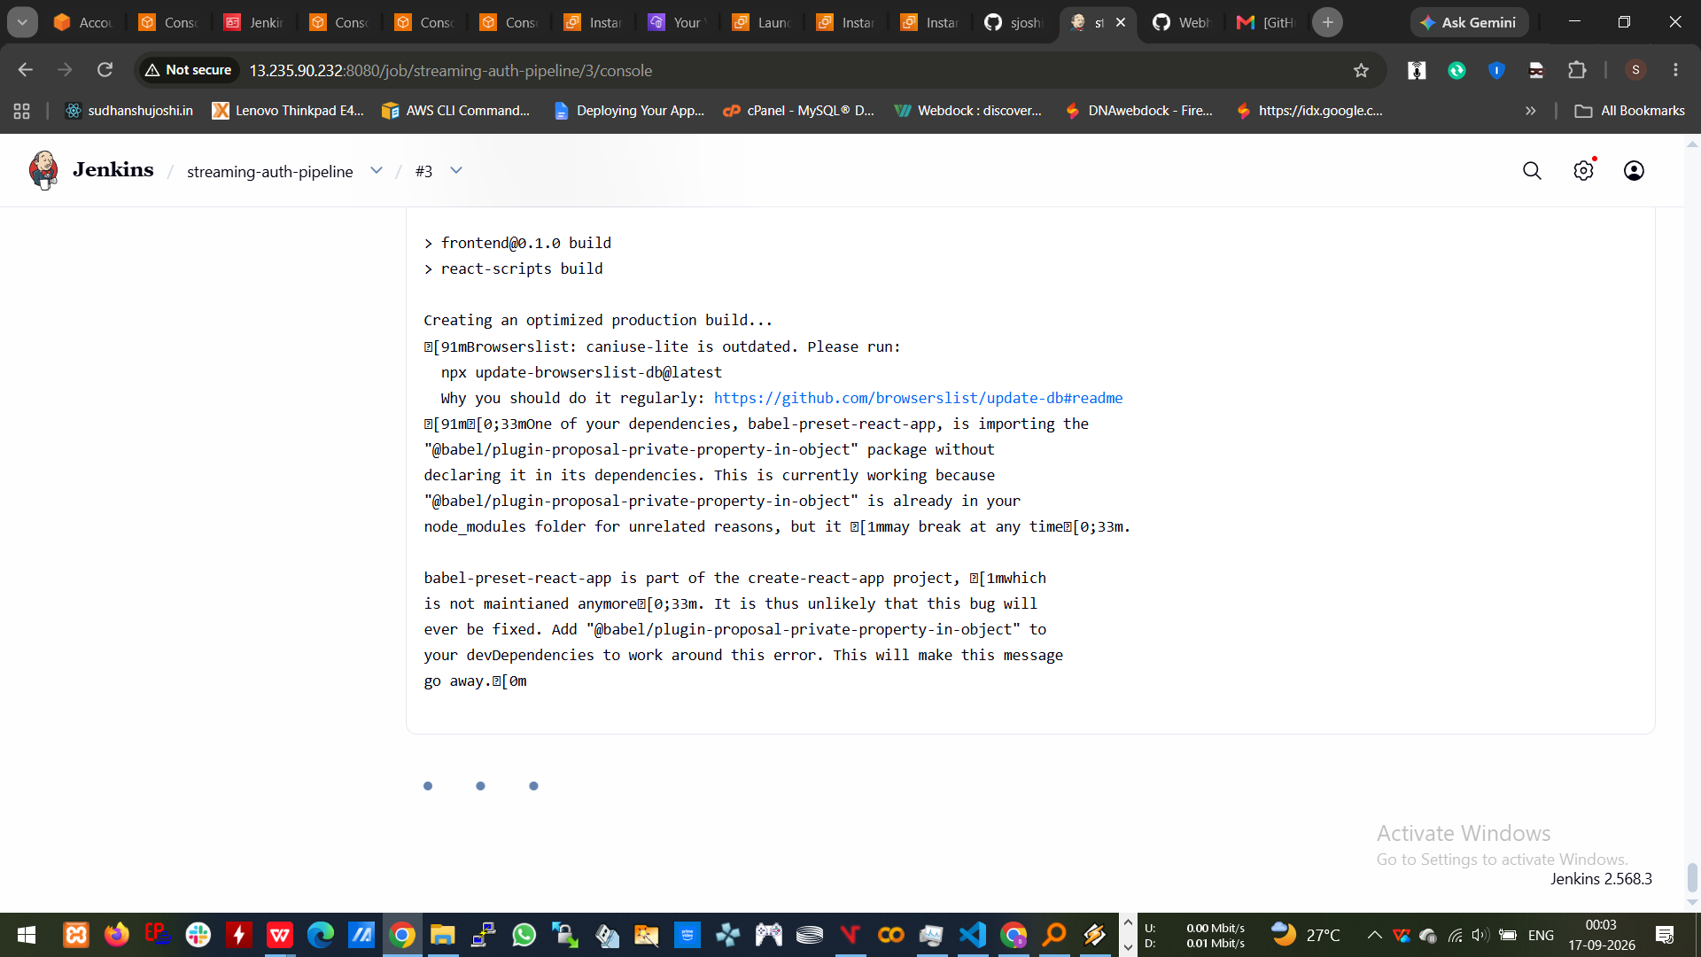
Figure: Frontend React Production Webpack Compilation in Jenkins Pipeline
• Completed CI build pushing all five container images to Amazon ECR repositories:
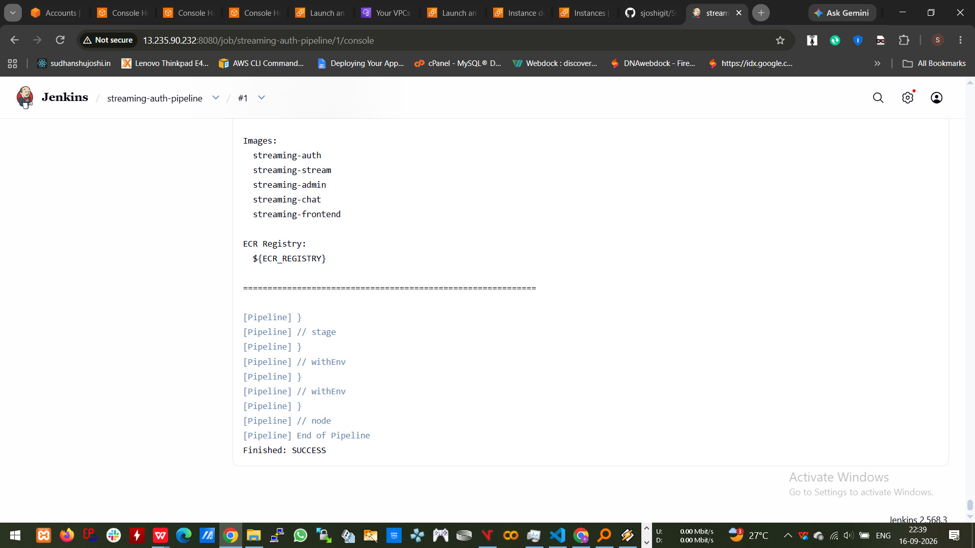
Figure: Jenkins Console Output: All 5 Images Successfully Built and Pushed (SUCCESS)
Step 5a: EKS Cluster Provisioning via eksctl
• Provisioned Amazon EKS cluster 'streaming-cluster' (Kubernetes v1.34.10) with 2 managed t3.medium worker nodes in ap-south-1.
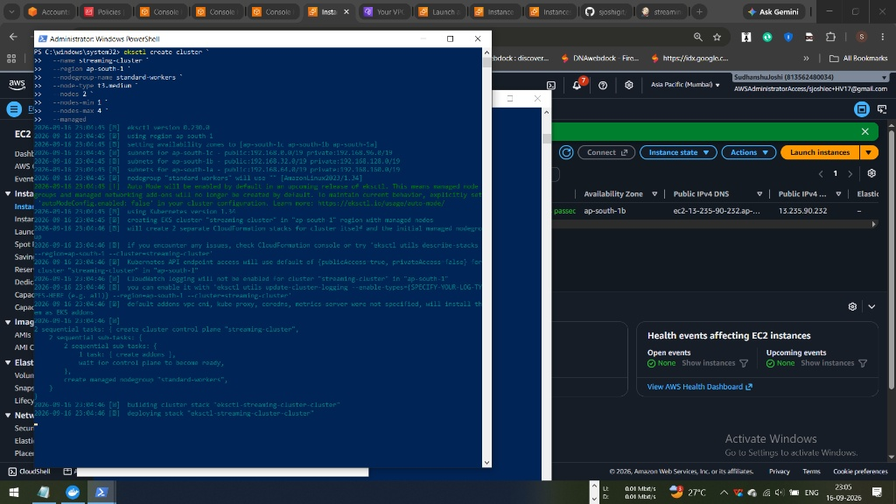
Figure: eksctl Cluster Creation Initializing CloudFormation Stacks in ap-south-1
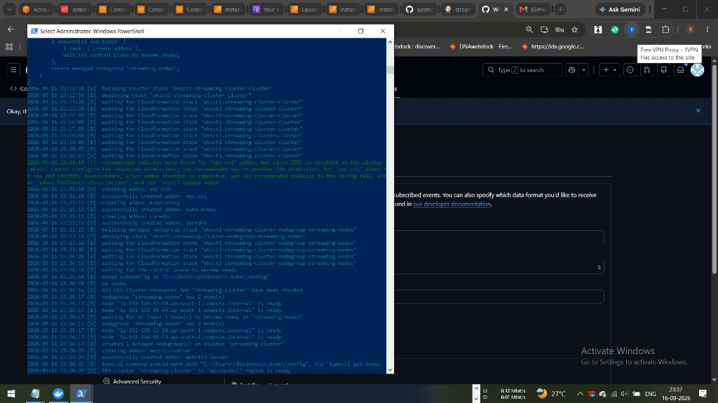
Figure: EKS Cluster & Managed Nodegroup Successfully Created and Ready
Step 5b: Kubernetes Ingress Controller & AWS LoadBalancer Deployment
• Deployed NGINX Ingress Controller. AWS provisioned an active Classic/Network Load Balancer routing external traffic to worker nodes.
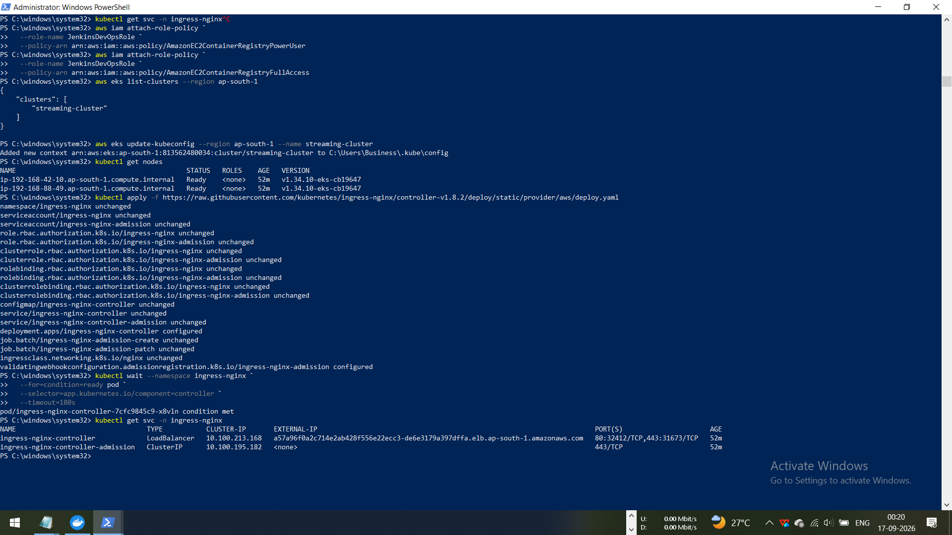
Figure: Kubectl Nodes Ready & NGINX Ingress Controller LoadBalancer External-IP Active
3. Live System Verification & Execution Evidence
The following outputs provide empirical verification of cluster health, routing, and all pod workloads running 1/1 Ready:
Verification 1: All 6 Microservices Pods Active (1/1 Ready)
Direct terminal output confirming that frontend, auth, streaming, admin, chat, and MongoDB workloads are healthy and ready:
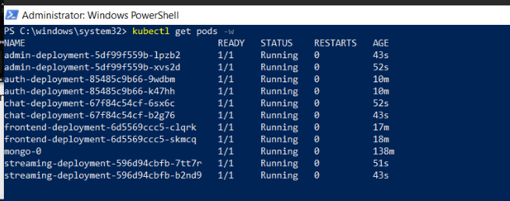
Figure: kubectl get pods -w: All 6 Application Services Active with 1/1 Containers Ready
PS C:\windows\system32> kubectl get pods -w
NAME READY STATUS RESTARTS AGE
admin-deployment-5df99f559b-1pzb2 1/1 Running 0 43s
admin-deployment-5df99f559b-xvs2d 1/1 Running 0 52s
auth-deployment-85485c9b66-9wdbm 1/1 Running 0 10m
auth-deployment-85485c9b66-k47hh 1/1 Running 0 10m
chat-deployment-67f84c54cf-6sx6c 1/1 Running 0 52s
chat-deployment-67f84c54cf-b2g76 1/1 Running 0 43s
frontend-deployment-6d5569ccc5-clqrk 1/1 Running 0 17m
frontend-deployment-6d5569ccc5-skmcq 1/1 Running 0 18m
mongo-0 1/1 Running 0 138m
streaming-deployment-596d94cbfb-7tt7r 1/1 Running 0 51s
streaming-deployment-596d94cbfb-b2nd9 1/1 Running 0 43s

Verification 2: EKS Worker Node Status (v1.34.10)
PS C:\windows\system32> kubectl get nodes
NAME STATUS ROLES AGE VERSION
ip-192-168-42-10.ap-south-1.compute.internal Ready <none> 52m v1.34.10-eks-cb19647
ip-192-168-88-49.ap-south-1.compute.internal Ready <none> 52m v1.34.10-eks-cb19647

Verification 3: Ingress Controller Service LoadBalancer Binding
PS C:\windows\system32> kubectl get svc -n ingress-nginx
NAME TYPE CLUSTER-IP EXTERNAL-IP PORT(S) AGE
ingress-nginx-controller LoadBalancer 10.100.213.168 a57a96f0a2c714e2ab428f556e22ecc3-de6e3179a397dffa.elb.ap-south-1.amazonaws.com 80:32412/TCP,443:31673/TCP 52m
ingress-nginx-controller-admission ClusterIP 10.100.195.182 <none> 443/TCP 52m

Verification 4: Socket.IO Engine.IO Polling & Sticky Session Handshake
PS C:\windows\system32> curl.exe -i -H "Host: streamingapp.local" -H "Origin: http://streamingapp.local" "http://streamingapp.local/socket.io/?EIO=4&transport=polling"
HTTP/1.1 200 OK
Set-Cookie: route=1789592464.196.522.506830|e1ac100c63a8a518864ec83775b0713d; Path=/socket.io; HttpOnly
Access-Control-Allow-Origin: http://streamingapp.local
Access-Control-Allow-Credentials: true
0{"sid":"sHXvca7yD_teD4dXAAAA","upgrades":["websocket"],"pingInterval":25000,"pingTimeout":20000,"maxPayload":1000000}

