DEVOPS / CI/CD DEPLOYMENT PROJECT
Student Registration System
CI/CD Pipeline Deliverable
Flask • MongoDB • Docker • GitHub Actions • Amazon ECR • Amazon EC2

Candidate Name | Sudhanshu Joshi
Course Module | DevOps CI/CD Deployment Project
Repository | github.com/sjoshigit/flask_practice
AWS Region | ap-south-1
Submission Date | August 16, 2026

Submission Scope
This document records the implemented CI/CD workflow, AWS container deployment, automated health verification, repository security controls, and visual evidence of both successful and intentionally failed pipeline executions.

. Document Contents
- 1. Project Overview & Deliverables Summary
- 2. CI/CD Architecture & Execution Flow
- 3. GitHub Secrets Configuration
- 4. Verification Evidence & Screenshots
- 5. Repository File Checklist Verification
- 6. Deployment & Operational Notes
- 7. Final Submission Statement

1. Project Overview & Deliverables Summary
This submission documents the complete automated Continuous Integration and Continuous Deployment (CI/CD) pipeline implemented for the Flask and MongoDB Student Registration System. The workflow is orchestrated with GitHub Actions, packages the application as a Docker image, publishes the image to Amazon Elastic Container Registry (ECR), deploys the selected image to an Ubuntu-based Amazon EC2 instance through SSH, and performs a deployment verification gate using the application's health endpoint.
Implementation Result
The pipeline demonstrates both positive and negative execution paths: a fully successful production-style deployment and a controlled deployment failure where the health verification gate terminates the job with a non-zero exit status. SMTP notifications communicate the outcome to the configured recipient.

Component | Implementation
Starter / Forked Repository | https://github.com/sjoshigit/flask_practice
Pipeline Configuration | .github/workflows/ci-cd.yml
Application Stack | Flask + MongoDB
CI Platform | GitHub Actions
Container Runtime | Docker
Container Registry | Amazon ECR
AWS Region | ap-south-1
ECR Repository | flask-app-sjoshi
Deployment Target | Amazon EC2 / Ubuntu
Target Host | 13.232.18.160
Health Endpoint | /health

Repository URL: https://github.com/sjoshigit/flask_practice
2. CI/CD Architecture & Execution Flow
The workflow is divided into two logical jobs. The first job provides continuous integration by creating a controlled Python/MongoDB test environment and executing the pytest suite. The second job runs only after the test job succeeds and performs image publication, remote deployment, verification, and notifications.
Git Push to main | Triggers the workflow

Job 1 — test | Python 3.10 → MongoDB 6.0 service → dependencies → pytest

Job 2 — build-and-deploy | AWS credentials → ECR login → Docker build → ECR push

EC2 Deployment | SSH → ECR authentication → pull image → replace running container

Verification Gate | curl --fail http://localhost:5000/health

Notification | Success email or Build/Deploy Failure email

Detailed execution sequence
- A push to the main branch initiates the GitHub Actions workflow.
- The test job provisions Python 3.10 and a MongoDB 6.0 service container on port 27017.
- Application dependencies are installed and the pytest suite, including test_app.py, is executed.
- When tests pass, the build-and-deploy job authenticates to AWS and Amazon ECR in ap-south-1.
- A Docker image is built and tagged with the Git commit SHA, creating an immutable deployment identifier.
- The image is pushed to the flask-app-sjoshi ECR repository.
- The workflow connects to EC2 through SSH, authenticates Docker to ECR, pulls the new image, and replaces the existing container.
- The new container is started on port 5000 with --restart unless-stopped.
- The deployment verification gate calls the local /health endpoint and fails the job if the endpoint does not return a successful response.
- SMTP notification logic reports the final pipeline state with deployment metadata and, for failures, the affected stage.

3. GitHub Secrets Configuration
Sensitive credentials and runtime values are supplied through GitHub repository secrets rather than being hard-coded into the source repository. This separation protects AWS credentials, SSH access material, the MongoDB connection string, and SMTP authentication data from accidental exposure.
Secret Key | Purpose / Description
AWS_ACCESS_KEY_ID | IAM programmatic access key used for AWS/ECR operations
AWS_SECRET_ACCESS_KEY | IAM secret access key used for AWS authentication
EC2_HOST | Public IPv4 address of the deployment instance: 13.232.18.160
EC2_USER | EC2 SSH username: ubuntu
EC2_SSH_KEY | Private SSH key used for remote EC2 access
MONGO_URI | MongoDB Atlas connection string passed to the container at runtime
SMTP_SERVER | SMTP server host, configured for smtp.gmail.com
SMTP_PORT | SMTP communication port, such as 465 or 587
SMTP_USERNAME | Authenticated sender account for CI/CD notifications
SMTP_PASSWORD | App-specific SMTP authentication credential
NOTIFICATION_EMAIL | Recipient address for pipeline outcome notifications

Security Compliance
No live credentials, .pem keys, or hard-coded secret values are intended to be committed to Git history. Secrets are injected at workflow/runtime boundaries and are not included in the application source or Docker image definition.

4. Verification Evidence & Screenshots
The following evidence captures the CI/CD pipeline operating in both successful and failed conditions. The successful execution demonstrates that the complete test-to-deploy path works end to end. The failed execution demonstrates that the deployment verification gate is capable of detecting an unhealthy deployment and returning a non-zero exit status, which correctly activates failure handling.

Proof A — Full Successful Pipeline Run (Run #15)
- Status: Passed / green across the test and build-and-deploy stages.
- Commit SHA: c8468646489fb966651e3d753ec429c97a0a39b3
Workflow Run: GitHub Actions Run #15
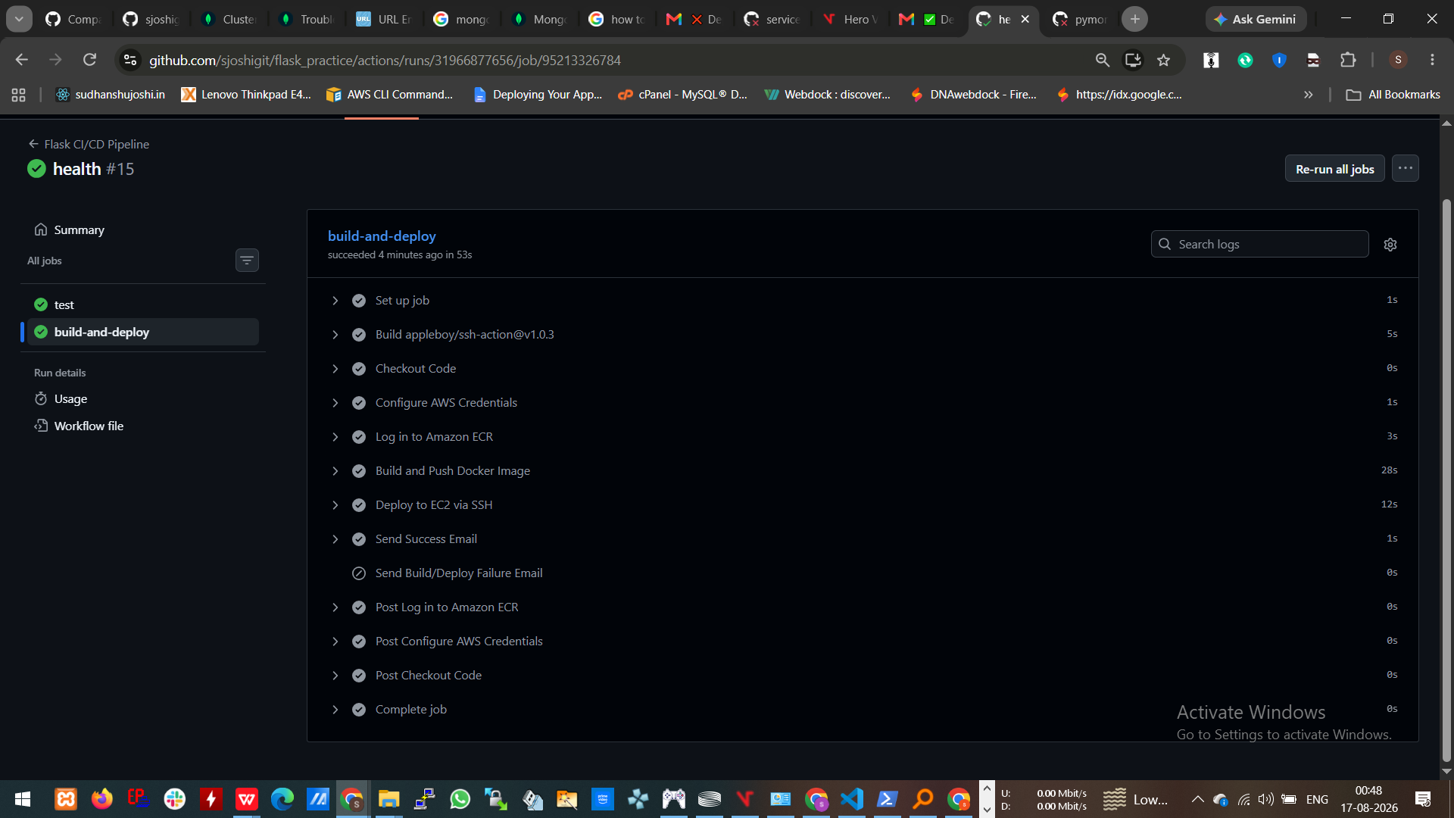
Figure 1 — Successful GitHub Actions pipeline run

Proof B — Success Notification Email
- Subject: Deployment SUCCESS — sjoshigit/flask_practice
- Target EC2 Host: 13.232.18.160
- Docker Image Tag: c8468646489fb966651e3d753ec429c97a0a39b3
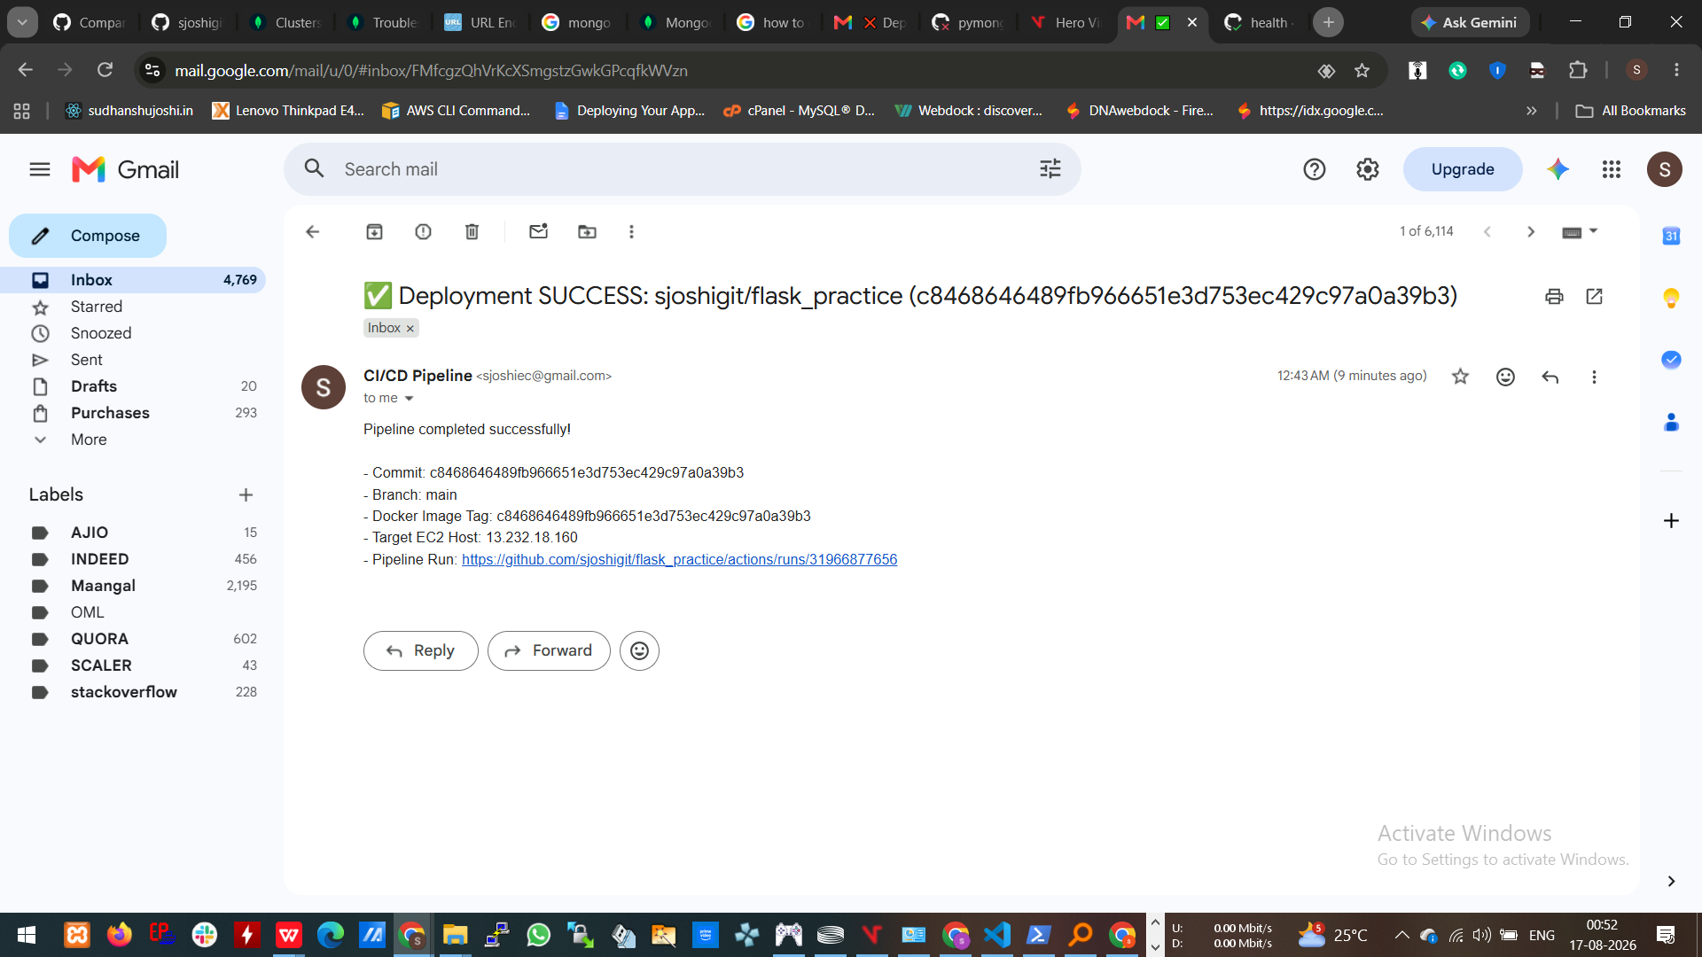
Figure 2 — Successful deployment notification received by email

Proof C — Failed Pipeline Run (Verification Gate Failure)
- Status: Failed at build-and-deploy → Deploy to EC2 via SSH.
- Failure condition: deployment health-check verification returned a non-zero exit status.
- Commit SHA: 8973d319e09b2ff31788a2d8f02b47219e687213
Workflow Run: GitHub Actions Failed Run
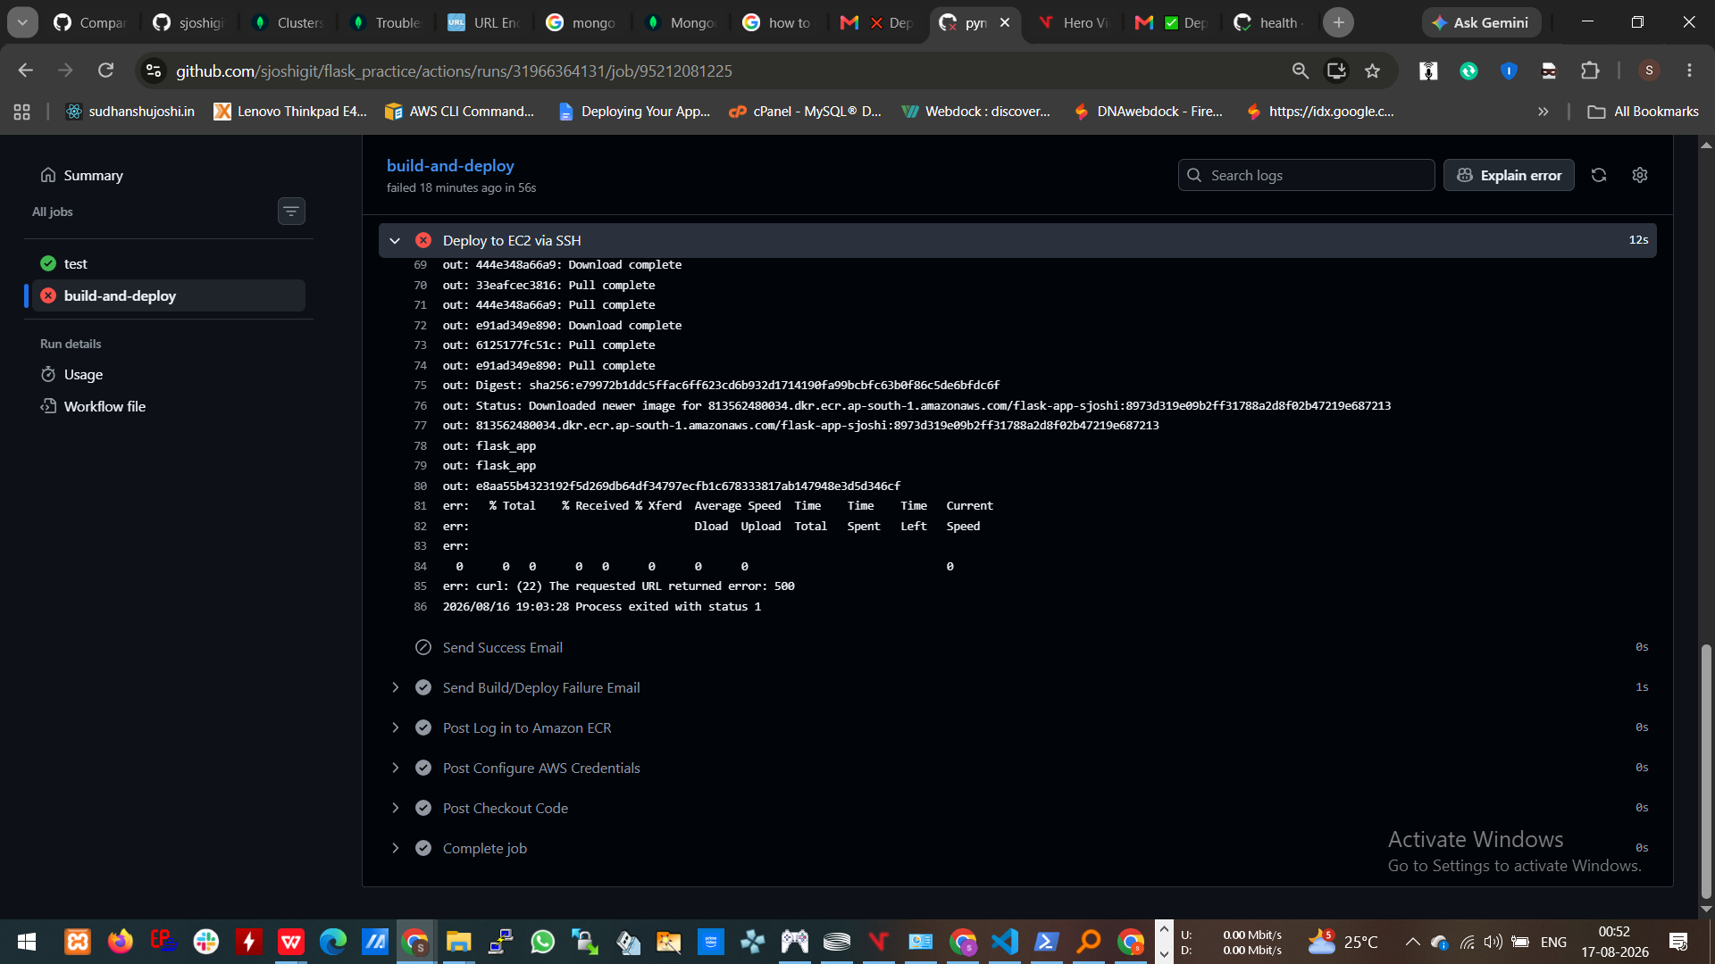
Figure 3 — Failed deployment at the EC2 deployment / health verification stage

Proof D — Failure Notification Email
- Subject: Deployment FAILED at Build/Deploy Stage — sjoshigit/flask_practice
- Failed Stage: Build, Push, or Deploy stage / health-check verification
- Target EC2 Host: 13.232.18.160
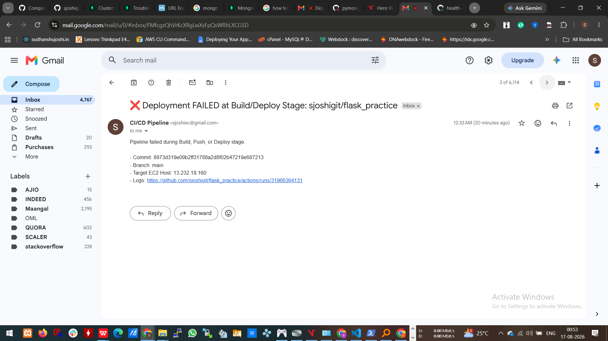
Figure 4 — Failed deployment notification received by email

5. Repository File Checklist Verification
Repository Item | Status | Verification Detail
Starter Repository Forked & Cloned | Verified | Repository maintained under the sjoshigit GitHub account.
Dockerfile & .dockerignore | Verified | Containerization files are present and support a slim production-oriented image.
app.py | Verified | Includes the /health endpoint used by deployment verification.
.github/workflows/ci-cd.yml | Verified | Contains test, ECR build/push, SSH deployment, health verification, and email notification stages.
README.md | Verified | Provides project documentation, architecture/secrets information, and recovery guidance.
Security Compliance | Verified | No hard-coded live credentials, .pem keys, or secret values are intended to be committed.

6. Deployment & Operational Notes

Container Deployment Strategy
- Docker images are tagged using the Git commit SHA, providing a traceable link between source code and the deployed artifact.
- The image is stored in Amazon ECR under the flask-app-sjoshi repository in ap-south-1.
- The EC2 deployment replaces the running application container with the newly pulled image.
- The container is configured with --restart unless-stopped so the application can recover automatically after routine container/host restarts.

Health Verification as a Release Gate
The /health endpoint is treated as the final release gate. A deployment is not considered successful merely because the Docker image was pushed or the container process was started. The workflow explicitly checks the running service from the EC2 host. If the health endpoint fails, curl --fail returns a failure status and the GitHub Actions job terminates with status 1. This behavior is visible in the failed evidence captured in Figure 3.

Notification Strategy
- Successful deployments trigger a success notification containing the commit SHA, Docker image tag, target EC2 host, and workflow run information.
- Build/deploy failures trigger a dedicated failure notification identifying the affected pipeline stage and target host.
- This separation provides immediate operational feedback without requiring the administrator to continuously monitor the GitHub Actions interface.

Suggested Operational Recovery
- Review the failed GitHub Actions step and identify whether the issue occurred during image build, ECR push, SSH access, container startup, or health verification.
- Confirm that the EC2 instance can authenticate to ECR and that the expected image tag exists in the configured ECR repository.
- Inspect the running container and application logs on EC2 when the health check fails.
- Validate MongoDB connectivity and the runtime MONGO_URI when the /health endpoint reports a database-related failure.
- Re-run the workflow only after the root cause has been corrected.
7. Final Submission Statement
The Student Registration System CI/CD implementation demonstrates an end-to-end DevOps delivery process from source-code commit through automated testing, container image creation, registry publication, remote cloud deployment, post-deployment verification, and outcome notification. The included evidence establishes that the pipeline can successfully deploy a tested build and can also correctly reject an unhealthy deployment through an automated verification gate.
Submission status: Complete — CI/CD workflow, AWS deployment, verification gate, security controls, and visual evidence documented.

Prepared for DevOps / CI/CD Deployment Project

