Figure 1
Background:
STDP: spike-timing dependent plasticity
A synaptic connects presynaptic neuron postsynaptic neuron
STDP says: the synapse strengthens or weakens depending on which neuron fires first.

Example:
1000 presynaptic neurons 1 post synaptic neuron
Imagine the postsynaptic neuron receives inputs form ABCDE, suppose B, C and D fire together.
B spike
C spike
D spike
post neuron spikes
Then after the spike, neuron A fires
For the synapse A post: t_pre > t_post, post happened before pre.

Paper big picture:
If many synapses project to one neuron and STDP is applied, what happens to the synaptic strengths?
Result: STDP automatically creates competition between synapses. Some synapses become strong; others become weak. This produces a bimodal distribution of weights.

The STDP rule used:
$$∆g=g_{max}F\left(∆t\right)$$
where
$$∆t=t_{pre}-t_{post}$$

If presynaptic spike before postsynaptic spike, $∆t<0$ Long term Potentiation (LTP)
$$F\left(∆t\right)= -A_{+}e^{∆t/τ_{+}}$$
If presynaptic spike after postsynaptic spike, $∆t>0$ Long term Depression (LTD)
$$F\left(∆t\right)= -A_{-}e^{-∆t/τ_{-}}$$

Simulation setup:
100 presynaptic neurons 1 postsynaptic neuron
Each presynaptic neuron: generate spikes (Poisson process) and has a synaptic weight $0<g_{i}≤g_{max}$, STDP update these weights

In the simulation: for each spike pair, compute delta t apply STDP rule update synapse
Over time: stronger synapses stronger, weaker synapses weaker
Results: two clusters of weights

Scenario 1 – All inputs are random
Setup: every presynaptic neuron fires independently (poison spikes)
There is no correlation structure
Because spikes are random: pre-before-post ~= post-before-pre
But there is an important bias: the postsynaptic neuron fires because of some inputs. Those inputs tend to fire slightly before the spike. So, they experience more: prepost LTP
Other synapses mostly random timing LTD dominates

Result synapses spilt into two groups:
Weak synapses near 0
Strong synapses near gmax
This creates a bimodal distribution of weights

Scenario 2 – one correlated input group
Now the inputs are divided into two groups
Inputs 1-500 random spikes
Inputs 501-100 correlated spikes

correlated mean those neurons tend to fire together, many spikes occur close in time.
If many inputs fire together: cluster of presynaptic spikes postsynaptic neuron spikes
So for those synapses: t_pre < t_post LTP dominates

For the random inputs(uncorrelated)
Post-before-pre ~50%
Pre-before-post ~50%
But because LTD area is larger, the average effect is weakening.

Result:
Correlated synapses strong
Uncorrelated synapses weak

Scenario 3 – Two competing correlated groups
Inputs 1-500 correlated
Inputs 501-1000 correlated
But the two groups are independent of each other.

Both groups try to derive the postsynaptic neuron, but whichever group happens to get slightly stronger first will fire trigger postsynaptic spike, then STDP strengthens that group’s synapses.
Positive feedback, once one group gains a small advantage: stronger synapses more likely to trigger spike more LTP even stronger, meanwhile the other group experiences post-before-pre LTD
Outcome, only one group survives, the winner is random.

For the info graph:
Solid line: how often does a presynaptic spike happen delta t ms before for after a postsynaptic spike?
Baseline is 1 chance level (no correlation)
>1 more spikes than expected
<1 fewer spikes than expected
The peak is higher on the left side, that means more pre-before-post events than post-before-events, because presynaptic spikes help cause the postsynaptic spike.

Analysis:
- Weight distribution
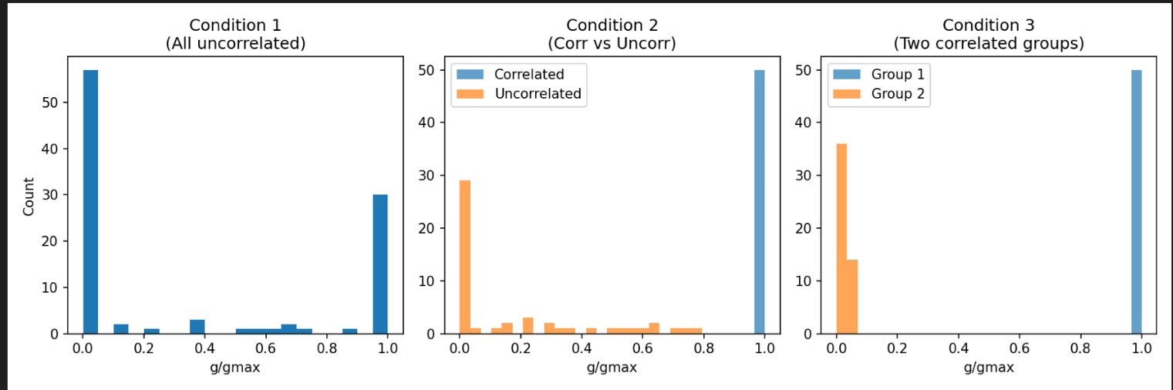
Weight distribution under different input conditions. In Condition 1 (all inputs uncorrelated), synaptic weights form a bimodal distribution with peaks near 0 and gmax​, reflecting stochastic competition under STDP. In Condition 2, STDP separates correlated and uncorrelated inputs, producing a bimodal distribution where correlated synapses strengthen toward gmax​ while uncorrelated ones weaken. In Condition 3, two correlated groups compete, and one group dominates while the other is suppressed, illustrating the competitive nature of STDP learning.

- Weight evolution
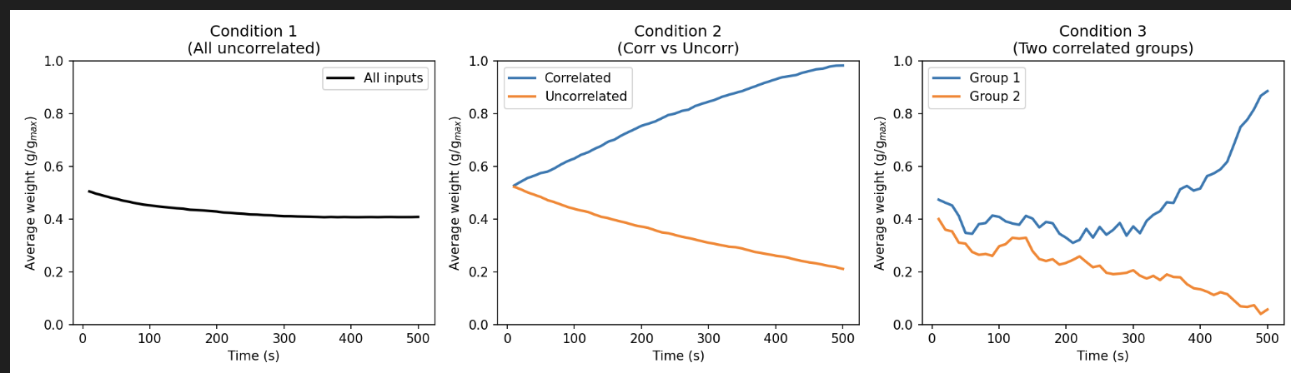
Weight evolution under different input conditions. In Condition 1 (all inputs uncorrelated), the average synaptic weight gradually converges to a stable plateau due to the balance between stochastic LTP and LTD under the STDP rule. In Condition 2, correlated inputs are progressively potentiated while uncorrelated synapses weaken, demonstrating how STDP selectively strengthens correlated pathways. In Condition 3, two correlated groups compete, leading to divergence where one group becomes dominant while the other is suppressed, illustrating competitive synaptic learning.

- STDP sensitivity to correlation strength and LTD/LTP ratio (case 2 only)

S measures how selective the neuron becomes

$$S= \frac{W_{corr}-W_{uncorr}}{W_{corr}+W_{uncorr}}$$

W_corr = mean weight of correlated inputs
W_uncorr = mean weight of uncorrelated inputs
S = 0 no selectivity
S> 0 Correlated inputs stronger
S <0 uncorrelated stronger

x-axis: correlation strength (yConst)
if yconst = 0 neurons are independent Poisson processes no correaltions
yconst > 0 input correlation

$$B=\frac{A_{-}}{A_{+}}$$
- = strength of LTP
A+ = strength of LTD
B < 1 LTP stronger
B = 1 balanced
B > 1 LTD stronger
Results: LTD becomes slightly stronger, the network becomes more selective
If LTP dominates, all synapses strengthen, even random inputs, so no selectivity.
If LTD dominates slightly, uncorrelated synapses weaken while correlated ones still get enough LTP to survive. So, we get strong synapses (Corr) and weak synapses(uncorr) which creates selectivity.

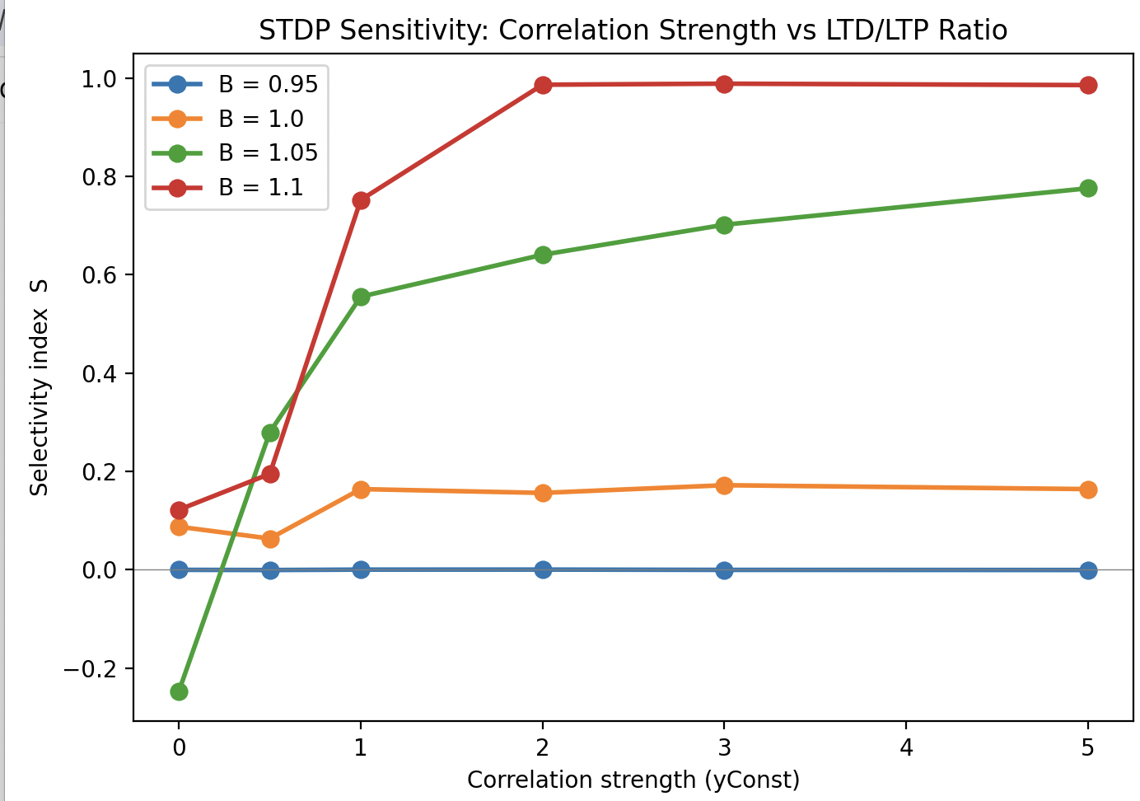
The selectivity index increases with correlation strength, but the effect strongly depends on the LTD/LTP ratio B=A−/A+. When LTD dominates (e.g., B=1.1), even weak correlations lead to strong selectivity. For balanced or LTP-dominated cases (B≤1), selectivity remains weak because synaptic competition is insufficient to separate correlated and uncorrelated inputs. This demonstrates that both spike correlation and the balance between LTD and LTP determine the effectiveness of STDP-based learning.

4. number of correlated inputs STDP need
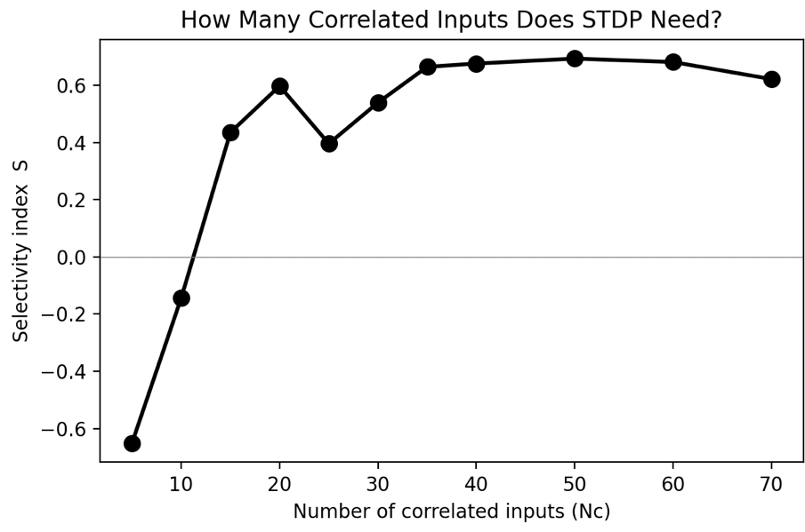
When the number of correlated inputs was small (Nc ≤ 10), selectivity was negative, indicating that correlated synapses were weakened rather than strengthened. This occurs because the correlated population is too small to reliably trigger postsynaptic spikes. As Nc increases beyond approximately 15–20 inputs, correlated spikes begin to dominate postsynaptic firing, producing causal spike timing and strong potentiation. Selectivity then increases and eventually saturates once correlated synapses reach their maximal strength.

Improvement? Run 5-10 simulations per Nc to avoid noise.

5. Effect of temporal precision on Selectivity
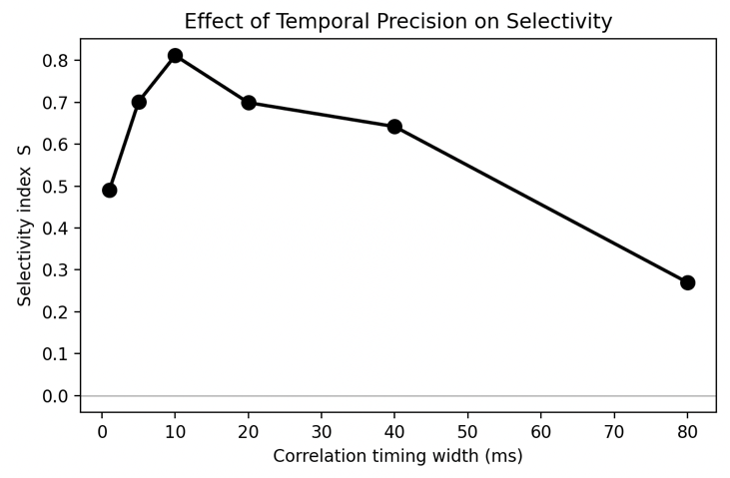
Correlation timing width (ms) means how precisely synchronized the correlated inputs are.
The curve here is increase peak decrease

Examined how the temporal precision of correlated spikes influences STDP selectivity. Selectivity increased as the correlation width expanded from 1 ms to approximately 10 ms, reaching a maximum when the correlation timescale matched the potentiation window of the STDP rule. When the correlation width increased beyond 20 ms, selectivity declined, indicating that STDP cannot reliably detect correlations when spike timing becomes too dispersed.

Figure 4.
Latency reduction using STDP

Panel A-B
All synapses start with similar weights.
So, when a burst of inputs arrives with different latencies, the neuron integrates many of them before firing.
Early spikes small EPSPs
More spikes accumulate threshold reached
Postsynaptic spike occurs relatively late

During STDP
Suppose the postsynaptic neuron spikes at t = 0.
Inputs at -20 ms strong LTP
Inputs at -10 ms some LTP
Inputs and +10ms LTD
Inputs a +20ms strong LTD
So STDP gradually reshape the weights

After learning (panel c)
The weights become step-like
Early latency inputs g ~gmax
Late latency inputs g ~0
This means the neuron has selected only the earliest inputs
So instead of many neurons contributing, only the earliest few synapses remain strong.

Postsynaptic response
Now run the same burst again. Because early synapses are strong:
Early spikes large EPSP
Threshold reached quickly
The neuron fires earlier in time. So STDP has effectively shifted the spike timing earlier. (Called reduction of latency)

Section 1 – reproduce Figure
Section2 – Latency reduction during learning
1 training iteration = 1 present burst +STDP weight update
- Early training means before STDP has significantly changed the weights. At this stage, all synapses are roughly equal. So, the neuron spikes only after many inputs accumulate.
- Late training means after STDP has modified the weights, now STDP has done in two things. Early inputs strong weights & late inputs weak weights, so the neuron can spike much earlier.
The presynaptic spikes follow a gaussian distribution with mean 0ms (center of the burst & as a reference time)
Negative time: the neuron spikes earlier than the average presynaptic spike
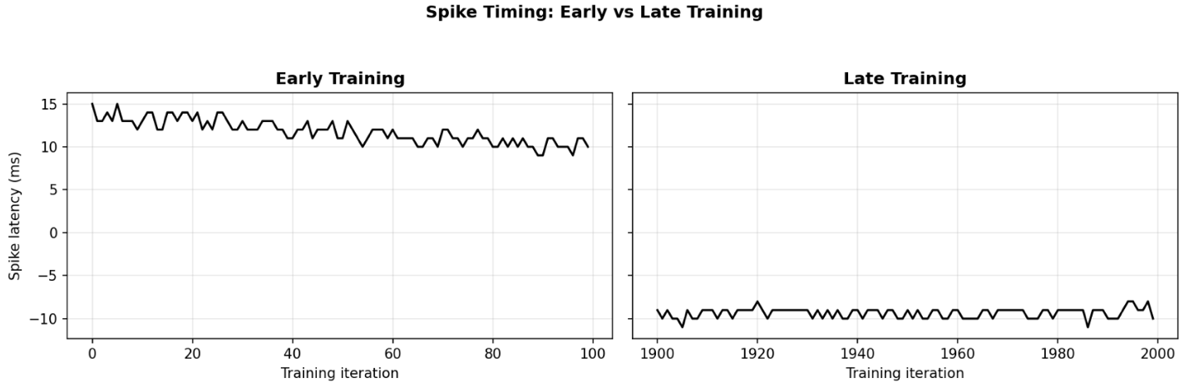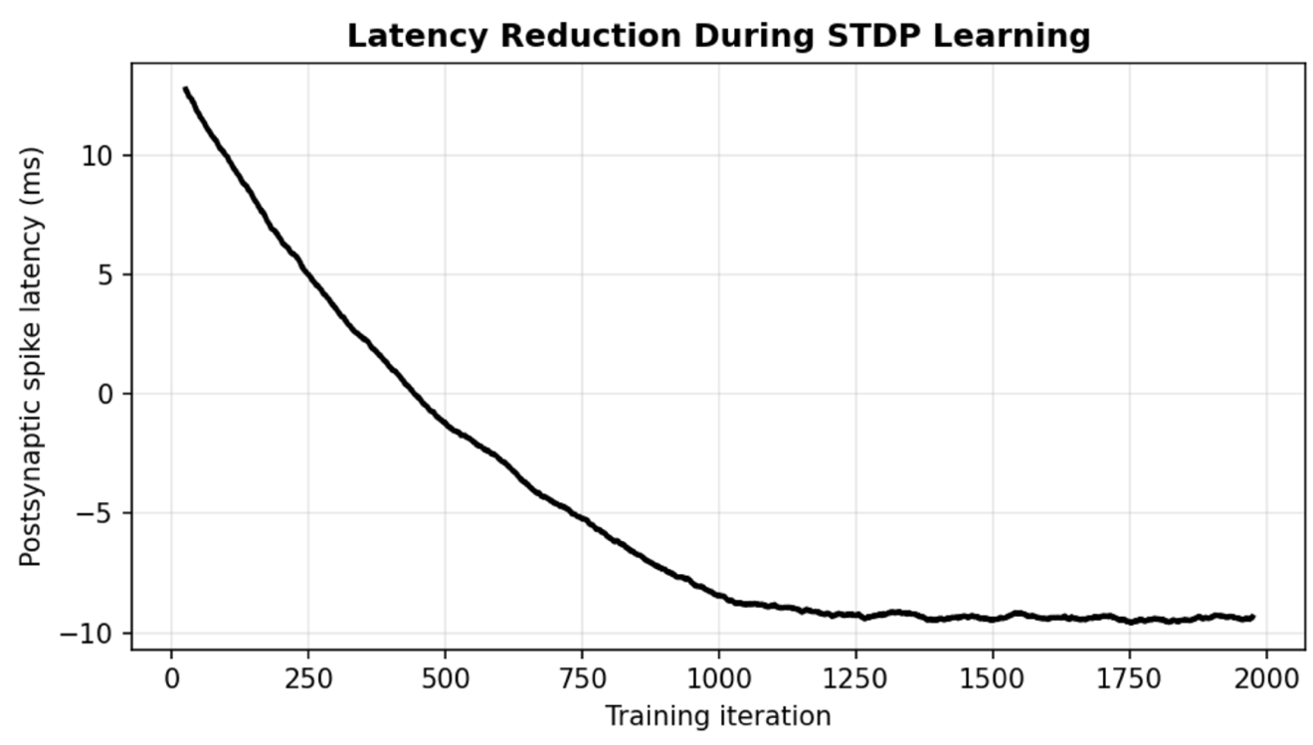
During training, spike-timing-dependent plasticity progressively shifts the postsynaptic response earlier in time. Initially the neuron fires late during the presynaptic burst because many inputs are required to reach threshold. As STDP strengthens synapses corresponding to early presynaptic spikes and weakens later ones, fewer inputs are required to trigger a spike. Consequently, the postsynaptic neuron begins firing earlier and earlier during the burst. After sufficient training, the spike latency stabilizes around −9 ms, indicating that the neuron has learned to respond primarily to the earliest predictive inputs.

Section 3 – temporal structure experiment

- LTD/LTP ratio
Varying the LTD/LTP ratio had relatively little effect on the qualitative structure of the learned weights within the tested range. Across all tested values, STDP consistently potentiated early synapses and depressed later ones, demonstrating that temporal competition is robust to moderate changes in the LTD/LTP balance.
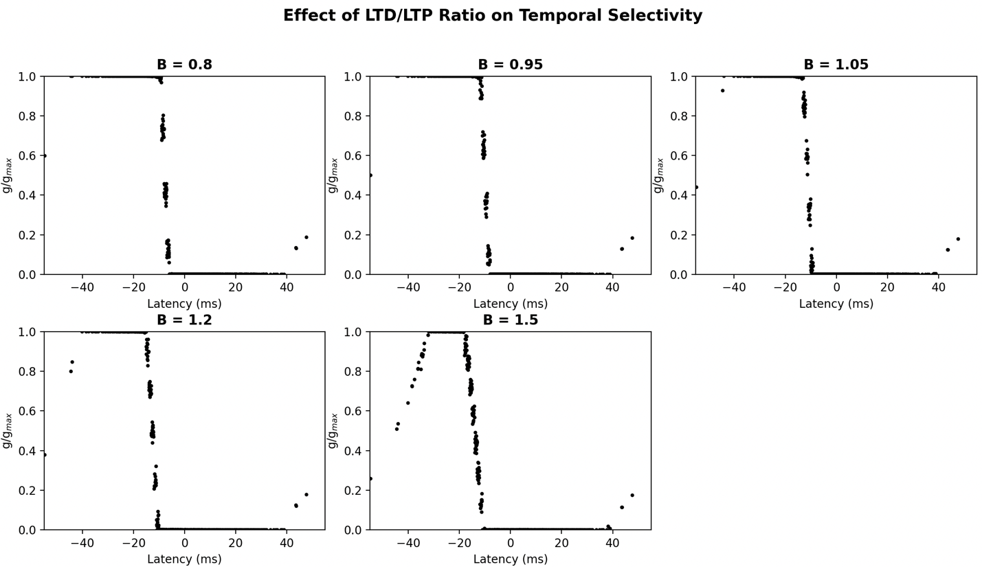

- Time constant (default is 20ms)
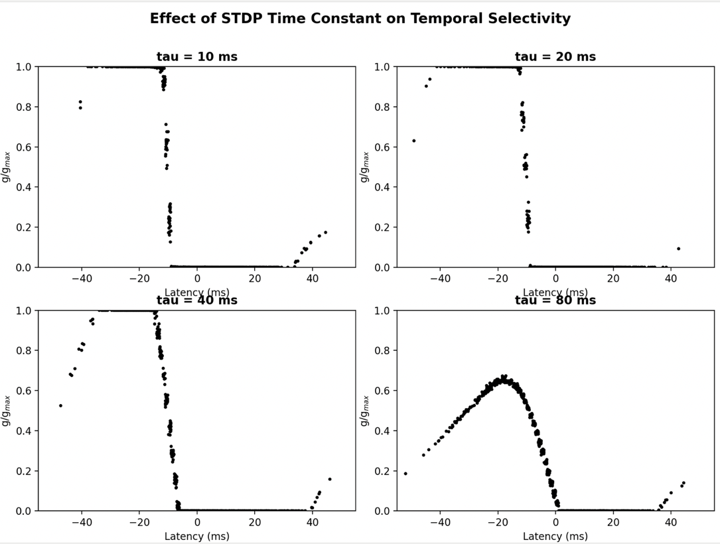
Small tau STDP acts like temporal winter-take-all
The neuron selects the earliest inputs only
Large tau STDP acts like temporal integration filter
The neuron encodes relative timing structure

Varying the STDP time constant significantly altered the structure of the learned synaptic weights. For small values of τ, strong competition emerged between synapses, resulting in a binary distribution in which early inputs were potentiated while later inputs were strongly depressed. As τ increased, the competition weakened, and intermediate weights appeared. When τ became very large, the sharp temporal boundary disappeared, and the learned weights formed a smooth latency-dependent profile. This suggests that the temporal precision of the STDP window determines whether the neuron performs strict temporal selection or more gradual temporal filtering.

- Number of inputs
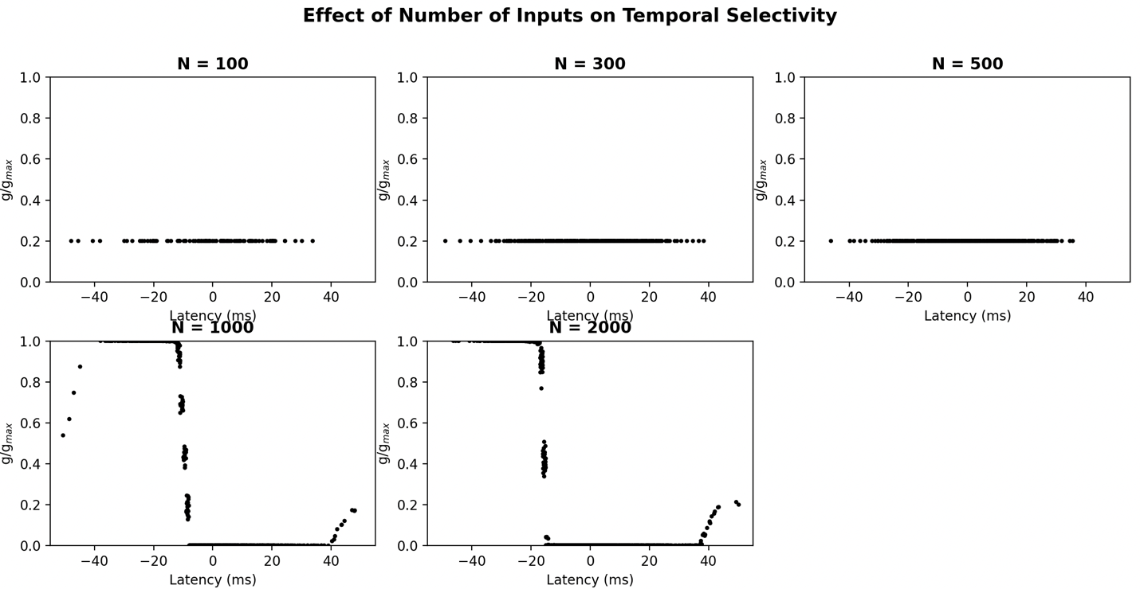
Temporal selectivity only emerged when the number of presynaptic inputs exceeded a critical threshold. For smaller networks, synaptic weights remained nearly uniform, indicating that insufficient synaptic drive prevented strong postsynaptic spiking and thus limited STDP-driven competition.

- temporal dispersion
Increasing the latency spread progressively weakened temporal selectivity. When presynaptic spikes were tightly clustered in time, STDP produced strong competition and potentiated the earliest inputs. However, when the latency spread exceeded the STDP time constant(20ms), synaptic competition disappeared, and weights converged to similar values. This indicates that STDP can only detect temporal structure within a limited time window.
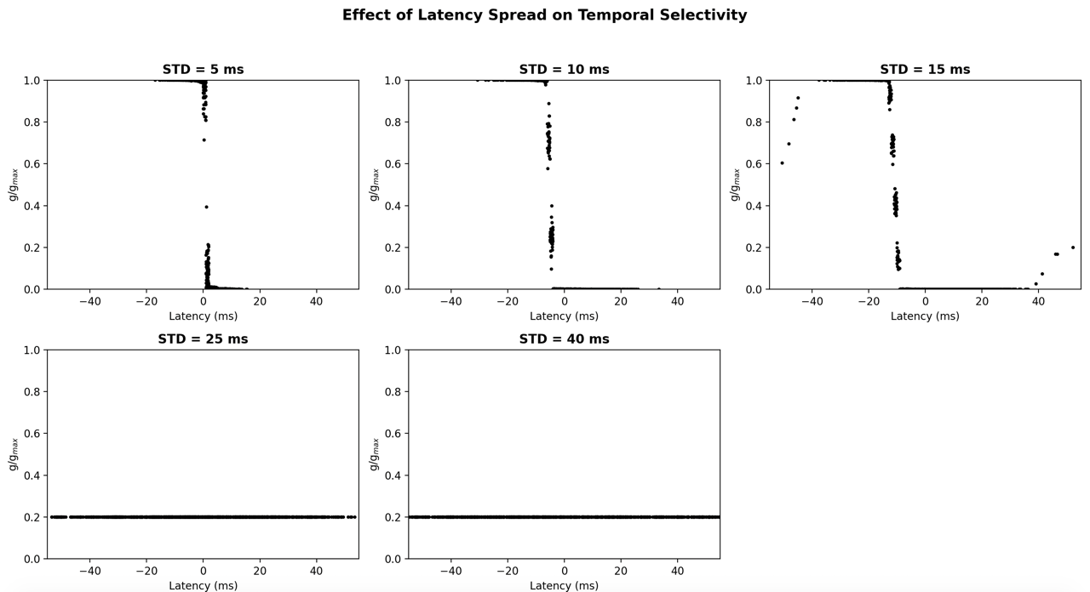

- burst rate
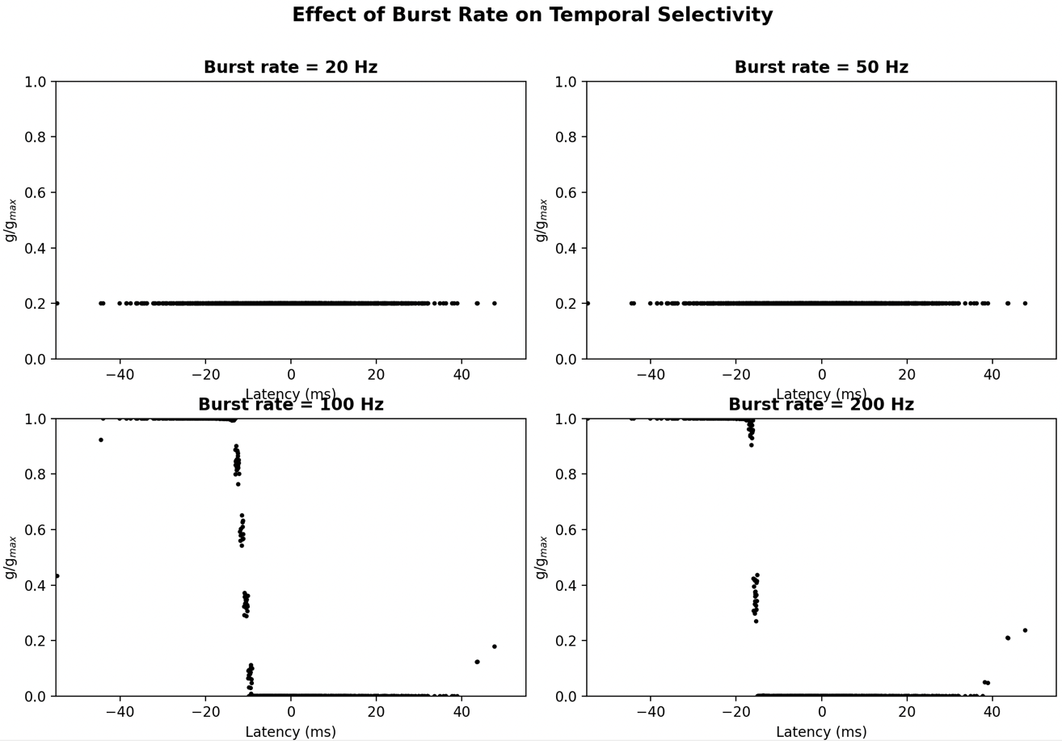
Burst rate is the firing frequency of each input neuron during its burst window. When burst rate is low, too few spikes occur to generate enough pre-post pairings, so the weights remain close to their initial values. As burst rate increases, spike pairings become more frequent, allowing STDP to strongly potentiate early inputs and depress late inputs. Therefore, higher burst rates produce stronger temporal selectivity.

STDP updates are activity dependent. Each pairing produces a small weight change: But learning requires many repetitions. If bursts occur too slowly: not enough spike pairings occur, weights barely move.
STDP requires sufficiently frequent correlated activity to shape synaptic structure.
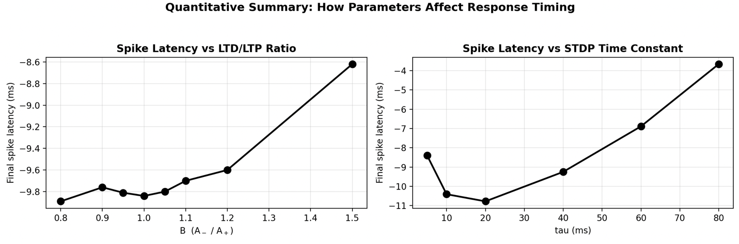
To quantify how STDP parameters influence network behavior, we measured the final postsynaptic spike latency after learning. Balanced LTD/LTP ratios produced the earliest response times, indicating efficient temporal competition among synapses. Varying the STDP time constant revealed an optimal temporal window around 20 ms. When the window was too narrow or too broad, the neuron responded later to the burst stimulus, suggesting reduced temporal selectivity.

Section 4
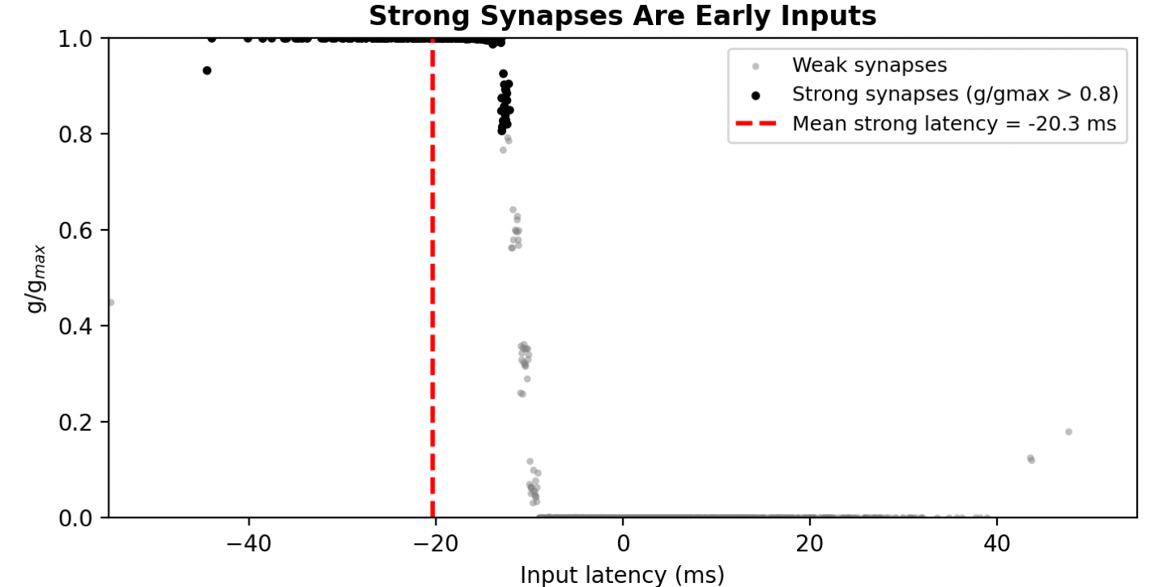
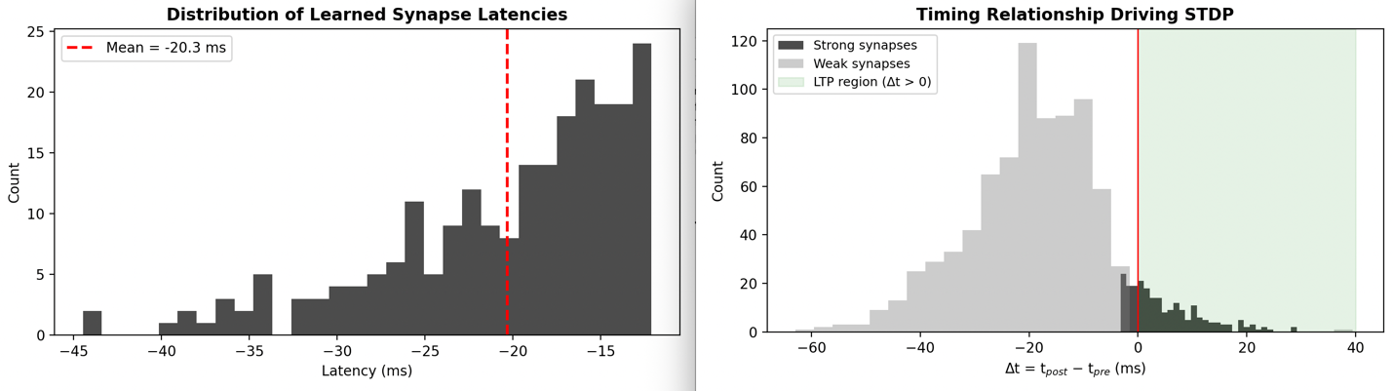
To understand the mechanism underlying temporal learning, we examined the distribution of synaptic latencies after learning. Strong synapses were concentrated among inputs that fired earlier than the postsynaptic spike. The average latency of strong synapses was approximately −20 ms relative to the burst center. Analysis of the timing difference Δt = t_post − t_pre revealed that strong synapses predominantly fell within the LTP region of the STDP window (Δt > 0), whereas weak synapses fell within the LTD region (Δt < 0). These results confirm that STDP selectively strengthens inputs that consistently fire before the postsynaptic spike, thereby shifting the postsynaptic response earlier in time.

