Mixed Effect Linear Modeling With Wisdom Diary Data
Sungjoon Park
10 May, 2019

PSYCH 468: Directed Studies – Advanced Statistics
Supervisors: Dr. Igor Grossmann & Dr. Anna Dorfman

Introduction
In this paper, I attempt to demonstrate the application of the lme4 package (Bates, Mächler, Bolker, & Walker, 2015)⁠ with the R statistical software (R Core Team, 2019)⁠ to perform multilevel modeling and to report on my exploratory data analysis of the Wisdom Diary Project data set. I will provide an in-depth explanation to the process taken to transform/re-code the data set, the method of using the lme4::lmer() function, the visualization of the data, and the troubleshooting involved in each steps. Lastly, I will provide my interpretation of the findings and suggest avenues for further investigation and improvement. (A supplementary material containing the codes involved in my analysis is provided on a separate document)
Linear mixed-effect models (LMEM) attempt to resolve deficiencies found in some statistical methods such as ANOVA or other types of regression analysis. In particular, LMEM “handles missing data and … continuous predictors that vary within ‘units’” (Brauer & Curtin, 2018)⁠. In other words, it can makes fewer assumptions to how some participants or groups might typically behave. For instance, it can assume that each participant or group can have a different baseline level of a measure instead of lumping the average of the whole data to represent each participant or group (Winter, 2013)⁠. As such, it is believed to “yield unbiased parameter estimates with acceptable type-I and type-II error rates” (Brauer & Curtin, 2018)⁠. I utilized LMEMs to investigate what factors might influence the polarity, a score based on the semantically positive and negative words used, of the diary entries from the diary data set.
The diary data set was part of a previous project (the Wisdom Diary Project) investigating how people might internalize their experience differently when instructed to write a diary from either a self-immersed (first person) or a self-distanced (third person) perspective. The data includes 164 participants (128 female and 1 other) recruited from a small southwestern Ontario city, and its local university, for an opportunity to earn up to $110. The data set includes demographic information from the pre-diary survey and the components involved in the diary study that lasted four weeks.
Before making the models, I re-coded some of the variables and employed rudimentary semantic analysis on the diary entries to extrapolate its polarity; the proportion of emotionally positive and negative words used. The full model involved the polarity as the dependent variable, the perspective condition as a fixed-effect between subject variable, how happy one feels after recall as a fixed-effect within subject variable, the type of event recalled as a fixed-effect within subject variable, date as a fixed effect between subject variable, and lastly, the participants were the level-1 random effect variable. Before analyzing the data, I hypothesized that 1) the polarity of the diary would be greater (semantically positive) if the event being recalled was a positive one instead of a negative one. I expected the polarity to be lower for recalling mixed events and even lower when recalling only negative events. 2) The slope of this relationship would be greater when under the self-immersed condition than the self-distanced condition. In other words, I expected a more neutral polarity with smaller variance for the self-distanced condition. And 3) the happiness after recall would predict higher polarity regardless of the types of event being recalled. The results partially supported my hypothesis.

Procedure
Before performing the semantic analysis, the diary entry had to be cleaned. The text data was encoded to the utf-8 format, then the numbers and punctuations were removed using the tm package (Feinerer & Hornik, 2018)⁠. Next, the qdap::polarity() function form the qdap package was used to calculate a polarity value based on a function of positive and negative words present in the diary entries (Rinker, 2019)⁠. This function uses a semantic dictionary based on Hu & Liu (2004) and no modification was made to it. In this analysis, I will focus on the polarity as the dependent variable of interest. And while there are many possible independent variables of interest, I will present my findings in regards to the first or third person condition, whether they experienced a positive or negative event, how happy they feel at the moment and the day of the diary entry.
Before modeling, all the independent variables were re-coded and centered. The perspective condition was contrast coded to be either -0.5 (first person) or +0.5 (third person) instead of 1 and 3. Positive or negative social experience was extrapolated from the daily event type questionnaire that asked whether they experienced conflict, celebration, enjoyment, annoyance, or negative news with others. Participants who only experienced any of the negative events were coded as -0.5, those who experienced both types were coded as 0, and those who only experienced positive events were coded as +0.5. How happy the participant after recall was recorded from a scale between 1 and 7, where higher numbers indicated unhappiness. This scale was reversed to ascend with greater happiness and group-mean centered to where the mean happiness of each participant throughout the whole study was set to zero. This was done to create a random-slope model. Finally, longitudinal data, as in the nth day of the study, was re-coded to start from zero instead of one. Once preparation was complete, I constructed models incrementally, starting with a null model involving only the dependent variable (polarity) and the random effect variable (participants) until the final one comprised all of the aforementioned variables.
Results
Means, standard deviations, correlations and confidence intervals are displayed in Table 1 and the number of subjects were reduced to 157 because some participants did not report recalling any social events. First, I created a null model for the polarity variable with the participant as a random effect and computed for its inter-class correlation coefficient (ICC = 0.071). The ICC signifies that about 7.1% of the of the polarity can be explained by the variability within participants. Next, I added my level-1 predictor of days as a fixed-effect, however, it was not a significant factor (β = 0.016, SE = 0.03, t = 0.59, p = 0.6). Next, I fitted a random slope model and found that the two models were not significantly different (chisq p > 0.1). Next, I added the perspective condition as a fixed effect into the random slope model and it too was not a significant factor (β = -0.05, SE = 0.035, t = -1.5, p = 0.13).
Table 1. Means, standard deviations, and correlations with confidence intervals among study variables
Variable | M | SD | 1 | 2 | 3 | 4
1. Polarity | 0.17 | 0.48
2. Perspective | 0.54 | 0.50 | -.05
 |  |  | [-.11, .00]
3. Day # | 11.85 | 8.09 | .02 | -.01
 |  |  | [-.03, .07] | [-.04, .03]
4. Recall Event Type | 1.35 | 0.89 | .64** | -.02 | .03
 |  |  | [.60, .67] | [-.07, .04] | [-.03, .08]
5. Happiness | 0.00 | 1.45 | .46** | -.00 | .04 | .58**
 |  |  | [.41, .50] | [-.04, .04] | [-.00, .08] | [.54, .61]
Note. Values in square brackets indicate the 95% confidence interval for each correlation. The confidence interval is a plausible range of population correlations that could have caused the sample correlation. * indicates p < .05. ** indicates p < .01.

Next, I added happiness and recall event type as fixed effects to the random slope model. Happiness was significant (β = 0.16, SE = 0.03, t = 5.18, p < .001), event recall type was significant (β = 0.54, SE = 0.03, t = 17.9, p < 0.001). This random slope model was significantly different from a fixed slope model (chisq p < 0.001) and had a smaller AIC (1034 vs 1059.43). Next, I fitted a random slope model with interaction between happiness and recall event type, and the interaction between the two were significant (β = 0.087, SE = 0.02, t = 3.62, p < 0.001). The random slope model was significantly different to a fixed slope model (chisq p < 0.001) and it’s AIC was smaller (1029.8 vs 1053.02). The previous model (without interaction) suggested that the feeling of happiness after recall was a significant factor to polarity, the newer model (with interaction) suggests that the type of event recalled might be a moderator between happiness and polarity. In other words, happiness is associated with the change in polarity depending on the type of event being recalled as depicted in Fig 2. In the figure we see that there is a large overlap in polarity between the high happiness and low happiness report, and they diverge for mixed and positive recall.
Table 2. Fixed effects for the final model of polarity of diary entry and their standardized beta estimates, standardized errors, lower and upper confidence intervals and P-values.
It is important to report that, at this point, I was faced with a warning of a singular boundary fit. This could occur if the model is over fitted, when the random effects are too complicated to model with the current data. Suggestions on how to resolve this issue range from using Bayesian methods to removing or modifying the variables one believes to be less necessary to be modeled (Bates, Kliegl, Vasishth, & Baayen, 2015)⁠. As such, I opted to change the model so that the interaction between happiness and recall event type no longer had a random slope. This model could be justified if the effect of the interaction between happiness and recall event type was consistent between the participants. Comparing the two models showed that the model before the change had a marginally smaller AIC (1029.802 vs 1030.52) and their difference was not significant. (chisq p < 0.1).

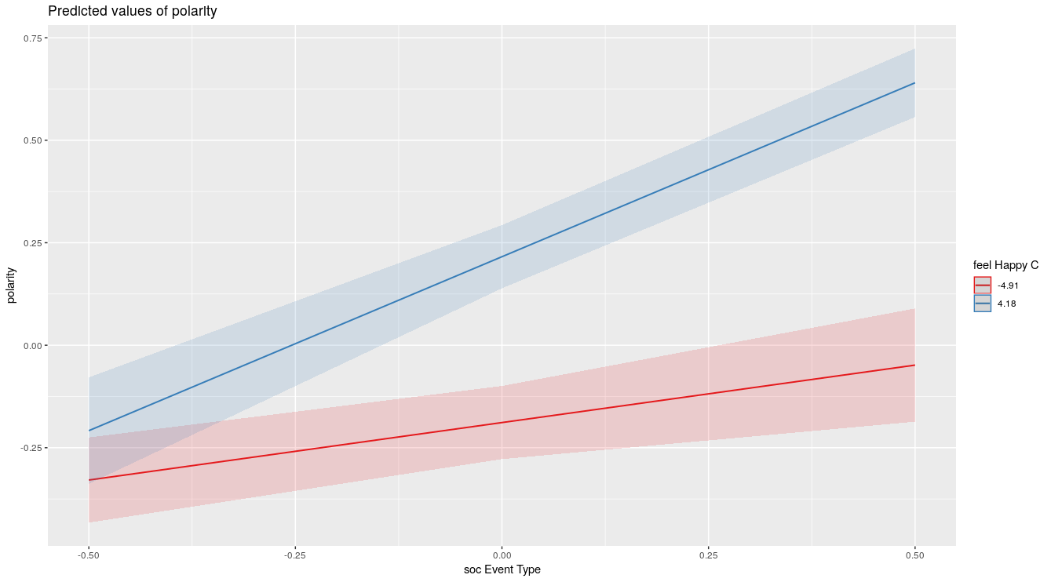Fig 2. Moderating effect of happiness between the event recall type. When the event being recalled is negative, there was no significant difference in polarity between happy and unhappy participants. However, when the event being recalled was positive there was a significant difference between happy and unhappy participants.

The next model involved setting the recall event type as factors. This modeled the relationship between the other variables and each recall event types more discretely. This model showed that recalling mixed events were not significantly different from recalling only negative events (β = 0.04, SE = 0.03, t = 1.36, p = 0.18) while recalling only positive events were significantly different (β = 0.59, SE = 0.03, t = 17.18, p < 0.001), as seen in Fig 2. In addition, interaction between happiness and mixed event was significant (β = 0.08, SE = 0.03, t = 2.53, p = 0.015), and the interaction between happiness and recalling only positive event was significant (β = 0.08, SE = 0.03, t = 2.27, p = 0.02) (Fig 3). Consistent with the previous model, happiness, by itself, was not a significant factor and it depended on the type of event being recalled. Attempt to model an interaction between perspective condition and recall event types or happiness yielded no significance.
The final model involved simplification. For parsimony and since neither perspective condition nor days were significant variables, I removed them from the model and left only the event recalled types and happiness as the fixed effects. This simpler model was not significantly different from the previous model (chisq p = .171) and yielded a smaller AIC value (972.88 vs 990.62). From it, we observed that recalling positive events had a moderate effect on polarity (β = 0.59, SE = 0.03, t = 17.3, p < 0.001). The effect of the interaction between recalling mixed events and happiness was weak (β = 0.07, SE = 0.02, t = 2.8, p = 0.005). And, the effect of the interaction between recalling positive events and happiness was also weak (β = 0.08, SE = 0.03, t = 2.3, p = 0.022). Recalling mixed events (β = 0.04, SE = 0.03, t = 1.5, p = 0.132) and happiness after recall (β = 0.06, SE = 0.04, t = 17.3, p = 0.176) individually were both very weak effects and, likely, insignificant (Table 2).
Fig 2. Relationship between polarity and recall event types. Self-immersed condition colored red and self-distanced condition colored green.
My hypothesis that there would be a significant difference in slope between the two perspective condition was not supported in my models. As predicted, the polarity was significantly lower when recalling negative events than positive events. However, recalling mixed events were not significantly different from recalling negative events. And greater happiness after recall by itself did not significantly relate to the increase polarity. However, its interaction with the type of event being recalled was significant. As shown in figure 3, we found that when recalling negative events, happiness did not relate to a significant change in polarity. However, on the other two recall types, happiness was significantly associated with higher polarity.
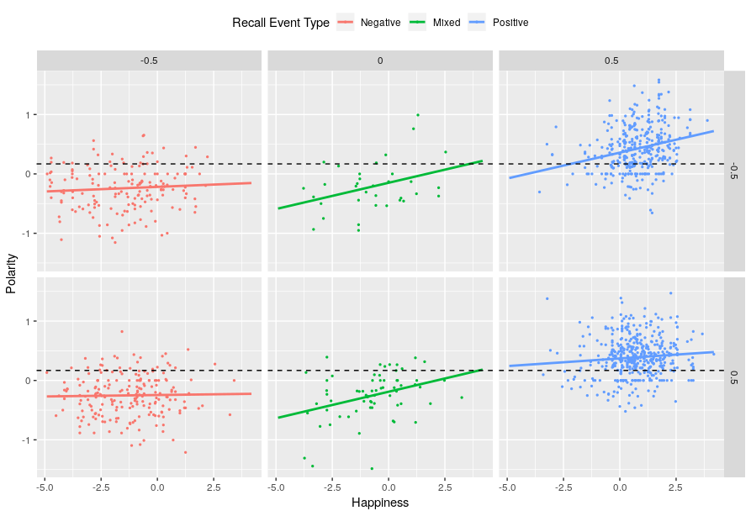Fig 3. Relationship between happiness and polarity between recall event types and perspective conditions. Top row represents self-immersed condition and the bottom row represents the self-distanced condition. Mean polarity indicated by the dashed black line.
On table 3, we see that the variance of the residual is larger than our random effects. This indicates that there is room for further investigation and that our model does not account for a large portion of the variability in polarity. However, if we compare this residual to that of our initial null model (.212), we see that our model does account for a larger portion of the variability. This is reflected in the final model’s R² (total) value of 0.54, which indicates the proportion of the variance of polarity predicted by the model (Table 4).
Table 3. Random effects and its variance and standard deviations
Discussion
Although the results of this study does not support all of my hypotheses, I did make some interesting observations. My hypothesis that there would be a significant difference in slope between the two perspective condition was not supported in my models. Of interest is the flatness of the relationship between happiness and polarity when recalling negative events. While being more or less happy after recalling positive events were associated with higher or lower polarity, being less or more happy while recalling negative events did not associate with lower or higher polarity. Instead polarity was consistent regardless of happiness after recall. Further research would be needed, however, if it is the case that one is less inclined to write about one’s negative experience, this may result in a smaller proportion of negative words used, resulting in a floor effect. Or, writing about positive events may motivate one to write more elaborately and further increasing their polarity score. Another possible explanation might be the difference in the breadth of negative and positive words commonly known. If this is the case, scoring lower or higher might be more difficult depending on the polarity of the vocabulary that are commonly used.
A limitation in my polarity score is that it’s semantic dictionary may not be indexing words as I would hope so. Since it was based on work done in 2004 and pertained to analyzing customer reviews, what constitutes as a positive or negative word may be different today and in this context (Hu & Liu, 2004)⁠. Future effort to study polarity more thoroughly should attempt to devise a semantic dictionary that reflects the study’s context.
The happiness measured in the diary study pertained to how happy participants felt after recalling an event. Although it may not be surprising that greater happiness tends to follow recalling positive events, this was not an issue for my purpose. I was interested in how reported happiness after recall might associate with polarity and how it might interact with other variables such as the perspective condition. And as I observed, we saw a unique lack of interaction when recalling only negative events.
Although we did not find a significant longitudinal effect, It may be worth controlling for the day of the week the diary entry pertains to. It may be the case that certain days in the week may elicit recall of either more negative or positive events. One might be inclined to write differently during middle of the week compared to the weekends due to fatigue. As for the perspective conditions, my analysis shows that whether one takes a self-immersed perspective or a self-distanced perspective, has little effect on polarity. This may be the case if there is few difference in the polarity score given to words used in either perspectives.
With the wealth of data procured during the Wisdom Diary Project, there is no lack of variables one might wish to model. Future investigators might wish to explore the the effect of the residential area as either a fixed or random effect. Fixed, because one’s residential area may predict the polarity of the words one uses. And random, because one might wish to account for the variability in baseline polarity between the residential areas. And polarity is not the only type of semantic analysis possible with the qdap package. One could extrapolate the diversity or formality of the words used in the diary entries and attempt to model them as the dependent variables. In conclusion, this analysis demonstrates that greater feeling of happiness after recalling an event is associated with greater polarity only if the participant is recalling positive or a mixture of positive and negative events. When participants recalled only negative events, the happiness rated after recall did not predict polarity.
Reference
Bates, D., Kliegl, R., Vasishth, S., & Baayen, H. (2015). Parsimonious Mixed Models. Retrieved from http://arxiv.org/abs/1506.04967
Bates, D., Mächler, M., Bolker, B., & Walker, S. (2015). Fitting Linear Mixed-Effects Models Using {lme4}. Journal of Statistical Software, 67(1), 1–48. https://doi.org/10.18637/jss.v067.i01
Brauer, M., & Curtin, J. J. (2018). Linear mixed-effects models and the analysis of nonindependent data: A unified framework to analyze categorical and continuous independent variables that vary within-subjects and/or within-items. Psychological Methods, 23(3), 389–411. https://doi.org/10.1037/met0000159
Feinerer, I., & Hornik, K. (2018). tm: Text Mining Package. Retrieved from https://cran.r-project.org/package=tm
Hu, M., & Liu, B. (2004). Mining and summarizing customer reviews. Proceedings of the 2004 ACM SIGKDD International Conference on Knowledge Discovery and Data Mining - KDD ’04, 168. https://doi.org/10.1145/1014052.1014073
R Core Team. (2019). R: A Language and Environment for Statistical Computing. Vienna, Austria. Retrieved from https://www.r-project.org/
Rinker, T. W. (2019). {qdap}: {Q}uantitative Discourse Analysis Package. Buffalo, New York. Retrieved from http://github.com/trinker/qdap
Winter, B. (2013). Linear models and linear mixed effects models in R with linguistic applications. Retrieved from http://arxiv.org/abs/1308.5499

