Spawlowski_Module_01_Activity_20180408

Module 1 Activity – Configure a Development Environment

Setup for the azure LAMP server

sjpcis3801c.northcentralus.cloudapp.azure.com

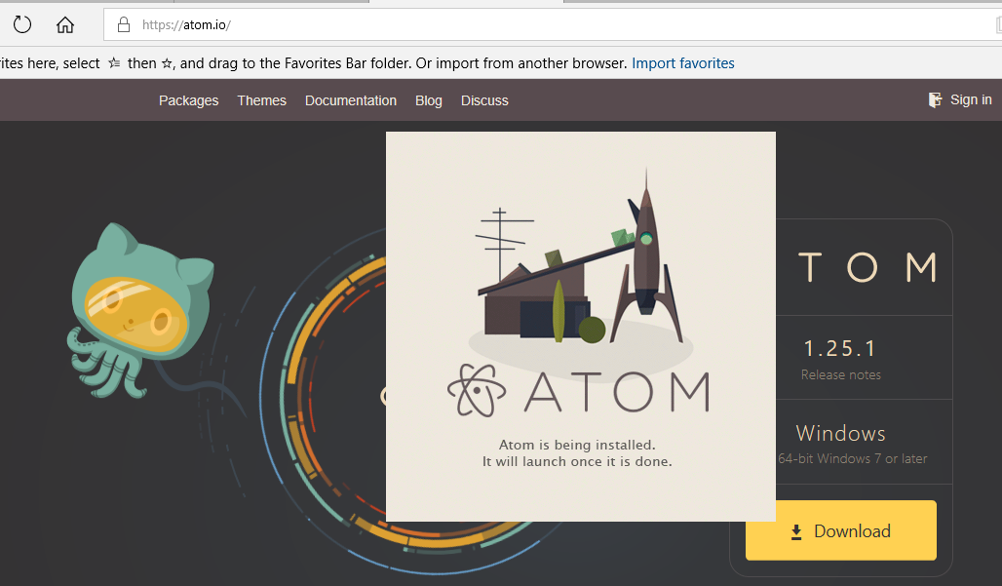

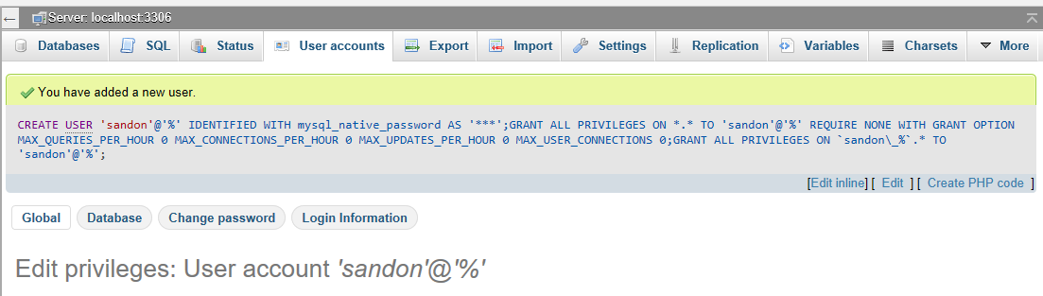

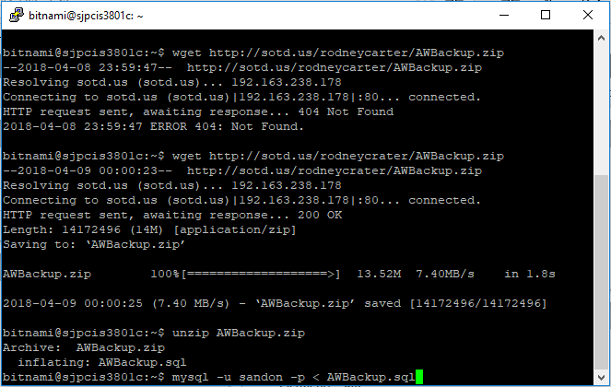

https://github.com/sjpawlowski/cis3801c.git

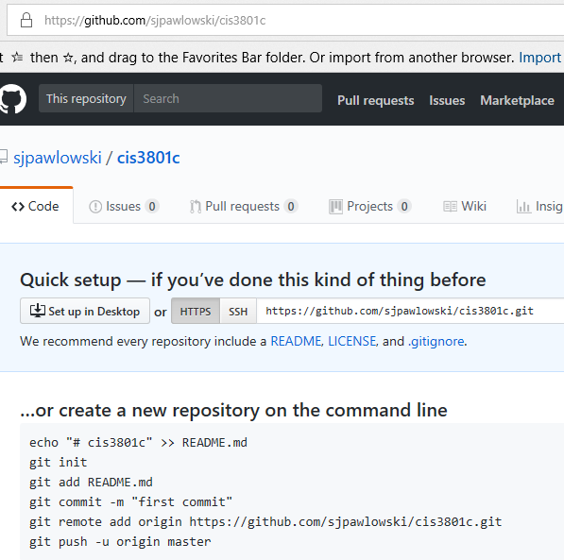

https://github.com/sjpawlowski/COP1801_Javascript