## CHEMISTRY NOTE FOR GRADE 10

**Unit 3 Electrochemistry**

After completing this unit, you will be able to:

* understand how a chemical reaction produces an electric current and how electricity brings about chemical reactions in electrochemical cells;
* understand the differences between metallic conduction and electrolytic conduction;
* develop skills in writing the oxidation half-reaction, reduction half-reaction and cell reaction for the electrolysis of molten electrolytes that occur in electrolytic cells; \
* know three types of voltaic cell; ( understand the difference between electrolytic cells and voltaic cells;

3.1. **Electrochemistry**

* The study of chemical reactions that produce electricity, and chemical reactions that occur due to electricity.
* the process occur in electrochemical cells
* There are **many processes that take place** because of electrochemical rxns:
  + Electroplating
  + Electrolysis of substance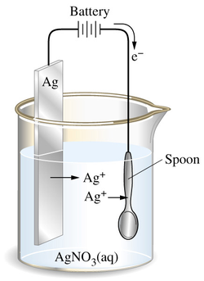
  + Production of metal
  + Storage of electricity in batteries

**electrochemical cells:**

* The devices that convert chemical energy to electrical energy or electrical energy to chemical energy.
* These cells can be classified as **electrolytic cells** and **galvanic or voltaic** cells

**3.2. Electrical Conductivity**

-Thecapacityofasubstancetotransmitelectricity.  
**-electrical conductors**:-materials that allow the passage of electricity through them.

* Depending on the nature of particles responsible for ﬂow of electric charges  
  through conductor in to two classes. 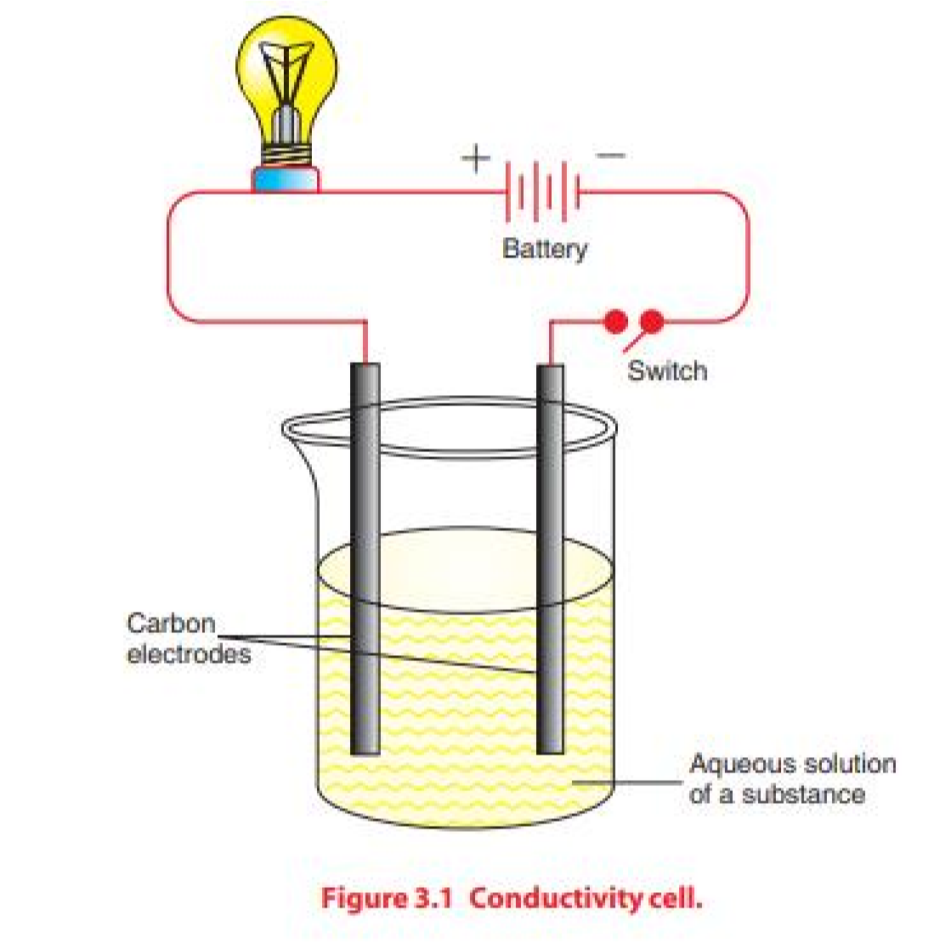 **A. Metallic conductivity/** electronic conductivity-Transmission of electric current through the metal  
  -Transmission directly related to the nature of metal  
  -The electrons entering the metal is place (replace) the freely moving electron at the point of entry.  
  -Caused by the ﬂow of mobile electron due to the repulsion exerted on them from the electrons entering to the metal from the source of electricity **B. Electrolytic conductivity**-Electrolytes are substances that transmit electricity in molten state or aqua's  
  solution.  
  -The electrolyte contains ions(cations and anions)  
  -The ions are able to move in the solution  
  -Electric charge is carried by ions

Example: Strong acid and Strong base

**Non-electrolytes:** are the substances that do not transmit electricity either in solution or in a molten state**.**

**Example:** sugar, ethanol, oil, benzene, and liquid nitrogen

##### **3.3 Electrolysis/ electrolytic cells**

* Electrolysis is a process in which electrical energy is used to produce chemical change.
* The process is carried out in electrolytic cell that contains Power source D.c , electrodes (active and inert) and connecting wire.
* The ability of an electrolyte to conduct an electric current is determined by the concentration of ions.
* a process in which electric energy is used to bring about an oxidation reduction reaction.
* the decomposition of an electrolyte, using electricity.
* a device which uses electricity to drive a non–spontaneous redox reaction.
* Composed of two half-cells--one is a reduction half-cell, the other is an oxidation half-cell



* **Electrodes:**
* are strips of metal or graphite that allow electrons to leave or enter the electrolytes.
* They can be chemically active or inert.
* **An anode:**
* the electrode attached to the positive terminal of a direct current source.
* the positive electrode at which oxidation (loss of electrons) by anions occurs.
* At which anions migrate towards it
* Electrodes at which electrons leave the cell.
* **A cathode:**
* is the electrode attached to the negative terminal of a dc source.
* the negative electrode at which reduction (gain of electrons) of cations occurs.
* At which cations migrate towards it
* Electrodes at which electrons enter the cell.
* **Salt Bridge:**
  + - Usually a U shaped tube filled with a concentrated salt solution.
    - The solution in this tube provides a way for ions to travel between the two electrode solutions so that they can remain electrically neutral in charge. This enables the continuous flow of electrons
    - Connects & separates two half-cell reactions
    - Prevents buildup of ions on one side of the cell and balances the charge
    - Contains electrolytes not involved in redox reaction
    - Completes circuit
    - ***Electrolysis of Molten (Fused) Electrolytes***
* When ionic solids melt, they dissociates into positive and negative ions that are not held in fixed positions

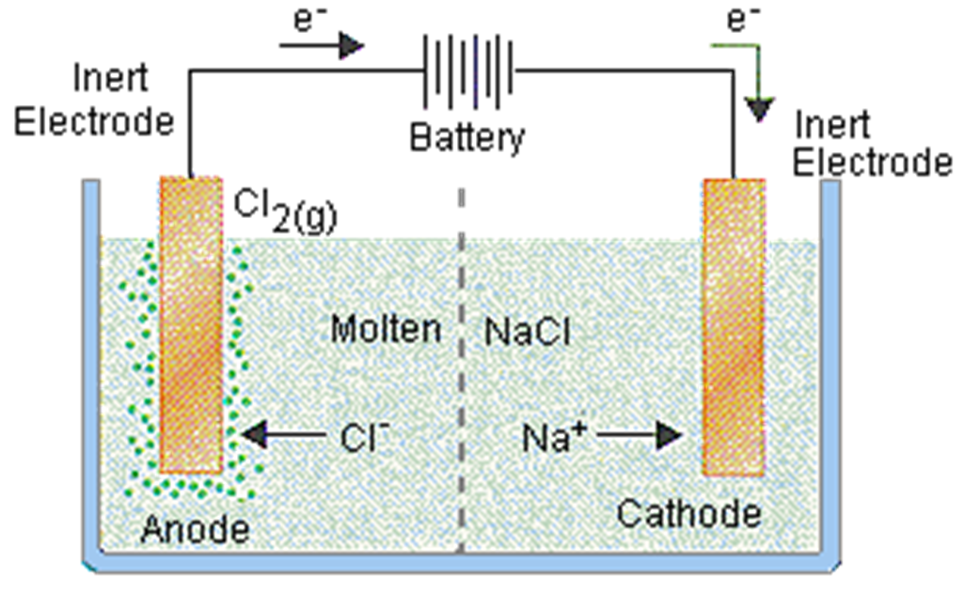

**Electrolysis of Molten (Fused) NaCl Electrolytes solution**

Cathode reaction: 2Na+ + 2e– → 2Na (Reduction-half reaction)

Anode reaction: 2Cl –  → Cl2 + 2e– (Oxidation half-reaction)

Cell reaction: 2Na+ + 2Cl– → 2Na + Cl2 (Oxidation-reduction(

**Reduction-oxidation reaction**

* + - A substance is *reduced* when it *gains* electrons from another substance
      * **gain of e- net decrease in charge of species**
      * **Oxidizing agent (oxidant)**
    - A substance is *oxidized* when it *loses* electrons to another substance
      * **loss of e- net increase in charge of species**
      * **Reducing agent (reductant)**

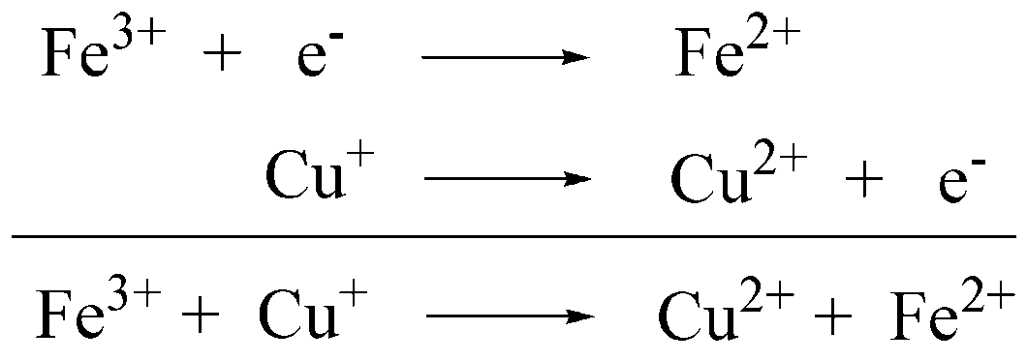

**½ cell reactions:**

**Net Reaction:**

**Exercise 3.2**

1. Consider the electrolysis of KI and MgCl

a Identify ions which migrate towards the anode.

b Identify ions which migrate towards the cathode.

c Write down the half-reactions at the anode and cathode and cell reactions.

d Write the substances produced at the electrodes

**3.4 GALVANIC (VOLTAIC) CELLS:**

* The reaction that occur inside the cell
* The reaction is spontaneous redox reaction
* Chemical reaction generates electricity
* Converts chemical energy to electrical energy
* Electrons flow from the oxidizing reactant (reducing agent) to the reducing reactant (oxidizing agent).
* If the two half–reactions can be separated, this flow of electrons, instead of occurring at the surface of the metal, occurs through an external wire and an electric current is generated.
* **Note that** the anode is the negative electrode and the cathode is the positive electrode in galvanic cells
* Classified into primary and secondary

**A. Primary Cells;**

* are those cells that are not rechargeable. Because the electrode reaction as well as the entire cell reaction cannot be reversed on recharging. Examples: **Daniel’s cell and zinc-carbon (Leclanche) dry cells.**
* The electrolyte in a Galvanic cell can be in the form of a solution( wet cells )or a paste (dry cells).

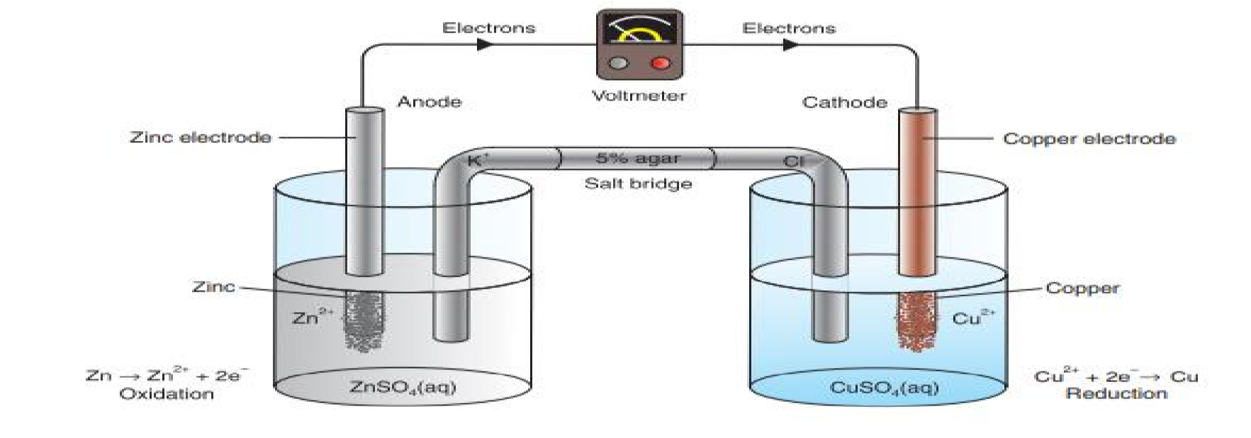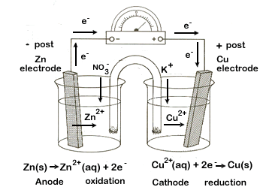

**The Daniel Cell**

The half-cell reactions and the cell reaction in Daniel cells are:

**Anode reaction: Zn (s) → Zn2+ (aq) + 2e– Cathode reaction: Cu2+ (aq) + 2e– → Cu (s)**

**Cell reaction: Zn (s) + Cu2+ (aq) → Zn2+ (aq) + Cu (s)**

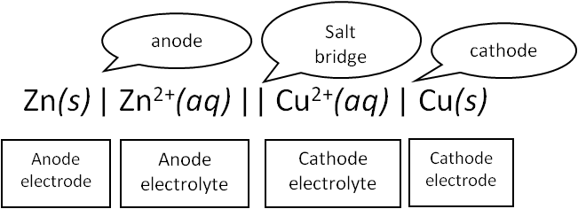

A zinc-carbon dry cell, which is also called a Leclanche cell is used in devices like portable radios and flashlights. The cell consists of a zinc cup that serves as the anode. The zinc cup is filled with a paste of manganese (IV) oxide, zinc

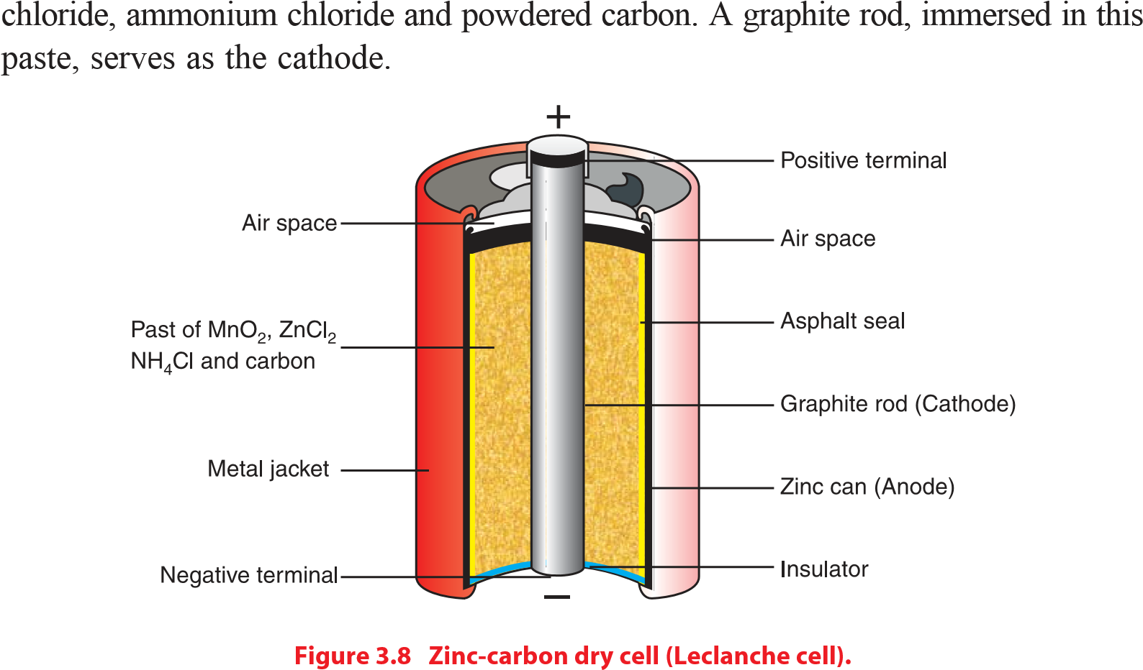

**Anode reaction:** Zn (s)  Zn2+ (aq) + 2e–

**Cathode reaction**: 2MnO2 (s) + 2NH+4 (aq) + 2e– → Mn2O3 (s) + 2NH3 (aq) + H2O (l)

A build up of ammonia gas around the cathode may disrupt the current. However, this is prevented by the reaction between Zn2+ and NH3 to form a complex ion, [Zn(NH3)2]2+ which crystallizes as a chloride salt.

Zn2+ (aq) + 2NH3 (g) + 2Cl– (aq) →Zn(NH3)2 Cl2 ( s )

**Cell reaction**: Zn (s) +2MnO2 (s) +2NH4Cl (aq)→Zn(NH3)2Cl2 (s) + Mn2O3 (s) + H2O (l)

There are other examples of **dry cells**, such as the alkaline dry cell, silver oxide cell, and copper oxide cell.

|  |  |
| --- | --- |
|  | **Exercise 3.3** |
| 1. | In a Daniell cell, copper and zinc are used as electrodes. Which metal serves as an anode and which one as a cathode? Is the anode the positive or the negative terminal in this cell? |
| 2. | Which electrode is negative and which one is positive in the Leclanche cell? Is the polarity of the electrodes in Galvanic cells similar to that of the electrodes in electrolytic cells? |
| 3. | Why do we refer to the redox reactions in electrolytic and voltaic cells as nonspontaneous and spontaneous, respectively? |



1. **Secondary Cells:**

* voltaic cells that are rechargeable since the reactions taking place in them are reversible.

**Example; Lead Storage Battery,**

A single lead-storage cell delivers **2 volts**. Therefore, a **12 V** battery contains six cells connected in series.

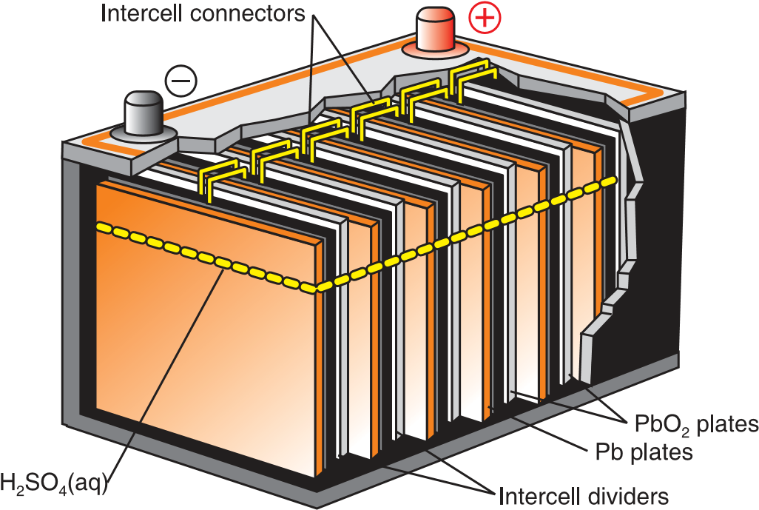

When a lead-storage battery is in operation (on discharge), the following reactions occur at the electrodes:

**Anode reactions: Pb (s) + SO2– 4 (aq) → PbSO4 (s) + 2e–**

**Cathode reactions: PbO2 (s) + 4H+ (aq) + SO2– 4 (aq) + 2e– →PbSO4 (s) + 2H2O(l)**

**Cell reaction is: Pb (s) + PbO2 (s) + 4H+ (aq) 2SO2– 4 (aq)→ 2PbSO4 (s) + 2H2O (l)**

The reaction that takes place on recharging a lead storage battery is given by the following equation.

**2PbSO4 (s) + 2H2O (l) → Pb (s) + PbO2 (s) + 2H2SO4 (aq)**

Exercise 3.4

1. Explain the differences between primary and secondary cells.
2. What substances are used as the anode, cathode and electrolyte in a lead storage battery?
3. What happens to the concentration of sulphuric acid when a lead storage battery is on discharge?
4. Write the overall reactions taking place in a lead storage battery when it is discharging.

## UNIT-4

## CHEMISTRY IN INDUSTRY AND ENVIRONMENTAL POLLUTION

***After completing this unit, you will be able to:***

* *know the renewable and non-renewable natural resources and appreciate their importance to industry as raw materials;*
* *know the three types of environmental pollution and the names of the pollutants;*
* *understand the causes and effects of air, water and land pollution and know the main methods to reduce them; and*
* *Demonstrate scientific inquiry skills such as observing, classifying, communicating, asking questions, applying concepts and problem solving*

## 4.1 Introduction

**Chemistry in Industry**

**Chemical industries**:

* an institutions involved in the production of chemical products
* Use naturally available raw materials to produce the desired products.
* Involve chemical reactions to transform raw materials into finished and semi-finished products.
* Consume relatively large quantities of energy during the manufacturing process.

Use safe operation methods in their manufacturing processes

* test their products during and after manufacture in their quality control laboratories to ensure that the products meet the required specifications.

**4.2. natural resources and industry**

**Natural resources** are classified as **renewable and non-renewable resources**.

A. **Renewable resources:** are replenished (replaced) by natural processes.

Examples: Plants, animals, soil and water.

**B. Non-renewable resources**: are resources that are found in a fixed amount in nature and cannot be replenished.

Examples: Natural gas, and coal.

**4.5. ENVIRONMENTAL POLLUTION**

* **Pollution:**
* When Harmful Substances Contaminate the environment.
* any discharge of a solid, liquid or gaseous substance or radiation (energy) into an environment that causes unwanted changes.
* causes short- quality of life in the environment
* **A pollutant**
* any substance that changes air, water or any other natural resource in a way that impairs the use of the resource.
* **Pollutants** can be classified by the type of pollution they cause: **air pollution, water pollution, and land pollution.**

1. **Air pollution:** 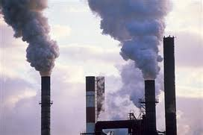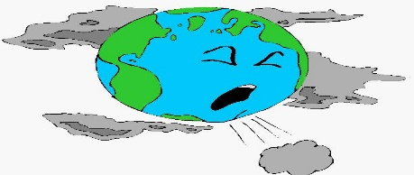

* **Air....**
* Air supplies us with *oxygen* which is essential for our bodies to live.
* Air is a mixture of nitrogen, oxygen, water vapor, carbon dioxide and inert gases.
* Human activities can release substances into the air, some of which can cause problems to humans, plants, and animals.
* Natural Composition of Gases 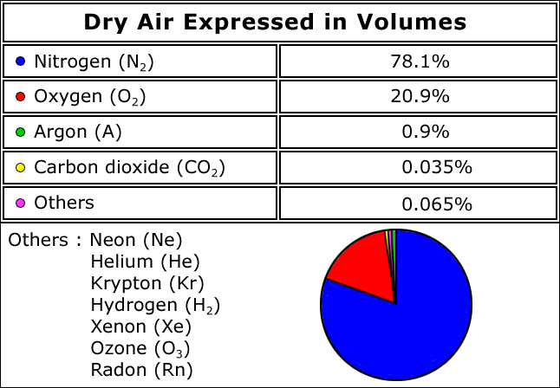
* **Air pollution:**
* Caused by the presence of contaminant gaseous substances in the air that affect the lives of plants and animals on earth.
* Some common air pollutants are sulphur dioxide, nitrogen oxides,(NOx) carbon monoxide, ozone, hydrocarbons, particulate matter(dust, smoke, fumes, etc), chlorofluorocarbons **(CFCs),** and lead compounds.

1. **Sulphur dioxide (SO2 ):**

* Formed from the combustion of coal and petroleum, and during extraction of metals from their sulphide ores.
  + It causes **coughing**, **chest pains** and **shortness of breath**.
* It is thought to be a cause for bronchitis and lung diseases.
* It slowly oxidizes to **SO3** by reacting with the oxygen in the air.
* precursor to acid rain along with NOx

1. **Oxides of nitrogen(**, **NO**, **NO2 )**:

* can be formed in the atmosphere by natural processes like thunderstorms. Combustion of fossil fuel containing nitrogen compounds as impurities and exhaust gases from furnaces and engines.
* Nitric oxide, **NO,** catalyzes the decomposition of ozone in the upper layer of the atmosphere to oxygen, thus decreasing the ozone layer.

**2O3 (g)  NO 3O2 (g)**

* **Nitric oxide** is oxidized by oxygen to nitrogen dioxide in the presence of ultraviolet light.

**2NO (g) + O2 (g) 2NO2 (g)**

* SO2 , SO3 and NO2 react with rainwater and form sulphurous acid (H2SO3 ), sulphuric acid (H2SO4 ) and nitric acid (HNO3 ), respectively and cause **acid rain**.
* **Acid rain** accelerates corrosion and the deterioration of metals, buildings, statues and also causes tree defoliation, release of heavy metal ions from soil into water courses and drop in the pH of water in rivers and lakes.

1. **Hydrocarbons and ozone:**

* are responsible for photochemical smog.
* characterized by a reddish-brown haze containing substances irritating to the eye, nose, and lungs, and causes extensive damage to vegetation.
* Considerable amounts of hydrocarbons are released into the atmosphere by the evaporation of gasoline as unburnt hydrocarbons in auto exhaust. These substances react with ozone to give compounds that contribute to the oxidizing nature of photochemical smog.

1. **Carbon monoxide:**

* Most of the carbon monoxide escapes into the atmosphere due to the incomplete combustion of fuel.
* Prolonged exposure to carbon monoxide impairs vision, produces headaches, and exerts strain on the heart.
* It also reduces the oxygen-carrying capacity of the blood by reacting with hemoglobin.

1. **particulates:**

* Dust storms, forest fires, volcanic eruptions and human activities increase the amount of solid particles in the air.
* Industrial areas contain particles of limestone, fertilizers, coal, stones, cement and silica.
* irritate the lungs and deleteriously affect breathing.

1. **Chlorofluorocarbons (CFCs):**

* used as refrigerants, solvents and plastic foam-blowing agents.
* When entering the atmosphere, they penetrate into the upper layers and interact with ultraviolet radiation as follows.

**CF2 Cl2  UV CF2 Cl. + .Cl**

The free chlorine, Cl, reacts with ozone to form chlorine monoxide and oxygen.

**.Cl + O3 ClO. + O2**

* These reactions result in the conversion of ozone to molecular oxygen and **contribute to depletion of the ozone layer**.
* This situation in the upper atmosphere allows dangerous ultraviolet radiation to reach the earth’s surface. This radiation causes **skin cancer in human beings.**

1. **Excess carbon dioxide:**

* The combustion of substance(coal and petroleum ) causes increase in the concentration of carbon dioxide in the atmosphere.
* The increase in the concentration of CO2 in the atmosphere has resulted in a rise in the average global temperature, owing to the **greenhouse effect**.
* Carbon dioxide and water vapour absorb infrared radiation, reradiated from the earth, behaving like the glass in a green house.
* Since CO2 and water vapour absorb heat they are called **green-house gases**.

1. **Heavy metals:**

* Lead contamination in the atmosphere is a result of vehicle engines that use fuels containing tetraethyl lead, which added to the fuel to reduce engine knocking.
* The use of lead paints also contributes towards lead contamination.
* High levels of lead cause damage to the brain, kidneys and liver.

***Qn. what are the potential air pollutants in and around your home? Methods of Reducing Air Pollution?***

* Control Of Air Pollution
* air pollution control devices in industries
* Using low sulphur coal
* Regular engine tune up, replacement of old more polluting vehicles
* Using mass transport system, bicycles etc
* Shifting to less polluting fuels
* Planting more trees
* No to FIRE CRACKERS in Diwali and other occasions

1. **Water Pollution**

* The Contamination of water with undesirable substances, which make it, unfit for usage.
* The degradation of the quality of water by the discharge of untreated  
  sewage, industrial waste, agricultural waste, and oil spillage.
* In general, water is said to be polluted if it contains matter that aﬀects the health of living things or cause damage to property.  
  • The major water pollutants are nitrate and phosphate fertilisers washed out of the soil , phosphate detergents, untreated sewage , insecticides and herbicides, and the  
  heavy metal ion , acidic and /or basic residues released by industrial processes.
* **Effects of water pollution**
* Depletion of dissolved oxygen
* Eutrophication
* change the PH of water
* change in water temperature
* Pathogen….spreading diseases

**Methods of Reducing Water Pollution:**• Treatment of water before discharge into rivers and lakes.  
• To avoid unnatural temperature change in natural water system, industries should not discharge heat-ladened water into them.  
• Recycling industrial and agricultural wastes.  
• Using moderate amounts of agricultural chemicals and increasing the use of organic  
fertilizers and biological method to control pests.

1. Land Pollution

* Caused by things we put into it.
* It results from the spillage of oil, leaching of harmful chemicals and heavy metal ions, and dumping of non-biodegradable wastes such as plastics.

**Factors involved in land pollution include:**

* Spillages of oil from leaking pipelines.
* Harmful heavy metal ions from buried waste leaching into water systems.
* Leaching of harmful chemicals from corroded metal drums which have been buried underground
* Dumping of non-biodegradable (do not decompose by the action of bacteria) wastes like plastics which remain unchanged in the soil for decades or hundreds of years. Their accumulation in the soil hinders air and water movement and affects the growth of plants.
* Excessive use of synthetic fertilizers in agricultural activities also contributes towards land pollution.

Effects

* Reduce soil productivity
* Affects soil flora and fauna
* Sludge contains worms, bacteria and pathogens.
* Radioactive wastes enter food chain:
* Treatment before discharge
* Convert waste to biogas, fuel etc.
* Recover from soil.

|  |  |
| --- | --- |
| **Exercise 4.5** |  |
| 1. Describe the main agents of: |  |
| a air pollution b water pollution c | land pollution |
| 2. What are the main methods of reducing: |  |
| a air pollution b water pollution c | land pollution |