**Purpose:** Determine the basics of how a circuit works and discover the relationships between circuit elements.

**Directions:** Google [“PHET Circuit Construction Kit: DC”](https://phet.colorado.edu/en/simulations/circuit-construction-kit-dc)

Answer each of the following questions in as much detail as possible. Start in the “Intro” section of the simulator.

**Part 1: Exploration**

1. For each of the circuit elements that can be found on the left-hand side of the simulator, describe them and explain what you think each of them are for.

|  |  |  |
| --- | --- | --- |
| **Circuit Element** | **Description** | **Purpose** |
| Wire |  |  |
| Battery |  |  |
| Light Bulb |  |  |
| Switch |  |  |
| Fuse |  |  |
| Resistor |  |  |



1. Underneath the lefthand panel, select the symbol that looks like this:

Draw in the symbol for each circuit element.

|  |  |  |  |  |  |
| --- | --- | --- | --- | --- | --- |
| **Wire** | **Battery** | **Light Bulb** | **Switch** | **Fuse** | **Resistor** |
|  |  |  |  |  |  |

* 1. What do you notice about the symbols for the other items (coin, dog, hand, etc.), and why do you think this is the case?

**Part 2: Building a Circuit**

Switch the circuit elements back to lifelike representations by clicking this button:



1. What do you think the blue circles represent?
2. Select a wire. What can you change about the wire?
3. Select a battery. What can you change about the battery?
4. Select a light bulb. What can you change about the light bulb?
5. Select a resistor. What can you change about the resistor?
6. Drag and drop elements onto the workspace and connect them together to make a working circuit. How do you know that the circuit is working?
7. What conditions must be true for the electrons to move?
8. Draw a schematic of your working circuit below:

|  |
| --- |
|  |

1. What could you change about your circuit and still get it to work?

**Part 3: Identifying Relationships**

Create a circuit like the one shown below:

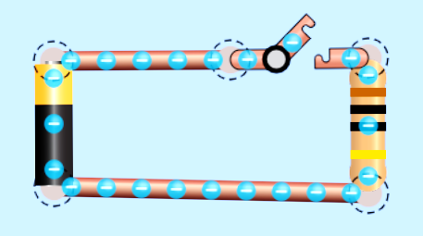

1. Which direction do the blue circles flow around the circuit?
2. Why do they flow in that direction?
3. **Prediction** - How will changing the resistance affect their flow?
4. **Prediction -** How will changing the voltage affect their flow?
5. Based on your observations, what do you think each of the following measures
   1. Current –
   2. Voltage –
   3. Resistance –

Using the ammeter record how a change in voltage or resistance affects the current flowing through the circuit. Then graph the relationship. For each data set, choose a fixed value for your constant variable and record it. You can also record your data in an excel sheet and draw a graph on there, or use python.

Data Set 1 – Voltage vs. Current

Constant Variable: Resistance = __________

|  |  |
| --- | --- |
| **Voltage**  Units:________ | **Current**  Units:________ |
|  |  |
|  |  |
|  |  |
|  |  |
|  |  |
|  |  |
|  |  |

Graph:

Describe the patterns and relationships that you see in your data table and graph.

Data Set 2 – Resistance vs. Current

Constant Variable: Voltage = __________

|  |  |
| --- | --- |
| **Resistance**  Units: ________ | **Current**  Units: ________ |
|  |  |
|  |  |
|  |  |
|  |  |
|  |  |
|  |  |
|  |  |

Graph:

Describe the patterns and relationships that you see in your data table and graph.