<https://phet.colorado.edu/sims/html/capacitor-lab-basics/latest/capacitor-lab-basics_en.html>

**Learning Goals:**

Students will be able to:

* Identify the variables that affect the capacitance and how each affects the capacitance.
* Determine the relationships between charge, voltage, and stored energy for a capacitor.
* Relate the design of the capacitor system to its ability to store energy.
* Explain how to use a capacitor to light a bulb.
* Describe what happens as charge drains away from a capacitor into a light bulb

**Develop your understanding:** Open the [**Capacitance**](https://phet.colorado.edu/sims/html/capacitor-lab-basics/latest/capacitor-lab-basics_en.html?screens=1) screen, then explore to develop your own ideas about how a capacitor is designed.

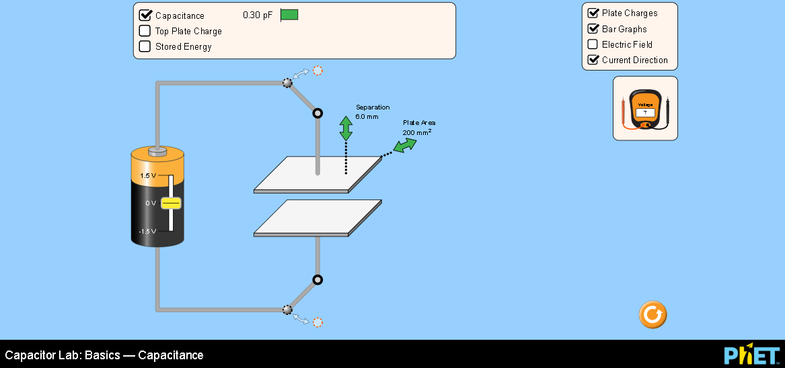

**Explain your understanding:** Use your own words and captured images from the simulation to show you can:

1. Identify what features of a capacitor can be maximized or minimized to make a capacitor with the greatest capacitance.
   1. What features of the simulation did you use to help you?
2. Design experiments to find the relationships between charge, voltage, and stored energy for a capacitor. Summarize your experimental procedures and findings.
   1. What features of the simulation did you use to help you?
3. If you wanted to design a capacitor system to store the greatest energy, what would you use?

**Develop your understanding:** Explore the [**Light Bulb**](https://phet.colorado.edu/sims/html/capacitor-lab-basics/latest/capacitor-lab-basics_en.html?screens=2) screen to investigate how to use a capacitor to turn on a light bulb.

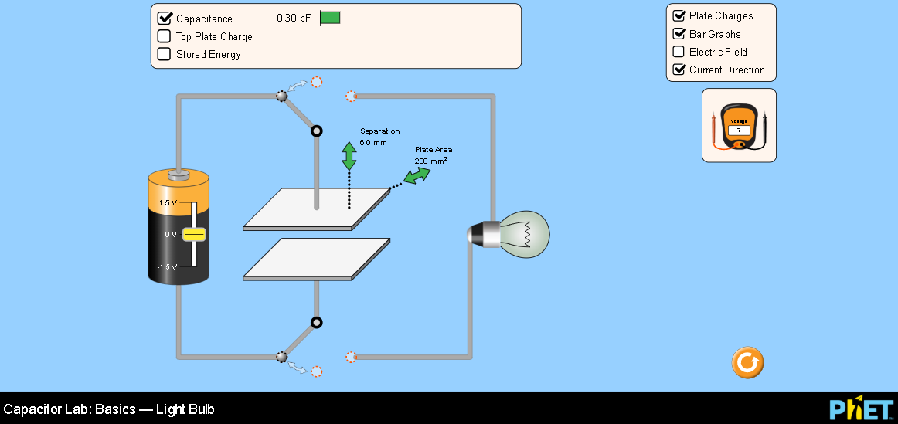

**Explain your understanding:** Use your own words and captured images from the simulation to show you know how to use a capacitor to light a bulb.

1. What are the required components to use a capacitor to light a bulb and how does the system operate?
2. How would using a capacitor to light a bulb compare to using just a battery as shown:

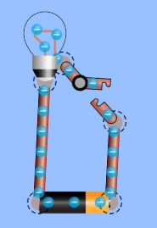

1. Use Circuit Construction Kit [Intro](https://phet.colorado.edu/sims/html/circuit-construction-kit-dc/latest/circuit-construction-kit-dc_en.html?screens=1) screen to test your ideas and provide supporting evidence.

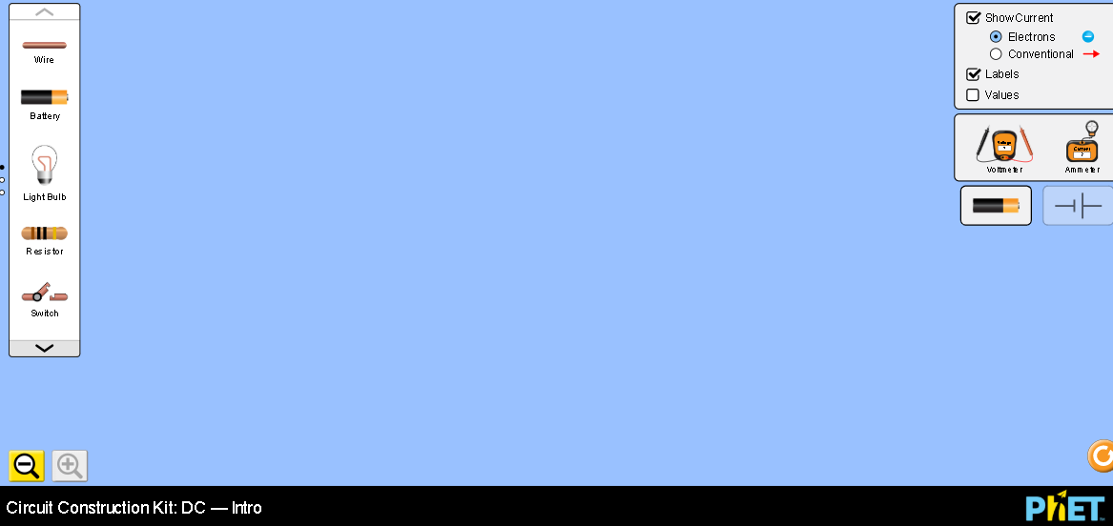

1. Describe what happens as charge drains away from a capacitor into a light bulb. Include the use of as many tools in the simulation as possible in your observations.
   1. What features of the simulation did you use to help you?
2. Research to find a practical application where the energy stored in a capacitor is used. (cite references)