FAGLB03 - G/L ACCOUNT BALANCE DISPLAY

Explanation | Screenshot
[1] Use transaction FAGLB03 to Display G/L Account Balance  Enter FAGLB03 in the Transaction box | 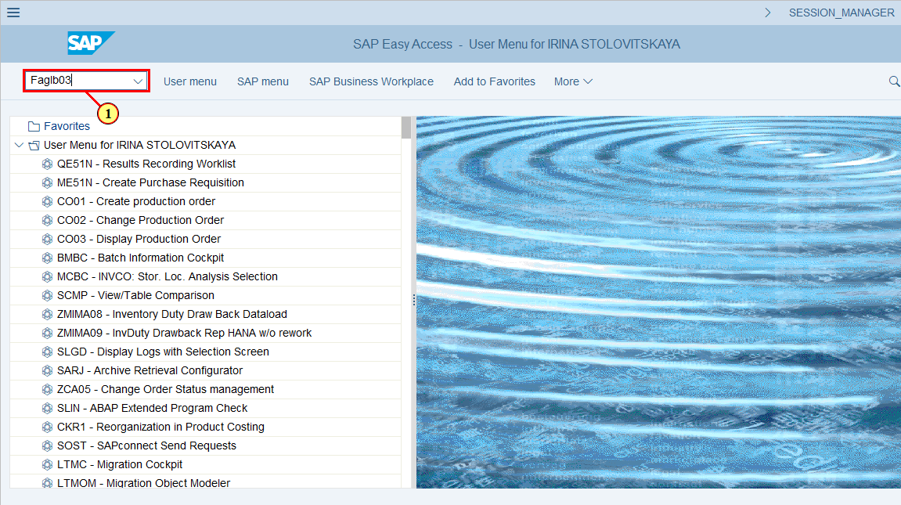
  This is a default Selection Screen where you can entry the Account Number for Balance Display  The General Ledger Balance displays the opening balance and all transactions for each posting period.  Based on these figures the SAP system calculates the balance per posting period as well as accumulated account balance. | 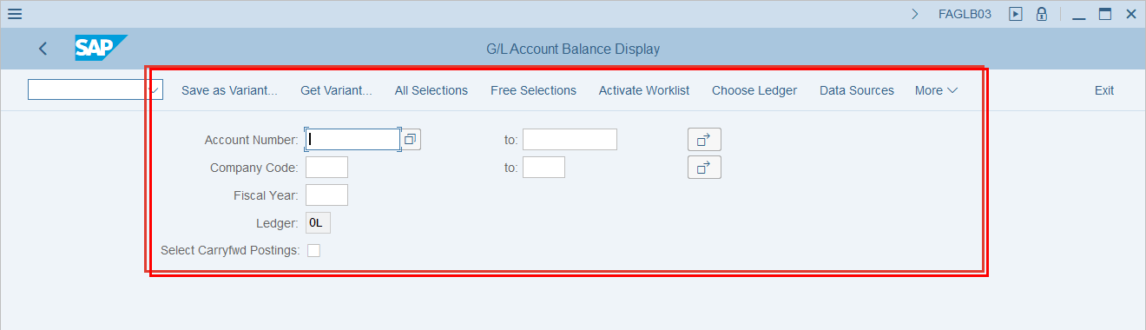
  You can run this transaction for a single General Ledger Account or for a range of accounts as well as for one or more Company Codes | 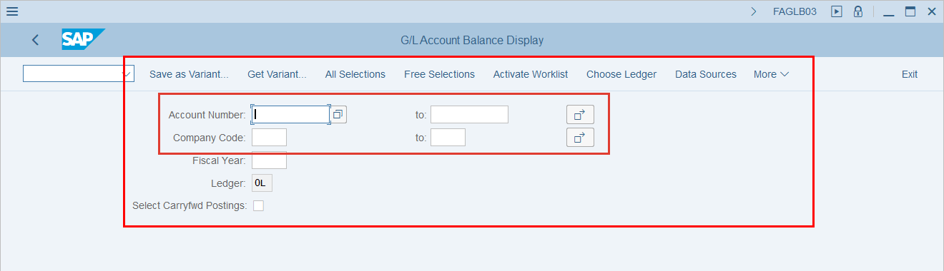
[2] Type the Account Number | 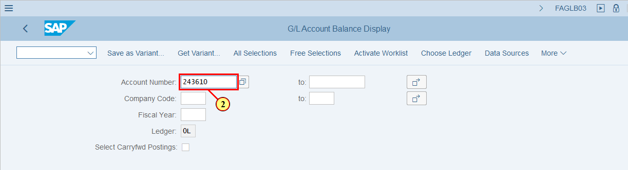
[3] Type the Company Code | 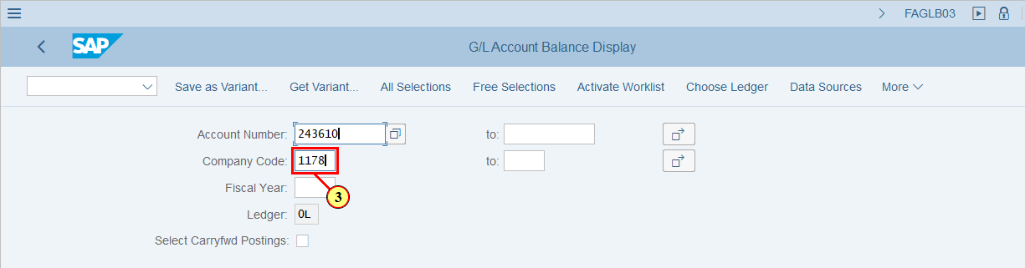
[4] Type the Fiscal Year | 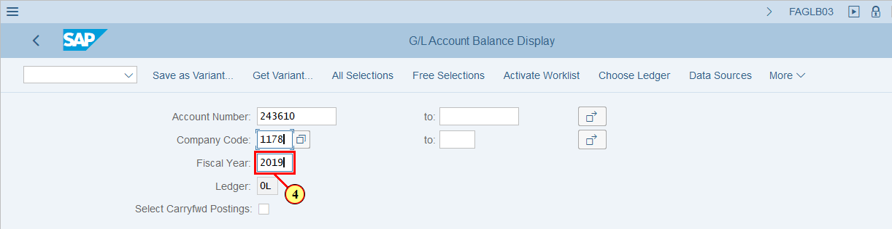
  This is a Default value of Ledger = 0L (IFRS) for G/L Account Balance Display  Let's display a G/L Account Balance in this Ledger  [5] Click Execute  You can also press F8 | 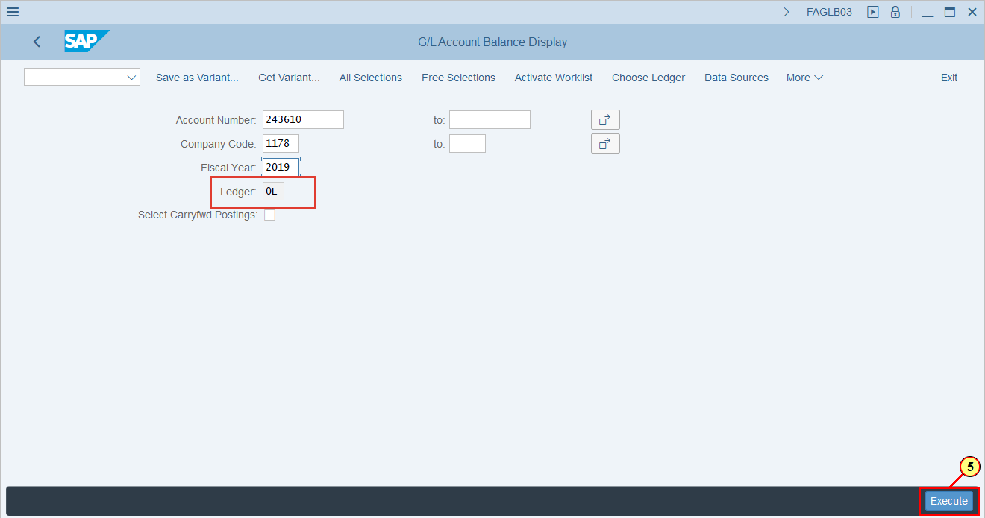
  These are a Debit, Credit and Balance amounts (difference between debit and credit) are displayed in these columns | 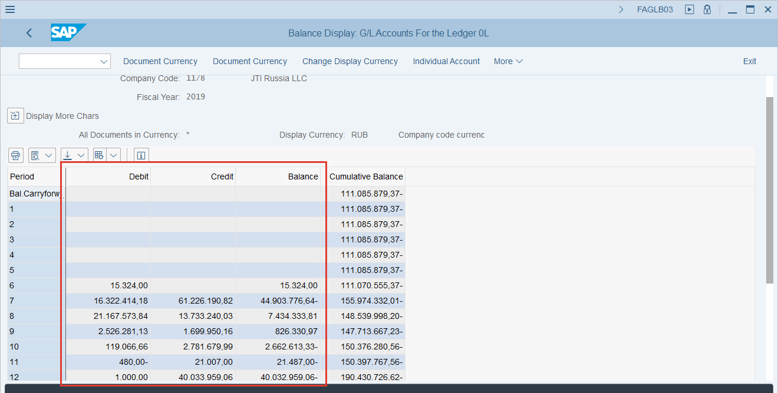
[6] Double Click on Balance box  to drill down to the Line Items | 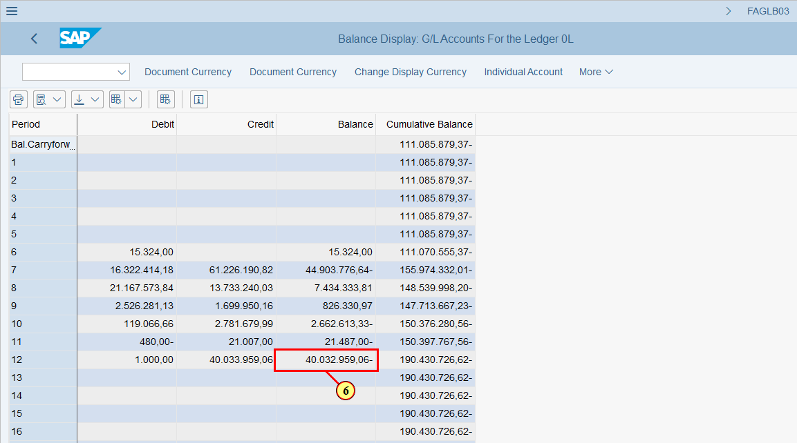
  When you double click from inside FAGLB03, you are taken to FAGLL03 - This is G/L Account Line Item Display | 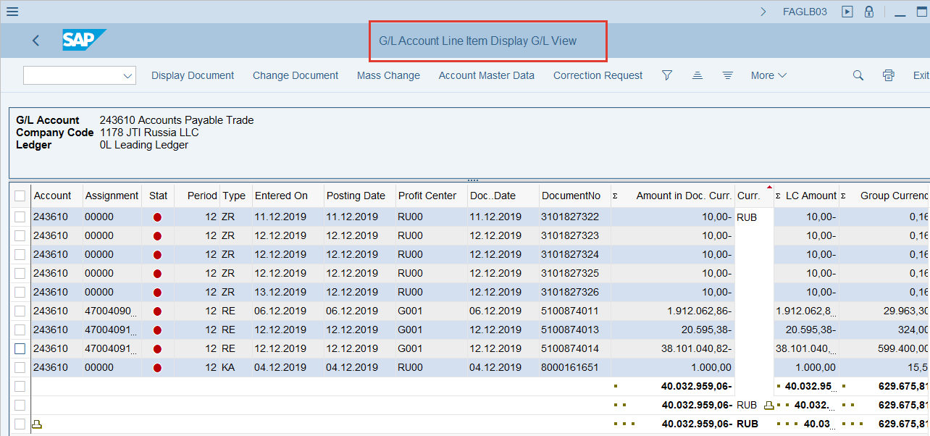
[7] To drill down to the document select check box  [8] And Click Display Document  You can also press Ctrl+Shift+F7 | 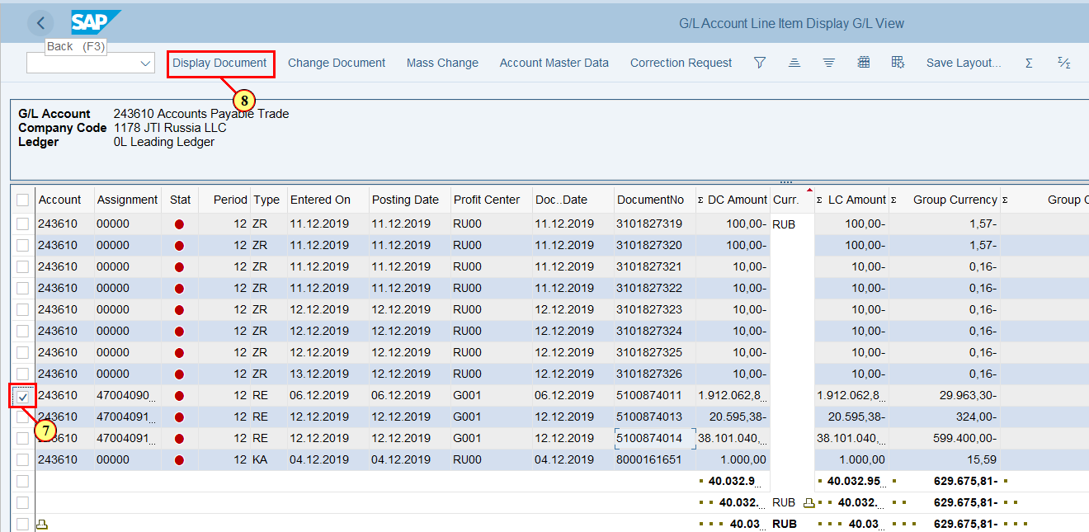
[9] Click on Call Up Document Overview to review the accounting item  You can also press F9 | 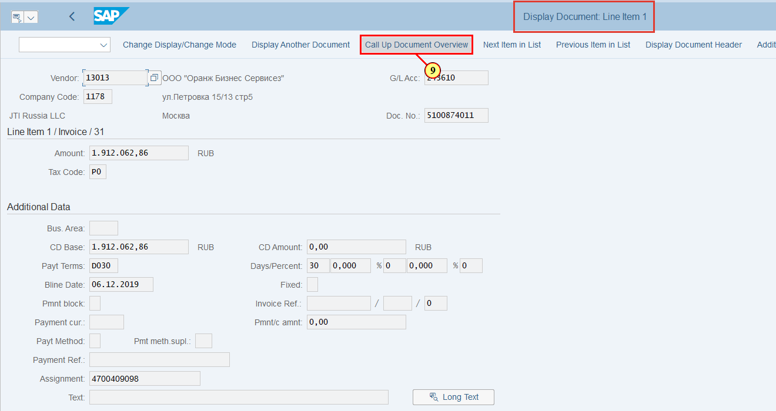
  This is all accounting details of the Document | 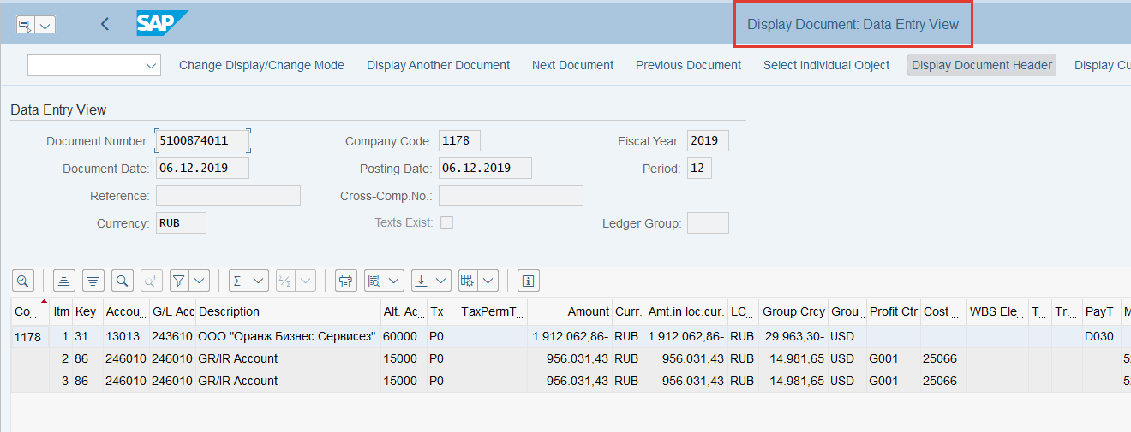
[10] Click on to Display Document Header  You can also press F5 | 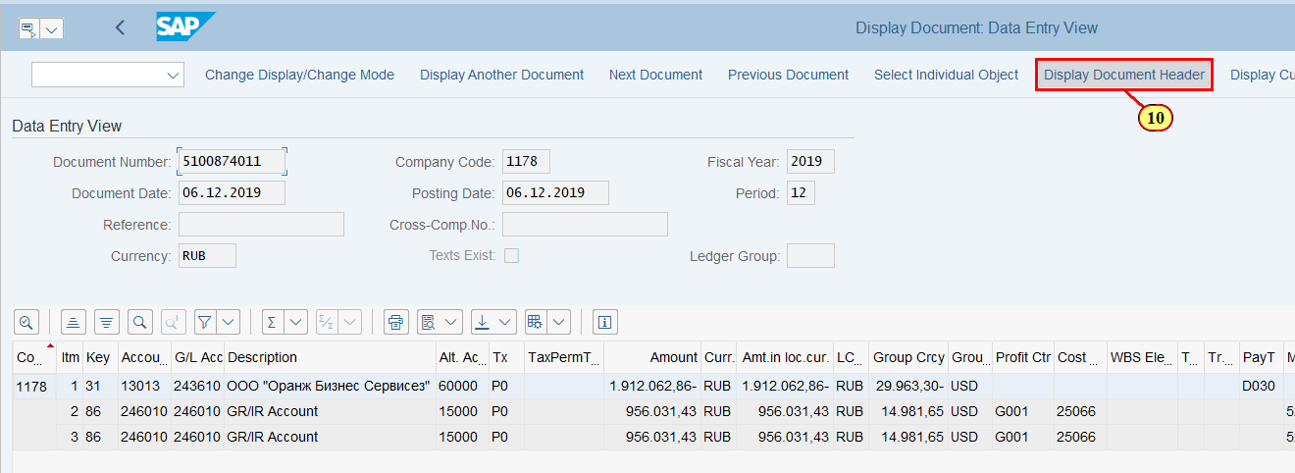
[11] Click on Close to close Document Header | 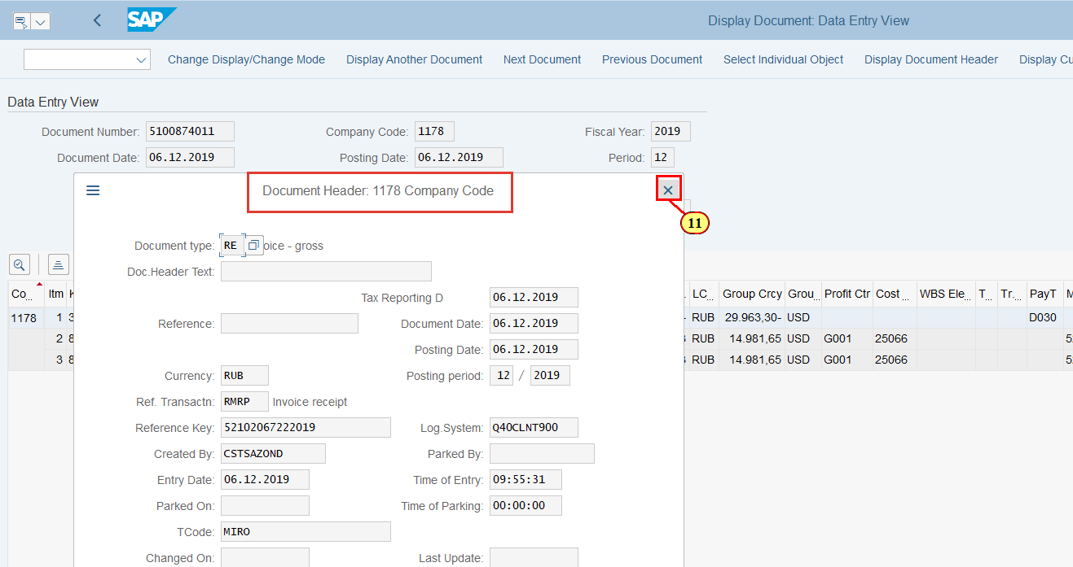
[12] Click Back   You can also press F3 | 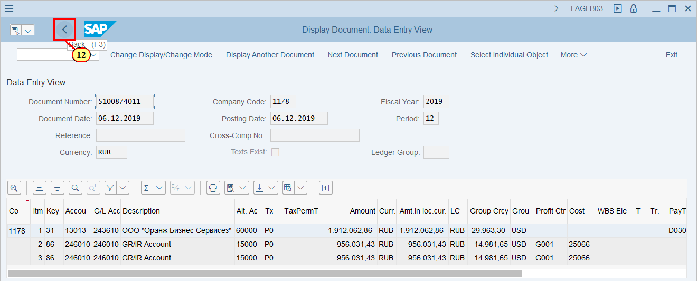
[13] Click Back  to close G/L Account Line Item Display  You can also press F3 | 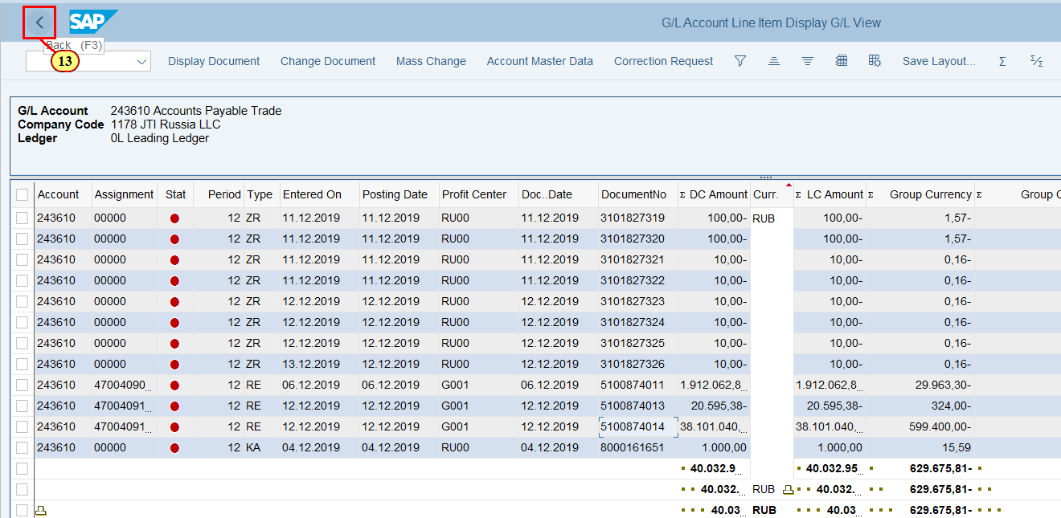
[14] Click Back  to return back to the Selection Screen  You can also press F3 | 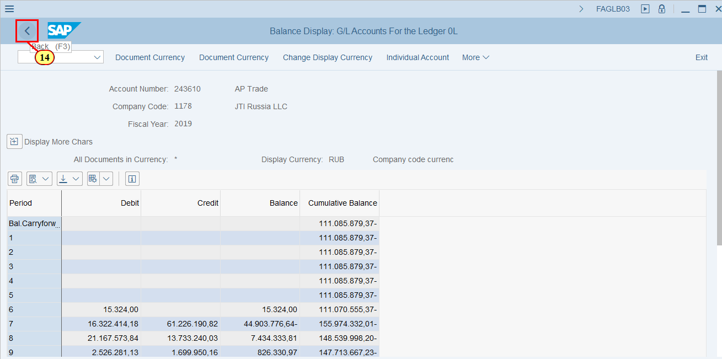
  In addition to default Selection Screen you can add one more Selection Parameter by clicking on the All Selections box | 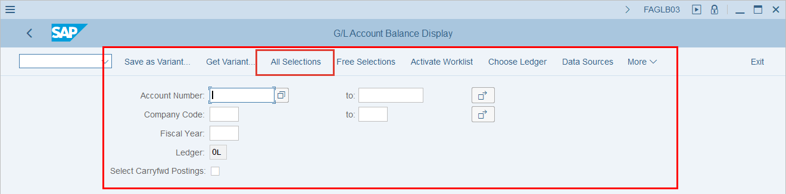
[15] Click All Selections in order to have Full Selection Screen  You can also press Shift+F7 | 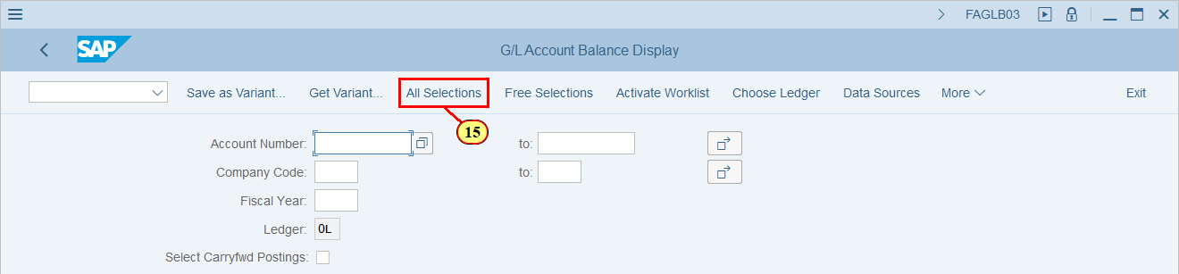
  Currency Type - this is an additional Selection Parameter  [16] Click on to open a dropdown list with valid Currency Type values | 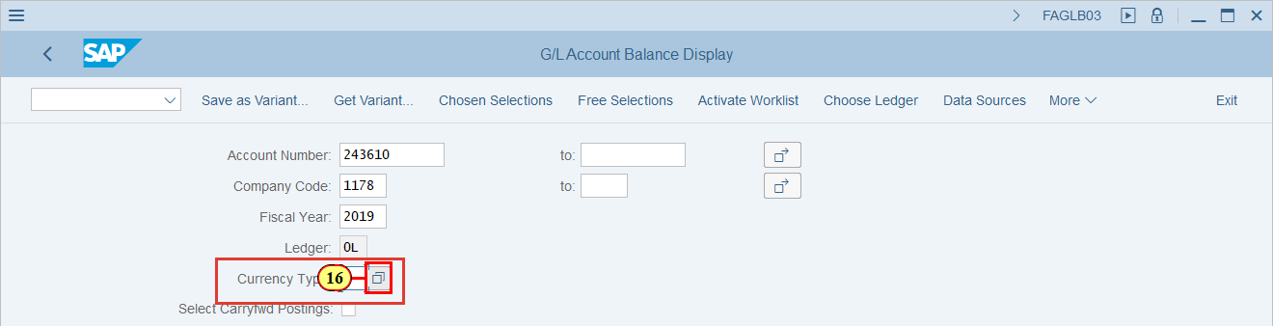
  This is a list of Currency Types are avaliable  FI documents contain the following currencies:  •DC - document currency, SAP currency type 00: transaction currency, in which a posting is made  •LC1 - 1st local currency, SAP currency type 10: company code currency  •LC2 – 2nd local currency, SAP currency type 30: group currency  •LC3 – 3rd local currency, SAP currency type 31: group currency  You may get the G/L Account Balance in all availiable for FI documents currency | 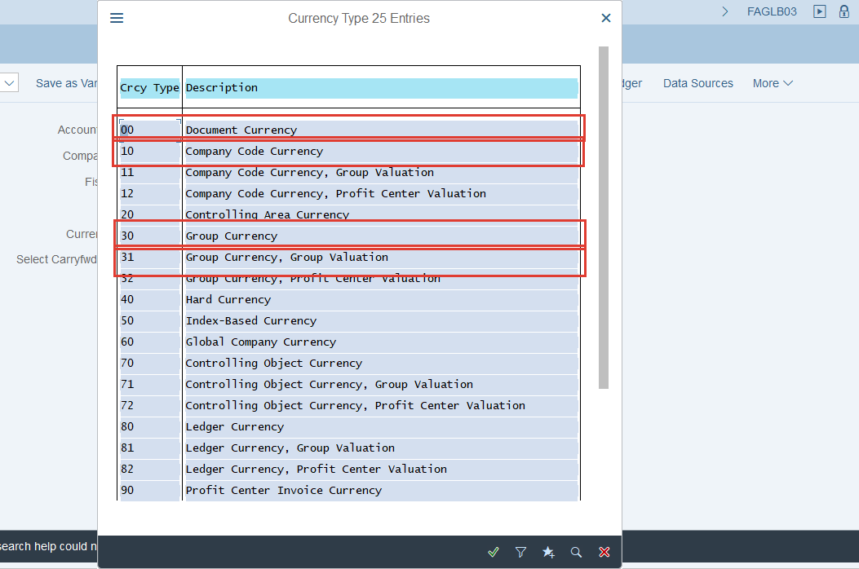
[17] Click  to choose LC3 Currency for G/L Account Balance display | 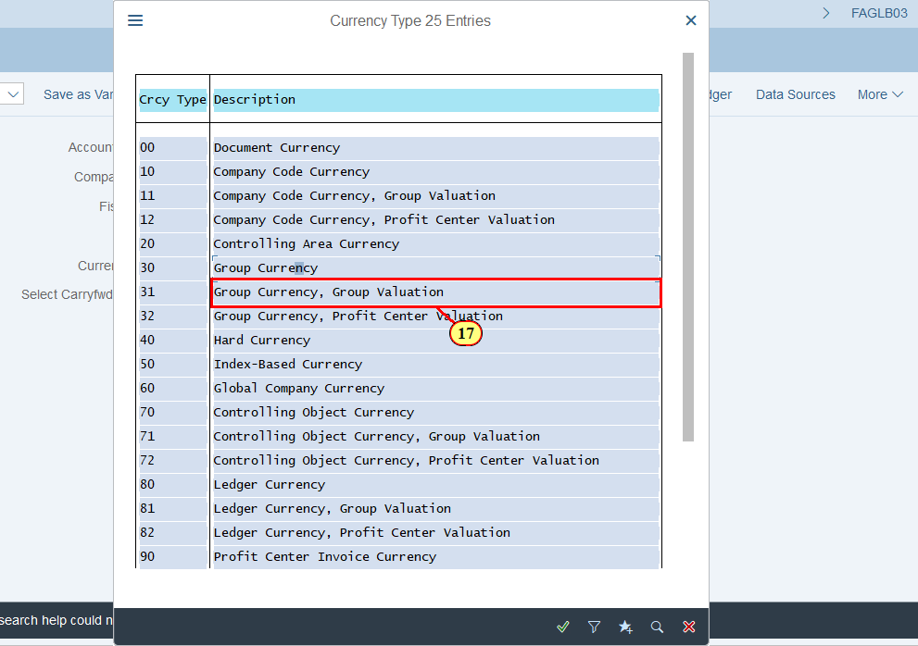
[18] Click Execute  You can also press F8 | 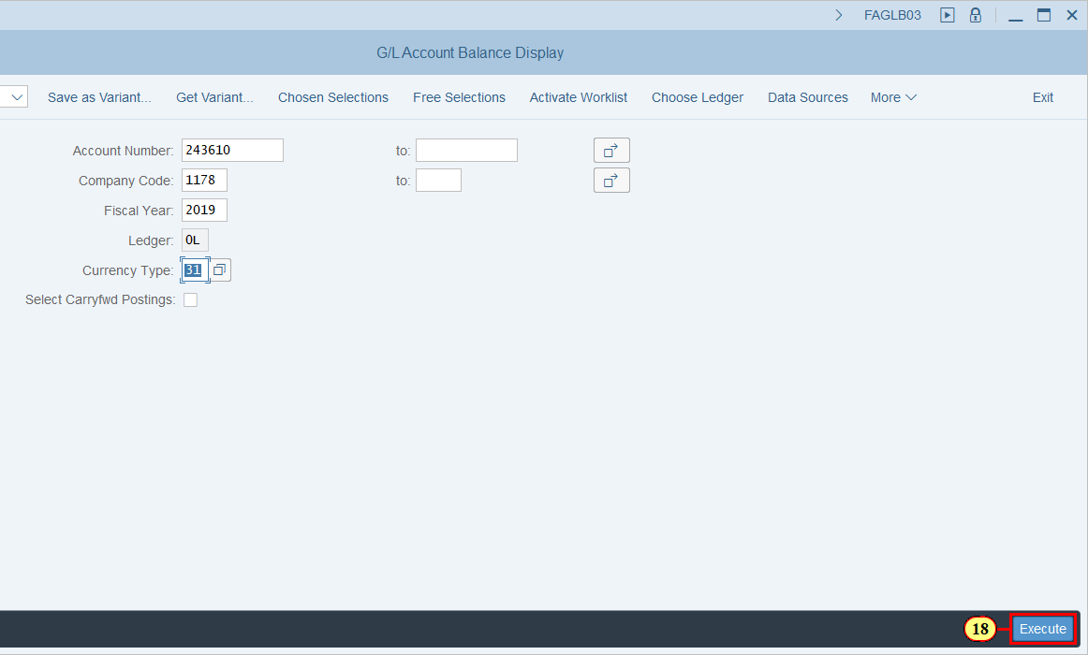
 | 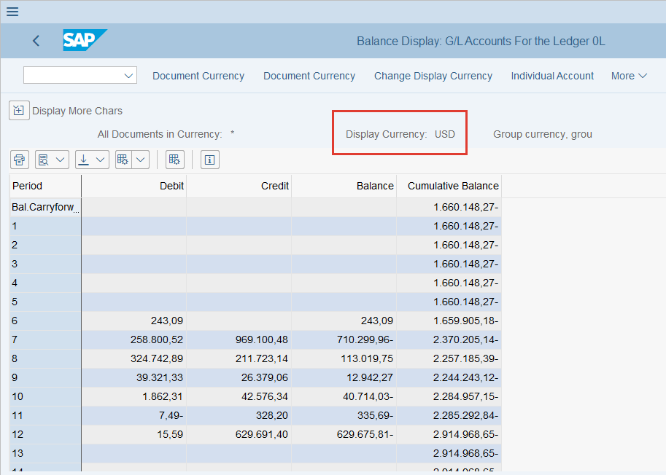
[19] Click Back   You can also press F3 | 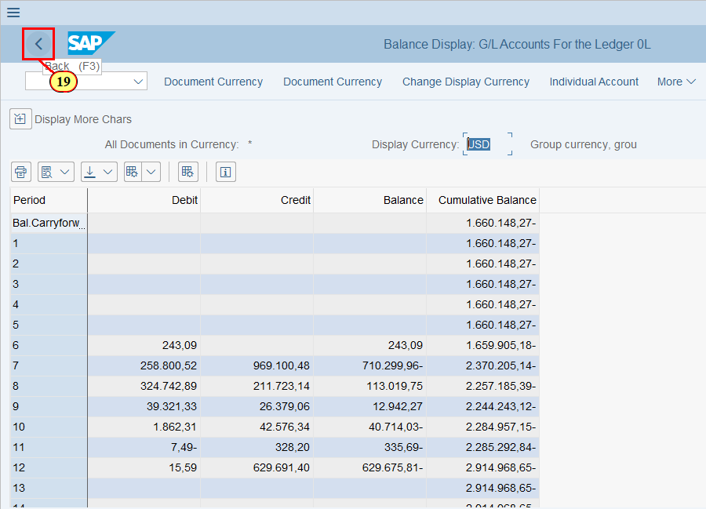
  This is a Default value of Ledger = 0L (IFRS) for G/L Account Balance Display  You can change the Ledger for G/L Account Balance Display  [20] Click Choose Ledger .  You can also press Ctrl+F4. | 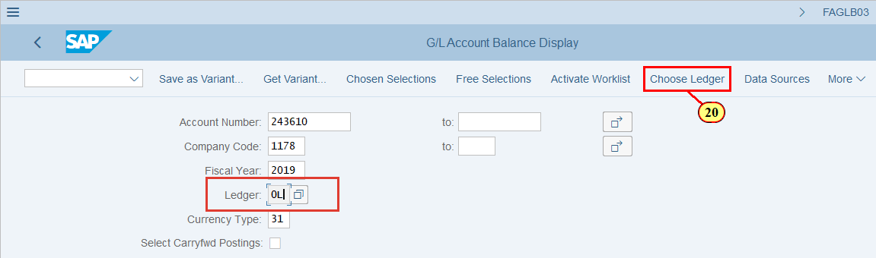
[21] Click to open a dropdown list with valid values of Ledgers | 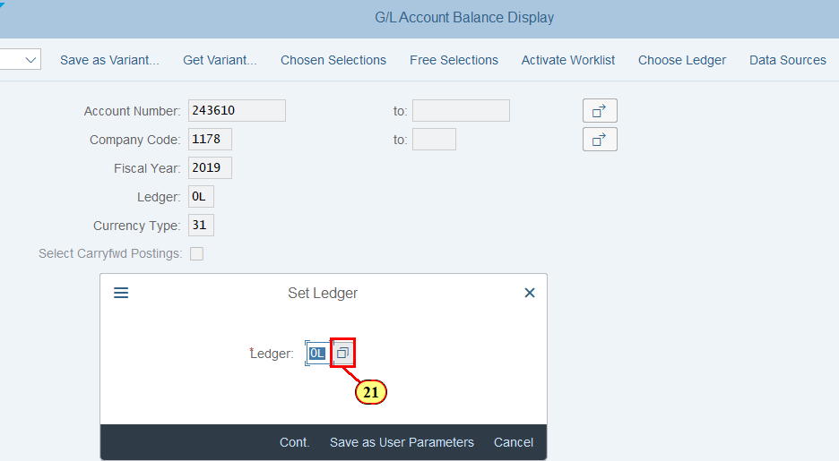
[22] Double Click to display G/L Account Balance in the Statutory Ledger | 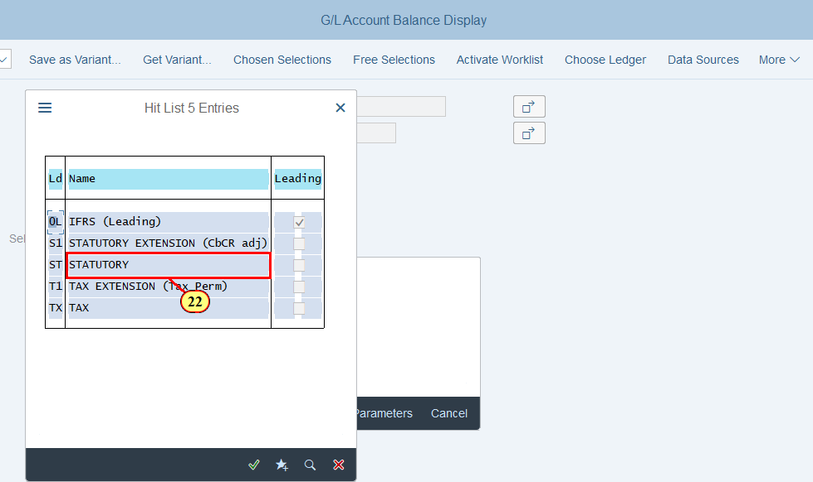
[23] Click Cont.  You can also press Enter | 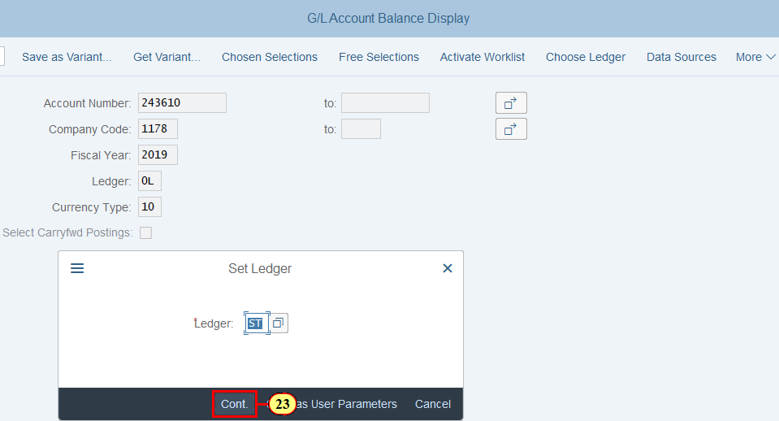
[24] Click Execute .  You can also press F8. | 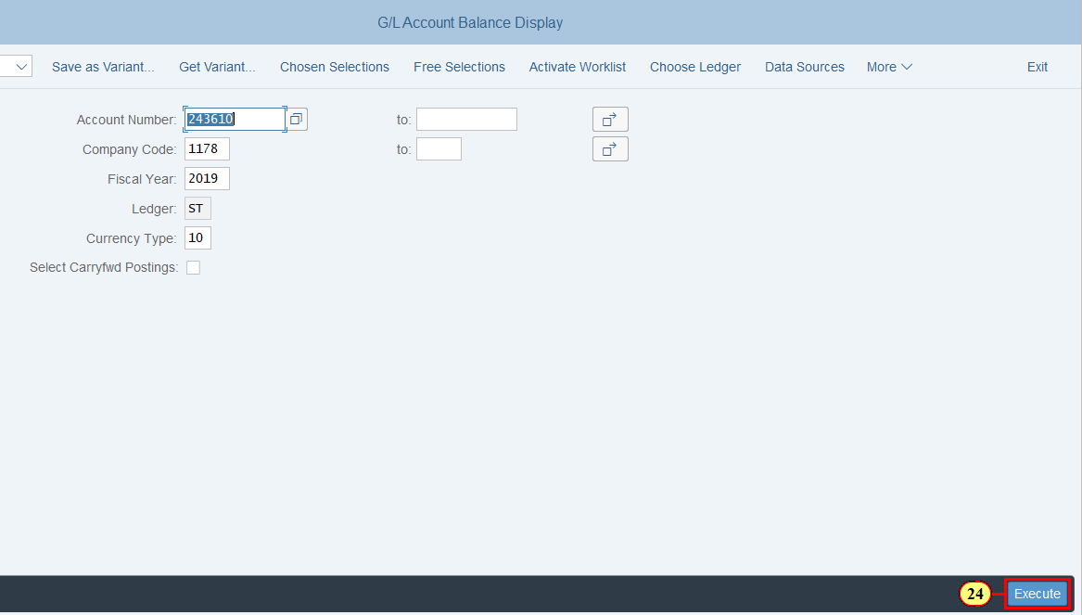
 | 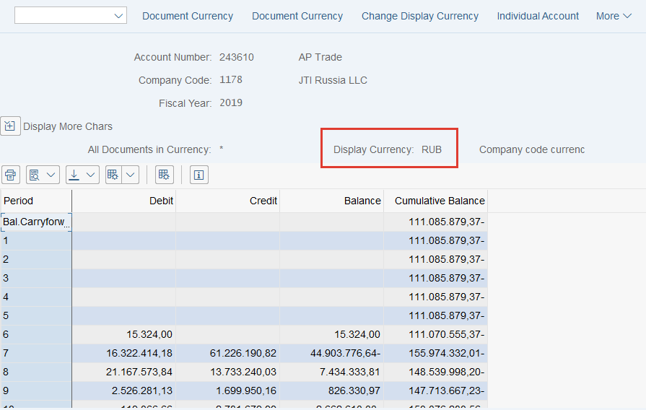
[25] Click Back   You can also press F3 | 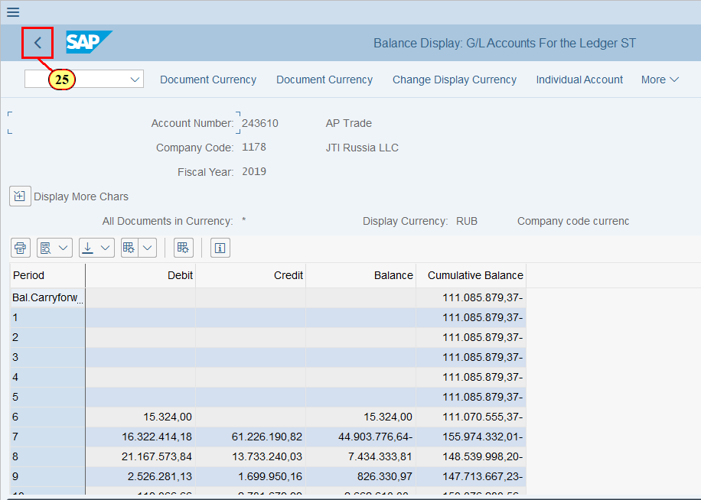
[26] Click Back   You can also press F3 | 