FB03 - DISPLAY FI DOCUMENT - GENERAL PURPOSE

Explanation | Screenshot
[1] Use transaction FB03 to Display Document  Enter FB03 in the Transaction box. | 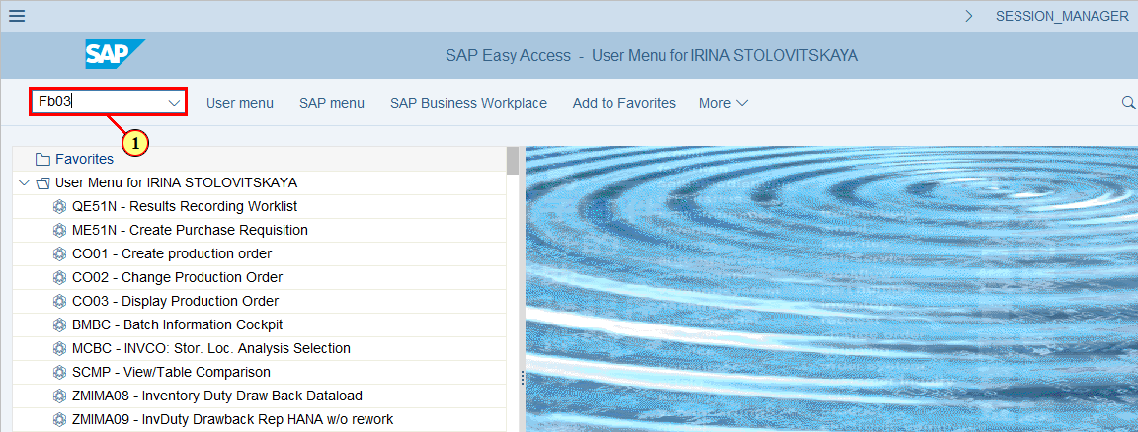
[2] Type the Document Number | 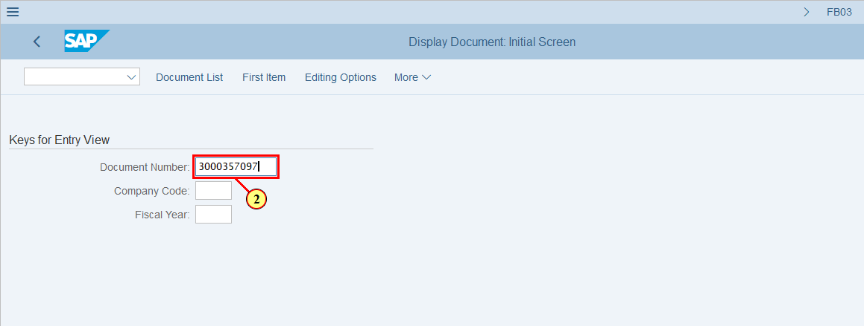
[3] Type the Company Code | 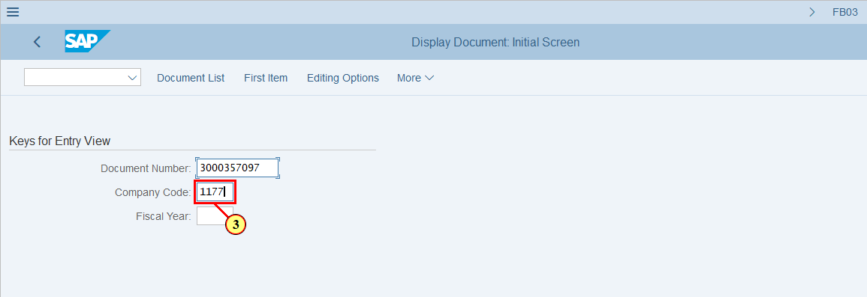
[4] Type the Fiscal Year of the Document | 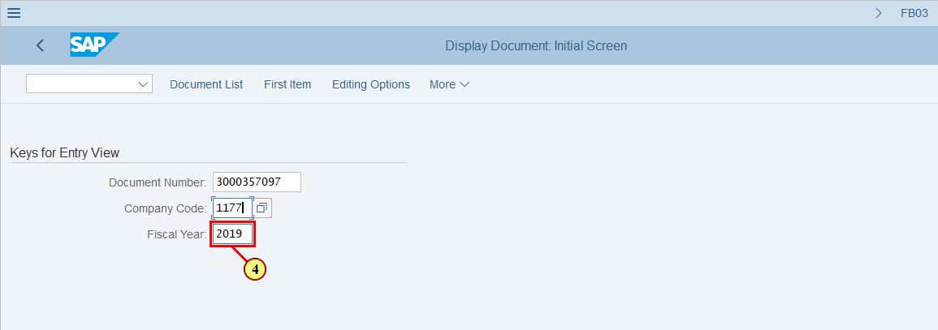
[5] Click Continue .  You can also press Enter. | 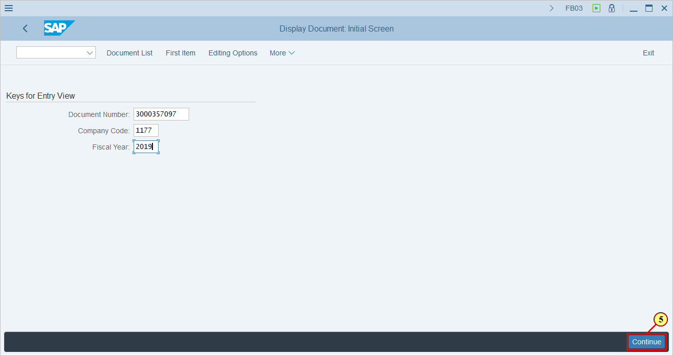
  This is an Entry View of the Document  Entry View means the system displays the document as it was entered by user. In Entry View we can't to see all of assigned Profit Centers and Balance Sheet split  The document is displayed on the Entry View  by default | 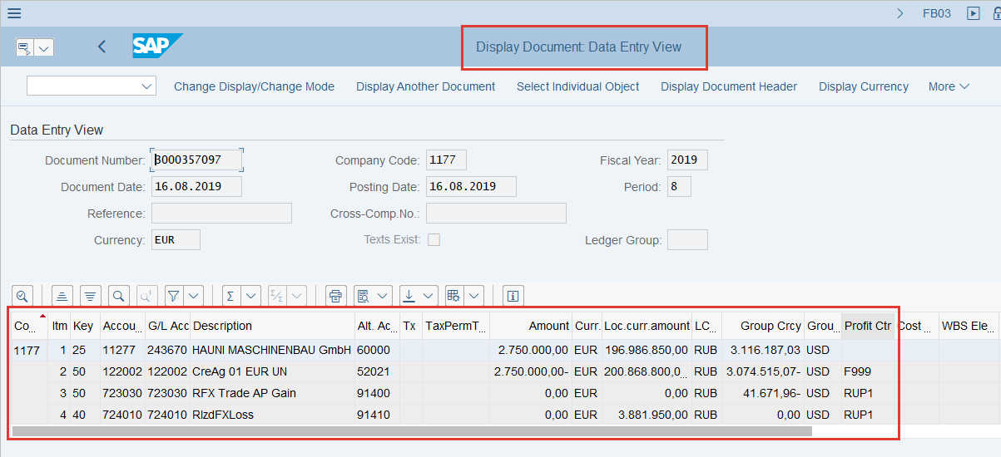
[6] The Ledger Groupfield is represent the Ledger in which the Document is posted  If the Ledger Group field is blank it means that the document was posted in ALL ledgers | 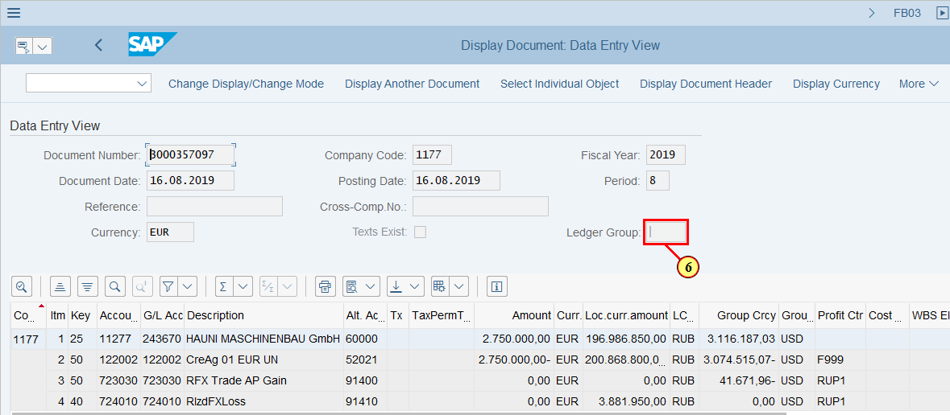
[7] To switch between Entry View and General Ledger View Click | 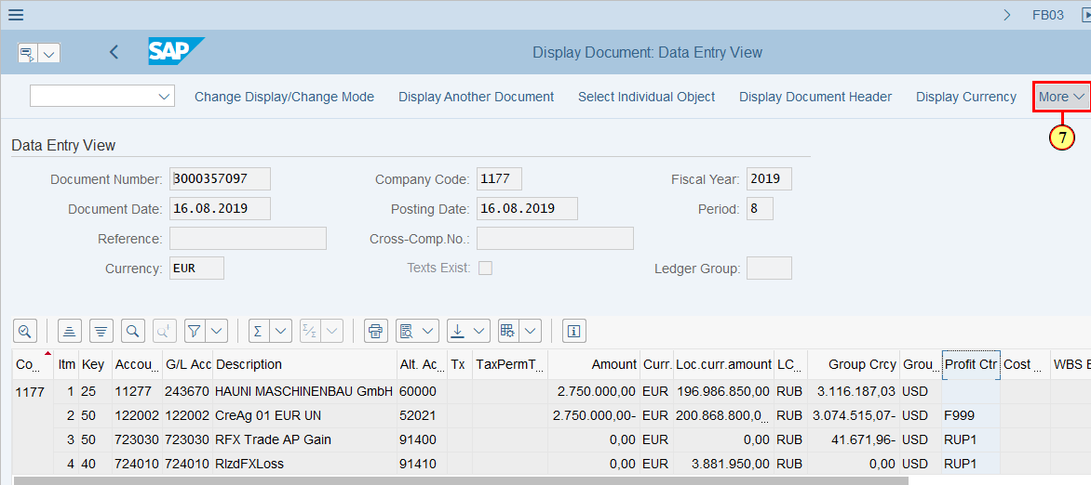
[8] Click on General Ledger View  You can also press Ctrl+F9 | 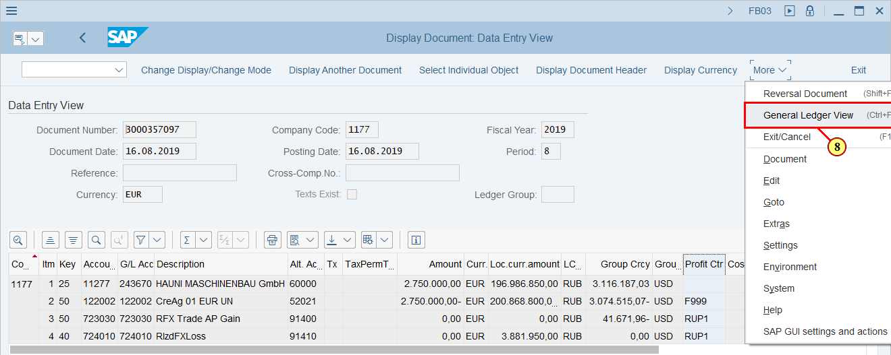
  This is a General Ledger View.  Here we can see the results of Document Splitting functionality.  The Profit Center is filled in for ALL the Vendor line items | 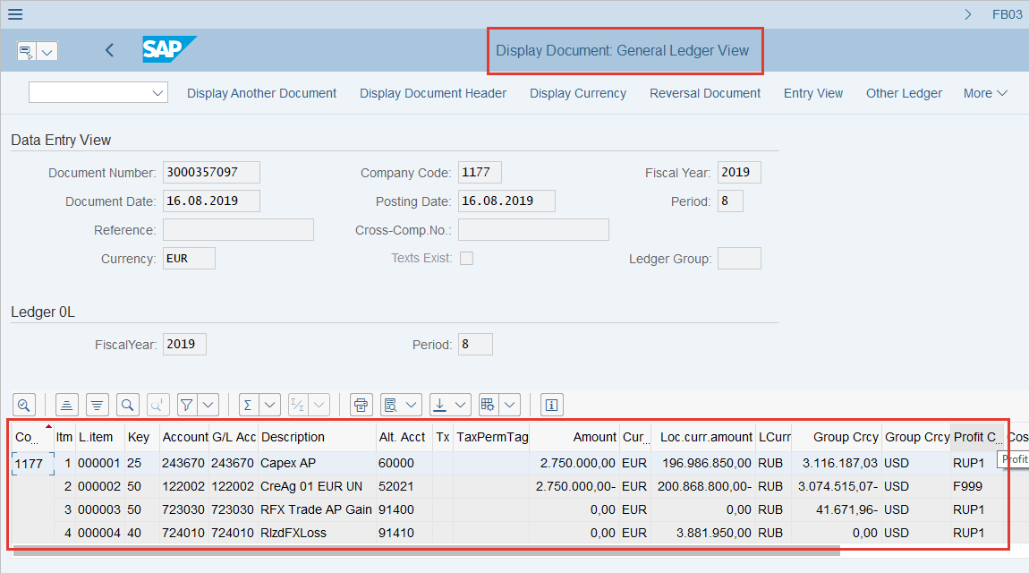
  Vendor Line Items are split and amount are calculated proportionally to the base rows (expense lines).  The Profit Center is filled in for ALL the Vendor line items | 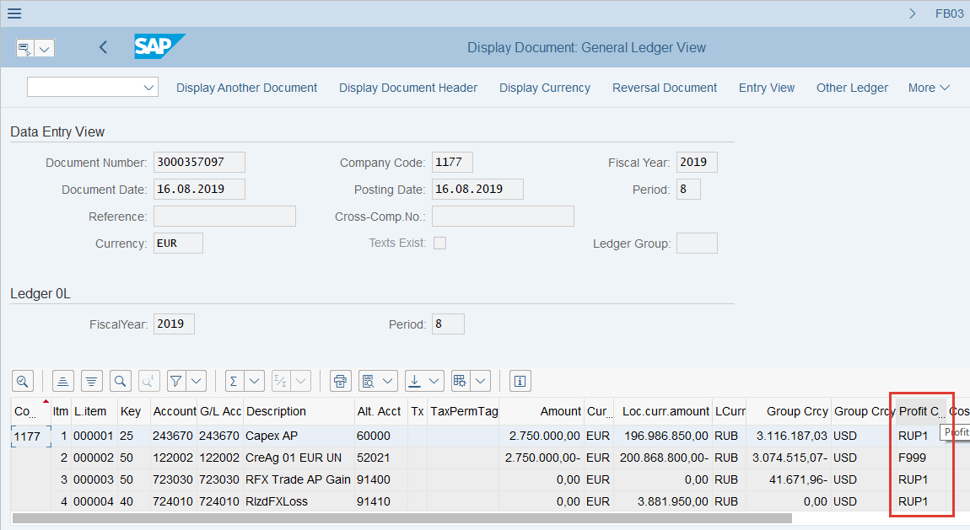
  This is a Ledger in which the Document is displayed    This is a LC3 amount is only availiable in IFRS (0L) Ledger | 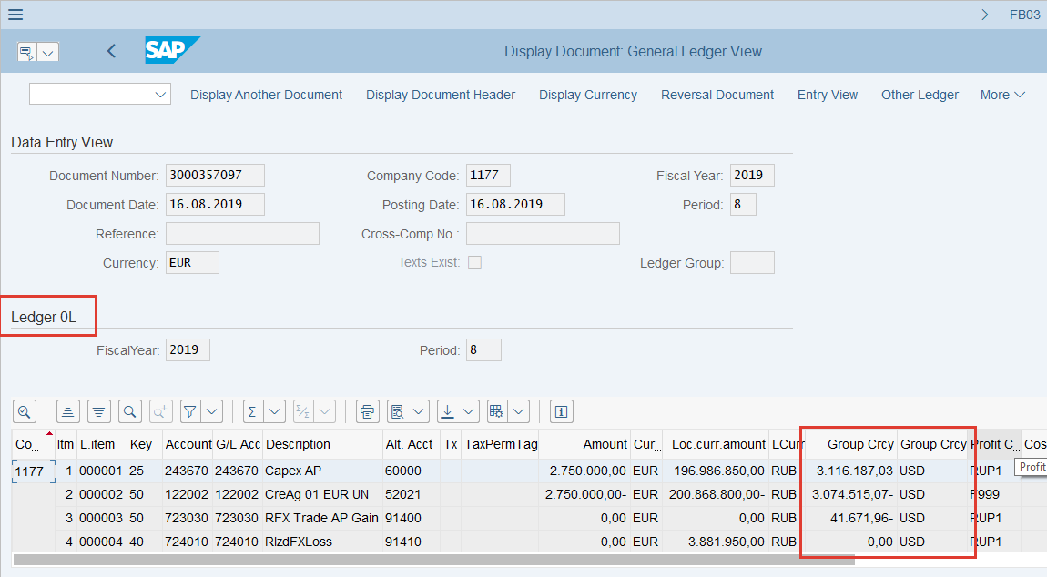
  In the General Ledger View we can select the Ledger | 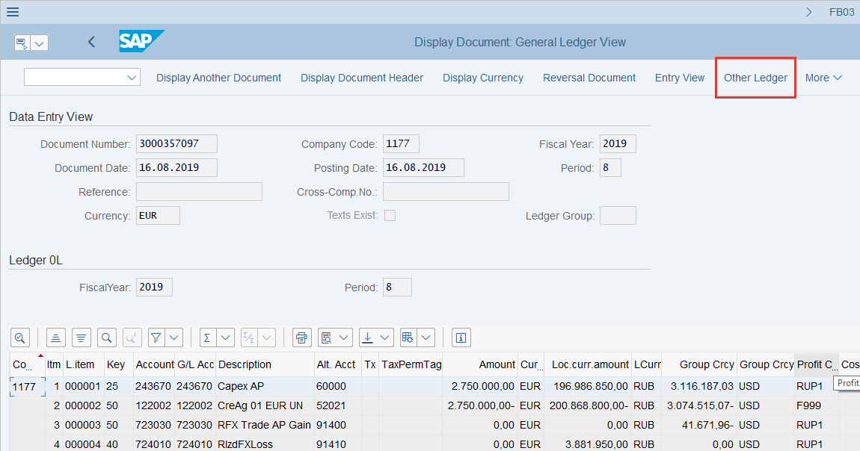
[9] Click Other Ledger in order to check How the document looks in other ledgers  You can also press Ctrl+F8 | 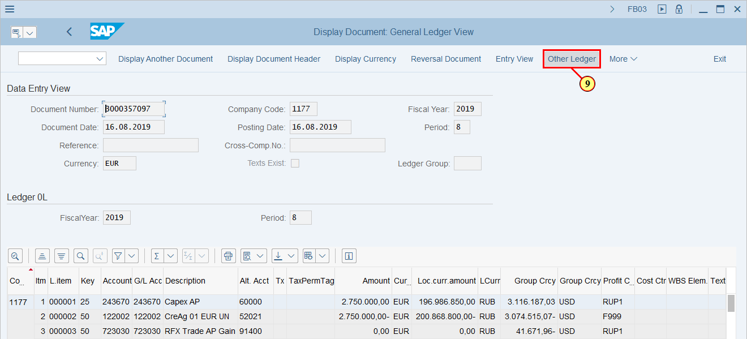
[10] This is a list of ALL Ledgers are avaliable  Choose the Ledger which you are interested in and  Click | 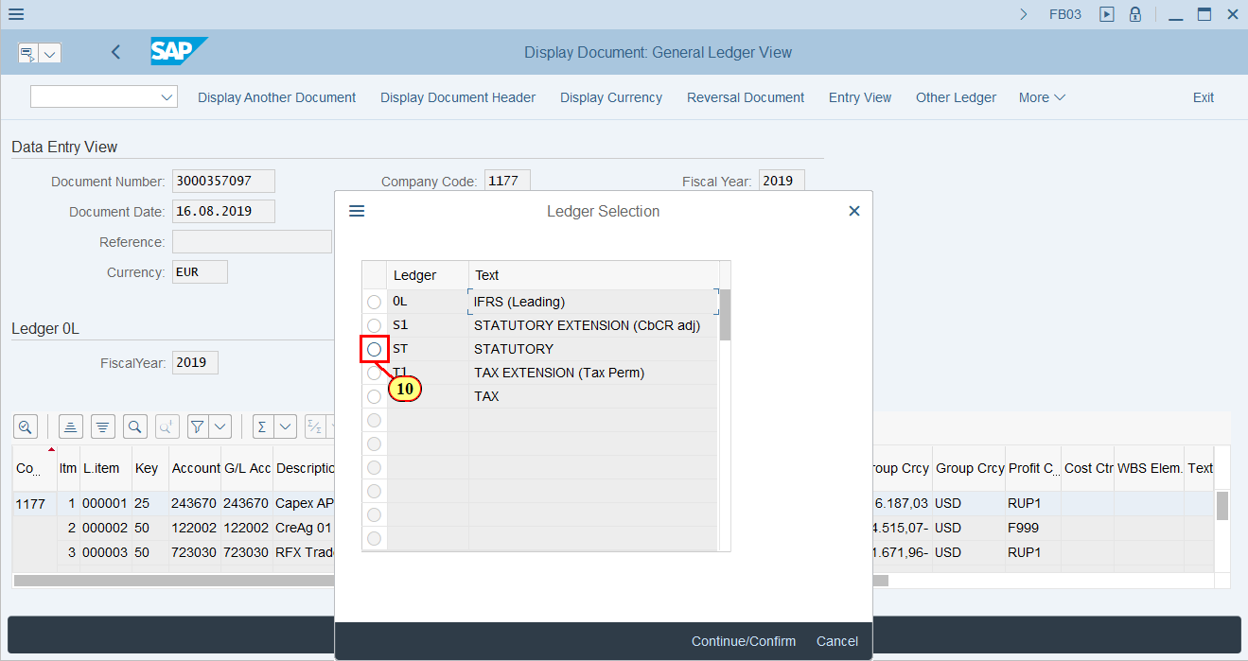
[11] Click Continue/Confirm  You can also press Enter | 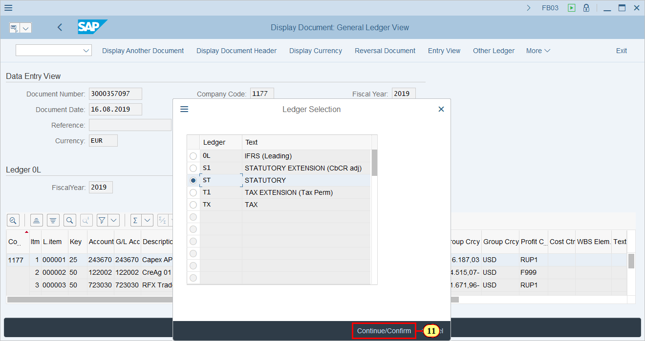
  This is a Statutory Ledger (ST)  Document is displayed in Other Ledger which you have choosen    This is a LC3 amount.  In ledgers other than 0L LC3 has zero amount  This is because LC3 is only available in IFRS(0L) Ledger | 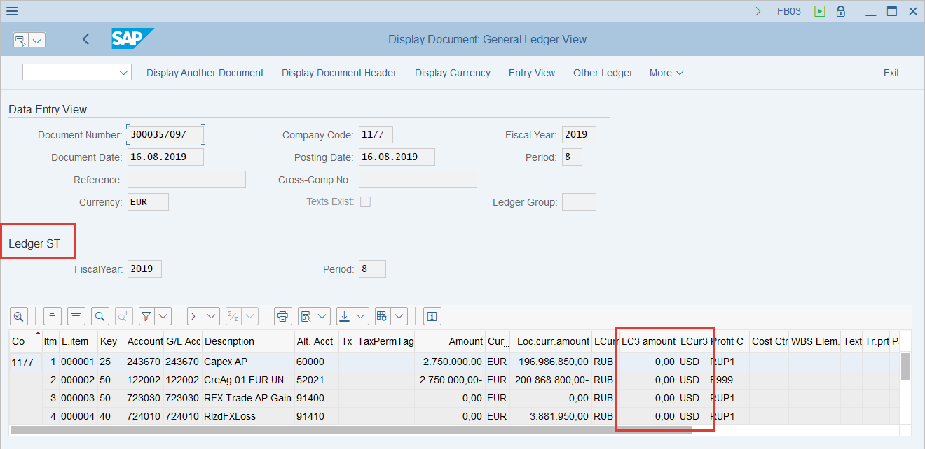
[12] Let's display the Document in TAX Ledger  Click Other Ledger  You can also press Ctrl+F8 | 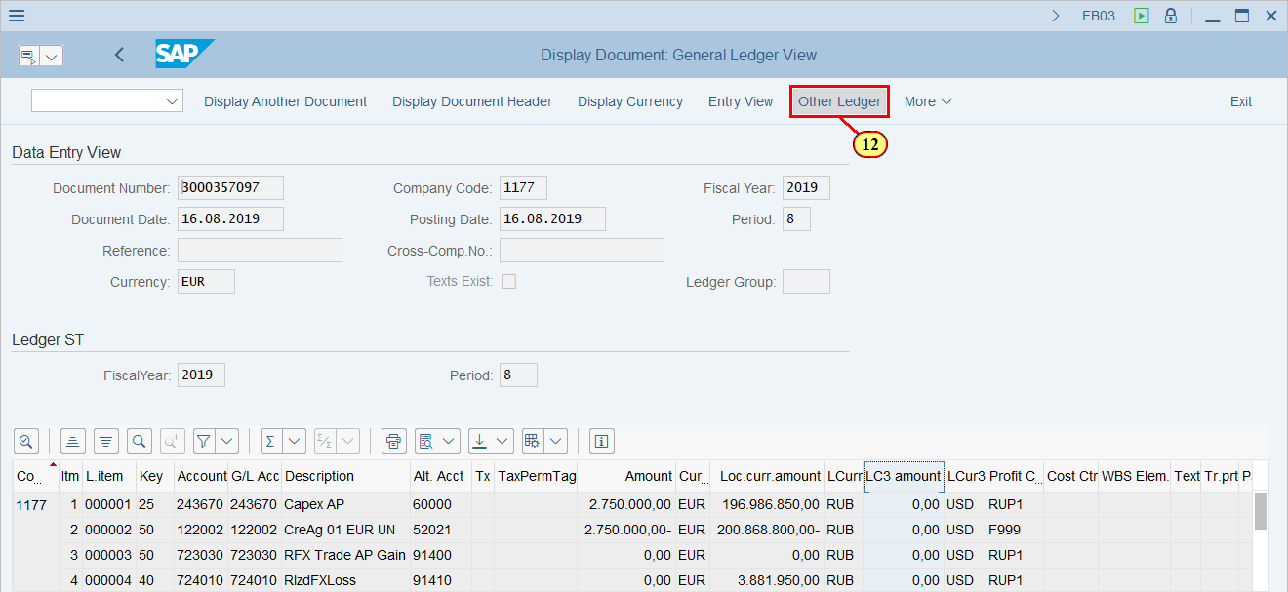
[13] Choose the TAX (TX) Ledger via tick this button | 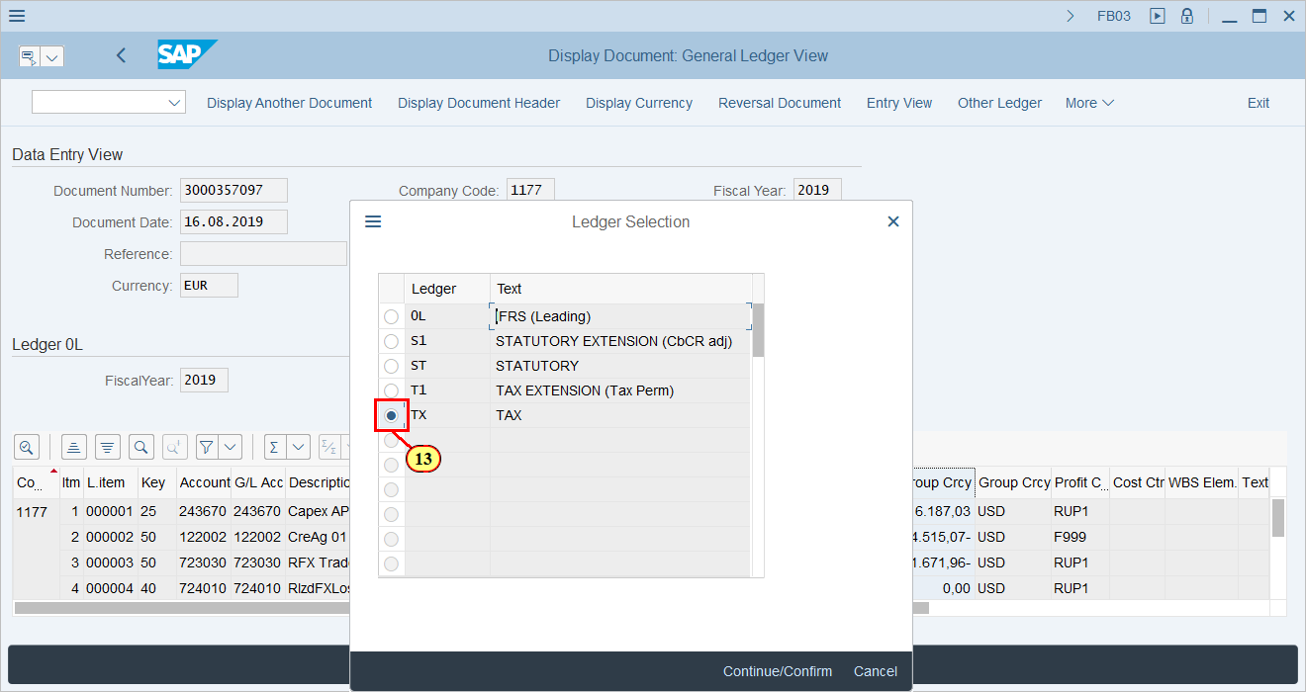
[14] Click Continue/Confirm .  You can also press Enter. | 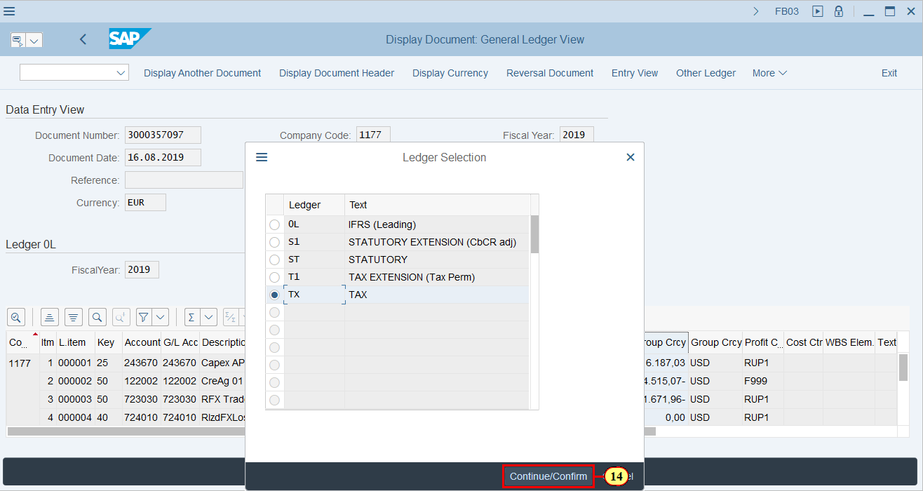
  This is a TAX Ledger (TX)  Document is displayed in Other Ledger which you have choosen    This is a LC3 amount.  In ledgers other than 0L LC3 has zero amount  This is because LC3 is only available in IFRS(0L) Ledger | 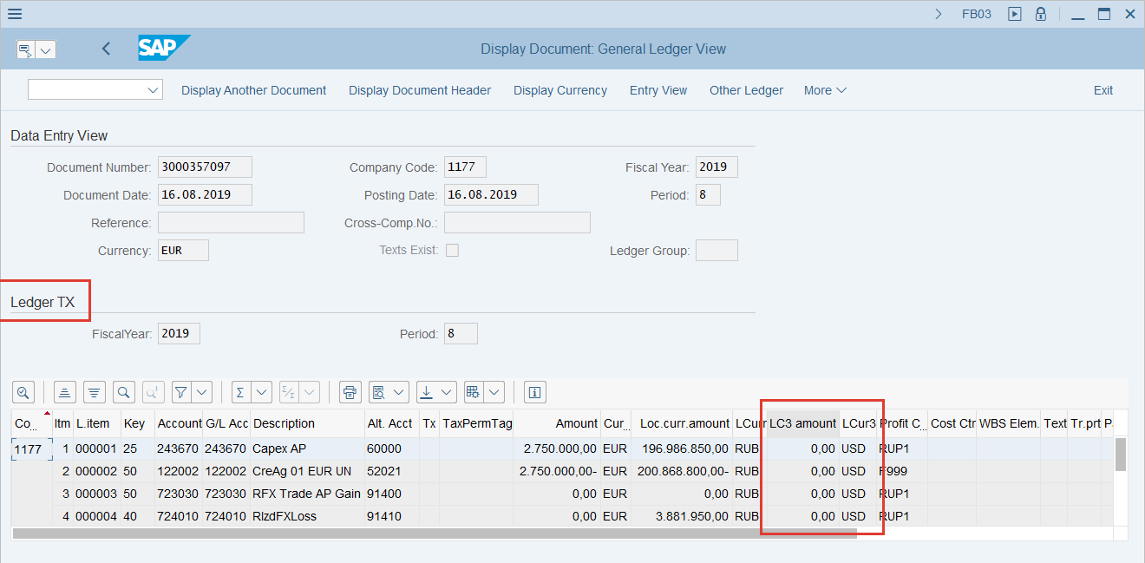
[15] Click Entry View in order to return back to the Document Entry View  You can also press Ctrl+F10. | 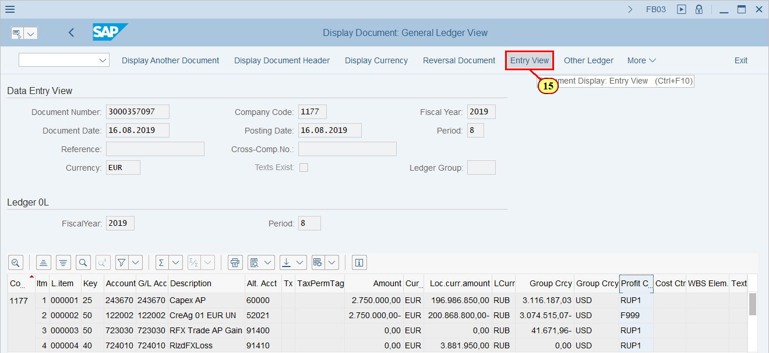
[16] Click Display Document Header in order to check the Document General Data  You can also press F5. | 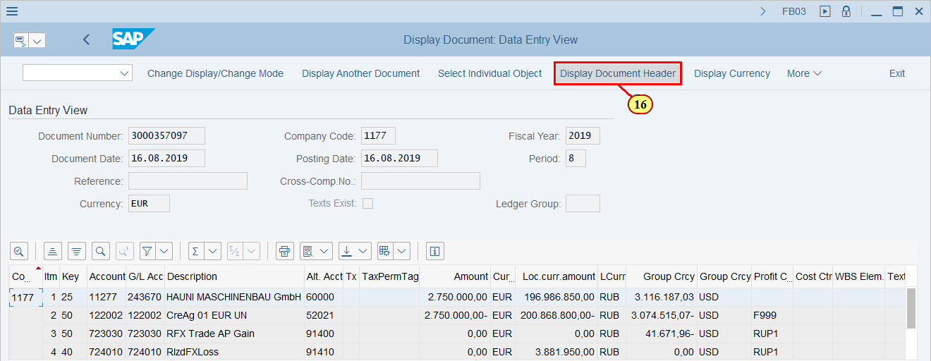
[17] This is a General Document Data  Scroll Mouse wheel down to see All the Data | 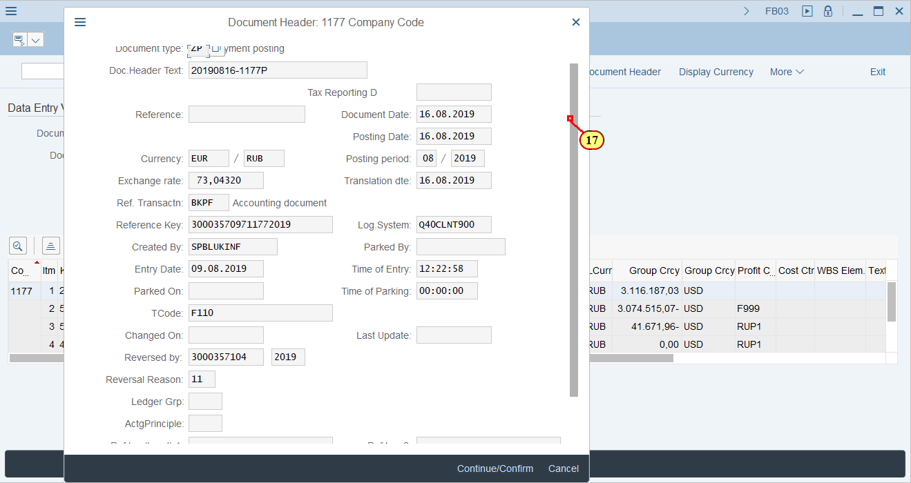
[18] Click Continue/Confirm in order to close Document Header Data  You can also press Enter. | 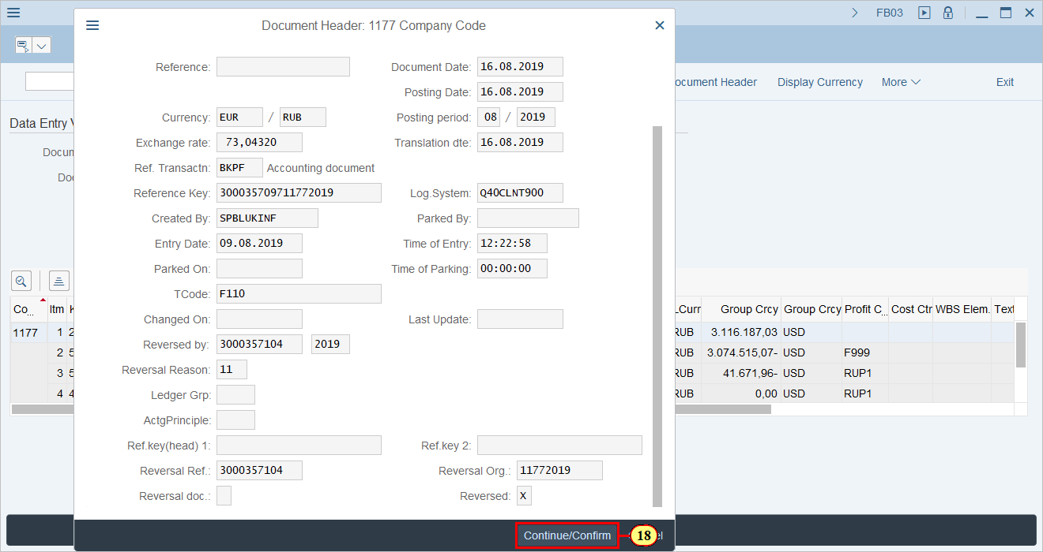
[19] Click Back .  You can also press F3. | 