If the “dot” tool is not available on your environment, please run the command below to install:

sudo apt-get install graphviz

Use graph visualizations to identify the input and output arrays.

## **Graph visualizations**

tflite_convert \  
  --graph_def_file=/path/to/model.pb \  
  --output_file=/path/to/output/model.dot \  
  --output_format=GRAPHVIZ_DOT \  
  --input_shape=input_shape \  
  --input_arrays=input_arrays \  
  --output_arrays=output_arrays

Identify the input_shape for converter. In this example, you can see that input_shape is “1,224,224,3”

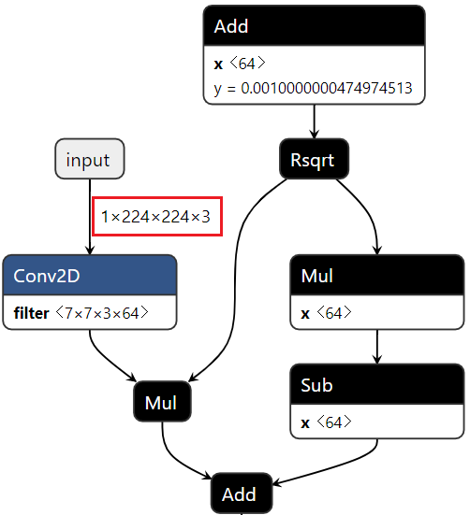

The input_arrays and output_arrays are chosen as instructions of section “how to get input and output arrays of the model”.

Finally, export a graph to the Graphviz Dot

tflite_convert \  
  --graph_def_file=/path/to/model.pb \  
  --output_file=/path/to/output/model.dot \  
  --output_format=GRAPHVIZ_DOT \  
  --input_shape=1,224,224,3 \  
  --input_arrays=input \  
  --output_arrays=InceptionV1/Logits/Predictions/Reshape_1

The resulting .dot file can be rendered into a PDF file as follow:

dot -Tpdf -O model.dot

The file model.dot.pdf will be generated, this file will be can be viewed in any PDF viewer and we will be used to identify the input and output arrays for converting in the section “specify input arrays and output arrays”

Open file model.dot.pdf and zoom in the graph, you can see the input arrays are chosen as following image:

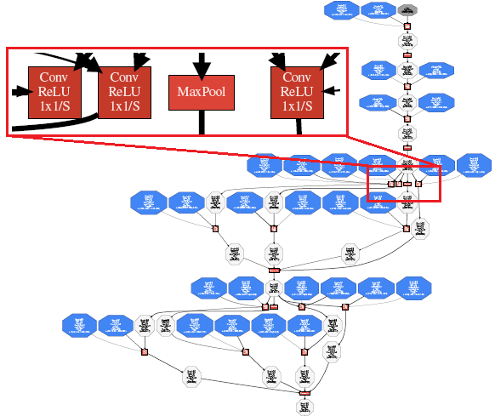

Each input arrays of each block can be identified as below:

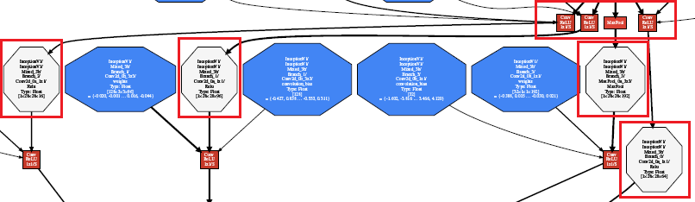

Zoom in each block for more details. For example, this image shows the input arrays of MaxPool:

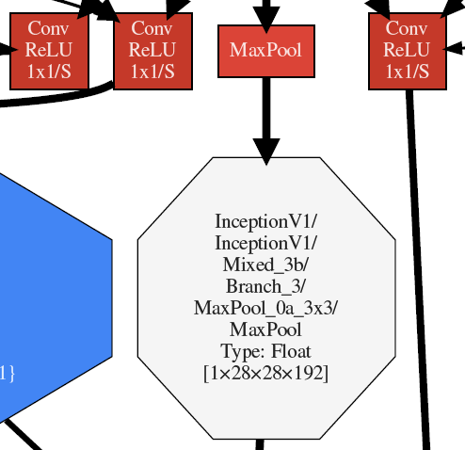

Identify the input_shapes in the blue box and input_arrays in the blue box.

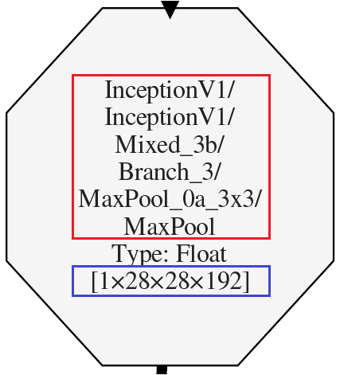

After zoom in the graph (the red boxes), we can see more details about the input arrays:

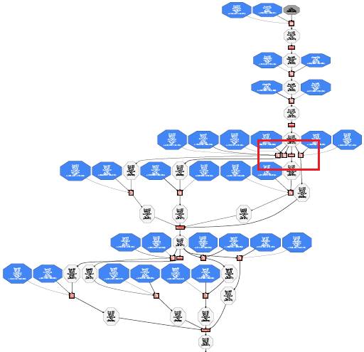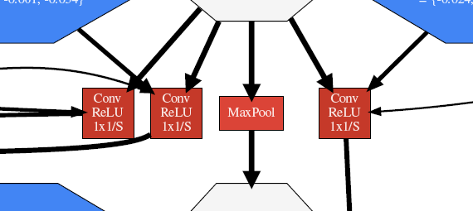

Each input arrays of each block can be identified as below:



Zoom in each block for more details. For example, this image shows the input arrays of MaxPool:



Identify the input_shapes in the blue box and input_arrays in the blue box.

