**Overall Objectives**

To develop a statistical model of iron production that explains trends in the data and allows for forecasting of future values.

**Study Objectives**

1. To analyze seasonal production variation and develop a model to forecast monthly production
2. To compare different time series models in modeling basic iron production and determine two models which fit the data well
3. To forecast monthly production two years into the future

**Research Questions**

1. Does the time series data become stationary after the first order differencing?
2. Do log/power transformations, or percent changes minimize variation?
3. Does the sample autocorrelation function show that the data is stationary or nonstationary?

**Relevant Techniques to Be Employed**

1. Inspection of the sample ACF and PACF plots for characteristic patterns that support our model parameter estimates
2. Determining the best model utilizing AIC and BIC
3. Analyze the plots of the first difference and combined seasonal first differences for trends that would suggest relevant models to explore
4. Use maximum likelihood, method of moments, and sum of squares estimates to determine statistical significance of coefficient estimates
5. Analyze residuals plots to confirm that our model is a good fit to the data
6. Use a variety of transformations to stabilize variance

DATA LINK: <https://datamarket.com/data/set/22qj/monthly-basic-iron-production-in-australia-thousand-tonnes-jan-1956-aug-1995#!ds=22qj&display=line>

**Data Analysis and Results**

**Testing for Stationarity of Data**

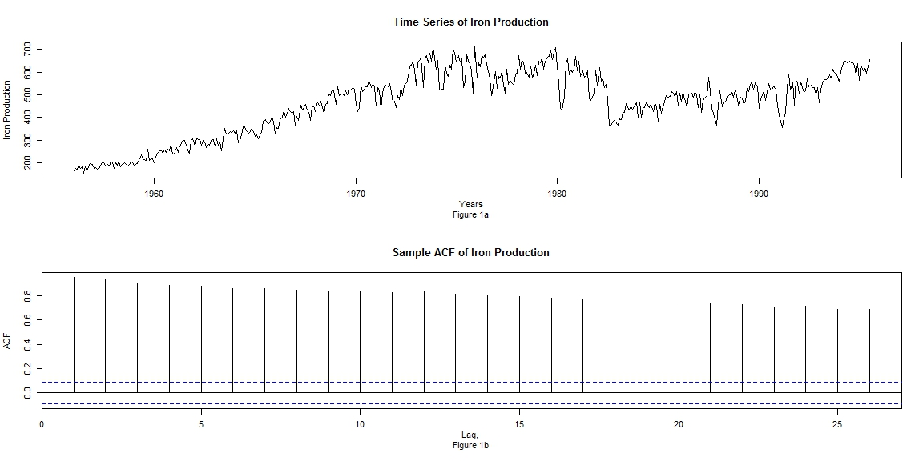

This is the initial plot of iron production without any transformations. Inspecting Figure 1a, iron production has a strong positive trend with increasing variance. Further, Figure 1b shows a strongly positive, slowly decaying ACF. These observations indicate nonstationary data. The upward trend suggests a log transformation should be performed, and then check again for stationarity.

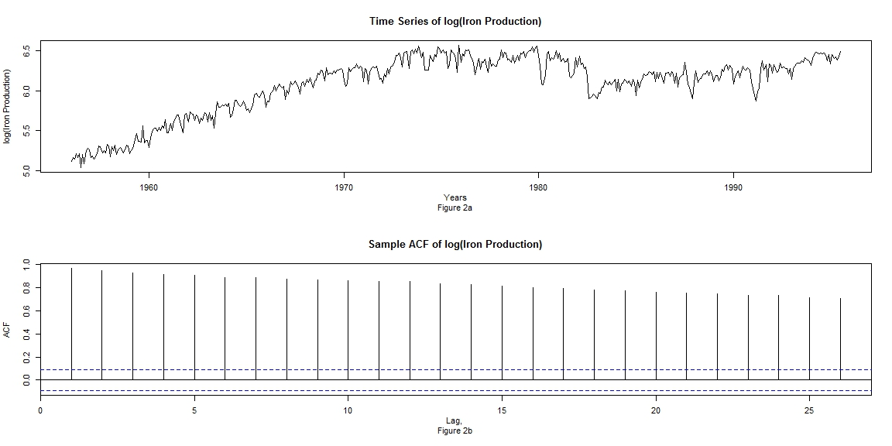

After taking a log transformation as seen in Figure 2a, the data still presents an upward trend with the variance being mostly stabilized. Figure 2b still shows a positive ACF indicating a first difference of the log transformation should be explored.

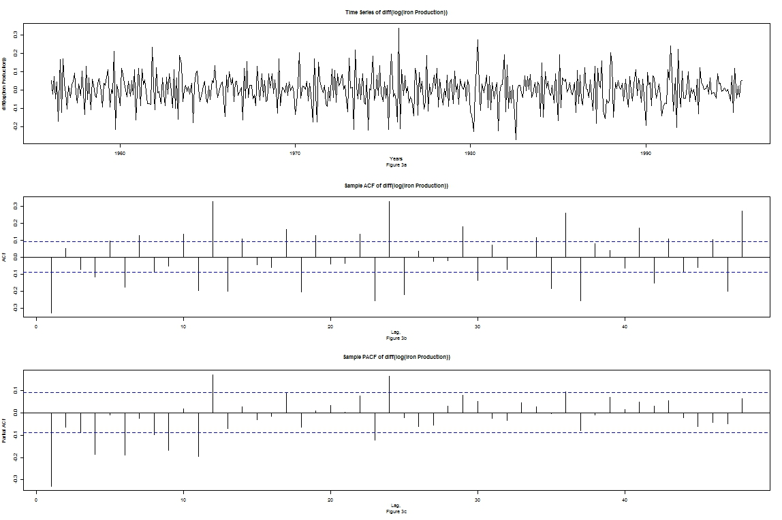

Subsequently in Figure 3a, the first difference of the log transformation of the iron production shows no trend and constant variance. This indicates stationarity has been achieved. With regards to non-seasonal behavior, both the ACF and PACF in Figures 3b and 3c, respectively, have a clear spike at lag 1. In addition, both of these figures do not taper off immediately after lag 1 and have a dampened sine wave as one continues to later lags. Because neither Figure 3b nor 3c just die off it would appear both AR and MA values will be needed, most likely AR(1) and MA(1). Both the ACF and PACF in Figures 3b and 3c have significant lag values between the seasonal lags at 12 and the lag 1 spike. Exploratory analysis showed that AR coefficients up to 12 resulted in models failing both the Ljung Box and Shapiro Wilkes Tests. The only model with higher order MA coefficients that passed the Ljung Box test in the second model described later on in this paper.

With regards to seasonal behavior, both Figures 3b and 3c show clear clusters around 12. Further, the ACF has spikes lags 12, 24, 36 and 48 while the PACF spikes are at 12 and 24 but die off after that. The PACF in Figure 3c indicates either a sAR(1) or sAR(2) will be useful for the model while the ACF in Figure 3b shows that potentially multiple sMA values will be needed. Exploratory analysis on higher orders of sMA and sAR values illustrated that coefficients above two were not significantly different than zero. Possible values were tried up to 6 for sAR and sMA modeling.

**Specifying a Model**

I. ARIMA (1,1,1) x (1,0,1)12

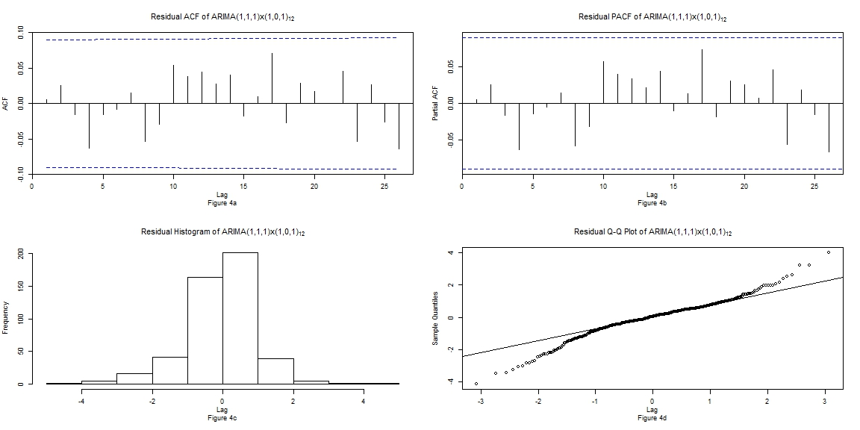

Observing Figures 4a and 4b, one can see the excellent ACF and PACF corresponding to the fitting data for the 12-period model. No significant lag values are apparent indicating non normal error terms. In addition, the Ljung Box test had a p-value of 0.4861 implying that the assumption of uncorrelation cannot be rejected. However, upon inspection of Figures 4c/d, one can see that the normality assumption is not held. The histogram has poor tails corresponding to the QQ plot with significant deviations at the tails. This agrees with the Shapiro-Wilkes test p-value of 5.683e-10 which indicates a rejection of the normality assumption.

ar1 ma1 sar1 sma1

0.6034 -0.8636 0.9988 -0.9697 sigma^2 estimated as 0.004903

s.e. 0.0572 0.0337 0.0035 0.0451 log likelihood = 576.36, aic = -1144.72

Figure 5

One can see that all of the coefficients are statistically significant in Figure 5. Other models attempted with additional AR/MA and sMA/sAR components had both higher AIC scores and coefficients that were not statistically different that zero. In addition, the removal of any of the AR/MA, sAR, and sMA resulted in failing both the Ljung-Box and Shapiro Wilkes tests. Finally, using a seasonal difference caused sMA value to not be significantly different than zero. The following model will explore seasonal differences.

II. ARIMA (1,1,5) x (1,0,1)12

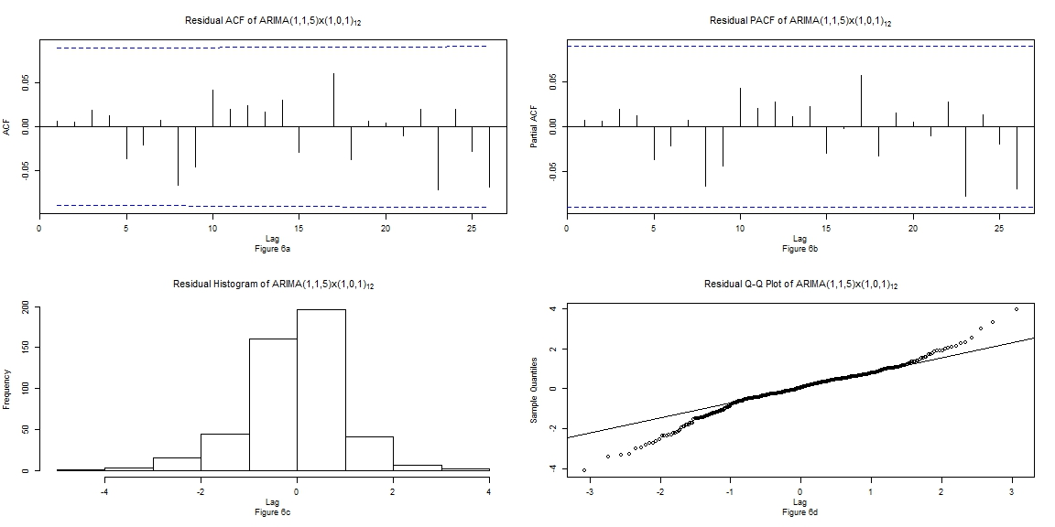

Inspecting Figure 6a/b, one can see that there are no significant lag values indicating there is no significant autocorrelation. The Ljung Box test confirms this with a p-value of 0.4543 confirming the assumption of independent error terms cannot be rejected. Moving on to Figures 6c/d, one can see the assumption of normality should be dropped. The histogram in Figure 6c mostly lacks normality characteristics at the tails and the QQ plot in Figure 6d shows significant deviations at the tails. The lack of normality is confirmed with the Shapiro Wilkes test has a p-value of 1.1609e-10 which confirms the normality assumption should be rejected.

ar1 ma1 ma2 ma3 ma4 ma5 sar1 sma1

0.9867 -1.2576 0.1282 0 0 0.1378 0.9994 -0.9791 sigma^2 estimated as 0.004828

s.e. 0.0140 0.0473 0.0568 0 0 0.0199 0.0014 0.0241 log likelihood = 578.8, aic = -1145

Figure 7

This model was an attempt at using higher order MA and/or AR coefficients in order to achieve normality. As stated earlier, no higher order AR models had both non-zero coefficients and at least passed the Ljung-Box or Shapiro-Wilke tests. The best model achieved used the same sMA(1) and sAR(1) and then going out to MA(5). Making both the MA(4) and MA(5) coefficients different than zero allowed for the model to pass the Ljung Box test and made the rest of the MA coefficients statistically different than zero.

**Model Forecasting of Data**

I. ARIMA (1,1,1) x (1,0,1)12

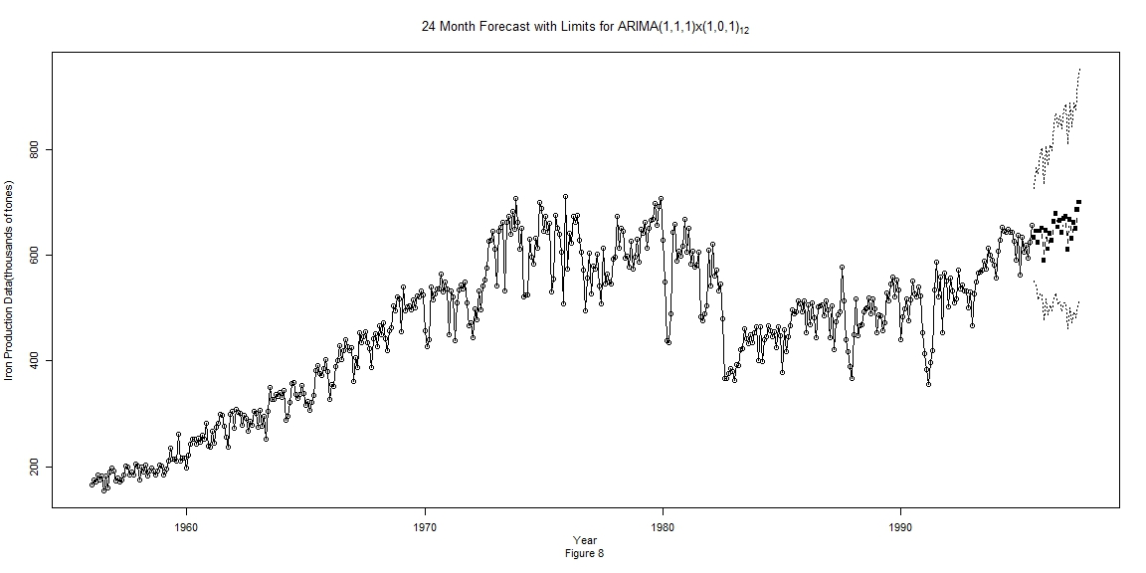

Here, in Figure 10, one can see the forecasting intervals 24 months into the future for the original iron production data in the 12-period model. The forecast are quite wide but the forecasted data follows the upward linear trend of the iron production data. In addition, the forecasted values appear to have some seasonality like the original data.

II. ARIMA (1,1,5) x (1,0,1)12

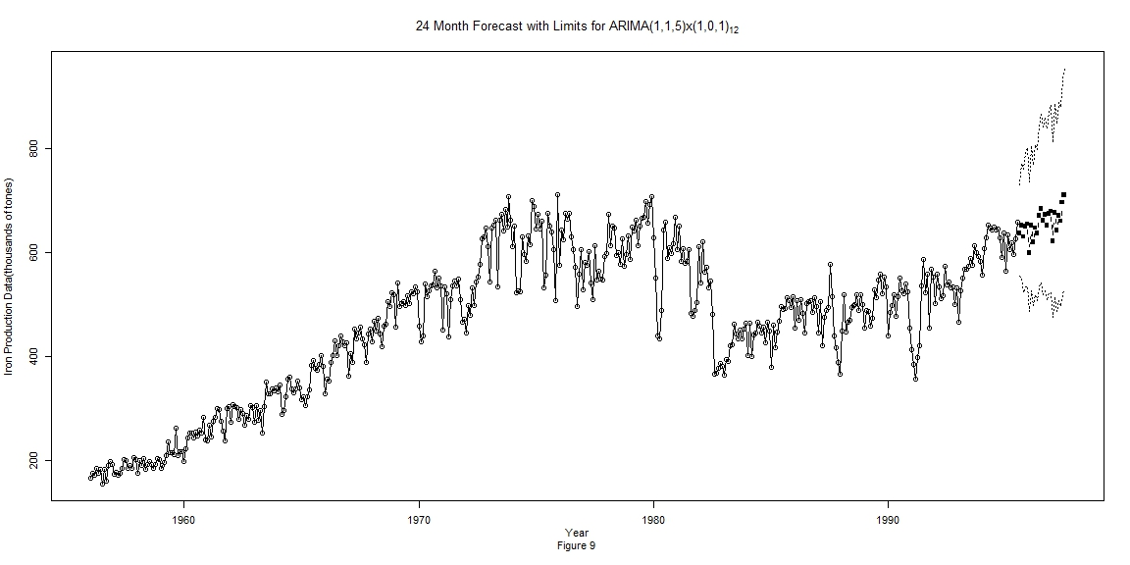

Observing Figure 9, one can see the similarities with forecasting in the previous model. Both models have wide forecasting limits while the forecasting values both follow the upward trend in the data and have some degree of seasonality.

**Conclusions**

Model fitting began by performing log transformations and non-seasonal differences to fix any stationarity problems in the iron production data. Next, analysis of the ACF and PACF in Figures 3a-c was used to predict possible models. Subsequently, two models were then created that fit the ACF/PACF trends. Residual testing was applied to both models. Both of these models had independent error terms but lacked normality. Finally, forecasting was performed by both models twenty-four months into the future. Model fitting for the iron production data proved quite difficult. In addition, the armasubset function in R indicated potential AR and MA coefficients up to 12 but no models using this information were viable besides the second model produced. Nearly all models attempted had independent residuals (passed Ljung Box Test) but lacked normality (failed Shapiro-Wilkes Test). The only models that passed both tests had to have a significant amount of data points removed from the model. As this is not ethical, it was not used to produce any models for the write-up. Further testing of models would emphasize regression techniques that could address the lack of normality.